3GPP TSG RAN WG1 Meeting #106-e R1-21xxxxx
e-Meeting, August 16th – 27th, 2021

Title: Draft LS on TA-based propagation delay compensation
Response to: -
Release: Rel-17
Study Item: NR_IIOT_URLLC_enh

Source: Huawei [TSG RAN WG1]
To: TSG RAN WG4
Cc: TSG RAN WG2

Contact Person:

Name: Yan Cheng

E-mail Address: chengyan.cheng@huawei.com

1. Overall Description:
RAN1 discussed TA-based propagation delay compensation enhancements and the key related agreements are copied here for RAN4 information:
Agreements:
The following options for propagation delay compensation are further studied in RAN1
- Option 1: TA-based propagation delay
  - Option 1a: Propagation delay estimation based on legacy Timing advance (potentially with enhanced TA indication granularity).
  - Option 1b: Propagation delay estimation based on timing advanced enhanced for time synchronization (as 1a but with updated RAN4 requirements to TA adjustment error and Te)
  - Option 1c: Propagation delay estimation based on a new dedicated signaling with finer delay compensation granularity (Separated signaling from TA so that TA procedure is not affected)
- Option 2: RTT based delay compensation:
  - Propagation delay estimation based on an RAN managed Rx-Tx procedure intended for time synchronization (FFS to expand or separate procedure/signaling to positioning).

Agreements:
Both 15 kHz and 30 kHz are assumed for both control-to-control and smart grid for evaluation of the time synchronization.

Working assumption:

Note that the two alternatives in the above working assumption can be modified as below based on the LS reply R4-2105850 from RAN4:
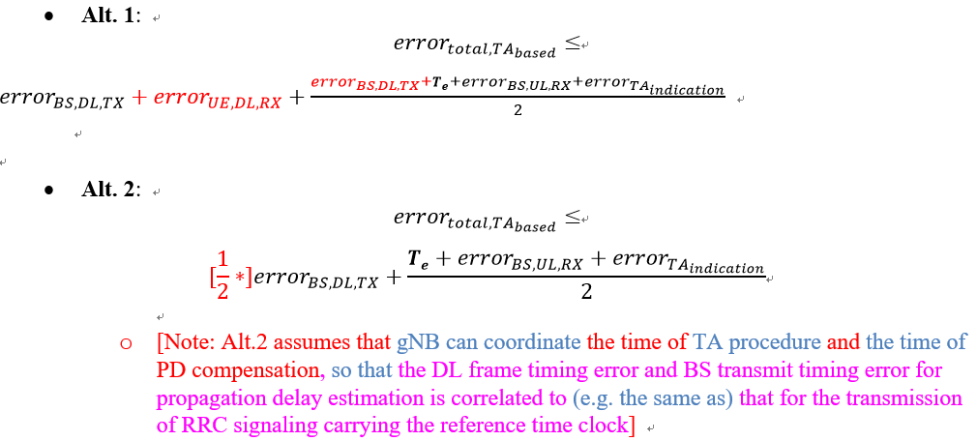

In order to evaluate the performance achievable by TA-based PDC in Rel-17, RAN1 identified the following questions that need feedback from RAN4:
Question 1: Is it feasible to support a smaller value than the current Te for the use of propagation delay compensation, assuming the existing conditions in TS 38.133 for Te requirement? If not, is it feasible under new conditions (e.g. using TRS instead of SSB)? If the answer is yes, please also provide feedback on how much it can be reduced at most.
Question 2: Is it feasible to introduce enhanced TA command indication granularity? If the answer is yes, please also provide feedback on how much it can be reduced at most (e.g. reduced to (1/16)* (16*64*T_{c}/2^{μ}), similar as the granularity for Rel-16 IAB based on the Timing Delta MAC CE) and related condition.
In addition, the following two addition points are for RAN4 information:
- Enhancements on Te and TA command indication granularity for propagation delay compensation may or may not have impact on normal TA related procedure, depending on which candidate option for TA-based PDC is adopted.
- Whether RAN1 will introduce specification enhancements is still undetermined.

2. Actions:
To RAN4
ACTION: RAN1 respectfully asks RAN4 to provide feedback on the above two questions and any additional information that may help RAN1 understand the feedback from RAN4.

3. Date of Next TSG-RAN WG1 Meetings:
TSG-RAN WG1 Meeting #106bis-e 11th – 19th October 2021 Electronic Meeting
TSG-RAN WG1 Meeting #107-e 11 – 19 November 2021 Electronic Meeting

