**3GPP TSG RAN WG1 #105-e R1-210xxxx**

**e-Meeting, May 10th – 27th, 2021**

**Agenda Item:** 7.2.5

**Source:** Moderator (LG Electronics)

**Title:** Feature lead summary on other aspects for URLLC/IIoT

**Document for:** Discussion and decision

# Introduction

This document summarizes the topics under AI 7.2.5 based on the contributions submitted to this AI [1-7], especially for related to other aspects for URLLC//IIOT, and provides FL recommendation to organize the subsequent email discussions.

# Summary of issues for others

|  |  |  |  |
| --- | --- | --- | --- |
| **Issue #** | **Description** | **Source** | **Recommended handling** |
| 1 | SPS PDSCH release and SPS receptions with slot aggregation | R1-2104312, R1-2104321, R1-2105418, R1-2105531 | Include in the email scope |
| 2 | Capture the agreement on SPS release that is not supported. | R1-2104215, R1-2104312 | Discuss after the decision on issue #1 |
| 3 | CSI-PUCCH-ResourceList where SPS HARQ-ACK multiplexed | R1-2104801, R1-2105418 | Include in the email scope |
| 4 | Interpretation of *startingSymbolIndex* when HARQ-ACK is multiplexed | R1-2104801, R1-2105418 | Include in the email scope |
| 5 | Clarification on “corresponding entry” for joint deactivation of SPS/CG | R1-2105851, | Hear more views during preparation phase |

FL recommendation for email scope:

* **Issue #1**: SPS PDSCH release and SPS receptions with slot aggregation
* **Issue #3**: *CSI-PUCCH-ResourceList* where SPS HARQ-ACK multiplexed
* **Issue #4**: Interpretation of *startingSymbolIndex* when HARQ-ACK is multiplexed

# Issues in RAN1#105-e

* 1. Issue #1 SPS PDSCH release and SPS receptions with slot aggregation

In [2, 3, 5, 6], the issue of SPS PDSCH release timing and SPS reception with slot-aggregation is mentioned. Most of contribution bring UE behaviors discussed in RAN1#104-e. Here are companies preference from their contributions and figures.

UE behavior 1: [2]

UE behavior 2: [3], [5], [6]

**UE behaviors discussed in [104-e-NR-L1enh-URLLC-05]**

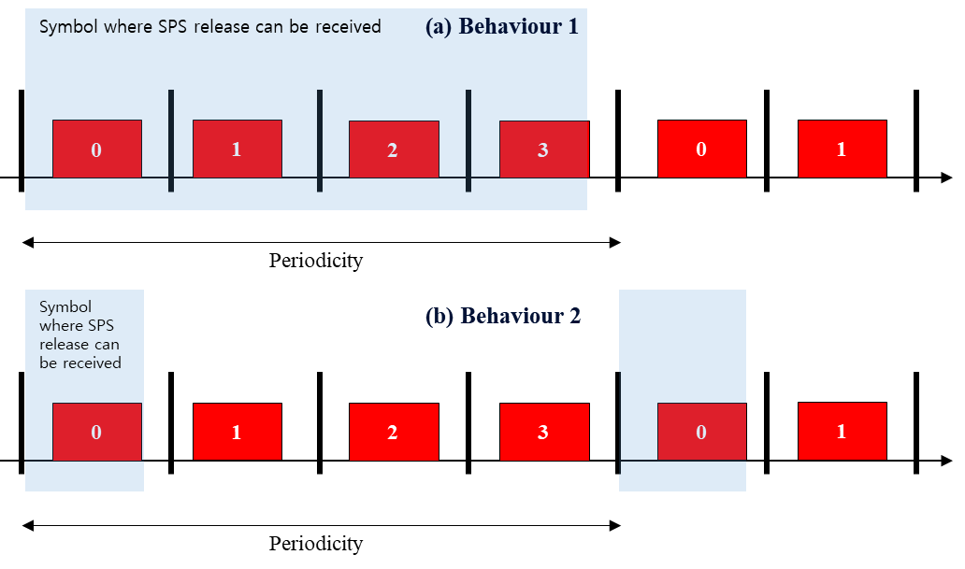

Proposal from [2]:

**Proposal 4.1: In case of SPS PDSCH with slot-aggregation, support behaviour 1 (discussed in [104-e-NR-L1enh-URLLC-05]) where UE can receive SPS release no later than the last repetition of a SPS PDSCH bundle.**

* **The UE stops the PDSCH decoding and does not generate HARQ-ACK feedback information for the SPS PDSCH reception**

Proposal from [3]:

***Proposal 1:*** *If a UE is configured to receive SPS PDSCH(s) in a slot for SPS configuration(s), the UE does not expect to receive a PDCCH providing a DCI format in the slot to indicate SPS PDSCH release of the these SPS configuration(s), where the end of a last symbol of the PDCCH reception is after the end of a last symbol of any of the SPS PDSCH reception(s), if HARQ-ACK information for the SPS PDSCH release and the SPS PDSCH receptions would be multiplexed in a same PUCCH.*

Proposal from [5]:

Proposal 1: For SPS PDSCH with slot-aggregation, same principle as SPS PDSCH without slot-aggregation are applied.

* If SPS release and SPS PDSCH is received in the same slot, SPS release should be received before the end of corresponding first SPS PDSCH occasion
* FFS: If SPS release and SPS PDSCH is received in the same slot, SPS PDSCH reception with slot-aggregation and SPS release should map to same PUCCH

Proposal from [6]:

***Proposal 3: If repetition is configured for SPS PDSCH, the UE can receive SPS release only before the end of the SPS PDSCH in the first slot among all the repetitions and the timeline for single-slot SPS PDSCH is applied in the slot.***

FL comment:

It is necessary to clarify to finalize the issue of SPS PDSCH release and corresponding receptions.

* 1. Issue #2 capture the agreement on SPS release that is not supported.

In [1], there is a proposal to capture previous agreements on SPS release timing that is not supported.

**Proposals from [1]:**

1. Adopt the text proposal to capture the agreement on SPS release that is not supported.

|  |
| --- |
| ---------------------------------Start of Text Proposal to TS 38.213 v16.5.0----------------------- 9.1 HARQ-ACK codebook determination ...  If a UE is configured to receive SPS PDSCHs in a slot for SPS configurations that are indicated to be released by a DCI format, and if the UE receives the PDCCH providing the DCI format in the slot where the end of a last symbol of the PDCCH reception is not after the end of a last symbol of any of the SPS PDSCH receptions, and if HARQ-ACK information for the SPS PDSCH release and the SPS PDSCH receptions would be multiplexed in a same PUCCH, the UE does not expect to receive the SPS PDSCHs, does not generate HARQ-ACK information for the SPS PDSCH receptions, and generates a HARQ-ACK information bit for the SPS PDSCH release.  < Unchanged parts are omitted >  If a UE is configured to receive SPS PDSCH(s) in a slot for SPS configuration(s), the UE does not expect to receive a PDCCH providing a DCI format in the slot to indicate SPS PDSCH release of the these SPS configuration(s), where the end of a last symbol of the PDCCH reception is after the end of a last symbol of any of the SPS PDSCH reception(s), if HARQ-ACK information for the SPS PDSCH release and the SPS PDSCH reception(s) would be multiplexed in a same PUCCH.  If a UE is configured to receive SPS PDSCH(s) in a slot for SPS configuration(s), the UE does not expect to receive a PDCCH providing a DCI format in the slot to indicate SPS PDSCH release of the these SPS configuration(s), if HARQ-ACK information for the SPS PDSCH release and the SPS PDSCH reception(s) would map to different PUCCHs.  < Unchanged parts are omitted >  --------------------------------- End of Text Proposal to TS 38.213 v16.5.0----------------------- |

Proposals from [2]:

In the following, we present a TP addressing the RAN1#101e agreement and the RAN1#104bis-e conclusion above based on our proposal 4.1 to support behavior 1, based on the following logic:

* The first added paragraph excludes the case of the release to be received after the last symbol for SPS PDSCHs in a slot (and for SPS repetition, this restriction only applies to the last SPS PDSCH occasion of the SPS repetition bundle) based on the RAN1#101-e agreement.
* As the first paragraph excludes these cases already, the related restrictions (for simplicity) can be removed from the second paragraph handling the case of same PUCCH for SPS HARQ and release indication.
* The third paragraph is added to reflect to the RAN1#104bis-e conclusion to not support different PUCCH for SPS HARQ and release indication.

**Proposal 4.2: Adopt the following TP to Sec. 9.1 of TS 38.213 to support behavior 1 as well as reflecting earlier RAN1 agreements and conclusion:**

|  |
| --- |
| 9.1 HARQ-ACK codebook determination *** Unchanged text is omitted ***  The UE is not expected to receive a DCI format in a slot to release SPS PDSCHs configured to be received in the same slot if the end of the last symbol of the PDCCH reception is after the end of a last symbol of any of the SPS PDSCH receptions for SPS configurations not subject to *pdsch-AggregationFactor* or any of the last occasions of SPS PDSCH receptions for SPS configurations subject to *pdsch-AggregationFactor* as described in Sec. 5.1.2.1 of [6].  If a UE is configured to receive SPS PDSCHs in a slot for SPS configurations that are indicated to be released by a DCI format, and if the UE receives the PDCCH providing the DCI format in the slot ~~where the end of a last symbol of the PDCCH reception is not after the end of a last symbol of any of the SPS PDSCH receptions~~, and if HARQ-ACK information for the SPS PDSCH release and the SPS PDSCH receptions would be multiplexed in a same PUCCH, the UE does not expect to receive the SPS PDSCHs, does not generate HARQ-ACK information for the SPS PDSCH receptions, and generates a HARQ-ACK information bit for the SPS PDSCH release.  The UE is not expected to receive a DCI format in a slot to release SPS PDSCHs configured to be received in the same slot if HARQ-ACK information for the SPS PDSCH release and the SPS PDSCH receptions would be multiplexed in a different PUCCH.  *** Unchanged text is omitted *** |

FL comment:

In the last meetings, there are requests from companies to postpone capturing agreement until a decision on slot-aggregation case. I would like to recommend to discuss how to capture the agreements after any outcome from issue #1.

* 1. Issue #3 CSI-PUCCH-ResourceList where SPS HARQ-ACK multiplexed

In the last meeting, this issue has been discussed but haven’t concluded yet. This is latest proposal in the last meeting.

**Latest Proposal 3-1 in RAN1#104bis-e:**

**For the multiplexing among overlapping channels with same a given priority index, if a UE is provided subslotLengthForPUCCH for the HARQ-ACK codebook of the given priority index, UE does not expect that the HARQ-ACK corresponding only to SPS PDSCH(s) in one sub-slot is moved to a different sub-slot after multiplexing.**

* **Note: It is up to the editor to decide whether/how to capture the proposal in the spec if agreed.**

In [4], there is an opinion that current specification already covers so not to move HARQ-ACK information to different sub-slot.

In [5], the proposal same as latest one is provided.

**Proposal from [4]:**

For the first aspect, it is common understanding that UE does not expect the SPS HARQ-ACK in one sub-slot is moved to another sub-slot due to multiplexing, but it has not been discussed whether to make changes on the specification. At the beginning of section 9 in TS 38.213, it is stated that “In the remaining of this Clause, if a UE is provided subslotLengthForPUCCH, a slot for an associated PUCCH transmission includes a number of symbols indicated by subslotLengthForPUCCH.” To our understanding, if a UE is provided subslotLengthForPUCCH for a given priority index, the multiplexing of SPS HARQ-ACK and CSI in section 9.2.5.2 (the following text) should be performed on sub-slot level, that is, the highlighted “slot” in the following text should be re-interpreted as sub-slot. In such a case, the SPS HARQ-ACK information would not be moved to a different sub-slot after multiplexing with CSI. Therefore, the current specification is clear and no needs for further clarification.

Proposal 1: For the multiplexing among overlapping channels with same a given priority index, if a UE is provided subslotLengthForPUCCH for the HARQ-ACK codebook of the given priority index, UE would not move the HARQ-ACK corresponding only to SPS PDSCH(s) in one sub-slot to a different sub-slot after multiplexing with the description of the current spec.

Proposal from [5]:

**Proposal 2: For the multiplexing among overlapping channels with same a given priority index, if a UE is provided subslotLengthForPUCCH for the HARQ-ACK codebook of the given priority index, UE does not expect that the HARQ-ACK corresponding only to SPS PDSCH(s) in one sub-slot is moved to a different sub-slot after multiplexing.**

Proposal from [6]:

***Proposal 4: Conclude that,***

***For the multiplexing among overlapping channels with a given priority index, if a UE is provided subslotLengthForPUCCH for the HARQ-ACK codebook of the given priority index, UE does not expect that the HARQ-ACK corresponding only to SPS PDSCH(s) in one sub-slot is moved to a different sub-slot after multiplexing.***

FL comment:

Based on the contributions, most of companies thinks that UL multiplexing procedure must keep the original sub-slot but specification changes is not necessary.

I would like to include the issue in the scope, since this issue is already treated due to its necessity and there seems a consensus.

* 1. Issue #4 interpretation of *startingSymbolIndex* when HARQ-ACK is multiplexed

In the last meeting, this issue has been discussed but haven’t concluded yet. This is latest proposal in the last meeting.

**Latest Proposal 3-2 in RAN1#104bis-e: Only for sub-slot-based PUCCH resource except where the PUCCH resource is provided by pucch-ResourceId in multi-CSI-PUCCH-ResoruceList, pucch-CSI-ResourceList and SchedulingRequestResourceConfig, for HARQ-ACK feedback, the first symbol of the PUCCH resource is relative to the first symbol of the sub-slot.**

Remaining discussion point was whether it is possible to use a PUCCH resource as either sub-slot PUCCH or slot PUCCH. The latest proposal addresses this issue by the phrase “**by pucch-ResourceId in**” so that starting symbol of PUCCH resource can be interpreted differently according to a list of PUCCH resource, even if the same pucch-ResourceId are configured in lists.

In [4], it is mentioned that it is unnecessary to restrict that PUCCH resource for sub-slot based HARQ-ACK and PUCCH resource for slot-based SR/CSI cannot share the same PUCCH resource ID. For this, TP is also provided.

In [5], the proposal same as latest one is provided.

**Proposal from [4]:**

***Proposal 2: Adopt the following text proposal for the reference of first symbol for PUCCH resource when sub-slot is configured:***

|  |
| --- |
| **9.2.1 PUCCH Resource Sets**  <omit text unchanged>  If a UE is provided *subslotLengthForPUCCH* in a *PUCCH-Config*, the first symbol of a PUCCH resource when the UE determines from *PUCCH-ResourceSet* or *sps-PUCCH-AN-List-r16* in *PUCCH-Config and n1PUCCH-AN* in *SPS-Config* for multiplexing HARQ-ACK in a PUCCH transmission is relative to the first symbol of the *subslotLengthForPUCCH* symbols [12, TS 38.331]. For the remaining cases, the first symbol of a PUCCH resource is relative to the first symbol of a slot with $N_{\text{sym}}^{\text{slot}}$ symbols [4, TS 38.211].  <omit text unchanged> |

Proposal from [5]:

**Proposal 3: Adopt following CR for TS 38.213 clause 9.2.1**

|  |
| --- |
| 9.2.1 PUCCH Resource Sets  < Unchanged parts are omitted >  If a UE is provided *subslotLengthForPUCCH* in a *PUCCH-Config*, the first symbol of a PUCCH resource in *PUCCH-Config* except when the PUCCH resource is provided by *pucch-ResourceId* in *multi-CSI-PUCCH-ResoruceList*, *pucch-CSI-ResourceList* and *SchedulingRequestResourceConfig*, for multiplexing HARQ-ACK in a PUCCH transmission is relative to the first symbol of the *subslotLengthForPUCCH* symbols [12, TS 38.331]  < Unchanged parts are omitted > |

* Reason for change: Clarify the case when a PUCCH resource in *PUCCH-*Config are interpreted as sub-slot PUCCH.
* Summary of change: Specify the exceptional case when a PUCCH resource in *PUCCH-*Config should be interpreted as slot-level PUCCH resource.
* Consequences if not approved: it remains unclear whether to interpret PUCCH resource for SR and CSI reporting when HARQ-ACK feedback is multiplexed into the PUCCH resource.

FL comment:

It is already identified that the current specification text has an ambiguity. it would be good to fix in this meeting.

* 1. Issue #5 Clarification on “corresponding entry” for joint deactivation of SPS/CG

In [7], it is argued that the mapping between HARQ process number field and entry is not defined in the standard.

two potential interpretations are provided in [7]:

Interpretation 1: value k of HARQ process number field mapped to k-th entry in the list

(i.e. k=0 cannot be used since the entries start from 1.)

Interpretation 2: value k of HARQ process number field mapped to (k+1)-th entry in the list

Proposal from [7]:

**Observation: The mapping between HARQ process number field and entry in deactivation state list is undefined (including how/whether to map value 0 to a specific entry of the list).**

**Proposal: RAN1 adopt the following TP for TS 38.213:**

******************begin of TP******************

If a UE is provided more than one configuration for UL grant Type 2 PUSCH or for SPS PDSCH

- if the UE is provided *ConfiguredGrantConfigType2DeactivationStateList* or *sps-ConfigDeactivationStateList*, a value k of the HARQ process number field in a DCI format indicates a corresponding (k+1)-th entry for scheduling release of one or more UL grant Type 2 PUSCH or SPS PDSCH configurations

- if the UE is not provided *ConfiguredGrantConfigType2DeactivationStateList* or *sps-ConfigDeactivationStateList*, a value of the HARQ process number field in a DCI format indicates a release for a corresponding UL grant Type 2 PUSCH or for a SPS PDSCH configuration with a same value as provided by *ConfiguredGrantConfigIndex* or by *sps-ConfigIndex*, respectively

******************end of TP******************

FL comment:

In my personal view, a word “corresponding” is used to simplify the description when the associative relation between them are obvious. I guess that it is a kind of intended description since HARQ process number field in a DCI field has 16 bit representations and –*ConfigDeactivationStateList* also has 16 entries maximally. It would be good to hear more view from companies.

# References

1. R1-2104215, Maintenance of PDCCH and SPS for Rel-16 NR URLLC, Ericsson
2. R1-2104312, Rel-16 URLLC/IIoT maintenance of PDCCH, Scheduling/HARQ and SPS enhancements, Nokia, Nokia Shanghai Bell
3. R1-2104321, Remaining issues on SPS enhancement in Rel-16 URLLC, ZTE
4. R1-2104801, Maintenance on SPS enhancements, OPPO
5. R1-2105418, Remaining issues of other aspects for URLLC/IIOT, LG Electronics
6. R1-2105531, Remaining issues on UCI enhancements and SPS, Huawei, HiSilicon
7. R1-2105851, Release of UL grant type 2 PUSCH or SPS PDSCH configurations, ASUSTeK