3GPP TSG RAN WG1 Meeting #103e R1-200XXXX

October 26th–November 13th, 2020

Agenda Item: 8.4.4

Source: MediaTek Inc.

Title: Summary #3 of 8.4.4 Other Aspects of NR-NTN

Document for: Discussion and Decision

# Introduction

This document contains a summary of the contributions under AI 8.2.4 at RAN1#103e. This include the topics for RAN1 that should be specified if beneficial and needed as listed in Release-17 NR NTN WID:

* *Enhancement on the PRACH sequence and/or format and extension of the ra-ResponseWindow duration (in the case of UE with GNSS capability but without pre-compensation of timing and frequency offset capabilities) [RAN1/2].*
* *Feeder link switch [RAN2,RAN1]*
* *Beam management and Bandwidth Parts (BWP) operation for NTN with frequency reuse [RAN1/2]*
  + *Including signalling of polarization mode*

# Beam Management, BWP

## Background

The following agreements were made in RAN1#102e

*One-beam per cell and multiple-beam per cell are supported in existing NR specifications and are baseline for NR NTN.*

* *FFS: The need for potential enhancement for beam management*
* *FFS: The need for potential enhancement on association of SSBs, beams and BWPs*

### Beam Management

During the rel-16 NR NTN SI, it was observed that the rel-15 NR beam management and BWP procedures can be re-used with the assumption that the beams are not co-located. Rel-15 NR UE uses initial BWP#0 for initial cell access including SSB, paging, and PRACH.  DCI signaling is used to indicate BWP switching, where the BWP switching in UL and DL is separately configured.  A device needs first to switch from the serving BWP#x to initial BWP#0, then switch to BWP#Y. The UE can fall back to initial BWP if the switching fails. There can be up to 4 BWPs configured in Rel-15 NR – i.e. BWP#0, BWP#1, BWP#2, and BWP#3.

There were two options for mapping of PCI and SSB in TR 38.821 [2].

* Option a: multiple beams per PCI with beam specific SSB.
* Option b: one beam per PCI.

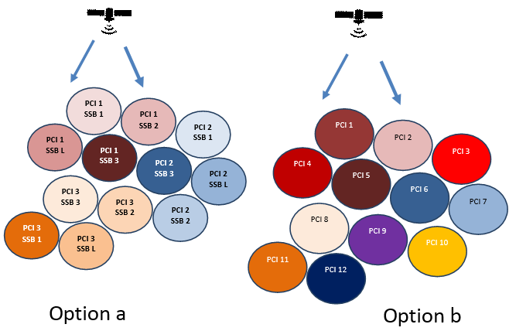

***Figure 1: Mapping options for PCI/SSBs in NTN***

In NR specification, the beam management procedure is used at the gNB and UE for training purpose to select the best beam. For beam selection at UE side, the UE measures SSB or NZP-CSI-RS of its serving beam and neighbouring beams and report measurements. It is possible for the UE to measure on any beam on the activated BWP. There is no association between spatial beam index and BWP index. The gNB indicate the serving beam via Transmission Configuration Index (TCI) on DCI or MAC CE. The TCI state includes fields for Cell index, BWP index, SSB index, CSI reference signal for a specific Control Resource Set (CORESET), which defines the PDCCH Search Space. For PDCCH, the MAC CE is used to activated one TCI state over a set of RRC configured TCI states for each CORESET. For PDSCH, DCI in the PDCCH can be used to indicate its TCI state, otherwise (i.e. the presence of TCI field in DCI is not configured), TCI state for PDSCH will follow PDCCH.

|  |  |
| --- | --- |
| **Source** | **Related Proposals & Observations** |
| Ericsson | ***Proposal 3****: RAN1 to discuss the scope of beam management, i.e., whether NR beam management framework (TCI state and spatial relations) should be restricted within the same satellite or support the switching of the service links associated with different satellites*  ***Proposal 4****: A first satellite providing coverage before a service link switch should assist UEs in RRC connected with signaling of the ephemeris of the second satellite providing coverage after the switch.*  ***Proposal 5****: The NR network should be able to indicate the timing of the service link switch to UEs in RRC idle and RRC inactive modes.* |
| Huawei | ***Proposal 1****: BWP configuration enhancement scheme should be studied for NTN.* |
| ZTE | ***Proposal 3:*** *To reduce power consumption and signaling cost, measurement can be disabled or be carried out with adaptive measurement period.*  ***Proposal 4:*** *Enhancement on beam management for UE-group based beam switching, can be considered to improve the performance.*  ***Proposal 5:*** *To reduce signaling cost and latency, UE dominant or UE assistant beam switch can be considered.*  ***Proposal 6:*** *Both BWP switching and TCI indication should be supported parallel to achieve the beam switching.* |
| Qualcomm | ***Proposal 5****: Consider BWP switching schemes to support efficient satellite beam switch.*  ***Proposal 6****: Consider efficient signalling of BWP configurations.*  ***Proposal 7****: Consider enhancements on beam measurement and reporting to support efficient switching between satellite beams using different frequency.* |
| Xiaomi | ***Proposal 2****: DL BWP switching and UL BWP switching simultaneously should be supported.*  ***Proposal 3****: Timer based BWP switching can be supported.* |
| Lenovo | ***Proposal 1****: Study a common BWP or separate different BWPs for beam management.*  ***Proposal 2****: Consider impact of BWP switching delay for NZP CSI-RS for beam management configured at in corresponding BWPs.*  ***Observation 1****: For NTN, current NR measurement-based beam management will result in large signaling overhead and long latency for periodic exchange of CSI-RS transmissions and corresponding reporting.*  ***Proposal 4****: Study further methods to perform beam measurements in order to reduce the signaling overhead and avoid long latency.* |
| Sony | ***Proposal 2****: Reuse the beam indication and BWP indication method in Rel.15/16, the BWP indication and beam indication should be coordinated.* |
| Panasonic | ***Proposal 3****: Schemes to reduce the signaling overhead and UE power consumption for beam management in moving cell scenarios can be considered, e.g. a list of multiple beams with associated timings for switching is indicated to the UE by RRC.* |
| LG | ***Proposal 3****. For NTN, potential enhancement on BWP switching can consider at least following aspects:*   * *Enhancement on bwp-InactivityTimer including value range extension and (re)start timing,* * *PDSCH transmission after transmission of ACK for BWP switching command.* |
| CATT | ***Proposal 4****: Support BWP based beam switching enhancement in NTN to reduce beam switching latency.*  ***Proposal 5****: Enable BWP switching of UL and DL simultaneously and support UE confirmation after BWP switching successfully.*  ***Proposal 6****: Support DCI to indicate beam switching with BWP index indication.* |
| Vivo | ***Proposal 6****: Multiple beams per cell should be prioritized.* |
| Apple | ***Proposal 4:*** *Consider performing beam measurement either in initial BWP or in different BWPs with BWP switching.*  ***Proposal 5:*** *Consider associating beam switching with BWP switching.* |

### Association of SSBs, beams and BWPs

In Rel-15 NR, initial beam selection is based on SSB detection before the PRACH procedure. All SSBs of the primary cell Pcell are transmitted in TDM manner over same frequency resource – i.e. SSB transmissions take place within a BWP and within the same frequency interval. The devices measures SSBs within the same frequency interval to determine the SSB index in time for the best beam and its corresponding CORESET for Common Search Space Set type 0 typically denoted by CORESET#0 (for SIB1). An SSB burst can contain up to 4 SSBs for frequencies below 3 GHz. This limits the number of beams to 4 assuming L or S band. On each beam, the corresponding SSB and CORESET#0 are time-domain multiplexed with multiplexing pattern 1 for frequencies below 3 GHz. The devices then decode SIB1 to get configuration for time domain resource allocation within DCI Format 1_0 and also get the configuration of initial Bandwidth part BWP#0 which is used when first accessing the cell. The SIB1 is also used for configuration of the CORESET type 0A (for SI acquisition), type 1 (for RAR and CR), type 2 (for paging). The UE-specific CORESET configuration for UE data transfer is obtained via dedicated signalling.

|  |  |
| --- | --- |
| **Source** | **Related Proposals & Observations** |
| Ericsson | ***Observation 6****: BWP based frequency reuse will negatively impact the supported system capacity.*  ***Observation 7****: Using BWPs to enable a frequency reuse can already be supported by existing NR specification. It is a choice of network configuration and implementation.*  ***Proposal 6****: RAN1 to conclude that there is no need for additional enhancements for using BWPs to enable a frequency reuse.* |
| Huawei | ***Proposal 2****: The UE in connected mode can perform BWP switching based on the mapping relationship between SSB index and BWP index.* |
| ZTE | ***Proposal 1****: Existing BWP and SSB structure in NR should be reused as the baseline.*  ***Proposal 2****: No explicit enhancements on the association among SSB/BWP/beams are needed.* |
| Qualcomm | ***Observation 1****: Different options for cell/beam/frequency planning call for flexible standard design.*  ***Observation 2****: Different beams of a satellite may have different carrier frequencies but the same corresponding UE transmit and receive spatial direction.*  ***Proposal 1****: Support satellite beam specific initial BWPs.*  ***Proposal 2****: 3GPP RAN1 to have an agenda item dedicated to SSB arrangements and BWP operation.*  ***Proposal 3****: Support the following SSB arrangements*   * *Alt 1: SSBs of all satellite beams in a same cell are transmitted within a same frequency interval and do not overlap in time* * *Alt 2: SSBs of a cell are transmitted in different frequency intervals, i.e., within their respective BWPs.*     ***Proposal 4****: Support signalling of the following configurations in SIB1*   * *initial BWPs of other satellite beams,* * *CORSET#0 of other satellite beams if different from that of the serving beam.* |
| MediaTek | ***Observation 1****: Anchor beam transmitting BWP#0 and comprising single or multiple spot beams each associated with a BWP dedicated for data transmission allows to re-use Rel-15 Beam management mechanisms.*  ***Observation 2****: SSB transmissions without anchor beam may lead to beam switching failure requiring device to access cell again.*  ***Observation 2****: SSB transmissions in same frequency interval without anchor beam requires beam-specific initial BWPs with longer initial access time.*  ***Observation 4****: SSB arrangements in different frequency intervals without anchor beam requires beam-specific initial BWPs with longer initial access time and may require specification of new measurements with gaps due to frequent R retuning and BWP switches.*  ***Proposal 1****: Anchor beam transmitting initial BWP#0 and comprising multiple spotbeams each associated with a BWP dedicated for data transmission is baseline for NR NTN Beam Management and BWP configuration.* |
| OPPO |  |
| Xiaomi | ***Proposal 1****: The association between BWP ID and beam ID can be considered.* |
| Lenovo | ***Proposal 3****: Study the restriction between beam and BWP.* |
| Sony | ***Proposal 1****: SSBs of satellite beams in the same cell are transmitted in the same BWP, e.g., BWP#0.* |
| Panasonic | ***Proposal 1****: Reuse Rel-15/16 SSB arrangement as the baseline for Rel-17 NR NTN.*  ***Proposal 2****: Reuse Rel-15/16 BWP operation framework as the baseline for Rel-17 NR NTN.* |
| LG |  |
| CATT | ***Proposal 1****: For RRC-IDLE UE, one cell is only associated with one satellite beam, no enhancement needed.*  ***Proposal 2****: For RRC-Connected UE, one cell comprises of multiple satellite beams, each beam linked to one BWP.*  ***Proposal 3****: SSB configuration in one BWP follows NR Rel-15 framework, no enhancement needed.* |
| Vivo | ***Proposal 9****: For frequency re-use with circular polarization, support to reuse BWP configuration and operation in the existing NR specification in one satellite beam.* |
| Apple | ***Proposal 1:*** *Each satellite beam is associated with a BWP.*  ***Proposal 2:*** *SSBs of all satellite beams in a cell are transmitted in a cell-specific initial BWP and SSBs do not overlap in time.*  ***Proposal 3:*** *All the SSBs in a cell have a common configuration of CORESET #0 and search space #0.* |

## Company Views (1st round discussions)

### Beam Management

In NR specifications, to conduct the measurement over different beams using SSBs, BWP switching from the serving beam associated with BWPx (i.e., carrying data) to initial BWP0 (i.e., carrying SSB) is needed. In case beam measurements based on CSI-RS, BWP switching from the serving beam associated with BWPx (i.e., carrying data) to another beam with BWPy (i.e., carrying data) is needed. Both types of measurements require that an initial BWP0 is configured and accessible by the UE for beam switching purpose. If initial BWP0 is not accessible, for example it is mapped to a beam that is not in coverage anymore due to satellite movement, beam switching is not possible and UE will need to access cell again.

Intel observed that polarisation and frequency reuse for different beams can be implemented using Rel. 15 NR beam management. In that case SSB corresponding to different beams can be transmitted in the same frequency band and multiplexed in time domain while other physical channels can be transmitted in different parts of the frequency band by using different frequency domain resource allocation for the UEs in different beams. Alternatively, it can be assumed that transmission with different beams corresponds to different BWP or different component carriers. Optimization of NR beam management design is not necessary for NTN. Beam management enhancements specified in Rel. 17 in feMIMO WI can be used for NTN.

Several companies discussed beam management mechanisms:

gNB dominated beam management: discussed by ZTE, Panasonic

In case of earth-fixed beam, the footprint of a satellite using steerable beam varies with elevation change, with dweling time in range 1 to 10 minutes. This makes periodical CSI-RS report ineffective. With GNSS assumption at UE side and broadcast of beam configuration in satellite ephemeris, UEs can calculate dwelling time. UEs close to beam edge can switch beam based on UE group-specific signaling assuming gNB has knowledge of UE positions.

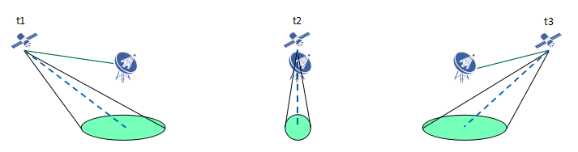

UE dominant beam management: discussed by ZTE, Panasonic, Xiaomi (timer based)

In case of earth-moving beams, the beam switching happens gradually with the movement of satellite. ZTE propose GNSS-capable UE can determine when to switch beams in two ways:

1. Option-1 Timer based: Network pre-configure UEs with beam switching timer based on UE position and beam layout information with satellite ephemeris, which conduct beam switching autonomously based on timer.
2. Option-2 Measurements based: Based on RSRP measurements and beam layout information with satellite ephemeris broadcast in SIB, UE autonomously do beam switching within the limited set accordingly.

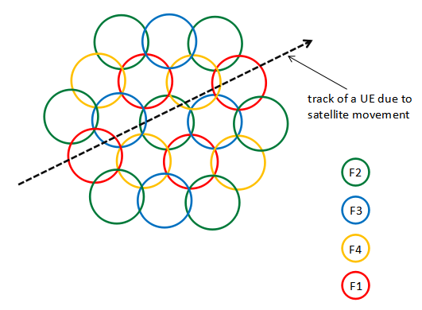

TCI sate indication enhancements for beam management: discussed by ZTE, Ericsson

In NR specification, indication for beam switching is indicated in TCI information via DCI or MAC CE. Assuming each beam is associated to a BWP, the beam switching can be done based on BWP switching mechanism. If polarization is used (e.g., two beams may use the same BWP and different polarization), the beam switching can further be done based on TCI indication.

Ericsson question whether NR beam management framework (TCI state and spatial relations) should be restricted within the same satellite or support the switching of the service links associated with different satellites. A first satellite providing coverage before a service link switch should assist UEs in RRC connected with signalling of the ephemeris of the second satellite providing coverage after the switch. A UE should refrain from initiating an RRC connection towards a satellite that is just about to hand over its service link to a next satellite. The NR network should be able to indicate the timing of the service link switch to UEs in RRC idle and RRC inactive modes.

ZTE propose both BWP switching and TCI indication should be supported parallel to achieve the beam switching.

BWP based frequency reuse: discussed by Ericsson, Panasonic, OPPO, Lenovo, CAICT, Apple

Ericsson, CAICT observed using BWPs to enable a frequency reuse can already be supported by existing NR specification. It is a choice of network configuration and implementation. There is no need for additional enhancements.

Panasonic question whether there is a need for introducing beam-specific BWP for NR NTN. The argument is to facilitate frequency reuse factor larger than 1 to reduce the interference of neighboring satellite beams. By assigning each satellite beam with a different BWP, beam switching would automatically trigger the switching of beam-specific BWP. Interference coordination can be handled in more dynamical way based on Rel-15/16 BWP operations defined from individual UE perspective – i.e. for interference coordination in NTN, BWP can be configured and activated/de-activated for each UE individually based on the actual interference the UE is experiencing. Panasonic propose to reuse Rel-15/16 BWP operation framework as the baseline for Rel-17 NR NTN.

OPPO propose to prioritize satellite beam layout with FRF > 1. The relationship between the satellite beam and the BWP operation should be studied and specified.

Lenovo propose to perform beam management among neighbour geographical areas, where NZP CSI-RS for beam management is configured in corresponding BWP for different geographical areas/footprints. This is an implemention method for BWP-based frequency reuse.

CAICT mentioned beam switch procedure for BWP specific beam management could be optimized by downlink signalling or optimized by UE procedure of beam switch/beam failure recovery for frequency re-use.

BWP switching enhancements: discussed by LG, CATT, Xiaomi

LG discussed that in NR, BWP switching is based on the DCI, MAC-CE or inactivity timer (bwp-InactivityTimer). When UE receives PDCCH scheduling DL or UL, the inactivity timer (re)starts. If there is no additional scheduling command before the timer expires, UE will perform BWP switching to initial BWP or default BWP. This is the way to resolve ambiguity when gNB and UE have different understanding on BWP switching. If a UE misses PDCCH carrying BWP switching indication, gNB can notice this situation at least after round-trip time + T_timer from the time of a PDCCH transmission. Thus, as RTT increase, this issue becomes non-negligible. LG propose that for NTN, potential enhancement on BWP switching consider enhancement on bwp-InactivityTimer including value range extension and (re)start timing, and PDSCH transmission after transmission of ACK for BWP switching command.

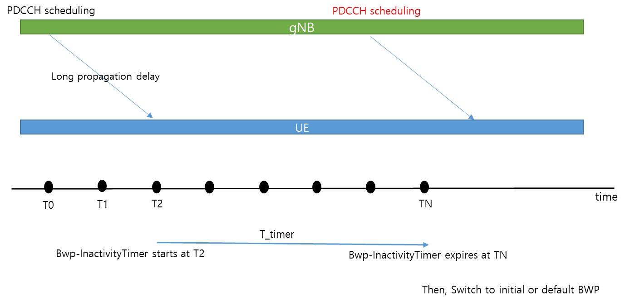

CATT, Xiaomi, mentioned needs to switch both the DL BWP and the UL BWP at the same time during beam switching. CATT proposed that BWP based beam switching enhancement in NTN to reduce beam switching latency is supported.

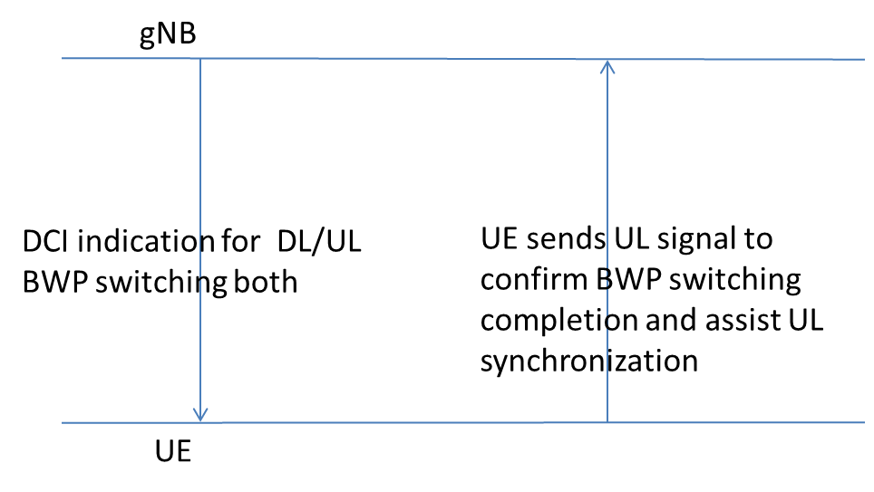

With consideration on the companies contributions, we encourage companies to further discuss potential enhancements for beam management to establish majority views for the 1st round of email discussions. In particular, whether companies agree that there is a need for some or all potential enhancements, whether down scoping of some potential enhancements can be agreed, and whether preference for some potential enhancements based on majority views could be agreed.

***Initial proposal#2.2.1-1 (Moderator)*:**

**Further discussions on potential enhancements of beam management in NTN is needed on the following:**

1. **gNB dominated beam management**
2. **UE dominant beam management**
3. **TCI sate indication enhancements for beam management**
4. **BWP based frequency reuse**
5. **BWP switching enhancements**

|  |  |
| --- | --- |
| **Company** | **Comments and Views on Beam Management** |
| Ericsson | We are fine to discuss further. But perhaps the discussion would be easier if we could first identify what the problem (if any) is before discussing enhancements. Further, this BM discussion is coupled with the discussion on association of SSBs, beams and BWPs. |
| ZTE | All solutions can be considered, but the design of this proposal is highly up to the decision in ***Initial proposal#2.2.2-1*** for the association among SSBs/beam and BWPs. Once the general framework is done, benefits of each option can be justified. For example, based on existing BWP and SSB structure in NR, we should mainly handle the issues on criteria for beam switching, (e.g. measurement or measure-less), and indication for beam switching (e.g., ground based switching signaling for BWP). |
| Panasonic | In general, Rel-15/16 beam management mechanism and BWP operation framework should be reused as the baseline for Rel-17 NTN. We agree with Ericsson that problems should be first identified before discussing the enhancements.  For bullet 1, gNB dominated beam management is already the case in Rel-15/16. Probably the intention here is to reduce the unnecessary measurements and perform UE-group based beam switching for LEO earth-fixed beam case? Actually, the measurements can be disabled via configurations, and furthermore, UE-group based beam switching seems not necessary because for LEO earth-fixed beam deployment, one-beam-one-cell mapping is more suitable without concerns of L3 handover overhead and RAN2 has already discussed UE-group based handover.  For bullet 2, it seems to target at LEO earth-moving beam. We see a need to reduce the beam switching signalling overhead in such case. It can be further discussed the timer based beam switching and location-based beam switching.  For bullet 3, TCI state indication in Rel-15/16 beam management mechanism should be baseline. Necessary modification for NTN might be to support polarization reuse.  For bullet 4, although we acknowledge that interference coordination among neighboring beams are necessary in view of the fact that the coverage of neighboring beams can be largely overlapping, we don’t favor the semi-static frequency reuse planning such as increasing the reuse factor more than 1. Instead, interference coordination should be handled in more dynamical way and the Rel-15/16 BWP operation has already supported it. Note that BWP as in Rel-15/16 can be configured and activated/de-activated for each UE individually based on the actual interference the UE is experiencing.  For bullet 5, it can be further discussed. But it seems not so essential. |
| Qualcomm | Since satellite beam switch is essentially a BWP switch in NTN with frequency reuse, enhancements on beam management are needed. |
| MediaTek | We agree with ZTE that the beam management potential enhancement depend on discussions on Initial proposal#2.2.2-1 for the association among SSBs/beam and BWPs. We also think that the needs of beam management potential enhancements should be discussed.  Bullet 1: earth-fixed beam may lead to all UEs switching beams at the same time. Assuming In case there are 1000s of devices connected, HO signalling bottleneck should be avoided. Whether existing specifications can allow this already could be further discussed. We may wait for RAN2 discussion on connected mobility to conclude first before discussing further this option in RAN1.  Bullet 2: earth-moving beams may need faster beam switching with dwelling time in the order of a few seconds at Nadir. We have preference for Option-2 Measurements based which is currently discussed in RAN2. Option 1 with use of UE location and timer seems a deviation from current mechanisms, and is also being discussed in RAN2. As for Bullet 1, we may first wait for RAN2 to conclude discussions.  On bullet 3, we share same view as Panasonic.  On bullet 4: We share same understanding as Qualcomm on satellite beam switch being essentially a BWP switch in NTN with frequency reuse. We share same understanding as Panasonic that the current specifications could already allow such frequency re-use without any enhancements.  On bullet 5: it could be further discussed. |
| Samsung | We share the similar view with Ericsson. RAN1 first needs to have the common understanding on what problem exists in NTN environments for BWP/BM operation. After having that observation, we could list up and choose the solution. |
| Apple | We support the proposal. Beam management in NTN needs to be examined, especially in BWP based frequency reuse situation. They can be discussed together with the association between BWP, SSB and beams.  It seems the references of the summary are the contributions from last meeting. We inserted our proposals from our contribution to the tables in Section 2.1.1 and Section 2.1.2. |
| Lenovo/MM | From our perspective, the listed enhancements can be divided into three categories: the first one (including gNB dominated beam management and UE dominant beam management)is based on beam layout and UE position to determine how to do beam switching; the second one (including TCI indication enhancement and BWP based frequency reuse) is considering the relationship/restriction between BWP and beam when the frequency reuse is larger than 1; and the third one is to efficiently beam switching such as introducing A/N for the switching command. All three categories address different issues, so we suggest discuss them separately. |
| CATT | Before discussing the enhancements, we need to identify what is optimized target and what is technical issue which can’t be resolved by current NR framework.  From technical prospective, BWP switching enhancement is very easy to implement it, which follows Rel-15 framework and can optimize beam switching for connected UE. |
| Xiaomi | Since different beams may use different BWPs, thus enhancements on beam management are needed.  For bullet 2, we support to study on UE dominant beam management. Timer based and location based beam switching can be further discussed.  For bullet 4, we support BWP based frequency reuse.  For bullet 5, we support to enhance the BWP switching such as simultaneously DL and UL BWP switching. |
| LG | We are fine with the proposal. Further prioritization is also ok for us. |
| Huawei | We are in general supportive to study the potential enhancement for beam management given the distinct characteristic of beams and BWPs in the context of NTN. However, we should reuse the NR schemes as much as possible and minimize the specification impact. In addition, it is probably not very helpful to list all the options without knowing the problems to be addressed and the detailed solutions. |
| APT | Agree with ZTE. We shall first agree to build a new association between SSB and satellite BEAM. Note that by far there is no agreement to support Option a: multiple beams per PCI **with beam-specific SSB**. Bean specific SSB is not explicitly supported in the TR, and no agreement can be found in RAN2.  **3GPP TR 38.821** V16.0.0 (2019-12)  Both options a) same PCI for several satellite beams and b) one PCI per satellite beam, can be considered in NTN. A satellite beam can consist of one or more SSB beams. One cell (PCI) can have maximum of L SSB beams, where L can be 4, 8 or 64 depending on the band.  Similar to TN, one or several SSB index can be used per PCI to separate SSB transmission on different beams. |
| Sony | Partially support Initial proposal#2.2.1-1.  Based on the description 2.1.1, it seems that both gNB dominated beam management and UE dominated beam management are measurement-less based beam switching. Measurement results are vital for beam management, we suggest replacing the sub-bullet 1 & 2 by measurement-based beam switching and measurement-less based beam switching as following:  **Further discussions on potential enhancements of beam management in NTN is needed on the following:**   1. **Measurement based beam management** 2. **Measurement-less based beam management**    * **gNB dominated beam management**    * **UE dominant beam management**   For TCI state indication enhancement and BWP switching enhancements, the existing mechanism of BWP/beam switching is enough. What’s needed is how to coordinate the parallel indication. For example, there are both TCI field and BWP field in DCI format 1_1 for downlink scheduling, while the QCL info together with BWP info are included in the TCI state which is pre-configured by RRC. UE is not expected to receive a beam indication, while the beam is not transmitted in the indicated BWP.  For BWP based frequency reuse, it is up to network implementation. |
| Nokia, Nokia Shanghai Bell | Proposal #2.2.1-1. We support enhancements based on option 1 solutions with the note that the beam shaping vs. time (or elevation angle) should be part of this beam management. The beam shaping (vs. time or elevation angle) is especially useful in earth-fixed beam scenarios to avoid large variation in the dwell time between UE at the beam center and beam edge. TCI state enhancement can be considered to further compensate for beam footprint distortions, in both earth-fixed and earth-moving beam scenarios. According to our understanding, there is no need to use BWP based enhancements in Release 17, as it would bring unnecessary overhead and complexity to the system. |
| Spreadtrum | We are fine with the proposal. |
| Thales | We would prefer to identify and agree on the potential issues in NTN before discussing the solutions. For instance, it seems that frequency reuse deployment can already be supported based on existing framework. |
| vivo | In NTN scenarios, it is hard to reuse beam measurement in NR specification. For example, measurement based on inactive BWPs is not supported. Furthermore, measurement based on SSB in common initial BWP seems to be coarse. In addition, there are always group UEs not only one when beam switching is forthcoming due to the movement of satellites. Thus, group UEs beam switching triggered by gNB with less signaling overhead is more preferable. Considering to the latency, enhancements on BWP switching should be necessary, especially if each beam has a dedicated BWP.  Thus, we prefer gNB dominated beam management and BWP switching enhancements. |
| Inmarsat | Option 1 – Timer based beam switch: Realistically only useful for scenarios where beam map is predictable, which in dynamic systems might not be the case  Option 2 – beam switching based on measurement by UE. This is agreeable as a default scenario  Option 3 – Beam and BWP switching driven by gNB based on beam load. The gNB should be able to decide if a UE has to switch beams or BWP based on beam load or overlapping coverages. There are also more complex mobility options, but moreover the gNB should be able to instruct the UE to change beam. |
| Intelsat | We support the proposal, beam management in NTN should be examined. |
| Intel | We share the same view as Ericsson. Rel. 15 beam management design should be assumed while enhancements can be proposed to solve particular issues. Moreover, beam management enhancements are discussed in Rel. 17 feMIMO WI, so some solutions proposed in this WI may be also applicable to NTN. |
| OPPO | Further discuss the enhancements is fine. Moreover, we agree that key issues should be explicitly listed while discussing the enhancements. |

### Association of SSBs, beams and BWPs

ZTE, MediaTek, Huawei, Qualcomm, Panasonic, Sony, OPPO, Xiaomi, CATT discussed options for association of SSB, beams, and BWPs as illustrated on Figure below:

**Option-1:** **same beam layout for BWP0 and BWPx**. The gNB can expect simultaneous transmission and reception on up to two BWPs (i.e., BWP0 and BWPx) on each beam with same operation for frequency offset compensation. The same link budget/beam gain can be ensured for SSB/common channel and data.

* Option-1 is compatible with Rel-15 BWP and SSB specifications can be re-used without enhancements.
* Further discussion on this option is supported by ZTE, MediaTek, Panasonic, Sony, OPPO

**Option-2: hierarchical beam layout for different BWPs**. An umbrella beam (i.e. wider beam or anchor beam) is allocated to the cell-specific BWP0 (including all SSBs and all common channel as mentioned in section 2.1.2 above) covering the whole satellite cell footprint. The narrow beams are allocated to the other BWPx.

* Option-2 is compatible with Rel-15 BWP and SSB specifications can be re-used without enhancements.
* Further discussion on this option is supported by ZTE, MediaTek, Huawei, Panasonic, Sony, OPPO, Apple

**Option -3: Mapping between SSB index and BWP index**. The UE implements synchronization, decodes SIB1, performs BWP switch to BWP1-3 based on SSB RSRP measurement in cell-specific BWP0. Linking SSB index to BWP index allows to increase the number of beams in the cell. A variant of this option is to have an association between beam ID and BWP ID, which seems similar assuming that a beam is mapped to an SSB using Rel-15 NR specifications.

* Option-3 is reasonable specification change without fundamental deviation from Rel-15 BWP and SSB specifications. The impact on specifications are (i) SSB-based BWP0 inter-frequency measurement gap for the UEs in BWP1-3 (ii) mapping between SSB index and BWP index.
* Further discussion on this option is supported by Huawei, Xiaomi

**Option-4: SSB transmission in beam-specific initial BWP**. Synchronization, SIB1 and measurements all within the serving beam.

* Option-4 is a significant specification change with fundamental deviation from Rel-15 BWP and SSB specifications. The impact on specifications are (i) Inter-frequency synchronization, decoding of SIB1, SSB-based measurements on beam-specific initial BWP; (ii) New signalling of the configurations in SIB1 for initial BWPs of other satellite beams and CORSET#0 of other satellite beams if different from that of the serving beam; (iii) enhancements on beam measurement and reporting to support efficient switching between satellite beams using different frequency. The robustness of this Option-4 can be questioned. If instead of initial BWP#0 we have initial BWPx, it is not clear what happens in case beam switch to beam mapped to BWPy should actually be beam switch to beam mapped to BWPz. gNB should indicate which beam to switch to via DCI based on measurements reported on BWPx. But device may already not be able to receive on BWPx since beam not in coverage of the corresponding beam anymore. What happens if measurements wrong due to weak signals or strong interference in overlapping region of beam X, Y, and Z. There may be serious error cases where the device cannot recover if no default initial BWP#0 mapped to anchor beam and would need to do an initial access to satellite cell again
* Further discussion on this option is supported by Qualcomm, OPPO, CATT

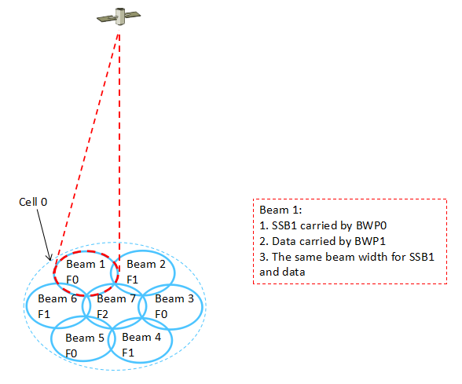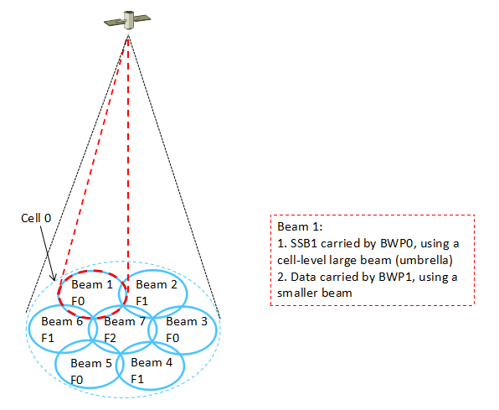

*(a)* ***Option-1****: Same beam layout (b)* ***Option-2****: hierarchical beam layout*



***Option-1****. A Narrow SSB beam*



***Option-2****: Wide SSB beam*



***Option-3****: Inter-frequency measurement configurations in a NTN cell*



***Option-4*** *based on Alt 2 with SSBs are within respective BWPs*.

With consideration on the companies contributions, we encourage companies to further discuss association for SSBs, beams, and BWPs to establish majority views for the 1st round of email discussions. In particular, companies can confirm whether they have same understanding that Options 1 or option 2 can be supported within the current NR specification framework and Option 3 has moderate impact on specification, and Option-4 has relatively higher impact on specifications.

***Initial proposal#2.2.2-1 (Moderator)*:**

Further discuss associations of SSBs, beams, and BWPs and their potential impact on NR specifications for the following options:

* Option-1: same beam layout for BWP0 and BWPx
* Option-2: hierarchical beam layout for different BWPs
* Option -3: Mapping between SSB index and BWP index
* Option-4: SSB transmission in beam-specific initial BWP

|  |  |
| --- | --- |
| **Company** | **Comments and Views on BWP configuration, activation/de-activation** |
| Ericsson | * Option 1 & 2: We feel in principle these two options have compatibility with existing NR design/spec. It would be better if they could be described in a clearer way so that companies have the same understanding of these two options before further discussions. * Option 3: From the description, it seems this option is just about linking BWP index to beam index. Isn’t this already supported in existing spec? I.e., on each BWP, there can be one or more CSI-RS beams, and these CSI-RS beams may be QCL’ed with SSB beams => This creates linking between BWP index and SSB index in an even more flexible way. * Option 4: By introducing a lot of unnecessary complications to the design/spec, the actual effect of this option is almost equivalent to 1-beam per cell, i.e., each beam is almost like a cell. The benefit of discussion along this option is highly questionable. |
| ZTE | We share the same understanding as Ericsson w.r.t Option-1 and option-2. Both are different implementations for satellite, but based on current framework (i.e., TDM-ed SSB carrying in same BWP, e.g., initial BWP).  For the Option-3 and Option-4, it seems that additional complexity are introduced, which is not preferred from specification perspective. More specifically, it according to the existing specification, it’s clear that all SSB are included in single BWP and for each BWP, other RS, e.g., CSI-RS can be configured.  If the intention of Option-3 and 4 is for the beam indication, in current spec, all related are done based on the TCI configuration by take the SSB/CSI-RS as reference RS and the mapping between RS to real beam is just implicit done via implementation, e.g., in NR FR2, one to one mapping is possible if larger beam is considered in the implementation.  So, in general, starting with existing specification should be taken as baseline. |
| Panasonic | Options 1 and 2 can already be supported by current spec and should be the baseline. Choosing between options 1 and 2 is up to implementation.  For option 3, we are not supportive that switching BWP always triggers the switching of beam and vice versa, because it is a very restrictive operation. We are not supportive of option 4 as well due to issues pointed by FL. |
| Qualcomm | The intention of the discussion is to identify additional enhancements to support NTN. Features supported by NR will be supported and don’t need to be further discussed. Before discussing the options, it is important to consider typical satellite implementations and feasibility of any features. For this, it might be beneficial to first agree the following:  **Proposal 1: Support satellite with analogue beams, e.g., with horn antennas.**  Below we discuss different options listed above.  Option 1 is already supported by NR. It is not related to beam switching and hence not need to be discussed for now.  Option 2 is supported by NR. It is not expected to be a typical implementation in NR-based NTN for the following reasons:   * Hierarchical beam layout indicates different link budget among beams. The wider beam is typically used for initial access. * NR initial access is not significantly more robust than data channels in connected mode. In fact, Msg3 is likely the bottle neck.   Since it is already supported by NR and not expected to be a typical NR-based NTN, we don’t think it needs to be discussed now. Instead, we considered to support current NR SSB transmission, i.e., all in the same frequency, by antenna frequency re-tuning. In such an implementation, an antenna that typically covers footprint B in frequency range B will frequency retuned to frequency rang A to serve UEs during initial access in footprint B. Moderator please either remove us from the supporter list of option 2 or change the description of option 2 to reflect our description.  Option 3 if SSB are to be transmitted in the same frequency, option 3 becomes Option 2; if SSBs are to be transmitted in different frequency ranges, option 3 is similar to Option 4. In the latter case, BWPs 1, 2,3 are mapped to different SSBs in option 3 whereas different initial BWPs are mapped to different SSBs. One problem with Option 3 is what the default BWP is.  Option 4 This could be the most typical implementation with analogue beams (e.g., horn antennas). Different satellite beams are mapped to different initial BWPs. By doing so, the default BWP, i.e., BWP0, is the initial BWP unless configured otherwise according to current spec.. In addition, beam switching is often highly predictable as discussed by several companies. Time based default BWPs can be configured. It’s unclear how BWP0 helps in Moderator’s described case. If UE is not able to receive DCI from BWPx, BWP0 will likely not help. In fact, if BWP0 corresponds to a larger beam or the beam used by the UE during initial access, its link budget will be worse. |
| Mediatek | We have same understanding as Ericsson, ZTE, and Panasonic. Options 1 & 2 can be supported in the existing specifications. This may be sufficient unless there is clear need to consider Option 3 & 4.  Option 1: Could be better suited to single beam satellite scenarios. This is not a likely option in a sparse satellite deployment, but would become more attractive in a satellite constellation with x100s or x1000s satellites, each with a large single beam and with Frequency Re-use 1.  Option 2 with hierarchical beam layout is already **de facto the legacy satellite solution** (e.g. a very wide regional beam of 1000s km is used for initial cell access including synchronization, System Information, Paging, authentication, and so on), then the UE switched to a narrow beam of 100s km for data exchange. The wider regional beam has a lower C/N that the narrow beam, but it all works. For LEO, a similar set up is used. This is a serious satellite system configuration that should be considered as the baseline for NR NTN. It seems natural thing then to map initial BWP0 to the wider beam with no change needed in the current specifications. The narrow beams can be configured with other BWPs. In case a beam with BWPx falls out of coverage and beam switching to next beam with BWPy cannot happen, the UE can fall back to wider beam with BWP0 using current NR mechanisms.  Option 3: We share same understanding as Panasonic that with this option, it is more restrictive if switching BWP always triggers the switching of beam and vice versa. We think it may be beneficial because typically in legacy satellite systems a colour code with frequency re-use 3 is used because the beams overlap in a substantial area which cause serious inter-beam interference. It seems not essential and could be left to the network implementation.  Option 4: This option is serious deviation from the current specifications. The need for this option should be very compelling to justify the specification and implementation changes. |
| Samsung | We also think Option 1 and Option 2 are supported by current NR specifications. In this regards, Option 1/2 could be baselines for NTN. |
| Apple | Overall, we support the proposal.  Option 1 and Option 2 are compatible with Rel-15 BWP and SSB specifications can be re-used without enhancements. Option 3 seems not quite different from Option 2 if SSBs are transmitted in the same frequency. Option 3 has less impact on specifications in terms of inter-frequency measurement gap and mapping between SSB index and BWP index. We slightly prefer Option 1 and 2 and are open to Option 3. |
| Lenovo/MM | Option 1/2/3: There is a common BWP#0 for robustness. The difference is that for Option 1/3, the antenna gain of BWP#0 and BWP#x are same, so some QCL information can be shared, which is different from Option 2. The difference between Option 1 and 3 is whether BWP#0 is for measurement only or for both measurement and data transmission. From our perspective, both Option 1 and 3 can be considered depending on the traffic load on common BWP#0, while Option 2 is not preferred due to the large antenna gain imbalance.  Option 4: We understand that the robustness is a question when there is no common BWP#0 especially for LEO scenario. However, only a single BWP needs to be active for Option 4, which is consistent with NR R15/16 specifications. And the robustness can be resolved by satellite broadcasting the relationship between beam and BWP, satellite broadcasting the beam layout information and the UE position acquired by GNSS. In this case, the UE knows which is the possible beam, and then it can derive the corresponding BWP for synchronization. |
| CATT | Option 1 and option 2 are supported by current NR specification.  Option 3 introduced frequency domain SSB index, and option 4 supported multiple initial BWPs. In general, we think R15 framework should be kept. If we want to target to enhance beam switching, BWP switching in connected mode can be optimized but no need introduce more initial BWPs or FDM based SSB index, those are not necessary. |
| Xiaomi | Option 1 refers to one beam per PCI. Option 2 refers to multiple beams per PCI with beam specific SSB. And both Option 1 and Option 2 can be supported by current spec.  While for Option 3, we intended to mapping between the BWP ID and data beam ID based on Option 2. It can be used to support intra-cell BWP switching and beam switching. |
| LG | We share the view with Samsung. Option 1 and 2 can be a baseline. |
| Huawei | As pointed out by many companies, Option 1 and Option 2 can be supported by current NR specification and it is just as matter of NTN deployment choices. We are supportive of Option 3 since this requires the least specification change to support BWP switching. Option 4 is not preferred due to large specification impact. |
| APT | Support Option 2. Option 1 may create some coverage holes which is bad for mobility. Option 2 can be interpreted as **one beam per cell** in RRC_IDLE to guarantee wide range access, and **multiple beams per cell** in RRC_CONNECTED to provide further throughputs. |
| Sony | Support initial proposal #2.2.2-1  From minimizing spec. impact perspective, we prefer Option 1 and Option 2.  In our understanding, Option 3 is similar with Option 2 from SSB location perspective, the vital difference between them is that in Option 3 the CORSET#0 may be in a different BWP and to the one in which RACH is carried out. Benefits should be first identified before starting the work. |
| Nokia, Nokia Shanghai Bell | Proposal #2.2.2-1. Support Option 1 or Option 2, compatible with Rel-15 BWP and SSB specifications, and without need for further specification changes. |
| Spreadtrum | Option 1/2 could be baselines for NTN |
| Thales | Option 1&2: Based on our understanding, Option1&2 can already be supported based on existing NR SSB/BW framework.  Option 3: It is not clear whether the linking of SSB index and BW index requires any specification effort or whether it is already implicitly supported in the specs and should be left to the implementation. The need for a new type of inter-frequency measurement gaps in this case should be further discussed.  Option 4: The benefits are not clear if the other options are already supported. Large specs impacts are expected.. |
| vivo | Support to discuss Option-2 and Option-3, due to minimum spec impact. |
| Inmarsat | Option 1 – most simplistic approach and relatively easy to implement in any multi-beam dynamic system, although not very efficient. Agreeable.  Option 2 - is the current standard implementation in dynamic satellite systems and hence can be agreed, because it allows dynamic signalling of BWP allocated for each UE in a beam upon acquisition. It is understood that different link budgets will exist between wide beams and narrow beams, but the mechanism works and has been tested in early trials. This is likely the most agreeable option.  Option 3 – No comments  Option 4 – This has the added challenge that in a dynamic frequency allocation scenario, the UE has no idea in advance of what frequency it can be allocated if no initial signalling of the BWP is available, hence it will have to do a blind cell search on the whole frequency space, with detrimental effects on battery and acquisition timing. It is unclear how this could be implemented in practice in a real system. FFS |
| Intel | Support the proposal. Option 1 and option 2 should have higher priority since they are already supported in the Rel. 15 NR specification. More study is needed for option 3 and option 4 to identify pros and cons comparing to options 1 and 2. |
| Eutelsat | Option 1 with single beam in cell can be supported with simple implementation but offers relatively lower satellite coverage on the ground in sparse satellite constellation. This option is more suitable to micro satellites (Cube satellites)  Option 2 with wider beam in multiple-beam cell can be supported without adding significantly to implementation. For satellite cell with several beams, the power is not a significant issue and can be shared between the wider beams and the smaller beams. The power sharing will determine the link budgets on wide beam and narrow beams. This option 2 has least impact on the specifications. |
| OPPO | For option 1, it is analogue to R15 concept and naturally can be supported.  For option 2, though it seems similar to option 1 and beam width is up to implementation, we echo Lenovo’s concern about the imbalanced antenna gain.  For option 3, from the FL’s summary, we would like to further ask if our understanding is correct, i.e. with option 3, the UE will perform RACH procedure in another BWP than the BWP#0.  For option 4, we share the same view as QC, and needs to have a confirmation if the frequency retuning causes any implementation issue. |

## Summary 1st round discussions

### Beam Management

In the first round of e-mails, 23 companies contributed views on beam management for NR NTN - Ericsson, ZTE, Panasonic, Qualcomm, MediaTek, Samsung, Apple, Lenovo/MM, CATT, Xiaomi, LG, Huawei, APT, Sony, Nokia / Nokia Shanghai Bell, Spreadtrum, Thales, Vivo, Inmarsat, Intelsat, Intel, Eutelsat, OPPO.

FL recommendation for 1st round discussions: With consideration on the companies contributions, companies were encouraged to further discuss potential enhancements for beam management to establish majority views for the 1st round of email discussions. In particular, whether companies agree that there is a need for some or all potential enhancements, whether down scoping of some potential enhancements can be agreed, and whether preference for some potential enhancements based on majority views could be agreed.

The following company views on Initial proposal 2.2.2-1 are summarized below

* Ericsson, Panasonic, MediaTek, Samsung, CATT, Huawei, Thales, Intel, Nokia, Nokia Shanghai Bell, commented Rel-15/16 beam management should be baseline, need for beam management enhancements to be clarified first
* ZTE, MediaTek, Apple, APT commented to discuss association of SSBs, beams, and BWPs first for beam management (proposal 2.2.-2)
* Qualcomm commented that since satellite beam switch is essentially a BWP switch in NTN with frequency reuse, enhancements on beam management are needed
* Lenovo/MM commented beam management can be divided into three categories: the first one (including gNB dominated beam management and UE dominant beam management) is based on beam layout and UE position to determine how to do beam switching; the second one (including TCI indication enhancement and BWP based frequency reuse) is considering the relationship/restriction between BWP and beam when the frequency reuse is larger than 1; and the third one is to efficiently beam switching such as introducing A/N for the switching command. All three categories address different issues and suggest discuss them separately
* LG, Spreadtrum, intelsat generally supportive of discussions on potential enhancements of beam management in NTN

W.r.t to initial proposal 2.2.1-1, we further list the company support based on their comments

* gNB dominated beam management (UE group-specific signaling)
  + Do not see need:
    - UE-group based beam switching not necessary in LEO earth-fixed beam deployment, where one-beam-one-cell mapping is more suitable without concerns of L3 handover overhead and RAN2 has already discussed UE-group based handover. Measurements can be disabled via configurations (Panasonic)
    - Timer based beam switch: Realistically only useful for scenarios where beam map is predictable, which in dynamic systems might not be the case (Inmarsat)
    - RAN2 discussions on connected mobility first (MediaTek)
  + Potential needed
    - For earth-fixed beam (Nokia) , Sony
* UE dominant beam management
  + Potentially needed:
    - timer based beam switching and location-based beam switching (Panasonic, Xiaomi, Sony)
    - Measurements based, RAN2 discussions on connected mobility first (MediaTek)
* TCI sate indication enhancements for beam management
  + Do not see need: Sony
  + Potentially needed:
    - Polarisation re-use (Panasonic), Nokia
* BWP based frequency reuse
  + Do not see need: Ericsson, Panasonic, MediaTek, Sony, Thales
    - Can be done already using rel-15 NR specifications, up to network configuration
  + Potentially needed:
* *BWP switching enhancements* 
  + Potentially needed
    - Panasonic (can be done, not essential)

### Association of SSBs, beams and BWPs

In the first round of e-mails, 23 companies contributed views on associations of SSBs, beams, and BWPs for NR NTN - Ericsson, ZTE, Panasonic, Qualcomm, MediaTek, Samsung, Apple, Lenovo/MM, CATT, Xiaomi, LG, Huawei, APT, Sony, Nokia / Nokia Shanghai Bell, Spreadtrum, Thales, Vivo, Inmarsat, Intelsat, Intel, Eutelsat, OPPO. The following company views on Initial proposal 2.2.2-1 are summarized below

* Ericsson, ZTE, Panasonic, Qualcomm, Samsung, Apple, MediaTek, CATT, Xiaomi, Huawei, Sony, Nokia, Spreadtrum, Thales, Inmarsat. Intel, Eutelsat, OPPO commented Option 1 and Option 2 are compatible with Rel-15/16 specifications. Ericsson, ZTE, Samsung, LG, Nokia commented Option 1 and 2 are sufficient and can be baseline. Apple, Huawei mention specification change of Option-3 is small.
* Inmarsat, Eutelsat, MediaTek mentioned Option 1 (single beam per cell) and Option 2 (wider beam and several narrow beams per cell) are implementation options in satellite. Option-2 with wider beam for cell access and narrow beam for data already used in legacy satellite constellations. Configuration of the beams (including power and frequency) are implementation considerations. Option-2 is a likely implementation. Qualcomm mentioned concern for link budget for wider beam in Option-2.
* Qualcomm mentioned if SSB are to be transmitted in the same frequency, option 3 becomes Option 2. Sony mentioned Option 3 is similar with Option 2 from SSB location perspective, the vital difference between them is that in Option 3 the CORSET#0 may be in a different BWP and to the one in which RACH is carried out. Benefits should be first identified before starting the work. Moderator view is that in Option-2 the wider beam is configured to BWP0 which includes SSBs and CORSET#0 The other narrow beams can be configured with BWP#1, 2, or 3. The SSBs are all transmitted in TDM fashion in BWP0 as in NR specifications. If as Sony suggest the CORSET#0 in Option-3 mapping between BWP index and BWP index can be in BWP#1-3, this is a further specification change. OPPO mentioned it is needed to have a confirmation if the frequency retuning causes any implementation issue in Option-4.
* Lenovo mentioned in Option 1/2/3: There is a common BWP#0 for robustness. The difference is that for Option 1/3, the antenna gain of BWP#0 and BWP#x are same, so some QCL information can be shared, which is different from Option 2. The difference between Option 1 and 3 is whether BWP#0 is for measurement only or for both measurement and data transmission. From our perspective, both Option 1 and 3 can be considered depending on the traffic load on common BWP#0. Lenovo, OPPO Option 2 is not preferred due to the large antenna gain imbalance.
* APT mentioned Option 1 may create some coverage holes which is bad for mobility. Option 2 can be interpreted as one beam per cell in RRC_IDLE to guarantee wide range access, and multiple beams per cell in RRC_CONNECTED to provide further throughputs.

W.r.t to initial proposal 2.2.2-1, we further list the company support based on their comments

* Option-1: same beam layout for BWP0 and BWPx
  + Support: Ericsson, ZTE, Panasonic, Qualcomm, Samsung, Apple, MediaTek, CATT,LG, Huawei, Sony, Nokia, Spreadtrum, Thales, Inmarsat. Intel, Eutelsat
* Option-2: hierarchical beam layout for different BWPs
  + Support: Ericsson, ZTE, Panasonic, Qualcomm, Samsung, Apple, MediaTek, CATT , LG, Huawei, APT, Sony, , Nokia, Spreadtrum, Thales , Vivo Inmarsat. Intel, Eutelsat
* Option -3: Mapping between SSB index and BWP index
  + Support: Apple, Lenovo, Huawei, Vivo
  + Not supportive: Ericsson, Panasonic, ZTE, CATT, Thales, Nokia
* Option-4: SSB transmission in beam-specific initial BWP
  + Support: Qualcomm,
  + Not supportive: Ericsson, Panasonic, ZTE, Apple, CATT, Huawei, Thales, MediaTek, Inmarsat

## Company Views (2nd round discussions)

### Beam Management

Based on the companies views in 1st round of discussions, it is the view of the moderator that there is no consensus on the need of potential beam management enhancements at this stage. This discussion can be postponed until some progress is made on the association of SSBs, beams and BWPs. There are also related discussions in RAN2 w.r.t. idle mobility and connected mobility.

***FL recommendation:*** Companies can further contribute on the need and potential enhancements for beam management with a view to achieve consensus on whether these potential enhancements are beneficial.

|  |  |
| --- | --- |
| Company | Comments |
| Samsung | Fine with recommendation. But, we don’t think RAN1 needs to make an agreement on this. Even without agreement, each company can contribute it. |
| ZTE | The potential enhancement can be considered once the issue in 2.4.2 is concluded firstly. Based on the current BWP/SSB allocation in NR, minor improvement to accelerate the beam management process and efficiency can be specified in RAN 1, more specifically:   1. Both TCI based and BWP switching mechanism are reused to achieve the beam switching from implementation perspective (e.g., due to the different reuse mechanism for beam implementation); 2. gNB dominate solution can be prioritized for switching with less spec effort. In addition, group based signaling is preferred for beam switching; |
| APT | Agree with ZTE. |
| CATT | Fine with this recommendation. If keeping R15 NR framework, BWP switching enhancement can be considered since only minor specification impact is needed. |
| LG | Fine with FL recommendation. |
| Huawei | Fine with the FL recommendation. |
| Xiaomi | Fine with the FL recommendation. |
| Sony | Fine with the FL recommendation. |
| Thales | Fine with the FL recommendation. |
| Panasonic | Fine with the FL recommendation. Please note that we have made small corrections to our position captured by FL in Section 2.3.1 Beam management. |
| Spreadtrum | Fine with the FL recommendation. |
| vivo | Fine with the FL recommendation. |
| Intelsat | Fine with the FL recommendation. |
| Nokia, Nokia Shanghai Bell | OK with FL recommendation. But we see no need to put this in any form of agreement on this topic. On top of this we would like to highlight that association of SSBs, beams and BWPs has not been agreed. |
| Ericsson | Fine with FL recommendation. We should first identify what the problem (if any) is before discussing enhancements. Further, this BM discussion is coupled with the discussion on association of SSBs, beams and BWPs. |

### Association of SSBs, beams and BWPs

Based on the companies views in 1st round of discussions, it is the view of the moderator that there is consensus on Option-1 and Option-2 being compatible with Rel-15/16 specifications and can be used as the baseline. Option-3 has some small impact on the specifications with no consensus on the need for it. Option-4 has the most impact on specifications with one company supporting it. RAN1 can further discuss needs for Option-3 and Option-4 for associations of SSBs, beams, and BWPs. In particular, discussion on impact on specifications and satellite scenarios where these options for potential enhancements may be beneficial. Hence, we make the updated proposal

***Proposal#2.3.2-1 (1st round outcome)*:**

At least the associations of SSBs, beams, and BWPs are supported:

* Option-1: same beam layout for BWP0 and BWPx in single-beam cell
* Option-2: hierarchical beam layout in multiple-beam cell, where wider beam is associated with cell-specific initial BWP0 and narrow beams are associated with beam-specific BWPx, with x≠0.

***FL recommendation: Further discuss Proposal#2.3.2-2 (1st round outcome)*:**

RAN1 can further discuss needs for associations of SSBs, beams, and BWPs. In particular, discussion on impact on specifications and satellite scenarios where these options for potential enhancements may be beneficial.

* Option -3: Mapping between SSB index and BWP index
* Option-4: SSB transmission in beam-specific initial BWP

|  |  |
| --- | --- |
| Company | Comments |
| Samsung | We are open to further discuss. But, we don’t think RAN1 needs to make an agreement on this. Even without agreement, each company can contribute it. |
| Qualcomm | Options 1 and 2 are already supported by NR. We don’t think the agreement is necessary. |
| ZTE | For ***Proposal#2.3.2-1***, we are fine to this proposal with following updates:  At least the associations of SSBs, beams, and BWPs are supported:   * Option-1: same beam layout for BWP0 and BWPx ~~in single-beam cell~~ * Option-2: hierarchical beam layout in multiple-beam cell, where wider beam is associated with cell-specific initial BWP0 and narrow beams are associated with beam-specific BWPx, with x≠0. * Note: TDMed SSBs are assumed in cell specific initial BWP (e.g., BWP0)   Both Option-1 and 2 are compatible to current spec and only difference just refers to implementation and we can take them as baseline. But for option 1 in this proposal, no need to add a limitation of single-beam cell, and it can also be applicable for cell with multiple beams.  W.r.t the necessity for Option 3/4, it should be justified once clear benefits over previous two options can be foreseen. Otherwise, it’s not necessary to introduce it with huge spec impacts. |
| APT | Support Proposal#2.3.2-1. If down-selection is needed in this meeting, we prefer Option 2. |
| CATT | We support Proposal#2.3.2-1, since it is the basic assumption for NTN beam layout.  In addition, we may consider another option within NR framework:   * Different beam layout for BWP0 and BWPx , and only one initial BWP0 is configured for one UE, after RRC connection, multiple adjacent beams are associated with multiple active BWPs. |
| LG | Agree with Samsung. |
| Huawei | For Proposal#2.3.2-1, we share the view that it is not needed since the current spec already support it.  For the FL recommendation, we are open to study further but still have some concern on Option 4 due to its large specification impact. |
| Xiaomi | Support Proposal#2.3.2-1 and we prefer Option 2. |
| Sony | Support the proposal. |
| Thales | Not sure we need to agree on Proposal 2.3.2-1 since the two options are already supported.  Fine with the FL recommendation. |
| Panasonic | For Proposal#2.3.2-1, we don’t think RAN1 needs an agreement for this. It is our understanding that the operation described as Option-1 and Option-2 are supported by existing NR design/spec. If the intention of Proposal #2.3.2-1 is to have some spec impact, it should be made clear first. We don’t support Proposal#2.3.2-1 in current formulation.  For FL recommendation of Proposal#2.3.2-2, we are open for further discussion. |
| Spreadtrum | Support the proposal. |
| vivo | We support the Proposal#2.3.2-1 in principle, but the proposal seems to make little progress. If down-selection is necessary, Option-2 is preferred.  For Proposal#2.3.2-2, we prefer Option-3 due to the minimum specification impact. From the discussion and contributions from companies, the assumption that a satellite beam is associated with a BWP seems to be stable. In order to support that, it is straightforward to set up the mapping between SSB index and BWP index, which has minimum impact on specifications. |
| Intelsat | Fine with the FL recommendation. |
| Nokia, Nokia Shanghai Bell | Please note that Nokia is also in the group of non-supporters of option 3. According to our understanding, there is no need to add further complexity in this domain, and options 1 and 2 would be sufficient for NTN operation. |
| Ericsson | We support Proposal#2.3.2-1 (wording could be further refined).  For Option 3 and 4 in FL recommendation, we reiterate our comments from the first round:   * Option 3: From the description, it seems this option is just about linking BWP index to beam index. Isn’t this already supported in existing spec? I.e., on each BWP, there can be one or more CSI-RS beams, and these CSI-RS beams may be QCL’ed with SSB beams => This creates linking between BWP index and SSB index in an even more flexible way * Option 4: By introducing a lot of unnecessary complications to the design/spec, the actual effect of this option is almost equivalent to 1-beam per cell, i.e., each beam is almost like a cell. The benefit of discussion along this option is highly questionable. |
| Apple | Fine with the FL recommendation. |

## Summary 2nd round discussion

In the second round of e-mails, 16 companies commented on beam management Ericsson, ZTE, Panasonic, MediaTek, Samsung, , CATT, Xiaomi, LG, Huawei, APT, Sony, Nokia / Nokia Shanghai Bell, Spreadtrum, Thales, Vivo, Intelsat. There were 18 companies commented on associations of SSBs, Beams, and BWPs - Ericsson, ZTE, Panasonic, Qualcomm, MediaTek, Samsung, Apple, CATT, Xiaomi, LG, Huawei, APT, Sony, Nokia / Nokia Shanghai Bell, Spreadtrum, Thales, Vivo, Intelsat.

It was mentioned by ZTE that the potential beam management enhancement can be considered once the issue on association of SSB, beams, and BWPs in 2.4.2 is concluded firstly.

There is consensus on associations of SSBs, beams, and BWPs with Option-1 and Option-2 that can already be supported within Rel-15/16 framework:

* Option-1: same beam layout for BWP0 and BWPx in single-beam cell. ZTE proposed to revise text for Option 1 and not include “in single beam cell”.
* Option-2: hierarchical beam layout in multiple-beam cell, where wider beam is associated with cell-specific initial BWP0 and narrow beams are associated with beam-specific BWPx, with x≠0.

Several companies mentioned there is no need for agreement on Option-1 and Option-2 since they can already be supported in the NR specifications.

Option-3: Mapping between SSB index and BWP index, Ericsson observed that this option is already supported in existing specifications. On each BWP, there can be one or more CSI-RS beams, and these CSI-RS beams may be QCL’ed with SSB beams. This creates linking between BWP index and SSB index in an even more flexible way. Huawei mentioned on Option 1-3 in [1] that by configuring a mapping relationship between SSB index and BWP index, a UE in connected mode can perform BWP switch based on SSB RSRP measurement in cell-specific BWP0, which can potentially reduce the signaling overhead of BWP activation. Vivo mentioned on Option-3 that it is straightforward to set up the mapping between SSB index and BWP index, which has minimum impact on specifications.

In these Options -1, -2, and -3, TDMed SSBs are assumed in cell specific initial BWP (e.g., BWP0).

CATT propose another option with different beam layout for BWP0 and BWPx , and only one initial BWP0 is configured for one UE, after RRC connection, multiple adjacent beams are associated with multiple active BWPs.

ZTE proposed based on the current BWP/SSB allocation in NR, minor improvement to accelerate the beam management process and efficiency can be specified in RAN 1, more specifically:

* Both TCI based and BWP switching mechanism are reused to achieve the beam switching from implementation perspective (e.g., due to the different reuse mechanism for beam implementation);
* NB dominate solution can be prioritized for switching with less spec effort. In addition, group based signaling is preferred for beam switching;

Ericsson observed that RAN1 should first identify what the problem (if any) is before discussing enhancements. Further, this BM discussion is coupled with the discussion on association of SSBs, beams and BWPs.

CATT proposed that if keeping R15 NR framework, BWP switching enhancement can be considered since only minor specification impact is needed.

To be added based on companies views in second round of email discussions

***FL recommendation on beam management:*** Companies are encouraged to further contribute on the need and potential enhancements for beam management with a view to achieve consensus on whether these potential enhancements are beneficial. Associations of SSBs, beams, and BWPs with Option-1 and Option-2 could be working assumption for the beam management:

* Option-1: same beam layout for BWP0 and BWPx in single-beam cell
* Option-2: hierarchical beam layout in multiple-beam cell, where wider beam is associated with cell-specific initial BWP0 and narrow beams are associated with beam-specific BWPx, with x≠0.

Companies are encouraged to consider need for potential beam management enhancements re-using specified TCI and BWP switching mechanisms.

***FL recommendation on association of SSBs, beams, and BWPs*:**

* Companies are encouraged to further discuss understanding of Option-3 Mapping between SSB index and BWP index, whether the impact on the specification is minimum, and whether it is beneficial if used with beam management mechanisms.
* Companies that are promoting Option-4: SSB transmission in beam-specific initial BWP are encouraged to discuss with other companies on the need and benefits of this option in the context of beam management, and also discuss the impact on specifications, measurements, and testing.

## GTW Agreement / Conclusion

To be added based on updated proposals following second round of email discussions

# Signalling of Polarization

## Background

The following agreements were made in RAN1#102e:

*Potential enhancements for support of polarisation signalling in NR NTN can consider at least the following:*

* *Configuration of DL and UL transmit polarization including Right hand and Left hand circular polarizations (RHCP, LHCP)*
* *Network broadcast DL and UL transmit polarization configuration*
* *UE polarization capability (RHCP, LHCP, Linear)*
* *Dependence of polarisation signaling on deployment scenarios. For example,*
  + *Resource reuse mode with/without polarization for the beam management enhancement*
  + *Fixed polarization per cell/beam for polarization reuse and circular polarisation with intra-UE and inter-UE multiplexing (intra-UE and inter-UE) signalling*

Support of polarisation antennas depends on the UE antenna design and implementation. Polarisation can be used in the network for example for inter-cell interference mitigation or higher frequency re-use (i.e. Frequency re-use factor 4 with two carriers). The UE cannot be expected to reliably detect the used DL polarization. The network and UE need to have same understanding on support of polarisation to avoid polarisation loss of several dBs.

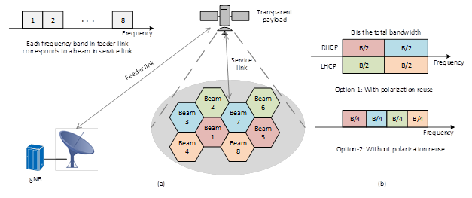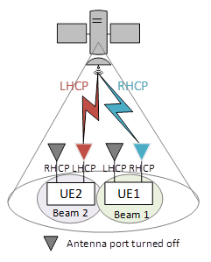

|  |  |
| --- | --- |
| **Source** | **Related Proposals & Observations** |
| Ericsson | ***Observation 8:*** *In some cases, a UE cannot be expected to reliably detect the used DL polarization.*  ***Proposal 7:*** *Support broadcast signaling that allows a gNB to indicate the gNB’s DL transmit polarization mode and UL receive polarizations mode to UE.*  ***Proposal 8:*** *Support signaling that allows the gNB to configure a UE’s polarization modes including the UE’s receive polarization mode in the DL and the UE’s transmit polarization mode in the UL.*  ***Proposal 9****: NTN UE should report its polarization capability (RHCP, LHCP, Linear) to the network.* |
| Nokia | ***Proposal 10****: Define a network configured basic polarization mode for UL operation which is used for initial access.* |
| Huawei | ***Proposal 3:*** *The indication of polarization state for NTN should be supported.*  ***Proposal 4:*** *The necessity of supporting UE polarization capability report should be further identified.*  ***Proposal 5:*** *Flexible polarization configuration for NTN should be supported.* |
| ZTE | ***Proposal 7:*** *Indication of polarization information should be supported with potential association with the SSBs.*  ***Proposal 8:*** *Polarization capability of a UE should be reported to the network.* |
| Qualcomm | ***Proposal 11****: Consider at least signalling of polarization per BWP.* |
| Sony | ***Observation 1****: The UE capability on the supported polarization mode is necessary for the NTN network to use the polarization domain. Such a capability can be either reported explicitly by the UE or implicitly through the UE measurement and reporting of the DL RS on two orthogonal polarizations.*  ***Observation 2****: The gNB can configure multi-user multiplexing on the polarization domain based on UE capability.*  ***Proposal 3****: UE polarization capability should be reported to the gNB, where the UE supported polarization mode can include linear polarization, circular polarization and adaptive polarization. How the UE polarization capability is reported can be further studied.*  ***Proposal 4****: Multi-user multiplexing on the polarization domain based on UE capability is supported.*  ***Proposal 5****: Beam management in NTN network can take polarization aspect into account.* |
| Panasonic | ***Proposal 4****: Signaling for the following two usages of circular polarization should be supported.*   * *Polarization reuse for inter-cell/beam interference mitigation* * *Polarization multiplexing for throughput improvement*   ***Proposal 5****: For operation with polarization reuse, information on satellite beam level polarization should be indicated. For the signaling design, polarization to be used at least for initial access, polarization to be used for SSB/CSI-RS measurement and polarization for target beam/cell should be taken into account.*  ***Proposal 6****: For operation with polarization multiplexing, information on the polarization should be indicated in DCI for scheduling PDSCH/PUSCH.* |
| LG | ***Proposal 2****. For NTN, support polarization mode (RHCP, LHCP) signaling broadcasted via SIB.* |
| CATT | ***Observation 1****: For the UEs supporting both RHCP and LHCP, polarization reuse configuration in the NTN is beneficial, while for the linear polarization UEs and single circular polarization UEs, network polarization reuse scheme is less useful.*  ***Proposal 7****: The polarization reuse scheme should be optional in NTN.*  ***Proposal 8****: Broadcasting the polarization is optional, and UE can connect the network even if without the information of network polarization information.*  ***Proposal 9****: The indication of the polarization mode can be linked to cell ID in network deployment without additional system information indication.*  ***Observation 2****: The single circular polarization UEs cannot work in in the different circular polarization beams, so that reporting the polarization capability is useless.*  ***Observation 3****: It is not necessary to report the circular polarization mode to the network for the dual circular polarization UEs.*  ***Observation 4****: For the linear polarization UEs, not only the polarization capability but also the capability of combination with two branches should be reported to network.*  ***Proposal 10****: For circular polarization UE, polarization capability is not needed to report, while for linear polarization UE, polarization type and combination way of receivers need to be reported.* |
| Vivo | ***Observation 1****: Circularly polarized antenna is preferred to NTN scenarios.*  ***Observation 2****: Circular polarization can be used to increase cell capacity or spectral efficiency.*  ***Proposal 1****: For satellite beam layout, frequency re-use with circular polarization should be prioritized.*  ***Proposal 2****: For downlink synchronization, support to indicate of polarization information.*  ***Proposal 3****: Solutions to improve the performance of SSB detection could be considered.*  ***Proposal 4****: Support TDMed associated LHCP and RHCP SSB.*  ***Proposal 5****: Deprioritize dynamically changing polarization.* |

## Companies Views (1st round discussions)

Several companies discussed signalling mechanisms for polarisation:

* Ericsson observe that a UE cannot be expected to reliably detect the used DL polarization.
* ZTE propose that polarization for each beam is represented based on SSB configuration in BWP0 and based on corresponding UL scheduling indication (e.g. TCI or spatial-relationship)
* Huawei propose to discuss coexistence scenarios of UEs with different polarization capability and polarization configurations (e.g., per beam/per cell indication, intra-UE/inter-UE polarization multiplexing)
* Nokia propose to define a network configured basic polarization mode supported by all UEs for UL operation which is used for initial access.
* Panasonic propose for the signalling design, polarization to be used at least for initial access, polarization to be used for SSB/CSI-RS measurement and polarization for target beam/cell should be taken into account.
* Panasonic, Sony propose polarization multiplexing, where RHCP and LHCP are used to multiplex separate data streams within a satellite beam and information on the polarization should be indicated in DCI for scheduling PDSCH/PUSCH.

Indication of polarization information for DL and UL via signalling is supported by ZTE, Ericsson, Huawei, Panasonic, Sony

* Details of indication of polarization have been discussed by several companies with many a wide range of aspects – i.e. polarization multiplexing, basic polarisation, polarisation-based measurements, co-existence scenarios with different polarization assumptions.
* More discussions and analysis will help to have some convergence on aspects of indication of polarisation.

Polarization capability of a UE reported to the network (RHCP, LHCP, Linear) is supported by ZTE, Ericsson, Panasonic, Sony

***Initial proposal#3.2-1 (Moderator)*:**

Polarization capability of a UE reported to the network (RHCP, LHCP, Linear) is supported

***Initial proposal#3.2-2 (Moderator)*:**

Indication of polarization information for DL and UL via signalling is supported. Details of indication of polarization can be further discussed for at least

* Polarization multiplexing
* Basic polarisation
* Polarisation-based measurements
* Co-existence scenarios with different polarization assumptions

|  |  |
| --- | --- |
| **Company** | **Comments and Views on Signalling of Polarisation** |
| Ericsson | We support the proposals. |
| ZTE | * Support initial proposal #3.2-1.   More specifically, supports on RHCP and LHCP should be defined as different capability. Meanwhile, “flexible” (UE is able to change its own polarization between linear and circular or between RHCP and LHCP) should also be taken as one case.   * Partially support initial proposal #3.3-2. We are fine with the main bullet and 2nd /4th sub-bullet. For the remaining part, i.e., multiplexing and polarization based measurement, no clear benefits are foreseen.   We should handle the discussion for detailed signalling design firstly. |
| Panasonic | We support proposals 3.2-1 and 3.2-2. |
| MediaTek | Support proposal 3.2-1.  Support proposal 3.2-2 |
| Lenovo/MM | Agree with the proposals. |
| CATT | Support initial proposal #3.2-1.  Network indication for polarization could be optional feature since network should be able to support different UE category. Before knowing the network polarization mode, UE should be able to access the network. |
| LG | Support the proposal 3.2-1 and 3.2-2. |
| Huawei | For Initial proposal#3.2-1, even though we support to have UEs with different circular polarizations, it is a bit too early to discuss about UE capability reporting at current stage. We would like to understand the scenarios and cases why this capability is needed at the network.  Supportive of Initial proposal#3.2-2. |
| APT | Support proposal#3.2-1  Support proposal#3.2-2 (expect more discussion in this meeting) |
| Sony | Support Initial proposal#3.2-1. We agree with ZTE that the flexible UE should be supported as one UE capability case.  Support Initial proposal#3.2-2. |
| Nokia, Nokia Shanghai Bell | Proposal #3.2-1: We do not see the need for mandating such support. The network transmission cannot be re-configured ‘on-the-fly’ to match the capabilities of different UEs served. Per PRB/TTI polarisation reconfiguration is not possible to achieve in transparent payload scenarios as the transmission depends on the satellite payload (transceiver) which is not under the control of the scheduler in the gNB. For simplicity and to avoid fragmentation of the UEs for scheduling, it would be preferable if common polarization assumptions could be agreed.  Proposal #3.2-2: A basic polarisation should be defined for UL and DL for all UEs, e.g. linear polarisation. Dynamic polarisation multiplexing (per PRB/TTI scheduling decisions) is unlikely to be supported by the transparent satellite payload where the gNB does not have control on the satellite transceiver for the service link. The practical use of different polarisation modes also depends on the frequency bands used on the service link. For example, for high frequency bands (Ka/Ku) the use of RHCP and LHCP should be supported. In these bands all UEs can be assumed to have the processing power to detect, and/or switch between, the different polarisation modes. For low frequency bands, the physical size of the UE and its antenna (e.g. handheld device) severely limit the polarisation modes and adaptivity supported. |
| CMCC | Agree with the proposals. |
| Spreadtrum | Agree with the proposals. |
| Thales | Support. In particular, UE behaviour for initial access shall be further clarified depending on the DL indication. |
| vivo | Support both of the proposals. |
| Intel | We are fine with the proposal. |
| OPPO | We can agree with FL proposals |

## Summary 1st round discussions

W.r.t the Initial Proposal 3.2-1 in section .3.2, there were 17 companies that commented:

* Support: Ericsson, ZTE, Panasonic, MediaTek, Lenovo/MM, CATT, LG, APT, Sony, CMCC, Spreadtrum, Thales, Vivo, Intel, OPPO
* Not support: Huawei (further discuss polarization scenarios), Nokia (basic common polarization)

W.r.t the Initial Proposal 3.2-2 in section .3.2, there were 16 companies that commented:

* Support: Ericsson, Panasonic, MediaTek, Lenovo/MM, LG, APT, Sony, CMCC, Spreadtrum, Thales, Vivo, Intel, OPPO
* Partially support: ZTE (main bullet), CATT (optional) , Nokia (basic polarization)

There is a majority of companies supporting proposals 3.2-1 and 3.2-2. The UE polarization capability and its reporting in initial proposal 3.2-1 to the network would be needed in case only a basic polarization for all UEs is not the only option in the network. For similar reasons, the indication of polarization information for DL and UL via signalling would be needed

## Company Views (2nd round of discussions)

Based on the companies views in 1st round of discussions, to make progress it is the view of the moderator to postpone discussion on UE polarization capacity. There are several polartization solutions considered in proposal 3.2-2 and down-scoping could be discussed.

***Initial proposal#3.4-1 (1st round outcome)*:**

Indication of polarization information for DL and UL via signalling is supported. Support of one or several options for potential polarization enhancements if beneficial can be further discussed for at least

* Option-1 Polarization multiplexing
* Option-2 Basic polarisation
* Option-3 Polarisation-based measurements
* Option-4 Co-existence scenarios with different polarization assumptions

|  |  |
| --- | --- |
| Company | Comments |
| Samsung | We are okay for Indication of polarization information.  But, the second statement is not clear. If it means to support one of the options above, we would suggest “further study” rather than “support”. We don’t see enough necessity of polarization enhancements. |
| ZTE | For the ***Initial proposal#3.4-1,*** we can only make the agreement on the 1st sentence in the main bullet as starting point. And following discussion for the signalling will be needed.  W.r.t the several options, actually, the Option-4 will be addressed during the detailed signalling design and it’s a valid point for potential commercial case, e.g., different UEs.  For the Option 2, it’s not clear about the definition of basic polarization since even during the initial access stage, all UEs will attempt to decode the SSB with their own capability for reception. And the potential suffered polarization loss should be compensated for the network implementation for link budget.  For Option-1/3, no clear about the gain and spec impacts. For example, if multiple polarization mode can be supported by either UE or satellite, the Option-3 (polarization) based measurement can be conducted via implementation by configuring different RSs with different indication for polarization. No further specific enhancement can be foreseen. |
| APT | Support Initial proposal#3.4-1 for the intention. Agree with ZTE many details are missing. |
| CATT | Share same view with Samsung. Supporting one or more options for listed techniques are not justified at this moment. |
| LG | Agree with Samsung and CATT. It would be better to revise from support to further study, since currently it is not clear how each option can be applied. |
| Huawei | Support the proposal in principle and agree that more details should be clarified. Hence it may be good to first agree on the first sentence of the main bullet. |
| Sony | Support the first part of the proposal which is Indication of polarization information for DL and UL via signalling is supported.  For the latter part, the options are related and the priority of different options is different. In our understanding, the Option-4 of deployment scenarios should be firstly identified. Then the other options such as polarization multiplexing can be further discussed in identified scenario. |
| Thales | We support the first sentence. Options may not be needed for the time being.  W.r.t. the options:  Option 1 and 3 are fine.  Option 2 is not very clear from our perspective. |
| Panasonic | We are generally fine with the direction of the Proposal #3.4-1, but the options should be described in clearer way before making any agreement. |
| Spreadtrum | We shared the similar view with ZTE. |
| CMCC | We share the same view with Samsung and ZTE to only support the 1st sentence in the main bullet. |
| vivo | Fine with the Proposal#3.4-1. In order to make the proposal forward, we suggest to support the first sentence of the Proposal#3.4-1, and the remaining need to further discussion. |
| Nokia, Nokia Shanghai Bell | In this discussion it is important to distinguish initial access and connected mode. For initial access it is crucial that the UE supports whatever polarization mode that is provided by the network configuration, or associated performance degradation should be taken into account for performance requirements. We agree with Samsung that at this stage it is better to study the different polarization enhancements further, rather than agreeing to supporting at least one enhancement. Before discussing potential enhancements we may need to first agree on the baseline operation in terms of polarization support. |
| Ericsson | Support |

## Summary 2nd round discussion

In the second round of e-mails, 14 companies commented on signalling of polarisatio – Samsung, ZTE, APT, CATT, LG ,Huawei, Sony, Thales, Panasonic, Spreadtrum, CMCC, vivo, Nokia /Nokia Shanghai Bell, Ericsson. There is consensus to support indication of polarization information (first sentence in Initial proposal #3.4-1). There is no consensus on the needs and details polarization enhancement options as listed below.

* Option-1 Polarization multiplexing
* Option-2 Basic polarisation
* Option-3 Polarisation-based measurements
* Option-4 Co-existence scenarios with different polarization assumptions

Hence it is the view of the moderator that only indication of polarisation information can be agreed at this stage and furt her discussions needed on the details.

***Proposal #3.5-1 (2nd round outcome)*:**

Indication of polarization information for DL and UL via signalling is supported.

* FFS need and details of polarization enhancement options

## GTW Agreement / Conclusion

To be added based on updated proposals following second round of email discussions

# Additional Aspects

Aspects on NTN discussed by one or two companies are discussed in this section.

## RACH Enhancements

Intel proposed that UEs without pre-compensation of time and frequency offset capabilities are not considered for the NTN WI.

Ericsson observed that NR NTN features (including PRACH) should have synergies with NR terrestrial solutions as much as possible to help NTN benefit from economies of scale. Simulation results show that the proposed PRACH design using two ZC sequences with an existing root and a complex-conjugate root, can provide satisfactory PRACH detection performance with sufficient time/frequency estimation accuracy for uplink synchronization, in case GNSS-equipped UEs cannot perform the pre-compensation task. To facilitate limiting the scope of enhanced PRACH in NTN, we provide a comparison of the options in the table below. Ericsson proposed RAN1 not to deviate from Zadoff-Chu sequences in enhancing PRACH for NTN.

***Table 1:*** *Comparison of different new PRACH design options*

|  |  |  |  |  |
| --- | --- | --- | --- | --- |
| **Option** | **Description** | **Meet the design target for facilitating both UL timing and freq estimation?** | **Specification effort** | **Implementation complexity** |
| Option 1 | One ZC sequence with larger SCS, repetition number | No   * A single ZC sequence is not sufficient | Small | Small |
| Option 2 | Multiple ZC sequences with new root pairs | Yes   * Mathematical properties of ZC sequences can be exploited for time and freq estimation | Large   * Significant efforts required to specify new root pairs | Moderate   * Moderately modified implementation at NW/UE would be required |
| Multiple ZC sequences with an existing root and a complex-conjugate root | Yes   * Mathematical properties of ZC sequences can be exploited for time and freq estimation | Small   * The change would be merely to request transmission of a second ZC sequence that is the complex conjugate of an existing ZC sequence | Small   * Slightly modified implementation at NW/UE would be required |
| Option 3 | Gold/m-sequence with additional process, e.g., modulation and transform precoding | Unclear   * It requires multiple frequency hypotheses at gNB, which is not desirable | Extremely large   * Deviate from well-established ZC sequences * With new types of sequences, there is huge impact on specification such as sequence selection, PRACH format design (SCS, CP, GP, etc.), PRACH occasion configuration, many new RRC parameters, etc. | Extremely Large   * Completely new implementation at NW/UE would be required * In particular, it requires multiple frequency hypotheses at gNB |
| Option 4 | One ZC sequence with scrambling sequence based on gold/m-sequences | Unclear   * It requires multiple frequency hypotheses at gNB, which is not desirable | Extremely large   * Since it relies on scrambling based on Gold/m-sequences, specification effort is similar to that required for Option 3. | Extremely Large   * New implementation at NW/UE would be required * In particular, it requires multiple frequency hypotheses at gNB |

Nokia proposed to enable additional SCS scaling factors for all formats defined in TS 38.211 table 6.3.3.1-2 and add one new format (C1) and support restricted set type A for formats defined in TS 38.211 table 6.3.3.1-2. Nokia observed that as GNSS is external to 3GPP, the standard cannot dictate how the UE implements its GNSS solution nor the system chosen (GPS, GLONASS,Galileo, Others). The precision and availability provided by different systems may vary significantly. The full-reliance on GNSS for synchornization and Random Access procedures leaves the 3GPP system implementation dependent on third part systems. Nokia proposed that NTN systems must contain a fall-back conservative solution that allows UE to access the network in case of faulty or malfunctioning GNSS systems.

ZTE propose that the RACH type selection between 2-step and 4-step RACH should be considered for initial access depending on UE antenna type assumption, UE time pre-compensation, accuracy and stability of local oscillator in UE.

Samsung observed that a GNSS-aware UE can determine the time and frequency pre-compensation that it should apply when transmitting a PRACH preamble, which improves preamble detection performance for all GNSS-aware UEs. The PRACH guard time for GNSS-aware UEs can be smaller than the PRACH guard time for GNSS-challenged UEs. If PRACH preamble transmissions from GNSS-aware UEs do not interfere with PRACH preamble transmissions from GNSS-challenged UEs, preamble detection performance for all GNSS-challenged UEs improves. Samsung propose that gNB can assign separate PRACH resources to GNSS-aware UEs and GNSS-challenged UEs.

LG propose that if enhanced PRACH formats and/or preamble sequences are necessary and supported in Rel-17 NTN, the option with simple modification, such as a single Zadoff-Chu sequence based on larger SCS and repetition number, is preferred.

Fraunhofer observe new ZC sequence lengths, introduced in Release 16, are suitable candidates for employment in NTN, given that they can support all numerologies. The use of new sequences will increase the root sequence reuse factor. RAN1 can consider formats B1, B2, B3, and B4 without CP and with increased number of repetitions for NTN. Targeted MDR can be achieved with Rel-16 NR NTN option-1 for PRACH enhancements.

***FL recommendation on RACH enhancements: The options for the RACH design were discussed in the Rel-16 NR NTN SI without consensus. It is not helpful at this stage to revisit the 4 options for the RACH design. It is proposed to wait for further progress in AI 8.4.2 on UL synchronization based on UE pre-compensation using GNSS and then revisit need for RACH enhancements if beneficial.***

## Feeder link switch

Feeder link switch occurs when the Gateway changes due to satellite moving from coverage of one Gateway into coverage of another Gateway as illustrated on Figure below.

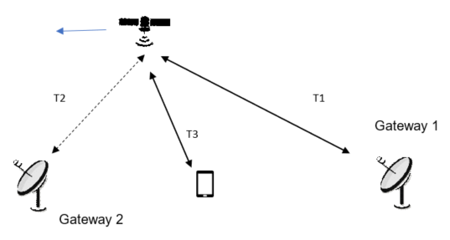

Soft Feeder link switch:

In soft feeder link switch, the satellite can simultaneously support two feeder links is illustrated in Figure below.

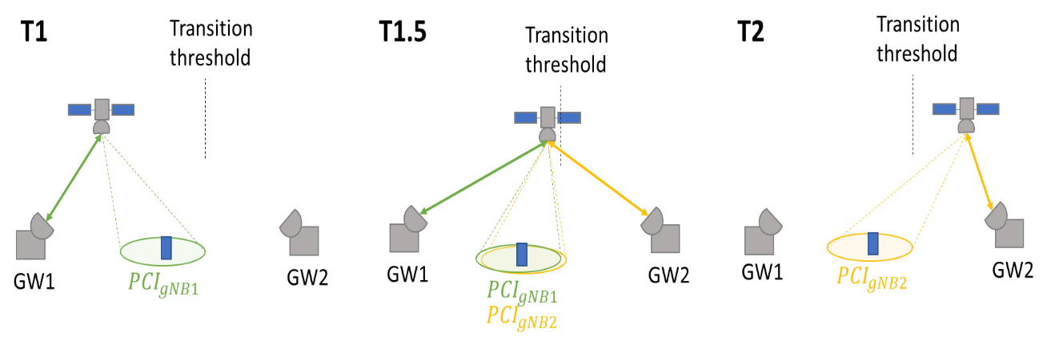

Ericsson observe that there were no major RAN1 issues for the solution identified in TR 38.821 for the soft feeder link switch scenario. Satellites typically have the capability to connect to multiple gateways by using multiple antennas. For feeder link switch, the validness of the scenario where the same gNB is connected to multiple satellite gateways is questionable. In contrast, the feeder link switch involving different gNB’s before and after the switch is more typical.

Interdigital observe that soft feeder link switch has less impact to current specification propose Rel-17 than a hard feeder link switch. Soft feeder link switch can support unique PCIs for cells from the source and target gNBs to be simultaneously relayed through the same satellite. The UE can distinguish the cells by different synchronization raster points for CD-SSBs. Interdigital propose to support soft feeder link switch for transparent LEO NTN

Hard Feeder link switch:

In Hard feeder link switch, the satellite only support one feeder link at a time.

Nokia observes that a feeder link switch for a transparent satellite may result in a cell switch. A gNB may switch links of the Uu interface from one satellite and feeder link to another satellite and feeder link, originating from the same NTN-GW. An NTN UE may be informed about imminent switch events including the resulting transmission gap. The knowledge of the gap is useful for the UE, because it can potentially continue obtaining service after the switch without declaring RLF, flushing of HARQ and reset of MAC. Nokia propose that RAN1 clarify impact of feeder link switch and benefit of signalling assistance information for imminent switch events and define an assumption on the maximum feeder link delay .

CATT proposed that the feeder link hard switch procedure should be based on group switching with accurate time control. In order to support hard feeder link switching, the following enhancements can be considered:

* Before handover, network should inform all UEs to stop UL transmission at one time point, and restart RRC connection in a new cell after a timer expired.
* The network should broadcast the propagation delay difference and UL TA offset of new targeted cell.
* PRACH parameters configuration need to be extended to support massive user handover, including ssb-perRACH-Occasion, Msg1-FDM, PRACH Mask index.

Interdigital observe that a hard feeder link switch can result in all connected mode UEs served by the satellite attempting mobility simultaneously, leading to RACH collisions, RLF and service interruption due to cumulative delay in RRC re-establishment signalling. Synchronizing UEs to perform HO without collision introduces complexity and additional signalling in the HO command. Providing assistance data to aid RRC re-establishment may assume a land-based connection between source and target gNBs, which cannot be guaranteed.

Other RAN1 aspects of feeder link switch:

Nokia propose that RAN1 define the feeder and service link type of amplification for gNB interpretation of measurement reports and configuration of UE uplink transmit power control with three options considered:

* Constant gain: The combined receive and transmit gain is a constant, independent of the received signal.
* Constant Emitted Isotropic Radiated Power (EIRP): The satellite will adjust the combined receive and transmit gain based on the received signal and a target EIRP to make the feeder link gain equal to one.
* Constant power at receiver: The satellite will attempt to compensate for the radio channel.

Nokia observes that transparent satellite can be analogue RF repeater or sample and forward a digital version of the analogue transmissions. The gNB may in principle compensate for the timing advance and Doppler on the NTN-GW – satellite link, which implies the UE only needs to handle the service link. Nokia propose that RAN1 clarifies that the satellite does not terminate the Uu interface. The gNB location relative to the NTN-GW may impact the NTN user experience and propose RAN1 defines an assumption of the maximum tolerable gNB – NTN-GW delay.

Xiaomi propose the change of the timing due to the switch of feeder link switch can be managed at the gNB side.

Inter-Satellite Link:

Nokia propose that RAN1 to define the maximum additional NR-Uu delay due to use of ISL and potential path gain impacts.

***FL recommendation on feeder link: The rel-17 NR NTN WI states clearly that in RAN2#113e meeting in January, RAN2 will “Agree on design alternatives for feeder link switch over options, send LS to RAN1, if necessary”. RAN1 can wait for RAN2 guidance before discussing specific RAN1 aspects requiring potential enhancements and specifications.***

## DL Synchronisation, System Information Acquisition

Qualcomm propose synch raster design to reduce initial access time and different SIBs design based on the system information updating rate.

Samsung observed that for a spot beam size that exceeds 250 km, a BS may need to perform a multi-valued Doppler pre-compensation; e.g. it may need to group distinct sets of SSBs using distinct Doppler values for pre-compensation. Indication for multi-Doppler pre-compensation pattern on DL benefits idle UE cell reselection, connected UE handover and connected UE data channel reception. The gNB/satellite can apply different values of Doppler pre-compensation to different SSBs. Samsung proposes that the BWP configuration is extended to indicate the amount of frequency offset to adjust the PRB grid with respect to the default BWP, as the experienced Doppler shifts at different spot beams are different.

|  |  |  |
| --- | --- | --- |
| fc (GHz) | spot beam size (km) | maximum Doppler difference between UEs (kHz) |
| 2 | 50 | 4.185 |
| 2 | 200 | 15.87 |
| 2 | 250 | 19.25 |
| 2 | 300 | 22.33 |
| 2 | ~ 600 | ~ 45 |

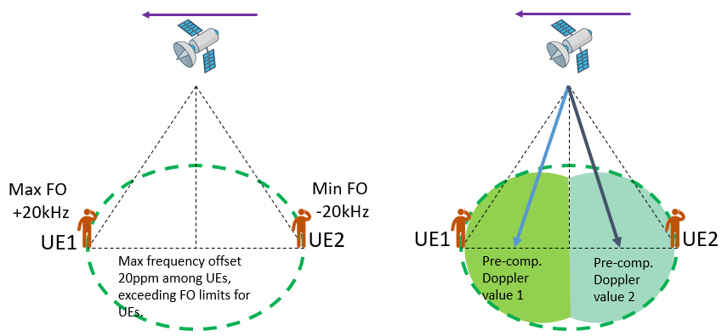

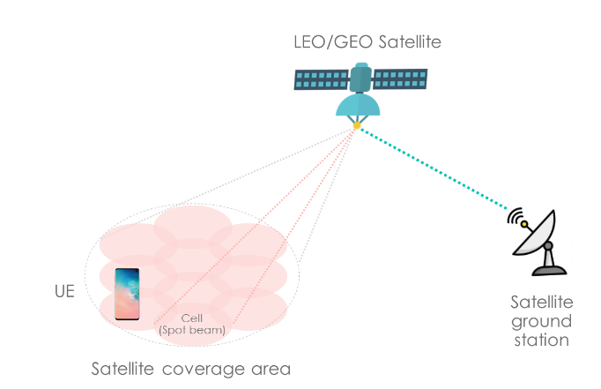 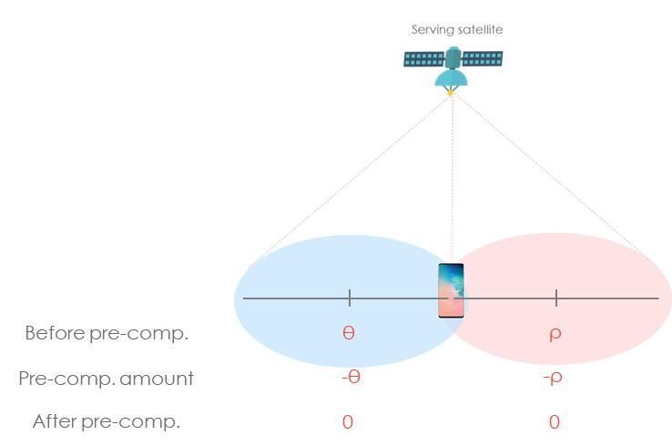

MediaTek observed that DL synchronization with much larger Doppler shift could be experienced with large beam spots of up to 1000 km beam diameter. This may require that the UE uses a larger tone raster for DL synchronization during initial cell access than the legacy NR raster spacing in Table 5.4.3.1-1 in TS 38.104, as shown below for a maximum residual frequency offset and corresponding maximum beam diameter at the Nadir. A +/-10ppm free running oscillator accuracy is used in the device.

* Fc<3GHz: raster 100KHz, residual frequency offset ±15 kHz, max beam diameter 340 km
* 3GHz<Fc<24.25GHz (effectively 6GHz): raster 1.44MHz, residual frequency offset ±58 kHz, max beam diameter > 1000 km
* Fc>24.25GHz: raster 17.28MHz, , residual frequency offset ±70 kHz, max beam diameter > 1000 km

***FL recommendation on DL synchronization: RAN1 have not made agreement on whether gNB does common Doppler pre-compensation and its indication via signaling. This knowledge is needed by UE for pre-compensation of Doppler shift for UL transmission. Whether a larger sync raster is needed can be left to RAN4. New raster and SSB design was not recommended in the rel-16 NR NTN SI.***

## PAPR

Qualcomm observed that a tone reservation method denoted by peak reduction tones (PRTs) can reduce Raw Cubic Metric of the CP-OFDM waveform in the NTN downlink by about 0.4 dB - 0.6 dB in Raw Cubic Metric reduction compared to hard-clipping power amplifier model for QPSK and 256QAM. Higher reduction for PAPR in 2 dB – 3.8 dB also observed. Tone reservation can increase the net transmit power of the CP-OFDM waveform in the NTN downlink by up to 1.5 dB.

 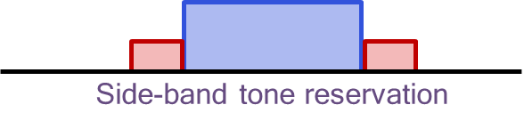

CAICT tested the DFT-s-OFDM signal both in lab and on orbit. They observed that the performance of DFT-S-OFDM signals in the satellite channel scenario meets the design and simulation expectations

## Power Control

Samsung proposed that open loop power control, UE should be allowed to predict its own transmission power not only based on DL measurement, e.g., pathloss measurement but also other available information, such as gNB ephemeris and UE trajectory. Samsung proposed closed loop power control should be supported in NTN and a mechanism to disable closed loop power control should be considered.

Qualcomm proposed to support autonomous reduction of MCS for PUSCH at least for cases when UE is power limited and to study the exact triggering condition and indication of the reduced MCS

## Air To Ground

CMCC proposed “implicit compatibility to support HAPS and ATG scenarios” in the WID means the enhancements for NTN can also be applicable for HAPS and ATG, although we do not need to discuss the enhancements specifically for HAPS and ATG. In principle,

* If there are several potential solutions for NTN, and some of them are more essential / important / applicable for ATG / HAPS, then these solutions should be prioritized.

## SLS Parameters

Nomor analyses the list of simulation study cases, used during the Study Item phase and tries to reduce the large set for system level simulations (SLS) during the Work Item phase [3]. Scenarios and need for throughput simulations with frequency re-use factors during the Work Item phase were discussed.

## Support of Handheld phone in LEO 1200

Thales, ESA, Firstnet, Fraunhofer IIS, Fraunhofer HHI, Qualcomm, Reliance Jio, Intelsat, Hughes Network Systems observe that in link budget cases SC19 and SC20, the C/N on UL can be as low as -8.6 dB. Thales propose RAN1 discuss and endorse the following UE characteristics for the normative phase in addition to the already considered UE characteristics of TR 38.821. Further, it is proposed RAN1 to consider UL coverage enhancements to support handheld devices including smart phones in Rel-17 with the following objective “At least support the connection of smart phones to satellites at orbit up to 1200 km and minimal elevation angle 30 degree or lower”.

|  |  |
| --- | --- |
| **Characteristics** | **Handheld Type 2 (smart phones)** |
| **Frequency band** | **S band (i.e. 2GHz)** |
| **Antenna type and configuration** | **1 Tx and 2 Rx with omni-directional antenna elements with possible transmit antenna switching/selection** |
| **Polarisation** | **Linear** |
| **Rx Antenna gain** | **[-5] dBi per element** |
| **Antenna temperature** | **290 K** |
| **Noise figure** | **7 dB** |
| **Tx transmit power** | **200 mW (23 dBm)** |
| **Tx antenna gain** | **[-5] dBi per element** |

## Companies views (1st round discussions )

Companies are invited to comment on Additional aspects.

|  |  |
| --- | --- |
| **Company** | **Comments and Views additional aspects of Section 6** |
| Ericsson | * 4.1, 4.2, 4.3: fine with FL recommendation * 4.4, 4.5: Not needed as concluded in Rel-16 NTN SI * 4.6, 4.7: Not sure what kind of inputs are needed as there are no proposals * 4.8: A couple of comments are listed as follows.   + 3GPP has always assumed 0 dBi antenna element gain for smartphone in FR1. In Rel-17 Coverage Enhancements work, 0 dBi is also assumed. In Rel-17 RedCap, - 3 dBi is assumed for wearable **not** smartphone.   + Both Rel-17 coverage enhancement work and RedCap work are considering enhancing/recovering the coverage. Though the use cases and channel conditions are not the same as NTN, tools/features to enhance the coverage are not fundamentally different. For example, the repetition method is also under consideration in Rel-17 coverage enhancement work and RedCap work.   + There is no corresponding objective in the NR NTN WID. Thus, RAN discussion is needed to revise the WID, as RAN is responsible for overall 3GPP RAN work. Working Group should respect RAN decision and arrangement. If coverage enhancements would be considered, it should be discussed in RAN plenary whether this should be handled first in the Rel-17 Coverage Enhancements work, to avoid parallel (and possibly duplicating/conflicting) work in RAN1. |
| ZTE | * 4.1: w.r.t the PRACH format self, agree with FL’s recommendation unless clear needs, e.g., link budget improvement, is needed. In addition, since 2-step RACH is also supported with RAN2’s agreement, corresponding discussion, e.g., RACH type selection. * 4.2, 4.3: fine with FL recommendation * 4.4, 4.5: Not needed as concluded in Rel-16 NTN SI * 4.6: As common understanding, we can just stick to the WI description and try to resolve the needs with consideration on the compatibility. * 4.7: No clear about the action, up to contribution. * 4.8: Open to discuss it with link budget first if the needs are justified (including clarification on the real device capability, relationship/impacts to other SIs). |
| Qualcomm | Agree with moderator’s recommendation on 4.1-4.3.  For 4.8, we note that smartphones are the most widely used handheld devices and their support through NTN should be addressed. In addition, we note the following concerning support of smart phones by NTN:   * There is typically only one UL receive antenna in NTN. But there can be typically 4 UL receive antennas in terrestrial networks for FR1. Consequently, it is expected at least 6 dB more SNR will be required in NTN than in terrestrial networks for a given MCS in the UL. As noted in R1-2009061, more than -3dB SNR will be required for Msg3 for agreed NTN LOS channel model. * A 0 dB polarization loss for system and link simulations was assumed with two transmit antennas during study item phase. This would require two orthogonally polarized antennas and the capability of coherent transmission. This is highly questionable for smart phones in FR1. * Although 0 dBi has been used as a baseline for phones in 3gpp, it is not representative for smartphones. Due to form factor limitation, smart phones typically use internal antennas that tend to have smaller antenna efficiency. In this regard, it is not different from wearables. Smart phones may require more durable and aesthetical packaging and may have larger packaging loss than wearables. We believe -5 dBi is representative. Companies are encouraged to provide inputs on smart phone antenna gains in L and S bands.   From the above, it is clear the use cases considered in NTN differ from that in NR coverage enhancement and Redcap.  Although it is expected that some techniques considered for NR coverage enhancement work can also be used for NTN, there could be some NTN-specific techniques, such as techniques to overcome the lack of receive diversity. In summary, we believe it’s RAN1’s responsibility to start the discussion and work because RAN1 is the best group to identify the gap between NR specification and what’s needed for the support smartphone. |
| MediaTek | Agree with FL recommendations for 4.1, 4.2, 4.3  Same view as Ericsson, ZTE on 4.4, 4.5: Not needed as concluded in Rel-16 NTN SI  On 4.6, we share understanding with ZTE.  On 4.7, it is related to 4.8 since LEO@1200 km DL was simulated at system level with Set1.It could be interesting to also show Set 2 SLS results. The link budget for LEO@1200 km set 1 and set already analysed in TR 38.821 Table 6.1.3.3-1. The DL SNR is several dBs above 0 dB and consistent with normal operations in NR specifications (also UTP SLS simulations would suggest no concern on DL). The C/N on UL seems reasonable with set 1 it is -2.6 dB; with set 2 it is -3.2 dB. We see no enhancements needed as level of repetitions / slot aggregation in current NR specifications should be sufficient. The RACH should be no concern as can be detected at much lower C/N.  On 4.8, we have same understanding as Ericsson on 3GPP has always assumed 0 dBi antenna element gain for smartphone in FR1. This antenna gain in device was discussed in the rel-16 NTN SI. It is fine if companies can contribute what they think this values for Rx antenna gain in smart phones could be and the likely impact on the link budget. |
| Samsung | For 4.1 and 4.2, we are supportive with FL’s proposal  For 4.3, our contribution describes the performance benefits of multi-valued Doppler pre-compensation (e.g. improved timing/frequency measurements, scheduling flexibility). As large spot beams (e.g. with sizes that exceed 250 km) will be employed in NTN, we believe that common Doppler pre-compensation by the gNB warrants further investigation by RAN1. We agree that RAN4 can determine the necessity of a larger sync raster.  For 4.4, this leads to too much changes on the implementation on UE/gNB sides.  For 4.8, similar to Qualcomm, we also support the addition of smart phone assumption. We see that smart phones are the most common type of handheld device and this would be one of the most important use cases for NTN. In practical developments, smartphone form factor does not have 0 dBi Tx/Rx antenna gains, but about -5 dBi is a very practical value. The difference between 0 dBi and 5 dBi may lead to quite big difference of performance expectation. |
| Apple | We are fine with FL recommendation on 4.1, 4.2, 4.3.  4.4 and 4.5 are not needed. There are no particular technical proposals related to 4.6 and 4.7.  For 4.8, we are supportive to discuss the link budget of handheld phone in NTN, in consideration of the potential market of NTN. Also, due to form factor limitation, smart phones may have smaller antenna efficiency, which may restrict their link budget. Although in 3GPP, UE antenna gain is assumed to be 0 dBi, some margin on that could help to ensure the connection between UE and satellite. |
| SoftBank | For 4.8, considering the fact that RAN plenary is going to discuss the scope refinements for Rel-17 items, we should have a RAN level discussion first. |
| Xiaomi | For 4.8, we are open to discuss the new addition of the handheld phone assumptions. For antenna gain, there may have different understanding. In our view, 0dBi assumed in SI phase just means omnidirectional antenna is assumed ,which doesn’t take into some factors in real development such as the antenna efficiency, pattern and phone cover. If the antenna gain here is including those factors. We suggest to have a -6dbi as the baseline assumption. |
| LG | OK with FL recommendations for 4.1, 4.2, 4.3. |
| Huawei | * 4.1, 4.2: Fine with FL recommendation. * 4.3: DL synchronisation can be discussed under 8.4.2 * 4.4, 4.5: PAPR and power control will not be enhanced in Rel-17 NTN as concluded already in SI. * 4.6: The detailed solutions can be discussed under separate AIs. * 4.7: SLS parameters in 38.821 should be the baseline. Not sure anything needs to be done. * 4.8: First of all, we had a feeling that the discussion should be held in RAN-P rather than RAN1. Secondly, our understanding is that the antenna gain of commercial smart phones varies a lot among vendors and/or frequency bands. In fact, they are very much implementation related. However, the typical assumption of UE antenna gain in other NR SI/WIs is 0dBi. This also holds in the Rel-17 coverage enhancement SI. We are wondering why we should be do differently for NTN. On the other hand, if in the end we should change the UE antenna gain assumptions, this should also be done in the ongoing Rel-17 coverage enhancement SI. |
| APT | Support 4.1, 4.2, and 4.3. No need for 4.4 and 4.5. For 4.8, we agree with QC’s summary. |
| Nokia, Nokia Shanghai Bell | 4.1: OK to wait with RACH enhancements until further progress in 8.4.2.  4.2: OK to wait for potential LS from RAN2.  4.5: It seem that under this topic we might also need to discuss the gain model of the satellite. That is, whether the satellite transmit and receive signals only considers the path loss on the service link or if it considers the path loss for the feeder link as well.  4.7: According to our understanding, the scope of the WID has not changed, so the scenarios considered under the SI should still apply.  4.8: We are a bit uncertain about the target of this paragraph. Is the intention to limit the target scenario (scope of WID) or is the target to expand the scope of the WID? |
| CMCC | Support 4.1, 4.2, and 4.3. No need for 4.4 and 4.5.  On 4.6, the following design principle can be considered, while the detailed solutions can be discussed under separate AIs.  “If there are several potential solutions for NTN, and some of them are more essential / important / applicable for ATG / HAPS, then these solutions should be prioritized.”  On 4.8, we share the same view as Huawei. |
| Thales | 4.1: Agree with FL recommendation. It is better to focus the normative work on UE with pre-compensation capabilities for the time being.  4.2: Agree  4.3: gNB pre/post compensation behaviour is discussed in AI 8.2.4.  4.8: Based on the NTN WID and the NTN SI assumptions, there is no doubt that handheld devices (including smartphones) shall be addressed as part of NR NTN WI for rel-17.  The purpose of the paper is to extend the type of NTN deployment scenarios where handheld devices (including smartphones) could be supported.  From our perspective, RAN1 can agree on these limited additional evaluation assumptions and consider the corresponding design targets (e.g. low SNR level) when working on the solutions for supporting NTN as part of Rel-17. Based on the above, discussions at RAN plenary are not needed.  It could also be beneficial to consider NTN scenarios as part of the Rel17 SI on NR coverage enhancements. The objective of this on-going SI (AI 8.8) is to study solutions for specific scenarios which do not include clearly the NTN scenarios. It is true that these enhancements will be also beneficial to a large extent to NTN but we need to make sure that they will be sufficient to support the targeted use cases |
|  |  |

## Summary 1st round discussions

In the first round of e-mails, 15 companies contributed views on additional aspects.- Ericsson, ZTE, Qualcomm, MediaTek, Samsung, Apple, Softbank, CMCC, Xiaomi, LG, Huawei, APT, Sony, Nokia / Nokia Shanghai Bell, Thales.

There was consensus on supporting FL recommendations on 4.1, 4.2, 4.3.

Ericsson, ZTE, MediaTek, Samsung, Apple, APT, CMCC questioned the need for 4.4 PAPR. Huawei mentioned that PAPR and power control will not be enhanced in Rel-17 NTN as concluded already in SI.

Support of handheld in 4.8 was discussed. Generally, there is interest in this new topic. Clarifications on the smart phone parameter assumptions w.r.t. to the TX antenna gain and RX antenna gains will needed. The impact on the link budget for LEO @1200 km could be further discussed.

## Companies views (2nd round discussions)

Based on companies views in first round of discussions

RACH enhancements (4.1):

FL recommendation on RACH enhancements: The options for the RACH design were discussed in the Rel-16 NR NTN SI without consensus. It is not helpful at this stage to revisit the 4 options for the RACH design. It is proposed to wait for further progress in AI 8.4.2 on UL synchronization based on UE pre-compensation using GNSS and then revisit need for RACH enhancements if beneficial.

Feeder link switch (4.2)

FL recommendation on feeder link: The rel-17 NR NTN WI states clearly that in RAN2#113e meeting in January, RAN2 will “Agree on design alternatives for feeder link switch over options, send LS to RAN1, if necessary”. RAN1 can wait for RAN2 guidance before discussing specific RAN1 aspects requiring potential enhancements and specifications.

DL synchronization (4.3)

FL recommendation on DL synchronization: RAN1 have not made agreement on whether gNB does common Doppler pre-compensation and its indication via signaling. This knowledge is needed by UE for pre-compensation of Doppler shift for UL transmission. Whether a larger sync raster is needed can be left to RAN4. New raster and SSB design was not recommended in the rel-16 NR NTN SI.

Support oh Handheld (4.8)

FL recommendation: Companies can contribute what they think this values for Tx and Rx antenna gain in smart phones could be and the likely impact on the link budget.

|  |  |
| --- | --- |
| **Characteristics** | **Handheld Type 2 (smart phones)** |
| **Frequency band** | **S band (i.e. 2GHz)** |
| **Antenna type and configuration** | **1 Tx and 2 Rx with omni-directional antenna elements with possible transmit antenna switching/selection** |
| **Polarisation** | **Linear** |
| **Rx Antenna gain** | **[-5] dBi per element** |
| **Antenna temperature** | **290 K** |
| **Noise figure** | **7 dB** |
| **Tx transmit power** | **200 mW (23 dBm)** |
| **Tx antenna gain** | **[-5] dBi per element** |

|  |  |
| --- | --- |
| Company | Comments |
| Samsung | Since it seems the table is absent, we added this table for collecting views.  For 4.3, we believe that RAN1 should consider the issue of large differences in the observed Doppler shifts by different UEs within a single large spot beam. We believe that whether multi-value Doppler pre-compensation by the gNB addresses this problem should be FFS. We would also be okay with discussing this issue in 8.4.2.  For 4.8, we think it’s better to capture the evaluation assumption in NTN TR. It makes the company’s common understanding on the smart phone form factor for NTN and enables to compare easily. |
| Qualcomm | For 4.4, companies’ views are missing in Sec. 4.9.  For 4.8, support moderator’s recommendation. |
| ZTE | W.r.t the 4.1/4.2, fine with FL’s proposal;  For 4.3, even the sync-raster design is up to RAN4, we do need provide the basic assumption used in RAN1 evaluation. Otherwise, potential collision between WGs are expected.  For 4.8, we can start to check the corresponding case with agreed simulation firstly. The necessity for the following impacts/enhancement can be up to the group decision. W.r.t the antenna gain, the value used in on-going coverage enhancement should be taken as baseline. |
| APT | Support 4.1, 4.2, and 4.8. |
| CATT | Support 4.3 and 4.8.  For 4.2, the feeder link switching impact can be considered in RAN1, though some aspects are related to implementation, and some aspects are related to performance bottleneck. RAN2 may have the conclusion, but RAN2 doesn’t provide careful performance analysis for feeder link switching. |
| LG | We are fine with FL recommendation 4.1, 4.2 and 4.8. |
| Huawei | 4.1 Support FL recommendation  4.2 Support FL recommendation  4.3 We think that RAN1 first needs to agree on common Doppler pre-compensation and only engage RAN4 if they are needed  4.8 Not sure how the FL recommendation can help the discussion in RAN1. Given that that the proposal to change the UE antenna gain clearly has an impact to the Rel-17 NTN as well as other SI/WI, we would suggest interested companies can bring the discussion to RAN plenary.  Just to repeat some of our views, the antenna gain for commercial smart phones varies a lot among vendors and/or frequency bands. They are very much implementation related. However, the typical assumption of UE antenna gain in all other NR SI/WIs is 0dBi. If there is indeed a need to change this common assumption, this should also be done in all the other SI/WI since it will have a big impact to NR UL coverage. This clearly has an impact to all other SI/WI which should be discussed in RAN plenary instead of RAN1. |
| Xiaomi | We are fine with FL recommendation 4.2.  For FL recommendation 4.8, we are open to discuss it, while detailed parameter setting can be FFS. |
| Thales | 4.1 Agree  4.2 Agree  4.3 Companies are invited to share their views in AI 8.4.2 to discuss whether RAN1 should specify make any agreement on whether gNB shall be able to frequency precompensate the DL signals.  4.8: Fine with the FL recommendation. Companies can further contribute on this part and propose values and we believe it would be beneficial for RAN1 to further discuss whether it is acceptable to update its evaluation assumption to extend the supported NTN scenarios with smartphones.  As already stated, from our perspective, RAN1 can agree on these limited additional evaluation assumptions and consider the corresponding design targets (e.g. low SNR level) when working on the solutions for supporting NTN as part of Rel-17. Based on the above, discussions at RAN plenary are not needed. |
| Intelsat | * 4.1, 4.2, 4.3: fine with FL recommendation * 4.4: We support the view that PAPR in the context of CP-OFDM and DFT-s-OFDM should be studied further in NTN. * 4.5: Not needed as concluded in Rel-16 NTN SI * 4.6: We support the view that support for HAPS and ATG scenarios should be considered for compatibility. * 4.7: It appears there is not a specific proposal. * 4.8: We support the discussion of link budget for a device that has a less efficient antenna. |
| Nokia, Nokia Shanghai Bell | For 4.8, it might be a bit late to change the scope of the work item. Further, RAN1 specifications are normally agnostic to frequency bands of operation. |
| Ericsson | On 4.8: Our view remains the same as in the first round. 3GPP has always assumed 0 dBi antenna element gain for smartphone in FR1. In Rel-17 Coverage Enhancements work, 0 dBi is also assumed. Further, this should be a RAN plenary discussion to change the scope of WID. |
| Hughes/EchoStar | Agree with 4.1 and 4.2 and 4.3  4.8: OK with FL recommendation. Further contribution may be needed to propose realistic values and would be beneficial for RAN1 to further discuss whether it is acceptable to update its evaluation assumption to extend the supported NTN scenarios with smartphones. |
| Apple | We are fine with FL recommendations on 4.1, 4.2, 4.3 and 4.8. |

## Summary 2nd round discussion

In the second round of e-mails, 14 companies commented on additional aspects - Samsung, Qualcomm, ZTE, APT, CATT, LG, Huawei, Xiaomi, Thales, Intelsat, Nokia, Nokia Shanghai Bell, Ericsson, Hughes/EchoStar, Apple. Based on companies views in second round of discussions,

RACH enhancements (4.1):

FL recommendation on RACH enhancements: The options for the RACH design were discussed in the Rel-16 NR NTN SI without consensus. It is not helpful at this stage to revisit the 4 options for the RACH design. It is proposed to wait for further progress in AI 8.4.2 on UL synchronization based on UE pre-compensation using GNSS and then revisit need for RACH enhancements if beneficial.

Feeder link switch (4.2)

FL recommendation on feeder link: The rel-17 NR NTN WI states clearly that in RAN2#113e meeting in January, RAN2 will “Agree on design alternatives for feeder link switch over options, send LS to RAN1, if necessary”. RAN1 can wait for RAN2 guidance before discussing specific RAN1 aspects requiring potential enhancements and specifications.

DL synchronization (4.3)

Samsung, ZTE, Huawei, Thales, have mentioned that first RAN1 need to discuss and agree on whether the gNB need to pre-compensate the common Doppler shift. ZTE mentioned the sync-raster design is up to RAN4 and basic assumption used in RAN1 evaluation should be provided. The moderator view is to wait first for agreement on gNB pre-compensation of common Doppler in AI 8.4.2.

Support on Handheld (4.8)

Huawei, Ericsson think a RAN Plenary discussion is needed for support of smart phones. It was mentioned that the antenna gain for commercial smart phones varies among vendors and/or frequency bands. They are very much implementation related. The typical assumption of UE antenna gain in all other NR SI/WIs is 0dBi. If there is indeed a need to change this common assumption, this should also be done in all the other SI/WI since it will have a big impact to NR UL coverage. This clearly has an impact to all other SI/WI which should be discussed in RAN plenary instead of RAN1. Moderator view is that companies promoting this topic are encouraged to further discuss with other companies on the needs to use different values for Tx and Rx antenna gain assumptions as agreed in TR 38.821 for support of smart phones. The moderator view is that there seems to be consensus from companies on confirming first the assumption for TX and RX antenna gain in a typical smart phone and this could be discussed further in RAN1.

## GTW Agreement / Conclusion

To be added based on updated proposals following second round of email discussions

# References

1. R1-2005268, Huawei, HiSilicon, Discussion on other design aspects for NTN, RAN1#102e, August 2020
2. R1-2005311, THALES, Considerations on PAPR requirements for NR NTN downlink transmission, RAN1#102e, August 2020
3. R1-2005313, Nomor Research GmbH, Thales, Study Cases for System-Level Simulations in NTN WI, RAN1#102e, August 2020
4. R1-2005498, MediaTek, Other Aspects of NR-NTN, RAN1#102e, August 2020
5. R1-2005547, Fraunhofer IIS, Fraunhofer HHI, NR-NTN: Physical Random Access Channel, RAN1#102e, August 2020
6. R1-2005576, Sony, Discussion on beam management and BWP operation for NTN, RAN1#102e, August 2020
7. R1-2005709, CATT, Discussion for beam management and feeder link switch enhancement, RAN1#102e, August 2020
8. R1-2005836, Lenovo, Motorola Mobility, Discussion on NTN beam management, RAN1#102e, August 2020
9. R1-2005876, Intel Corporation, On pre-compensation capabilities and beam management for NTN, RAN1#102e, August 2020
10. R1-2005966, ZTE, Discussion on additional enhancement for NTN, RAN1#102e, August 2020
11. R1-2006032, OPPO, Discussion on other aspects, RAN1#102e, August 2020
12. R1-2006147, Samsung, Remaining issues for NTN, RAN1#102e, August 2020
13. R1-2006213, CMCC, Discussion on implicit compatibility to support ATG scenarios in NTN, RAN1#102e, August 2020
14. R1-2006328, Panasonic, Beam management, PRACH enhancement and polarization for NTN, RAN1#102e, August 2020
15. R1-2006381, LG Electronics, Considerations on PRACH, CSI and polarization signaling in NTN, , RAN1#102e, August 2020
16. R1-2006424, Nokia, Shanghai Bell, Clarification of NTN assumptions, RAN1#102e, August 2020
17. R1-2006466, Ericsson, On other enhancements for NTN, RAN1#102e, August 2020
18. R1-2006605, Beijing Xiaomi Mobile Software, Discussion on the beam management for NTN, RAN1#102e, August 2020
19. R1-2006620, Interdigital Inc, On feeder link switch, , RAN1#102e, August 2020
20. R1-2006643, Asia Pacific Telecom, Discussion on reference timing delivery for NTN, , RAN1#102e, August 2020
21. R1-2006678, THALES, Other RAN1 aspects for NR NTN, RAN1#102e, August 2020
22. R1-2009061, THALES, ESA, Firstnet, Fraunhofer IIS, Fraunhofer HHI, Qualcomm, Reliance Jio, Intelsat, Hughes Network Systems Support of smart phones in NTN, RAN1#102e, August 2020
23. R1-2006807, Qualcomm, SSB arrangements, BWP operation and other issues for NTN, RAN1#102e, August 2020
24. R1-2006858, CAICT, Discussion on beam management of NTN, RAN1#102e, August 2020