3GPP TSG RAN WG1 Meeting #103e R1-200XXXX

October 26th–November 13th, 2020

Agenda Item: 8.4.4

Source: MediaTek Inc.

Title: Summary #1 of 8.4.4 Other Aspects of NR-NTN

Document for: Discussion and Decision

# Introduction

This document contains a summary of the contributions under AI 8.2.4 at RAN1#103e. This include the topics for RAN1 that should be specified if beneficial and needed as listed in Release-17 NR NTN WID:

* *Enhancement on the PRACH sequence and/or format and extension of the ra-ResponseWindow duration (in the case of UE with GNSS capability but without pre-compensation of timing and frequency offset capabilities) [RAN1/2].*
* *Feeder link switch [RAN2,RAN1]*
* *Beam management and Bandwidth Parts (BWP) operation for NTN with frequency reuse [RAN1/2]*
  + *Including signalling of polarization mode*

# Beam Management, BWP

## Background

The following agreements were made in RAN1#102e

*One-beam per cell and multiple-beam per cell are supported in existing NR specifications and are baseline for NR NTN.*

* *FFS: The need for potential enhancement for beam management*
* *FFS: The need for potential enhancement on association of SSBs, beams and BWPs*

### Beam Management

During the rel-16 NR NTN SI, it was observed that the rel-15 NR beam management and BWP procedures can be re-used with the assumption that the beams are not co-located. Rel-15 NR UE uses initial BWP#0 for initial cell access including SSB, paging, and PRACH.  DCI signaling is used to indicate BWP switching, where the BWP switching in UL and DL is separately configured.  A device needs first to switch from the serving BWP#x to initial BWP#0, then switch to BWP#Y. The UE can fall back to initial BWP if the switching fails. There can be up to 4 BWPs configured in Rel-15 NR – i.e. BWP#0, BWP#1, BWP#2, and BWP#3.

There were two options for mapping of PCI and SSB in TR 38.821 [2].

* Option a: multiple beams per PCI with beam specific SSB.
* Option b: one beam per PCI.

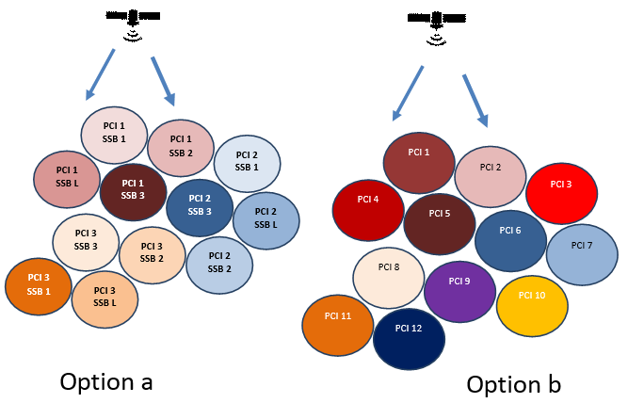

***Figure 1: Mapping options for PCI/SSBs in NTN***

In NR specification, the beam management procedure is used at the gNB and UE for training purpose to select the best beam. For beam selection at UE side, the UE measures SSB or NZP-CSI-RS of its serving beam and neighbouring beams and report measurements. It is possible for the UE to measure on any beam on the activated BWP. There is no association between spatial beam index and BWP index. The gNB indicate the serving beam via Transmission Configuration Index (TCI) on DCI or MAC CE. The TCI state includes fields for Cell index, BWP index, SSB index, CSI reference signal for a specific Control Resource Set (CORESET), which defines the PDCCH Search Space. For PDCCH, the MAC CE is used to activated one TCI state over a set of RRC configured TCI states for each CORESET. For PDSCH, DCI in the PDCCH can be used to indicate its TCI state, otherwise (i.e. the presence of TCI field in DCI is not configured), TCI state for PDSCH will follow PDCCH.

|  |  |
| --- | --- |
| **Source** | **Related Proposals & Observations** |
| Ericsson | ***Proposal 3****: RAN1 to discuss the scope of beam management, i.e., whether NR beam management framework (TCI state and spatial relations) should be restricted within the same satellite or support the switching of the service links associated with different satellites*  ***Proposal 4****: A first satellite providing coverage before a service link switch should assist UEs in RRC connected with signaling of the ephemeris of the second satellite providing coverage after the switch.*  ***Proposal 5****: The NR network should be able to indicate the timing of the service link switch to UEs in RRC idle and RRC inactive modes.* |
| Huawei | ***Proposal 1****: BWP configuration enhancement scheme should be studied for NTN.* |
| ZTE | ***Proposal 3:*** *To reduce power consumption and signaling cost, measurement can be disabled or be carried out with adaptive measurement period.*  ***Proposal 4:*** *Enhancement on beam management for UE-group based beam switching, can be considered to improve the performance.*  ***Proposal 5:*** *To reduce signaling cost and latency, UE dominant or UE assistant beam switch can be considered.*  ***Proposal 6:*** *Both BWP switching and TCI indication should be supported parallel to achieve the beam switching.* |
| Qualcomm | ***Proposal 5****: Consider BWP switching schemes to support efficient satellite beam switch.*  ***Proposal 6****: Consider efficient signalling of BWP configurations.*  ***Proposal 7****: Consider enhancements on beam measurement and reporting to support efficient switching between satellite beams using different frequency.* |
| Xiaomi | ***Proposal 2****: DL BWP switching and UL BWP switching simultaneously should be supported.*  ***Proposal 3****: Timer based BWP switching can be supported.* |
| Lenovo | ***Proposal 1****: Study a common BWP or separate different BWPs for beam management.*  ***Proposal 2****: Consider impact of BWP switching delay for NZP CSI-RS for beam management configured at in corresponding BWPs.*  ***Observation 1****: For NTN, current NR measurement-based beam management will result in large signaling overhead and long latency for periodic exchange of CSI-RS transmissions and corresponding reporting.*  ***Proposal 4****: Study further methods to perform beam measurements in order to reduce the signaling overhead and avoid long latency.* |
| Sony | ***Proposal 2****: Reuse the beam indication and BWP indication method in Rel.15/16, the BWP indication and beam indication should be coordinated.* |
| Panasonic | ***Proposal 3****: Schemes to reduce the signaling overhead and UE power consumption for beam management in moving cell scenarios can be considered, e.g. a list of multiple beams with associated timings for switching is indicated to the UE by RRC.* |
| LG | ***Proposal 3****. For NTN, potential enhancement on BWP switching can consider at least following aspects:*   * *Enhancement on bwp-InactivityTimer including value range extension and (re)start timing,* * *PDSCH transmission after transmission of ACK for BWP switching command.* |
| CATT | ***Proposal 4****: Support BWP based beam switching enhancement in NTN to reduce beam switching latency.*  ***Proposal 5****: Enable BWP switching of UL and DL simultaneously and support UE confirmation after BWP switching successfully.*  ***Proposal 6****: Support DCI to indicate beam switching with BWP index indication.* |
| Vivo | ***Proposal 6****: Multiple beams per cell should be prioritized.* |

### Association of SSBs, beams and BWPs

In Rel-15 NR, initial beam selection is based on SSB detection before the PRACH procedure. All SSBs of the primary cell Pcell are transmitted in TDM manner over same frequency resource – i.e. SSB transmissions take place within a BWP and within the same frequency interval. The devices measures SSBs within the same frequency interval to determine the SSB index in time for the best beam and its corresponding CORESET for Common Search Space Set type 0 typically denoted by CORESET#0 (for SIB1). An SSB burst can contain up to 4 SSBs for frequencies below 3 GHz. This limits the number of beams to 4 assuming L or S band. On each beam, the corresponding SSB and CORESET#0 are time-domain multiplexed with multiplexing pattern 1 for frequencies below 3 GHz. The devices then decode SIB1 to get configuration for time domain resource allocation within DCI Format 1_0 and also get the configuration of initial Bandwidth part BWP#0 which is used when first accessing the cell. The SIB1 is also used for configuration of the CORESET type 0A (for SI acquisition), type 1 (for RAR and CR), type 2 (for paging). The UE-specific CORESET configuration for UE data transfer is obtained via dedicated signalling.

|  |  |
| --- | --- |
| **Source** | **Related Proposals & Observations** |
| Ericsson | ***Observation 6****: BWP based frequency reuse will negatively impact the supported system capacity.*  ***Observation 7****: Using BWPs to enable a frequency reuse can already be supported by existing NR specification. It is a choice of network configuration and implementation.*  ***Proposal 6****: RAN1 to conclude that there is no need for additional enhancements for using BWPs to enable a frequency reuse.* |
| Huawei | ***Proposal 2****: The UE in connected mode can perform BWP switching based on the mapping relationship between SSB index and BWP index.* |
| ZTE | ***Proposal 1****: Existing BWP and SSB structure in NR should be reused as the baseline.*  ***Proposal 2****: No explicit enhancements on the association among SSB/BWP/beams are needed.* |
| Qualcomm | ***Observation 1****: Different options for cell/beam/frequency planning call for flexible standard design.*  ***Observation 2****: Different beams of a satellite may have different carrier frequencies but the same corresponding UE transmit and receive spatial direction.*  ***Proposal 1****: Support satellite beam specific initial BWPs.*  ***Proposal 2****: 3GPP RAN1 to have an agenda item dedicated to SSB arrangements and BWP operation.*  ***Proposal 3****: Support the following SSB arrangements*   * *Alt 1: SSBs of all satellite beams in a same cell are transmitted within a same frequency interval and do not overlap in time* * *Alt 2: SSBs of a cell are transmitted in different frequency intervals, i.e., within their respective BWPs.*     ***Proposal 4****: Support signalling of the following configurations in SIB1*   * *initial BWPs of other satellite beams,* * *CORSET#0 of other satellite beams if different from that of the serving beam.* |
| MediaTek | ***Observation 1****: Anchor beam transmitting BWP#0 and comprising single or multiple spot beams each associated with a BWP dedicated for data transmission allows to re-use Rel-15 Beam management mechanisms.*  ***Observation 2****: SSB transmissions without anchor beam may lead to beam switching failure requiring device to access cell again.*  ***Observation 2****: SSB transmissions in same frequency interval without anchor beam requires beam-specific initial BWPs with longer initial access time.*  ***Observation 4****: SSB arrangements in different frequency intervals without anchor beam requires beam-specific initial BWPs with longer initial access time and may require specification of new measurements with gaps due to frequent R retuning and BWP switches.*  ***Proposal 1****: Anchor beam transmitting initial BWP#0 and comprising multiple spotbeams each associated with a BWP dedicated for data transmission is baseline for NR NTN Beam Management and BWP configuration.* |
| OPPO |  |
| Xiaomi | ***Proposal 1****: The association between BWP ID and beam ID can be considered.* |
| Lenovo | ***Proposal 3****: Study the restriction between beam and BWP.* |
| Sony | ***Proposal 1****: SSBs of satellite beams in the same cell are transmitted in the same BWP, e.g., BWP#0.* |
| Panasonic | ***Proposal 1****: Reuse Rel-15/16 SSB arrangement as the baseline for Rel-17 NR NTN.*  ***Proposal 2****: Reuse Rel-15/16 BWP operation framework as the baseline for Rel-17 NR NTN.* |
| LG |  |
| CATT | ***Proposal 1****: For RRC-IDLE UE, one cell is only associated with one satellite beam, no enhancement needed.*  ***Proposal 2****: For RRC-Connected UE, one cell comprises of multiple satellite beams, each beam linked to one BWP.*  ***Proposal 3****: SSB configuration in one BWP follows NR Rel-15 framework, no enhancement needed.* |
| Vivo | ***Proposal 9****: For frequency re-use with circular polarization, support to reuse BWP configuration and operation in the existing NR specification in one satellite beam.* |

## Company Views

### Beam Management

In NR specifications, to conduct the measurement over different beams using SSBs, BWP switching from the serving beam associated with BWPx (i.e., carrying data) to initial BWP0 (i.e., carrying SSB) is needed. In case beam measurements based on CSI-RS, BWP switching from the serving beam associated with BWPx (i.e., carrying data) to another beam with BWPy (i.e., carrying data) is needed. Both types of measurements require that an initial BWP0 is configured and accessible by the UE for beam switching purpose. If initial BWP0 is not accessible, for example it is mapped to a beam that is not in coverage anymore due to satellite movement, beam switching is not possible and UE will need to access cell again.

Intel observed that polarisation and frequency reuse for different beams can be implemented using Rel. 15 NR beam management. In that case SSB corresponding to different beams can be transmitted in the same frequency band and multiplexed in time domain while other physical channels can be transmitted in different parts of the frequency band by using different frequency domain resource allocation for the UEs in different beams. Alternatively, it can be assumed that transmission with different beams corresponds to different BWP or different component carriers. Optimization of NR beam management design is not necessary for NTN. Beam management enhancements specified in Rel. 17 in feMIMO WI can be used for NTN.

Several companies discussed beam management mechanisms:

gNB dominated beam management: discussed by ZTE, Panasonic

In case of earth-fixed beam, the footprint of a satellite using steerable beam varies with elevation change, with dweling time in range 1 to 10 minutes. This makes periodical CSI-RS report ineffective. With GNSS assumption at UE side and broadcast of beam configuration in satellite ephemeris, UEs can calculate dwelling time. UEs close to beam edge switch beam based on UE group-specific signaling assuming gNB has knowledge of UE positions.

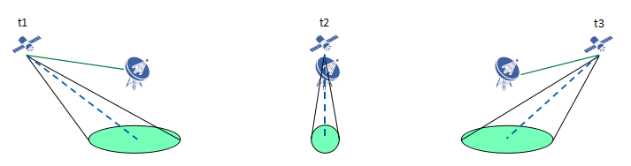

UE dominant beam management: discussed by ZTE, Panasonic, Xiaomi (timer based)

In case of earth-moving beams, the beam switching happens gradually with the movement of satellite. ZTE propose GNSS-capable UE can determine when to switch beams in two ways:

1. Option-1 Timer based: Network pre-configure UEs with beam switching timer based on UE position and beam layout information with satellite ephemeris, which conduct beam switching autonomously based on timer.
2. Option-2 Measurements based: Based on RSRP measurements and beam layout information with satellite ephemeris broadcast in SIB, UE autonomously do beam switching within the limited set accordingly.

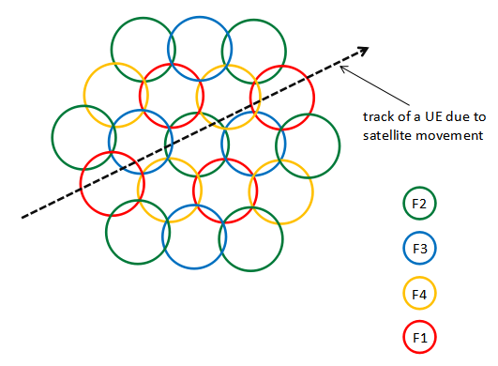

TCI sate indication enhancements for beam management: discussed by ZTE, Ericsson

In NR specification, indication for beam switching is indicated in TCI information via DCI or MAC CE. Assuming each beam is associated to a BWP, the beam switching can be done based on BWP switching mechanism. If polarization is used (e.g., two beams may use the same BWP and different polarization), the beam switching can further be done based on TCI indication.

Ericsson question whether NR beam management framework (TCI state and spatial relations) should be restricted within the same satellite or support the switching of the service links associated with different satellites. A first satellite providing coverage before a service link switch should assist UEs in RRC connected with signalling of the ephemeris of the second satellite providing coverage after the switch. A UE should refrain from initiating an RRC connection towards a satellite that is just about to hand over its service link to a next satellite. The NR network should be able to indicate the timing of the service link switch to UEs in RRC idle and RRC inactive modes.

ZTE propose both BWP switching and TCI indication should be supported parallel to achieve the beam switching.

BWP based frequency reuse: discussed by Ericsson, Panasonic, OPPO, Lenovo, CAICT

Ericsson, CAICT observed using BWPs to enable a frequency reuse can already be supported by existing NR specification. It is a choice of network configuration and implementation. There is no need for additional enhancements.

Panasonic question whether there is a need for introducing beam-specific BWP for NR NTN. The argument is to facilitate frequency reuse factor larger than 1 to reduce the interference of neighboring satellite beams. By assigning each satellite beam with a different BWP, beam switching would automatically trigger the switching of beam-specific BWP. Interference coordination can be handled in more dynamical way based on Rel-15/16 BWP operations defined from individual UE perspective – i.e. for interference coordination in NTN, BWP can be configured and activated/de-activated for each UE individually based on the actual interference the UE is experiencing. Panasonic propose to reuse Rel-15/16 BWP operation framework as the baseline for Rel-17 NR NTN.

OPPO propose to prioritize satellite beam layout with FRF > 1. The relationship between the satellite beam and the BWP operation should be studied and specified.

Lenovo propose to perform beam management among neighbour geographical areas, where NZP CSI-RS for beam management is configured in corresponding BWP for different geographical areas/footprints. This is an implemention method for BWP-based frequency reuse.

CAICT mentioned beam switch procedure for BWP specific beam management could be optimized by downlink signalling or optimized by UE procedure of beam switch/beam failure recovery for frequency re-use.

BWP switching enhancements: discussed by LG, CATT, Xiaomi

LG discussed that in NR, BWP switching is based on the DCI, MAC-CE or inactivity timer (bwp-InactivityTimer). When UE receives PDCCH scheduling DL or UL, the inactivity timer (re)starts. If there is no additional scheduling command before the timer expires, UE will perform BWP switching to initial BWP or default BWP. This is the way to resolve ambiguity when gNB and UE have different understanding on BWP switching. If a UE misses PDCCH carrying BWP switching indication, gNB can notice this situation at least after round-trip time + T_timer from the time of a PDCCH transmission. Thus, as RTT increase, this issue becomes non-negligible. LG propose that for NTN, potential enhancement on BWP switching consider enhancement on bwp-InactivityTimer including value range extension and (re)start timing, and PDSCH transmission after transmission of ACK for BWP switching command.

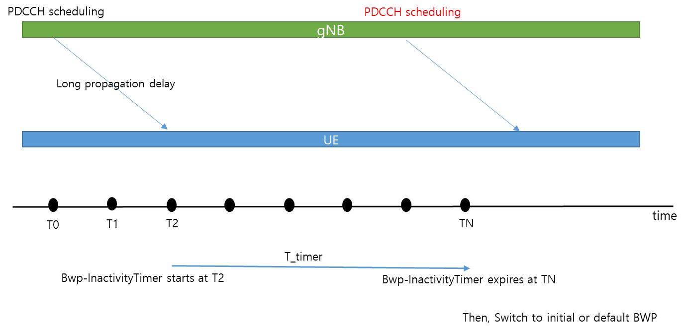

CATT, Xiaomi, mentioned needs to switch both the DL BWP and the UL BWP at the same time during beam switching. CATT proposed that BWP based beam switching enhancement in NTN to reduce beam switching latency is supported.

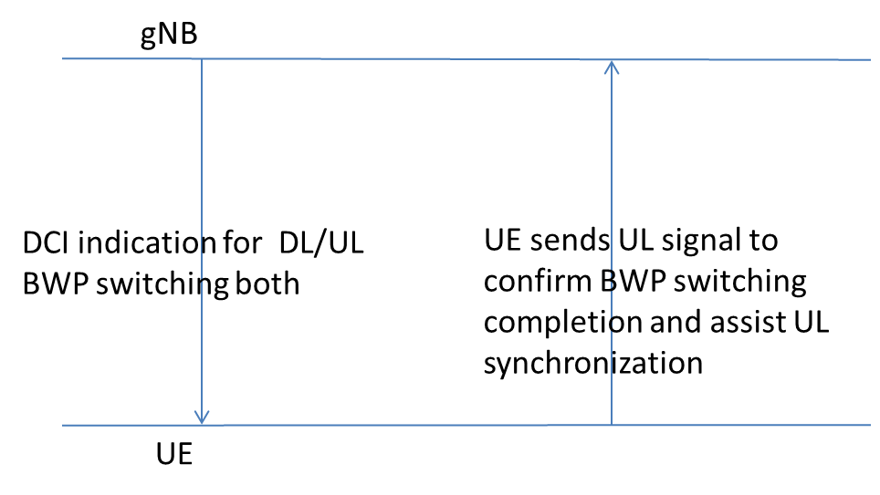

With consideration on the companies contributions, we encourage companies to further discuss potential enhancements for beam management to establish majority views for the 1st round of email discussions. In particular, whether companies agree that there is a need for some or all potential enhancements, whether down scoping of some potential enhancements can be agreed, and whether preference for some potential enhancements based on majority views could be agreed.

***Initial proposal#2.2.1-1 (Moderator)*:**

**Further discussions on potential enhancements of beam management in NTN is needed on the following:**

1. **gNB dominated beam management**
2. **UE dominant beam management**
3. **TCI sate indication enhancements for beam management**
4. **BWP based frequency reuse**
5. **BWP switching enhancements**

|  |  |
| --- | --- |
| **Company** | **Comments and Views on Beam Management** |
| Ericsson |  |
|  |  |
|  |  |
|  |  |
|  |  |
|  |  |
|  |  |
|  |  |
|  |  |
|  |  |
|  |  |
|  |  |
|  |  |
|  |  |
|  |  |
|  |  |
|  |  |

### Association of SSBs, beams and BWPs

ZTE, MediaTek, Huawei, Qualcomm, Panasonic, Sony, OPPO, Xiaomi, CATT discussed options for association of SSB, beams, and BWPs as illustrated on Figure below:

**Option-1:** **same beam layout for BWP0 and BWPx**. The gNB can expect simultaneous transmission and reception on up to two BWPs (i.e., BWP0 and BWPx) on each beam with same operation for frequency offset compensation. The same link budget/beam gain can be ensured for SSB/common channel and data.

* Option-1 is compatible with Rel-15 BWP and SSB specifications can be re-used without enhancements.
* Further discussion on this option is supported by ZTE, MediaTek, Panasonic, Sony, OPPO

**Option-2: hierarchical beam layout for different BWPs**. An umbrella beam (i.e. wider beam or anchor beam) is allocated to the cell-specific BWP0 (including all SSBs and all common channel as mentioned in section 2.1.2 above) covering the whole satellite cell footprint. The narrow beams are allocated to the other BWPx.

* Option-2 is compatible with Rel-15 BWP and SSB specifications can be re-used without enhancements.
* Further discussion on this option is supported by ZTE, MediaTek, Huawei, Qualcomm, Panasonic, Sony, OPPO

**Option -3: Mapping between SSB index and BWP index**. The UE implements synchronization, decodes SIB1, performs BWP switch to BWP1-3 based on SSB RSRP measurement in cell-specific BWP0. Linking SSB index to BWP index allows to increase the number of beams in the cell. A variant of this option is to have an association between beam ID and BWP ID, which seems similar assuming that a beam is mapped to an SSB using Rel-15 NR specifications.

* Option-3 is reasonable specification change without fundamental deviation from Rel-15 BWP and SSB specifications. The impact on specifications are (i) SSB-based BWP0 inter-frequency measurement gap for the UEs in BWP1-3 (ii) mapping between SSB index and BWP index.
* Further discussion on this option is supported by Huawei, Xiaomi

**Option-4: SSB transmission in beam-specific initial BWP**. Synchronization, SIB1 and measurements all within the serving beam.

* Option-4 is a significant specification change with fundamental deviation from Rel-15 BWP and SSB specifications. The impact on specifications are (i) Inter-frequency synchronization, decoding of SIB1, SSB-based measurements on beam-specific initial BWP; (ii) New signalling of the configurations in SIB1 for initial BWPs of other satellite beams and CORSET#0 of other satellite beams if different from that of the serving beam; (iii) enhancements on beam measurement and reporting to support efficient switching between satellite beams using different frequency. The robustness of this Option-4 can be questioned. If instead of initial BWP#0 we have initial BWPx, it is not clear what happens in case beam switch to beam mapped to BWPy should actually be beam switch to beam mapped to BWPz. gNB should indicate which beam to switch to via DCI based on measurements reported on BWPx. But device may already not be able to receive on BWPx since beam not in coverage of the corresponding beam anymore. What happens if measurements wrong due to weak signals or strong interference in overlapping region of beam X, Y, and Z. There may be serious error cases where the device cannot recover if no default initial BWP#0 mapped to anchor beam and would need to do an initial access to satellite cell again
* Further discussion on this option is supported by Qualcomm, OPPO, CATT

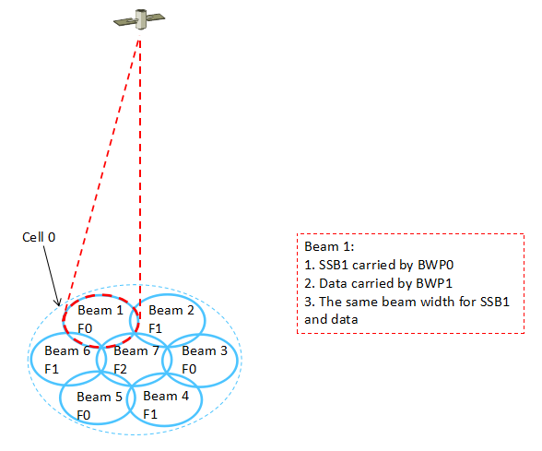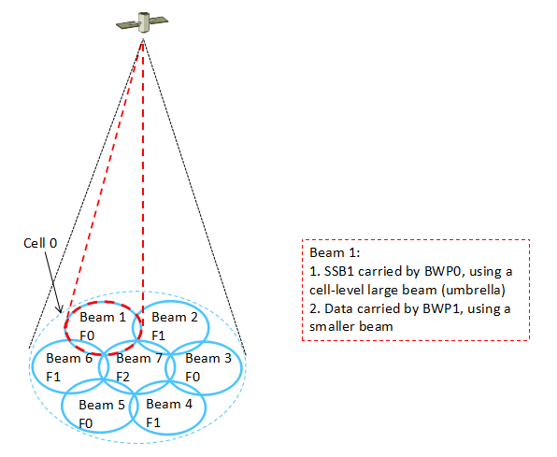

*(a)* ***Option-1****: Same beam layout (b)* ***Option-2****: hierarchical beam layout*



***Option-1****. A Narrow SSB beam*



***Option-2****: Wide SSB beam*



***Option-3****: Inter-frequency measurement configurations in a NTN cell*



***Option-4*** *based on Alt 2 with SSBs are within respective BWPs*.

With consideration on the companies contributions, we encourage companies to further discuss association for SSBs, beams, and BWPs to establish majority views for the 1st round of email discussions. In particular, companies can confirm whether they have same understanding that Options 1 or option 2 can be supported within the current NR specification framework and Option 3 has moderate impact on specification, and Option-4 has relatively higher impact on specifications.

***Initial proposal#2.2.2-1 (Moderator)*:**

Further discuss associations of SSBs, beams, and BWPs and their potential impact on NR specifications for the following options:

* Option-1: same beam layout for BWP0 and BWPx
* Option-2: hierarchical beam layout for different BWPs
* Option -3: Mapping between SSB index and BWP index
* Option-4: SSB transmission in beam-specific initial BWP

|  |  |
| --- | --- |
| **Company** | **Comments and Views on BWP configuration, activation/de-activation** |
|  |  |
|  |  |
|  |  |
|  |  |
|  |  |
|  |  |
|  |  |
|  |  |
|  |  |
|  |  |
|  |  |
|  |  |
|  |  |
|  |  |
|  |  |
|  |  |
|  |  |

## Updated proposal based on company views

### Beam Management

To be added based on companies views.

### Association of SSBs, beams and BWPs

To be added based on companies views.

## Company Views (2nd round of email discussions)

### Beam Management

To be added based on companies views.

### BWP Configuration and Activation/De-activation

To be added based on companies views.

## Updated proposal based on company views (2nd round of email discussion)

To be added based on companies views in second round of email discussions

## GTW Agreement / Conclusion

To be added based on updated proposals following second round of email discussions

# Signalling of Polarization

## Background

The following agreements were made in RAN1#102e:

*Potential enhancements for support of polarisation signalling in NR NTN can consider at least the following:*

* *Configuration of DL and UL transmit polarization including Right hand and Left hand circular polarizations (RHCP, LHCP)*
* *Network broadcast DL and UL transmit polarization configuration*
* *UE polarization capability (RHCP, LHCP, Linear)*
* *Dependence of polarisation signaling on deployment scenarios. For example,*
  + *Resource reuse mode with/without polarization for the beam management enhancement*
  + *Fixed polarization per cell/beam for polarization reuse and circular polarisation with intra-UE and inter-UE multiplexing (intra-UE and inter-UE) signalling*

Support of polarisation antennas depends on the UE antenna design and implementation. Polarisation can be used in the network for example for inter-cell interference mitigation or higher frequency re-use (i.e. Frequency re-use factor 4 with two carriers). The UE cannot be expected to reliably detect the used DL polarization. The network and UE need to have same understanding on support of polarisation to avoid polarisation loss of several dBs.

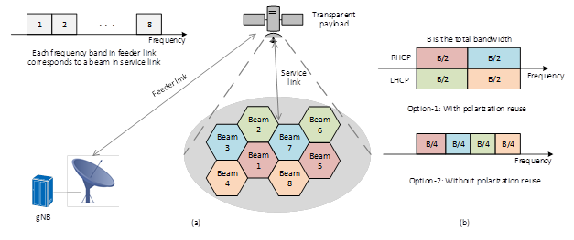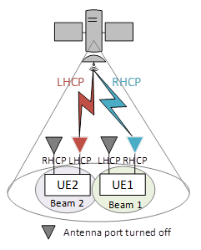

|  |  |
| --- | --- |
| **Source** | **Related Proposals & Observations** |
| Ericsson | ***Observation 8:*** *In some cases, a UE cannot be expected to reliably detect the used DL polarization.*  ***Proposal 7:*** *Support broadcast signaling that allows a gNB to indicate the gNB’s DL transmit polarization mode and UL receive polarizations mode to UE.*  ***Proposal 8:*** *Support signaling that allows the gNB to configure a UE’s polarization modes including the UE’s receive polarization mode in the DL and the UE’s transmit polarization mode in the UL.*  ***Proposal 9****: NTN UE should report its polarization capability (RHCP, LHCP, Linear) to the network.* |
| Nokia | ***Proposal 10****: Define a network configured basic polarization mode for UL operation which is used for initial access.* |
| Huawei | ***Proposal 3:*** *The indication of polarization state for NTN should be supported.*  ***Proposal 4:*** *The necessity of supporting UE polarization capability report should be further identified.*  ***Proposal 5:*** *Flexible polarization configuration for NTN should be supported.* |
| ZTE | ***Proposal 7:*** *Indication of polarization information should be supported with potential association with the SSBs.*  ***Proposal 8:*** *Polarization capability of a UE should be reported to the network.* |
| Qualcomm | ***Proposal 11****: Consider at least signalling of polarization per BWP.* |
| Sony | ***Observation 1****: The UE capability on the supported polarization mode is necessary for the NTN network to use the polarization domain. Such a capability can be either reported explicitly by the UE or implicitly through the UE measurement and reporting of the DL RS on two orthogonal polarizations.*  ***Observation 2****: The gNB can configure multi-user multiplexing on the polarization domain based on UE capability.*  ***Proposal 3****: UE polarization capability should be reported to the gNB, where the UE supported polarization mode can include linear polarization, circular polarization and adaptive polarization. How the UE polarization capability is reported can be further studied.*  ***Proposal 4****: Multi-user multiplexing on the polarization domain based on UE capability is supported.*  ***Proposal 5****: Beam management in NTN network can take polarization aspect into account.* |
| Panasonic | ***Proposal 4****: Signaling for the following two usages of circular polarization should be supported.*   * *Polarization reuse for inter-cell/beam interference mitigation* * *Polarization multiplexing for throughput improvement*   ***Proposal 5****: For operation with polarization reuse, information on satellite beam level polarization should be indicated. For the signaling design, polarization to be used at least for initial access, polarization to be used for SSB/CSI-RS measurement and polarization for target beam/cell should be taken into account.*  ***Proposal 6****: For operation with polarization multiplexing, information on the polarization should be indicated in DCI for scheduling PDSCH/PUSCH.* |
| LG | ***Proposal 2****. For NTN, support polarization mode (RHCP, LHCP) signaling broadcasted via SIB.* |
| CATT | ***Observation 1****: For the UEs supporting both RHCP and LHCP, polarization reuse configuration in the NTN is beneficial, while for the linear polarization UEs and single circular polarization UEs, network polarization reuse scheme is less useful.*  ***Proposal 7****: The polarization reuse scheme should be optional in NTN.*  ***Proposal 8****: Broadcasting the polarization is optional, and UE can connect the network even if without the information of network polarization information.*  ***Proposal 9****: The indication of the polarization mode can be linked to cell ID in network deployment without additional system information indication.*  ***Observation 2****: The single circular polarization UEs cannot work in in the different circular polarization beams, so that reporting the polarization capability is useless.*  ***Observation 3****: It is not necessary to report the circular polarization mode to the network for the dual circular polarization UEs.*  ***Observation 4****: For the linear polarization UEs, not only the polarization capability but also the capability of combination with two branches should be reported to network.*  ***Proposal 10****: For circular polarization UE, polarization capability is not needed to report, while for linear polarization UE, polarization type and combination way of receivers need to be reported.* |
| Vivo | ***Observation 1****: Circularly polarized antenna is preferred to NTN scenarios.*  ***Observation 2****: Circular polarization can be used to increase cell capacity or spectral efficiency.*  ***Proposal 1****: For satellite beam layout, frequency re-use with circular polarization should be prioritized.*  ***Proposal 2****: For downlink synchronization, support to indicate of polarization information.*  ***Proposal 3****: Solutions to improve the performance of SSB detection could be considered.*  ***Proposal 4****: Support TDMed associated LHCP and RHCP SSB.*  ***Proposal 5****: Deprioritize dynamically changing polarization.* |

## Companies Views

Several companies discussed signalling mechanisms for polarisation:

* Ericsson observe that a UE cannot be expected to reliably detect the used DL polarization.
* ZTE propose that polarization for each beam is represented based on SSB configuration in BWP0 and based on corresponding UL scheduling indication (e.g. TCI or spatial-relationship)
* Huawei propose to discuss coexistence scenarios of UEs with different polarization capability and polarization configurations (e.g., per beam/per cell indication, intra-UE/inter-UE polarization multiplexing)
* Nokia propose to define a network configured basic polarization mode supported by all UEs for UL operation which is used for initial access.
* Panasonic propose for the signalling design, polarization to be used at least for initial access, polarization to be used for SSB/CSI-RS measurement and polarization for target beam/cell should be taken into account.
* Panasonic, Sony propose polarization multiplexing, where RHCP and LHCP are used to multiplex separate data streams within a satellite beam and information on the polarization should be indicated in DCI for scheduling PDSCH/PUSCH.

Indication of polarization information for DL and UL via signalling is supported by ZTE, Ericsson, Huawei, Panasonic, Sony

* Details of indication of polarization have been discussed by several companies with many a wide range of aspects – i.e. polarization multiplexing, basic polarisation, polarisation-based measurements, co-existence scenarios with different polarization assumptions.
* More discussions and analysis will help to have some convergence on aspects of indication of polarisation.

Polarization capability of a UE reported to the network (RHCP, LHCP, Linear) is supported by ZTE, Ericsson, Panasonic, Sony

***Initial proposal#3.2-1 (Moderator)*:**

Polarization capability of a UE reported to the network (RHCP, LHCP, Linear) is supported

***Initial proposal#3.2-2 (Moderator)*:**

Indication of polarization information for DL and UL via signalling is supported. Details of indication of polarization can be further discussed for at least

* Polarization multiplexing
* Basic polarisation
* Polarisation-based measurements
* Co-existence scenarios with different polarization assumptions

|  |  |
| --- | --- |
| **Company** | **Comments and Views on Signalling of Polarisation** |
| Ericsson |  |
| Sony |  |
| Nokia |  |
| ZTE |  |
| Huawei |  |
| Thales |  |
| Intel |  |
| Eutelsat |  |
| MediaTek |  |
| Loon, Google |  |
| Lenovo/MM |  |
| Apple |  |
| CATT |  |
| Asia pacific telecom |  |
| OPPO |  |
| SS |  |

## Updated proposal based on company views

To be added based on companies views.

## Company Views (2nd round of email discussions)

To be added based on updated proposals

## Updated proposal based on company views (2nd round of email discussion)

To be added based on companies views in second round of email discussions

## GTW Agreement / Conclusion

To be added based on updated proposals following second round of email discussions

# Additional Aspects

Aspects on NTN discussed by one or two companies are discussed in this section.

## RACH Enhancements

Intel proposed that UEs without pre-compensation of time and frequency offset capabilities are not considered for the NTN WI.

Ericsson observed that NR NTN features (including PRACH) should have synergies with NR terrestrial solutions as much as possible to help NTN benefit from economies of scale. Simulation results show that the proposed PRACH design using two ZC sequences with an existing root and a complex-conjugate root, can provide satisfactory PRACH detection performance with sufficient time/frequency estimation accuracy for uplink synchronization, in case GNSS-equipped UEs cannot perform the pre-compensation task. To facilitate limiting the scope of enhanced PRACH in NTN, we provide a comparison of the options in the table below. Ericsson proposed RAN1 not to deviate from Zadoff-Chu sequences in enhancing PRACH for NTN.

***Table 1:*** *Comparison of different new PRACH design options*

|  |  |  |  |  |
| --- | --- | --- | --- | --- |
| **Option** | **Description** | **Meet the design target for facilitating both UL timing and freq estimation?** | **Specification effort** | **Implementation complexity** |
| Option 1 | One ZC sequence with larger SCS, repetition number | No   * A single ZC sequence is not sufficient | Small | Small |
| Option 2 | Multiple ZC sequences with new root pairs | Yes   * Mathematical properties of ZC sequences can be exploited for time and freq estimation | Large   * Significant efforts required to specify new root pairs | Moderate   * Moderately modified implementation at NW/UE would be required |
| Multiple ZC sequences with an existing root and a complex-conjugate root | Yes   * Mathematical properties of ZC sequences can be exploited for time and freq estimation | Small   * The change would be merely to request transmission of a second ZC sequence that is the complex conjugate of an existing ZC sequence | Small   * Slightly modified implementation at NW/UE would be required |
| Option 3 | Gold/m-sequence with additional process, e.g., modulation and transform precoding | Unclear   * It requires multiple frequency hypotheses at gNB, which is not desirable | Extremely large   * Deviate from well-established ZC sequences * With new types of sequences, there is huge impact on specification such as sequence selection, PRACH format design (SCS, CP, GP, etc.), PRACH occasion configuration, many new RRC parameters, etc. | Extremely Large   * Completely new implementation at NW/UE would be required * In particular, it requires multiple frequency hypotheses at gNB |
| Option 4 | One ZC sequence with scrambling sequence based on gold/m-sequences | Unclear   * It requires multiple frequency hypotheses at gNB, which is not desirable | Extremely large   * Since it relies on scrambling based on Gold/m-sequences, specification effort is similar to that required for Option 3. | Extremely Large   * New implementation at NW/UE would be required * In particular, it requires multiple frequency hypotheses at gNB |

Nokia proposed to enable additional SCS scaling factors for all formats defined in TS 38.211 table 6.3.3.1-2 and add one new format (C1) and support restricted set type A for formats defined in TS 38.211 table 6.3.3.1-2. Nokia observed that as GNSS is external to 3GPP, the standard cannot dictate how the UE implements its GNSS solution nor the system chosen (GPS, GLONASS,Galileo, Others). The precision and availability provided by different systems may vary significantly. The full-reliance on GNSS for synchornization and Random Access procedures leaves the 3GPP system implementation dependent on third part systems. Nokia proposed that NTN systems must contain a fall-back conservative solution that allows UE to access the network in case of faulty or malfunctioning GNSS systems.

ZTE propose that the RACH type selection between 2-step and 4-step RACH should be considered for initial access depending on UE antenna type assumption, UE time pre-compensation, accuracy and stability of local oscillator in UE.

Samsung observed that a GNSS-aware UE can determine the time and frequency pre-compensation that it should apply when transmitting a PRACH preamble, which improves preamble detection performance for all GNSS-aware UEs. The PRACH guard time for GNSS-aware UEs can be smaller than the PRACH guard time for GNSS-challenged UEs. If PRACH preamble transmissions from GNSS-aware UEs do not interfere with PRACH preamble transmissions from GNSS-challenged UEs, preamble detection performance for all GNSS-challenged UEs improves. Samsung propose that gNB can assign separate PRACH resources to GNSS-aware UEs and GNSS-challenged UEs.

LG propose that if enhanced PRACH formats and/or preamble sequences are necessary and supported in Rel-17 NTN, the option with simple modification, such as a single Zadoff-Chu sequence based on larger SCS and repetition number, is preferred.

Fraunhofer observe new ZC sequence lengths, introduced in Release 16, are suitable candidates for employment in NTN, given that they can support all numerologies. The use of new sequences will increase the root sequence reuse factor. RAN1 can consider formats B1, B2, B3, and B4 without CP and with increased number of repetitions for NTN. Targeted MDR can be achieved with Rel-16 NR NTN option-1 for PRACH enhancements.

Moderator recommendation on RACH enhancements: The options for the RACH design were discussed in the Rel-16 NR NTN SI without consensus. It is not helpful at this stage to revisit the 4 options for the RACH design. It is proposed to wait for further progress in AI 8.4.2 on UL synchronization based on UE pre-compensation using GNSS and then revisit need for RACH enhancements if beneficial.

## Feeder link switch

Feeder link switch occurs when the Gateway changes due to satellite moving from coverage of one Gateway into coverage of another Gateway as illustrated on Figure below.

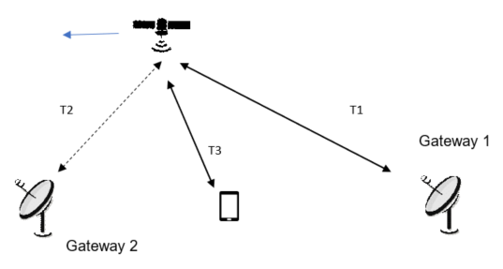

Soft Feeder link switch:

In soft feeder link switch, the satellite can simultaneously support two feeder links is illustrated in Figure below.

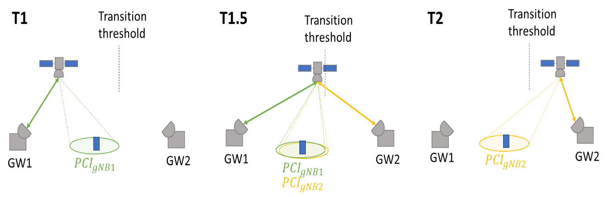

Ericsson observe that there were no major RAN1 issues for the solution identified in TR 38.821 for the soft feeder link switch scenario. Satellites typically have the capability to connect to multiple gateways by using multiple antennas. For feeder link switch, the validness of the scenario where the same gNB is connected to multiple satellite gateways is questionable. In contrast, the feeder link switch involving different gNB’s before and after the switch is more typical.

Interdigital observe that soft feeder link switch has less impact to current specification propose Rel-17 than a hard feeder link switch. Soft feeder link switch can support unique PCIs for cells from the source and target gNBs to be simultaneously relayed through the same satellite. The UE can distinguish the cells by different synchronization raster points for CD-SSBs. Interdigital propose to support soft feeder link switch for transparent LEO NTN

Hard Feeder link switch:

In Hard feeder link switch, the satellite only support one feeder link at a time.

Nokia observes that a feeder link switch for a transparent satellite may result in a cell switch. A gNB may switch links of the Uu interface from one satellite and feeder link to another satellite and feeder link, originating from the same NTN-GW. An NTN UE may be informed about imminent switch events including the resulting transmission gap. The knowledge of the gap is useful for the UE, because it can potentially continue obtaining service after the switch without declaring RLF, flushing of HARQ and reset of MAC. Nokia propose that RAN1 clarify impact of feeder link switch and benefit of signalling assistance information for imminent switch events and define an assumption on the maximum feeder link delay .

CATT proposed that the feeder link hard switch procedure should be based on group switching with accurate time control. In order to support hard feeder link switching, the following enhancements can be considered:

* Before handover, network should inform all UEs to stop UL transmission at one time point, and restart RRC connection in a new cell after a timer expired.
* The network should broadcast the propagation delay difference and UL TA offset of new targeted cell.
* PRACH parameters configuration need to be extended to support massive user handover, including ssb-perRACH-Occasion, Msg1-FDM, PRACH Mask index.

Interdigital observe that a hard feeder link switch can result in all connected mode UEs served by the satellite attempting mobility simultaneously, leading to RACH collisions, RLF and service interruption due to cumulative delay in RRC re-establishment signalling. Synchronizing UEs to perform HO without collision introduces complexity and additional signalling in the HO command. Providing assistance data to aid RRC re-establishment may assume a land-based connection between source and target gNBs, which cannot be guaranteed.

Other RAN1 aspects of feeder link switch:

Nokia propose that RAN1 define the feeder and service link type of amplification for gNB interpretation of measurement reports and configuration of UE uplink transmit power control with three options considered:

* Constant gain: The combined receive and transmit gain is a constant, independent of the received signal.
* Constant Emitted Isotropic Radiated Power (EIRP): The satellite will adjust the combined receive and transmit gain based on the received signal and a target EIRP to make the feeder link gain equal to one.
* Constant power at receiver: The satellite will attempt to compensate for the radio channel.

Nokia observes that transparent satellite can be analogue RF repeater or sample and forward a digital version of the analogue transmissions. The gNB may in principle compensate for the timing advance and Doppler on the NTN-GW – satellite link, which implies the UE only needs to handle the service link. Nokia propose that RAN1 clarifies that the satellite does not terminate the Uu interface. The gNB location relative to the NTN-GW may impact the NTN user experience and propose RAN1 defines an assumption of the maximum tolerable gNB – NTN-GW delay.

Xiaomi propose the change of the timing due to the switch of feeder link switch can be managed at the gNB side.

Inter-Satellite Link:

Nokia propose that RAN1 to define the maximum additional NR-Uu delay due to use of ISL and potential path gain impacts.

Moderator recommendation on feeder link: The rel-17 NR NTN WI states clearly that in RAN2#113e meeting in January, RAN2 will “Agree on design alternatives for feeder link switch over options, send LS to RAN1, if necessary”. RAN1 can wait for RAN2 guidance before discussing specific RAN1 aspects requiring potential enhancements and specifications.

## DL Synchronisation, System Information Acquisition

Qualcomm propose synch raster design to reduce initial access time and different SIBs design based on the system information updating rate.

Samsung observed that for a spot beam size that exceeds 250 km, a BS may need to perform a multi-valued Doppler pre-compensation; e.g. it may need to group distinct sets of SSBs using distinct Doppler values for pre-compensation. Indication for multi-Doppler pre-compensation pattern on DL benefits idle UE cell reselection, connected UE handover and connected UE data channel reception. The gNB/satellite can apply different values of Doppler pre-compensation to different SSBs. Samsung proposes that the BWP configuration is extended to indicate the amount of frequency offset to adjust the PRB grid with respect to the default BWP, as the experienced Doppler shifts at different spot beams are different.

|  |  |  |
| --- | --- | --- |
| fc (GHz) | spot beam size (km) | maximum Doppler difference between UEs (kHz) |
| 2 | 50 | 4.185 |
| 2 | 200 | 15.87 |
| 2 | 250 | 19.25 |
| 2 | 300 | 22.33 |
| 2 | ~ 600 | ~ 45 |

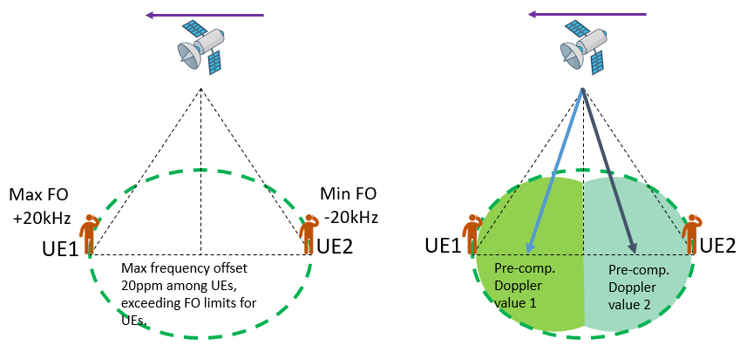

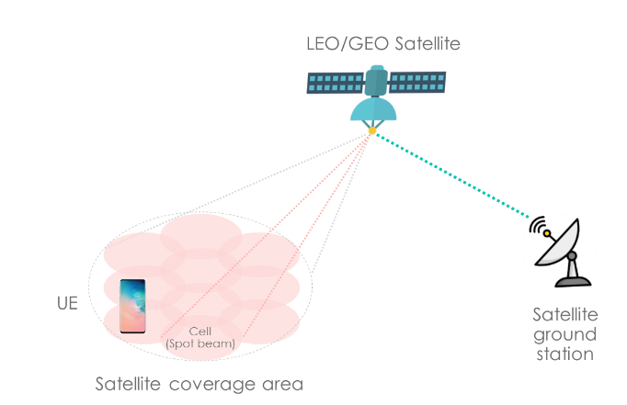 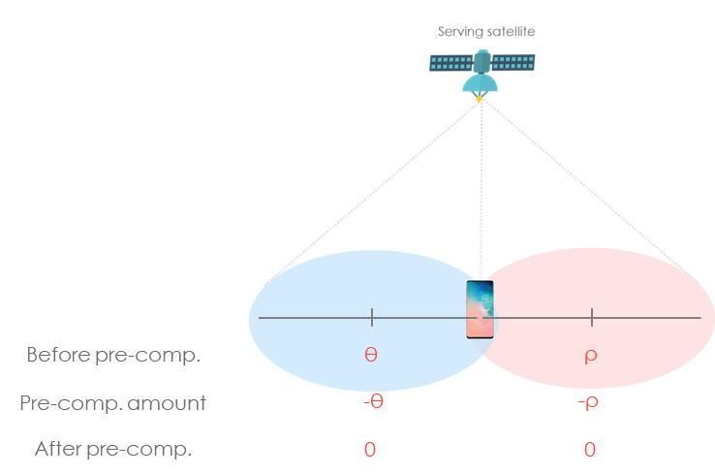

MediaTek observed that DL synchronization with much larger Doppler shift could be experienced with large beam spots of up to 1000 km beam diameter. This may require that the UE uses a larger tone raster for DL synchronization during initial cell access than the legacy NR raster spacing in Table 5.4.3.1-1 in TS 38.104, as shown below for a maximum residual frequency offset and corresponding maximum beam diameter at the Nadir. A +/-10ppm free running oscillator accuracy is used in the device.

* Fc<3GHz: raster 100KHz, residual frequency offset ±15 kHz, max beam diameter 340 km
* 3GHz<Fc<24.25GHz (effectively 6GHz): raster 1.44MHz, residual frequency offset ±58 kHz, max beam diameter > 1000 km
* Fc>24.25GHz: raster 17.28MHz, , residual frequency offset ±70 kHz, max beam diameter > 1000 km

Moderator recommendation on DL synchronization: RAN1 have not made agreement on whether gNB does common Doppler pre-compensation and its indication via signaling. This knowledge is needed by UE for pre-compensation of Doppler shift for UL transmission. Whether a larger sync raster is needed can be left to RAN4. New raster and SSB design was not recommended in the rel-16 NR NTN SI.

## PAPR

Qualcomm observed that a tone reservation method denoted by peak reduction tones (PRTs) can reduce Raw Cubic Metric of the CP-OFDM waveform in the NTN downlink by about 0.4 dB - 0.6 dB in Raw Cubic Metric reduction compared to hard-clipping power amplifier model for QPSK and 256QAM. Higher reduction for PAPR in 2 dB – 3.8 dB also observed. Tone reservation can increase the net transmit power of the CP-OFDM waveform in the NTN downlink by up to 1.5 dB.

 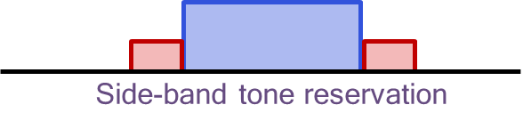

CAICT tested the DFT-s-OFDM signal both in lab and on orbit. They observed that the performance of DFT-S-OFDM signals in the satellite channel scenario meets the design and simulation expectations

## Power Control

Samsung proposed that open loop power control, UE should be allowed to predict its own transmission power not only based on DL measurement, e.g., pathloss measurement but also other available information, such as gNB ephemeris and UE trajectory. Samsung proposed closed loop power control should be supported in NTN and a mechanism to disable closed loop power control should be considered.

Qualcomm proposed to support autonomous reduction of MCS for PUSCH at least for cases when UE is power limited and to study the exact triggering condition and indication of the reduced MCS

## Air To Ground

CMCC proposed “implicit compatibility to support HAPS and ATG scenarios” in the WID means the enhancements for NTN can also be applicable for HAPS and ATG, although we do not need to discuss the enhancements specifically for HAPS and ATG. In principle,

* If there are several potential solutions for NTN, and some of them are more essential / important / applicable for ATG / HAPS, then these solutions should be prioritized.

## SLS Parameters

Nomor analyses the list of simulation study cases, used during the Study Item phase and tries to reduce the large set for system level simulations (SLS) during the Work Item phase [3]. Scenarios and need for throughput simulations with frequency re-use factors during the Work Item phase were discussed.

## Companies views on Additional Aspects

Companies are invited to comment on Additional aspects.

|  |  |
| --- | --- |
| **Company** | **Comments and Views additional aspects of Section 6** |
|  |  |
|  |  |
|  |  |
|  |  |
|  |  |
|  |  |
|  |  |
|  |  |
|  |  |
|  |  |
|  |  |
|  |  |
|  |  |

## Company Views (2nd round of email discussions)

To be added based on companies views.

## Updated proposal based on company views (2nd round of email discussion)

To be added based on companies views in second round of email discussions

## GTW Agreement / Conclusion

To be added based on updated proposals following second round of email discussions

# References

1. R1-2005268, Huawei, HiSilicon, Discussion on other design aspects for NTN, RAN1#102e, August 2020
2. R1-2005311, THALES, Considerations on PAPR requirements for NR NTN downlink transmission, RAN1#102e, August 2020
3. R1-2005313, Nomor Research GmbH, Thales, Study Cases for System-Level Simulations in NTN WI, RAN1#102e, August 2020
4. R1-2005498, MediaTek, Other Aspects of NR-NTN, RAN1#102e, August 2020
5. R1-2005547, Fraunhofer IIS, Fraunhofer HHI, NR-NTN: Physical Random Access Channel, RAN1#102e, August 2020
6. R1-2005576, Sony, Discussion on beam management and BWP operation for NTN, RAN1#102e, August 2020
7. R1-2005709, CATT, Discussion for beam management and feeder link switch enhancement, RAN1#102e, August 2020
8. R1-2005836, Lenovo, Motorola Mobility, Discussion on NTN beam management, RAN1#102e, August 2020
9. R1-2005876, Intel Corporation, On pre-compensation capabilities and beam management for NTN, RAN1#102e, August 2020
10. R1-2005966, ZTE, Discussion on additional enhancement for NTN, RAN1#102e, August 2020
11. R1-2006032, OPPO, Discussion on other aspects, RAN1#102e, August 2020
12. R1-2006147, Samsung, Remaining issues for NTN, RAN1#102e, August 2020
13. R1-2006213, CMCC, Discussion on implicit compatibility to support ATG scenarios in NTN, RAN1#102e, August 2020
14. R1-2006328, Panasonic, Beam management, PRACH enhancement and polarization for NTN, RAN1#102e, August 2020
15. R1-2006381, LG Electronics, Considerations on PRACH, CSI and polarization signaling in NTN, , RAN1#102e, August 2020
16. R1-2006424, Nokia, Shanghai Bell, Clarification of NTN assumptions, RAN1#102e, August 2020
17. R1-2006466, Ericsson, On other enhancements for NTN, RAN1#102e, August 2020
18. R1-2006605, Beijing Xiaomi Mobile Software, Discussion on the beam management for NTN, RAN1#102e, August 2020
19. R1-2006620, Interdigital Inc, On feeder link switch, , RAN1#102e, August 2020
20. R1-2006643, Asia Pacific Telecom, Discussion on reference timing delivery for NTN, , RAN1#102e, August 2020
21. R1-2006678, THALES, Other RAN1 aspects for NR NTN, RAN1#102e, August 2020
22. R1-2009061, THALES, ESA, Firstnet, Fraunhofer IIS, Fraunhofer HHI, Qualcomm, Reliance Jio, Intelsat, Hughes Network Systems Support of smart phones in NTN, RAN1#102e, August 2020
23. R1-2006807, Qualcomm, SSB arrangements, BWP operation and other issues for NTN, RAN1#102e, August 2020
24. R1-2006858, CAICT, Discussion on beam management of NTN, RAN1#102e, August 2020