3GPP TSG-RAN WG1 #103-e R1-20xxxxx
eMeeting, Oct 26th – Nov 13th, 2020
Source: Moderator (Ericsson)
Title: Summary of Email discussion [103-e-NR-1024QAM-01]
Agenda item: 8.16
Document for: Discussion and Decision

1 Introduction
This document summarizes the discussions for email thread [103-e-NR-1024QAM-01] under agenda item 8.16 for Introduction of DL 1024QAM for NR FR1.

2. Discussion
Below is a short moderator summary based on the tdocs [2-11] submitted for RAN1#103-e.
- 1024-QAM Constellation
  - Most companies propose reuse LTE 1024-QAM constellation [2] [3] [4] [5] [6] [9][10][11]
- CQI table with 1024-QAM
  - Reuse LTE CQI table with 1024-QAM entries [3][4][5][6][7][10] ([9] unless conflicts with MCS table)
  - At least 4 CQI entries for 1024-QAM [2]
  - Remove N entries from 256-QAM table, and add N new entries for 1024-QAM [11]
- MCS table with 1024-QAM entries
  - 5-bit vs 6-bit
    - Most companies seem to be OK with having a 5-bit MCS table [2][3][4][5] [6][7][9][10][11]
    - Some companies also suggest using a six-bit MCS table also [7][11]
      - Six-bit MCS table since five-bit MCS table may lead to reduced number of entries affecting transition point, non-uniform SE between MCS entries, better account for overhead
      - Adopt both 5-bits and 6-bits MCS tables [7]
        - Six-bit MCS table to indicate MCS and an overhead parameter to account for variable overhead.
    - Note the WI objective specifies the DCI overhead for MCS indication should be the same as in Rel-15.
  - MCS design principles
    - Most companies suggest starting with 256-QAM MCS table and remove M entries to accommodate M entries for 1024-QAM MCSes [2][3][4][5][6][7][10][11]
      - Several companies seem to be OK with M=5 [3][4][5][6][7][10], while one company mentioned M = 7 ([2]).
    - Implicit MCS entries
      - Most companies seem to prefer having five total implicit MCS entries with one modulation order per MCS entry ([2][3][4][5][6][7][9][10]) while one company proposed to consider multiple modulation order per MCS entry with less than five total implicit MCS entries([11]).
    - Explicit MCS entries (with modulation order/Target Code rate/Spectral efficiency)
      - Four entries for 1024-QAM [3][4][5][6][7][10]
      - Six entries for 1024-QAM [2]
      - Evaluate more [9][11] (including evaluation assumptions)
      - Regarding M=5 entries to be removed, different alternatives were mentioned:
        - remove {5,7,9,12,14} from the 256-QAM table [4][5][7]
        - remove {6, 8, 10, 12, 14} from the 256QAM table [3]
        - remove {2,4,6,8,10} from the 256-QAM table [10]
        - remove {1,3,5,7,9} from the 256-QAM table [11]
- RRC configuration and DCI formats
  - Configuration of 1024QAM CQI/MCS[3][9][10]
  - DCI formats and RNTIs for which 1024QAM is used/not used [3][5][9][10]
- Remaining aspects of 1024-QAM including spec impacts, etc
  - Specification impacts [6][9][10] – 38.201, 38.211, 38.212 38.214, including
    - PTRS reception procedure
    - LBRM procedure
  - Processing time relaxation [6]
  - UE capability reporting[3]
  - System-level simulation to identify the cell size(s) [2]

1st round

Proposal 1
- For supporting 1024-QAM in NR downlink, adopt the LTE 1024-QAM constellation.
Companies are requested to indicate their view about the above proposal in the Table below.
Company Name | support/not support | Comments (Proposal 1)
Intel | Support
Samsung | Support
vivo | Support
CATT | Support
ZTE,Sanechips | Support
Huawei, HiSilicon | Support

Proposal 2
- For supporting 1024-QAM in NR downlink, adopt the LTE 1024-QAM CQI table.
Companies are requested to indicate their view about the above proposal in the Table below.
Company Name | support/not support | Comments (Proposal 2)
Intel | Support
Samsung | Support
vivo | Support | Suggest to replace the entry {853, 8.3321} by {853, 8.3301} to ensure that the value of SE can be calculated according to the value of code rate. (853/1024*10≈8.3301)
CATT | Support | Fine with vivo’s proposal.
ZTE,Sanechips | Support
Huawei, HiSilicon | Not support | There are only two entries for 1024QAM in the CQI table specified in LTE, while most of entries are of low SE which may be seldom used by FWA/small cell users with good coverage. It is recommended to specify more entries for 1024QAM than that in LTE so as to improve the accuracy of CQI feedback for UEs with good coverage.

Proposal 3
- For supporting 1024-QAM in NR downlink, adopt a five-bit MCS table with 1024-QAM entries.
  - Remove M (=5) entries from the NR 256QAM MCS table and add M new entries for 1024QAM
  - Introduce one implicit MCS entry corresponding to 1024QAM
  - Introduce 4 explicit MCS entries corresponding to 1024-QAM modulation
    - Highest MCS corresponding to code rate 948/1024, 1024-QAM
Companies are requested to indicate their view about the above proposal in the Table below.
Company Name | support/not support | Comments (Proposal 3)
Intel | Support
Samsung | Support
vivo | Support
CATT | Support
ZTE,Sanechips | Support
Huawei, HiSilicon | Partly support. | Support adopting a five-bit MCS table with 1024-QAM entries as well as introducing one implicit MCS entry corresponding to 1024QAM.  As LTE and NR have different coding schemes and available REs, the breaking point between 256QAM and 1024QAM needs re-evaluation for NR. While more than 4 explicit MCS entries corresponding to 1024QAM are recommended, which can increase the scheduling efficiency and data rates for UEs with good channel quality.  From the evaluation results below, the SINR step for 256QAM is about 1dB (18.5dB to 25.3dB for 8 points), then for 1024QAM, if the same SINR step is retained, the entries for 1024QAM should be 6 entries (25.5dB to 32dB).  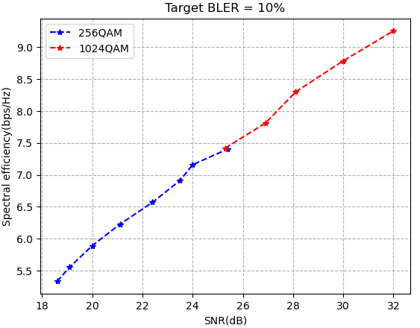

Discussion point 1
- Indicate your preference on which M=5 MCS entries from 256-QAM can be removed, in order of preference from 1st to last.
    - Alt 1: remove {5,7,9,12,14} from the 256-QAM table
    - Alt 2: remove {6, 8, 10, 12, 14} from the 256QAM table
    - Alt 3: remove {2,4,6,8,10} from the 256-QAM table
    - Alt 4: remove {1,3,5,7,9} from the 256-QAM table
Companies are requested to indicate their view about the above discussion point in the Table below.
Company Name | Preferred Alternative (most preferred first) | Comments (Discussion point 1)
Intel | Alt 1 | Low MCS should be kept as they were already sub-sampled for 256QAM, i.e. Alt 3 and Alt 4 are not good options
Samsung | Alt. 1 | Do not support alts. 3 and 4 as these are not quite aligned with LTE 1024 QAM table.
vivo | Alt 2 | Follow NR MCS table design principle, CQI entries should be kept, so {5,7,9} should be kept as they were already included in the 1024-QAM CQI table. In addition, SE vs SNR curves at BLER=10% in fig.1 indicate that more equally spaced SNR can be obtained by adopting Alt 2, instead of Alt 1.  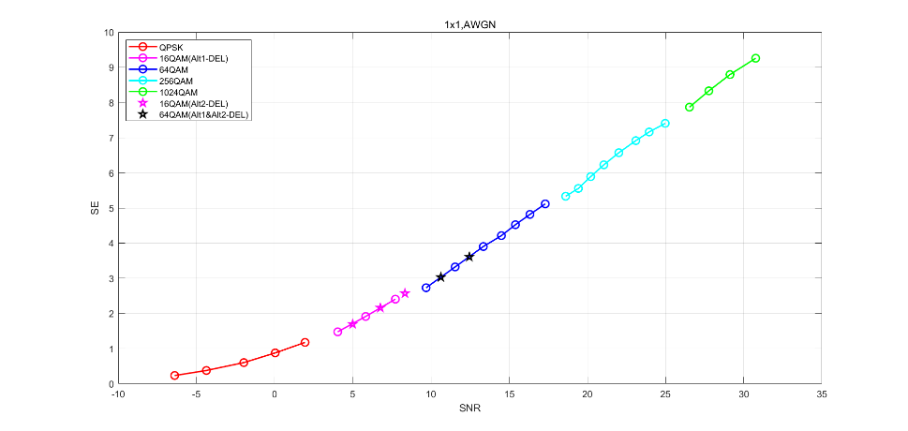  Fig.1 SE vs SNR curves at BLER=10% by using NR LDPC coding
CATT | Alt. 1
ZTE,Sanechips | Alt 1 | Firstly, we agree with the comments from Intel.  Secondly, Alt 1 is based on the following agreements in LTE.  Agreements in RAN1#90bis:  - For introduction of 1024QAM MCS table:  - Remove M entries from the 256QAM table while maintaining (close to) uniformly spaced SE, while keeping the lowest MCS  - Add M new entries for 1024QAM, with (close to) uniformly spaced SE  - Including 1 entry to support re-transmission with 1024 QAM  Agreements in RAN1#92:  The removed entries from 256QAM table are {5, 7, 9, 12, 14}.  Hence, we think Alt 1 is aligned with the following objective.  - Specify corresponding MCS table with 1024QAM entries as defined in E-UTRA
Huawei, HiSilicon | Neither | As comment to proposal 3, we support to remove at least 6 entries.

Discussion point 2
- Indicate your preference on which 4 explicit MCS entries for 1024-QAM can be added.
  - Alt 1:
Modulation Order Qm | Target code Rate R x [1024] | Spectral efficiency
10 | 806 | 7.8711
10 | 853 | 8.3321
10 | 900.5 | 8.7939
10 | 948 | 9.2578
  - Alt 2:
Modulation Order Qm | Target code Rate R x [1024] | Spectral efficiency
10 | 841 | 8.2129
10 | 885 | 8.6426
10 | 916.5 | 8.9502
10 | 948 | 9.2578
  - Alt 3:
Modulation Order Qm | Target code Rate R x [1024] | Spectral efficiency
10 | 805.5 | 7.8662
10 | 853 | 8.3301
10 | 900.5 | 8.7939
10 | 948 | 9.2578

Companies are requested to indicate their view about the above discussion point in the Table below.
Company Name | Preferred Alternative | Comments (Discussion point 2)
Intel | Alt 1 | Alt 2 doesn’t have the entry {853, 8.3321} from CQI table
Samsung | Alt 1 | According to proposal 2, if LTE CQI table is just reused, alt 1 is straightforward way.
vivo | Alt 3 | Prefer to replace the entry {853, 8.3321} by {853, 8.3301} to ensure that the value of SE can be calculated according to the value of code rate. (853/1024*10≈8.3301)  Then for {805.5, 7.8662}, which SE is closer to the mean of the SEs of the previous and next entries compared to{806, 7.8711}, can be obtained by interpolating.
CATT | Alt 1 or Alt 3
ZTE,Sanechips | Alt 1 | We support Alt 1. Reasons are as follows:  - The spacing of SE in Alt1 is uniform, which satisfies with the following agreements in LTE, but it is obvious that the SE spacing in Alt2 is unequal .  Agreements in RAN1#90bis:  - For introduction of 1024QAM MCS table:  - Remove M entries from the 256QAM table while maintaining (close to) uniformly spaced SE, while keeping the lowest MCS  - Add M new entries for 1024QAM, with (close to) uniformly spaced SE  - Including 1 entry to support re-transmission with 1024 QAM  - Alt 1 includes the entry {853, 8.3321} from CQI table, but Alt 2 does not.  - Simulation results in R1-2007977 show an equal SNR spacing between the adjacent MCS entries of Alt 1.
Huawei, HiSilicon | Neither | As our comment to proposal 6, we propose to add 6 entries for 1024QAM with interpolation between SE 7.4063 bps/Hz to 9.2578 bps/Hz.  Modulation Order Qm Spectral efficiency  10 7.4063  10 7.7766  10 8.1469  10 8.5172  10 8.8875  10 9.2578

Proposal 5
- Introduce new RRC signaling to indicate use of 1024-QAM CQI table.
Company Name | support/not support | Comments (Proposal 5)
Intel | Support
Samsung | Support
vivo | Support
CATT | Support
ZTE,Sanechips | Support
Huawei, HiSilicon | Support

Proposal 6
- Introduce new RRC signaling to indicate use of 1024-QAM MCS table for DCI format 1_1.
Companies are requested to indicate their view about the above proposal in the Table below.
Company Name | support/not support | Comments (Proposal 6)
Intel |  | The proposal should be modified to include “at least for DCI format 1_1” given the discussion point #3
Samsung | Support
vivo | Support
CATT | Support | Agree with Intel’s addition.
ZTE,Sanechips | Support
Huawei, HiSilicon | Support | Maybe the RRC signaling in proposal 6 can be the same as that in proposal 5.

Discussion point 3
- Can 1024-QAM MCS table can be used with DCI format 1_2 ?
  - If yes, indicate your preferred alternative for enabling it.
    - Alt 1: Separate RRC signaling is used for DCI format 1_2
    - Alt 2 : Same RRC signaling applies to both DCI format 1_1 and DCI format 1_2
Companies are requested to indicate their view about the above discussion point in the Table below.
Company Name | Yes/No | Preferred Alternative (if yes) | Comments (Discussion point 3)
Intel | Yes | Alt 2 | Open to consider DCI specific modulation, but the gains should be justified.
Samsung | Yes | Alt. 1 | Can provide better flexibility. It is noted that almost RRC parameters for DCI format 1_2 have been designed separately with DCI format 1_1. No strong point to have same RRC signaling.
vivo | No |  | DCI format 1_2 is used for URLLC scheduling, the motivation is unclear to use 1024QAM to achieve high reliability and low latency.
CATT | Yes | Alt. 1 | Agree with Samsung.
ZTE,Sanechips | No |  | DL 1024QAM is mainly deployed in FWA, IAB backhaul link and CPE link,etc. DCI format 1_2 is designed for URLLC. Hence, 1024-QAM MCS table cannot be used with DCI format 1_2.
Huawei, HiSilicon | Yes | Alt 1 | Alt 1 can provide better flexibility than alt 2.

Proposal 7
- 1024-QAM MCS table can be used only with DCI format with CRC scrambled by C-RNTI or CS-RNTI.
Companies are requested to indicate their view about the above proposal in the Table below.
Company Name | support/not support | Comments (Proposal 7)
Intel | Support
Samsung | Support
vivo | Support
CATT | Support
ZTE,Sanechips | Support
Huawei, HiSilicon | Support

2nd round proposals (TBD)
Including spec impacts, etc

3 Conclusions
TBD

4 References
- RP-202044, New WID on Introduction of DL 1024QAM for NR FR1, RAN Meeting #89e, Sep 2020
- R1-2007617 On support of DL 1024QAM for NR FR1 Huawei, HiSilicon
- R1-2007700 On supporting DL 1024QAM for NR FR1 vivo
- R1-2007846 DL 1024QAM for NR FR1 CATT
- R1-2007977 Discussion on DL 1024QAM for NR FR1 ZTE
- R1-2008201 Discussion on DL 1024QAM for NR FR1 Samsung
- R1-2009009 Support of 1024QAM Intel Corporation
- R1-2009171 Work plan on supporting 1024 QAM Rapporteurs (Nokia, Ericsson)
- R1-2009172 Considerations for NR DL 1024 QAM in FR1 Nokia, Nokia Shanghai Bell
- R1-2009209 1024QAM for NR DL Ericsson
- R1-2009282 Introduction of 1024-QAM modulation for NR PDSCH Qualcomm Incorporated

