3GPP TSG-RAN WG1 #103-e R1-20xxxxx
eMeeting, Oct 26th – Nov 13th, 2020
Source: Moderator (Ericsson)
Title: Summary of Email discussion [103-e-NR-1024QAM-01]
Agenda item: 8.16
Document for: Discussion and Decision

1 Introduction
This document summarizes the discussions for email thread [103-e-NR-1024QAM-01] under agenda item 8.16 for Introduction of DL 1024QAM for NR FR1.

2. Discussion
Below is a short moderator summary based on the tdocs [2-11] submitted for RAN1#103-e.
- 1024-QAM Constellation
  - Most companies propose reuse LTE 1024-QAM constellation [2] [3] [4] [5] [6] [9][10][11]
- CQI table with 1024-QAM
  - Reuse LTE CQI table with 1024-QAM entries [3][4][5][6][7][10] ([9] unless conflicts with MCS table)
  - At least 4 CQI entries for 1024-QAM [2]
  - Remove N entries from 256-QAM table, and add N new entries for 1024-QAM [11]
- MCS table with 1024-QAM entries
  - 5-bit vs 6-bit
    - Most companies seem to be OK with having a 5-bit MCS table [2][3][4][5] [6][7][9][10][11]
    - Some companies also suggest using a six-bit MCS table also [7][11]
      - Six-bit MCS table since five-bit MCS table may lead to reduced number of entries affecting transition point, non-uniform SE between MCS entries, better account for overhead
      - Adopt both 5-bits and 6-bits MCS tables [7]
        - Six-bit MCS table to indicate MCS and an overhead parameter to account for variable overhead.
    - Note the WI objective specifies the DCI overhead for MCS indication should be the same as in Rel-15.
  - MCS design principles
    - Most companies suggest starting with 256-QAM MCS table and remove M entries to accommodate M entries for 1024-QAM MCSes [2][3][4][5][6][7][10][11]
      - Several companies seem to be OK with M=5 [3][4][5][6][7][10], while one company mentioned M = 7 ([2]).
    - Implicit MCS entries
      - Most companies seem to prefer having five total implicit MCS entries with one modulation order per MCS entry ([2][3][4][5][6][7][9][10]) while one company proposed to consider multiple modulation order per MCS entry with less than five total implicit MCS entries([11]).
    - Explicit MCS entries (with modulation order/Target Code rate/Spectral efficiency)
      - Four entries for 1024-QAM [3][4][5][6][7][10]
      - Six entries for 1024-QAM [2]
      - Evaluate more [9][11] (including evaluation assumptions)
      - Regarding M=5 entries to be removed, different alternatives were mentioned:
        - remove {5,7,9,12,14} from the 256-QAM table [4][5][7]
        - remove {6, 8, 10, 12, 14} from the 256QAM table [3]
        - remove {2,4,6,8,10} from the 256-QAM table [10]
        - remove {1,3,5,7,9} from the 256-QAM table [11]
- RRC configuration and DCI formats
  - Configuration of 1024QAM CQI/MCS[3][9][10]
  - DCI formats and RNTIs for which 1024QAM is used/not used [3][5][9][10]
- Remaining aspects of 1024-QAM including spec impacts, etc
  - Specification impacts [6][9][10] – 38.201, 38.211, 38.212 38.214, including
    - PTRS reception procedure
    - LBRM procedure
  - Processing time relaxation [6]
  - UE capability reporting[3]
  - System-level simulation to identify the cell size(s) [2]

1st round

Proposal 1
- For supporting 1024-QAM in NR downlink, adopt the LTE 1024-QAM constellation.
Companies are requested to indicate their view about the above proposal in the Table below.
Company Name | support/not support | Comments (Proposal 1)
Intel | Support
Samsung | Support
vivo | Support

Proposal 2
- For supporting 1024-QAM in NR downlink, adopt the LTE 1024-QAM CQI table.
Companies are requested to indicate their view about the above proposal in the Table below.
Company Name | support/not support | Comments (Proposal 2)
Intel | Support
Samsung | Support
vivo | Support | Suggest to replace the entry {853, 8.3321} by {853, 8.3301} to ensure that the value of SE can be calculated according to the value of code rate. (853/1024*10≈8.3301)

Proposal 3
- For supporting 1024-QAM in NR downlink, adopt a five-bit MCS table with 1024-QAM entries.
  - Remove M (=5) entries from the NR 256QAM MCS table and add M new entries for 1024QAM
  - Introduce one implicit MCS entry corresponding to 1024QAM
  - Introduce 4 explicit MCS entries corresponding to 1024-QAM modulation
    - Highest MCS corresponding to code rate 948/1024, 1024-QAM
Companies are requested to indicate their view about the above proposal in the Table below.
Company Name | support/not support | Comments (Proposal 3)
Intel | Support
Samsung | Support
vivo | Support

Discussion point 1
- Indicate your preference on which M=5 MCS entries from 256-QAM can be removed, in order of preference from 1st to last.
    - Alt 1: remove {5,7,9,12,14} from the 256-QAM table
    - Alt 2: remove {6, 8, 10, 12, 14} from the 256QAM table
    - Alt 3: remove {2,4,6,8,10} from the 256-QAM table
    - Alt 4: remove {1,3,5,7,9} from the 256-QAM table
Companies are requested to indicate their view about the above discussion point in the Table below.
Company Name | Preferred Alternative (most preferred first) | Comments (Discussion point 1)
Intel | Alt 1 | Low MCS should be kept as they were already sub-sampled for 256QAM, i.e. Alt 3 and Alt 4 are not good options
Samsung | Alt. 1 | Do not support alts. 3 and 4 as these are not quite aligned with LTE 1024 QAM table.
vivo | Alt 2 | Follow NR MCS table design principle, CQI entries should be kept, so {5,7,9} should be kept as they were already included in the 1024-QAM CQI table. In addition, SE vs SNR curves at BLER=10% in fig.1 indicate that more equally spaced SNR can be obtained by adopting Alt 2, instead of Alt 1.  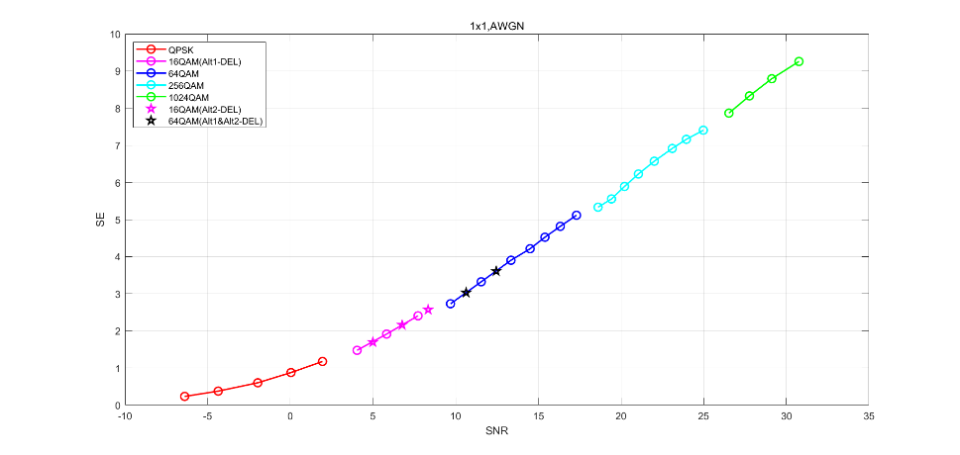  Fig.1 SE vs SNR curves at BLER=10% by using NR LDPC coding

Discussion point 2
- Indicate your preference on which 4 explicit MCS entries for 1024-QAM can be added.
  - Alt 1:
Modulation Order Qm | Target code Rate R x [1024] | Spectral efficiency
10 | 806 | 7.8711
10 | 853 | 8.3321
10 | 900.5 | 8.7939
10 | 948 | 9.2578
  - Alt 2:
Modulation Order Qm | Target code Rate R x [1024] | Spectral efficiency
10 | 841 | 8.2129
10 | 885 | 8.6426
10 | 916.5 | 8.9502
10 | 948 | 9.2578
  - Alt 3:
Modulation Order Qm | Target code Rate R x [1024] | Spectral efficiency
10 | 805.5 | 7.8662
10 | 853 | 8.3301
10 | 900.5 | 8.7939
10 | 948 | 9.2578

Companies are requested to indicate their view about the above discussion point in the Table below.
Company Name | Preferred Alternative | Comments (Discussion point 2)
Intel | Alt 1 | Alt 2 doesn’t have the entry {853, 8.3321} from CQI table
Samsung | Alt 1 | According to proposal 2, if LTE CQI table is just reused, alt 1 is straightforward way.
vivo | Alt 3 | Prefer to replace the entry {853, 8.3321} by {853, 8.3301} to ensure that the value of SE can be calculated according to the value of code rate. (853/1024*10≈8.3301)  Then for {805.5, 7.8662}, which SE is closer to the mean of the SEs of the previous and next entries compared to{806, 7.8711}, can be obtained by interpolating.

Proposal 5
- Introduce new RRC signaling to indicate use of 1024-QAM CQI table.
Company Name | support/not support | Comments (Proposal 5)
Intel | Support
Samsung | Support
vivo | Support

Proposal 6
- Introduce new RRC signaling to indicate use of 1024-QAM MCS table for DCI format 1_1.
Companies are requested to indicate their view about the above proposal in the Table below.
Company Name | support/not support | Comments (Proposal 6)
Intel |  | The proposal should be modified to include “at least for DCI format 1_1” given the discussion point #3
Samsung | Support
vivo | Support

Discussion point 3
- Can 1024-QAM MCS table can be used with DCI format 1_2 ?
  - If yes, indicate your preferred alternative for enabling it.
    - Alt 1: Separate RRC signaling is used for DCI format 1_2
    - Alt 2 : Same RRC signaling applies to both DCI format 1_1 and DCI format 1_2
Companies are requested to indicate their view about the above discussion point in the Table below.
Company Name | Yes/No | Preferred Alternative (if yes) | Comments (Discussion point 3)
Intel | Yes | Alt 2 | Open to consider DCI specific modulation, but the gains should be justified.
Samsung | Yes | Alt. 1 | Can provide better flexibility. It is noted that almost RRC parameters for DCI format 1_2 have been designed separately with DCI format 1_1. No strong point to have same RRC signaling.
vivo | No |  | DCI format 1_2 is used for URLLC scheduling, the motivation is unclear to use 1024QAM to achieve high reliability and low latency.

Proposal 7
- 1024-QAM MCS table can be used only with DCI format with CRC scrambled by C-RNTI or CS-RNTI.
Companies are requested to indicate their view about the above proposal in the Table below.
Company Name | support/not support | Comments (Proposal 7)
Intel | Support
Samsung | Support
vivo | Support

2nd round proposals (TBD)
Including spec impacts, etc

3 Conclusions
TBD

4 References
- RP-202044, New WID on Introduction of DL 1024QAM for NR FR1, RAN Meeting #89e, Sep 2020
- R1-2007617 On support of DL 1024QAM for NR FR1 Huawei, HiSilicon
- R1-2007700 On supporting DL 1024QAM for NR FR1 vivo
- R1-2007846 DL 1024QAM for NR FR1 CATT
- R1-2007977 Discussion on DL 1024QAM for NR FR1 ZTE
- R1-2008201 Discussion on DL 1024QAM for NR FR1 Samsung
- R1-2009009 Support of 1024QAM Intel Corporation
- R1-2009171 Work plan on supporting 1024 QAM Rapporteurs (Nokia, Ericsson)
- R1-2009172 Considerations for NR DL 1024 QAM in FR1 Nokia, Nokia Shanghai Bell
- R1-2009209 1024QAM for NR DL Ericsson
- R1-2009282 Introduction of 1024-QAM modulation for NR PDSCH Qualcomm Incorporated

