3GPP TSG-RAN Meeting #95e RP-220xxx  
Electronic meeting, March 17 – 23, 2022

Title: draft LS to ISED-Canada to clarify the RSS-195 requirement related to wireless communication service equipment operating in 2305-2320 MHz / 2345-2360MHz frequency range

Response to:

Source: Telus (TSG-RAN)

To: ISED-Canada

Cc: 3GPP RAN4

**Contact Person:**

Name: Ivo Maljevic

E-mail Address: ivo(dot)maljevic(at)telus(dot)com

**Send any reply LS to: 3GPP Liaisons Coordinator,** [**mailto:3GPPLiaison@etsi.org**](mailto:3GPPLiaison@etsi.org)

Attachments: None

**1. Overall Description:**

TSG RAN would like to request clarification from ISED-Canada regarding the RSS-195 regulatory requirements related to Wireless Communication Service (WCS) equipment operating in the Bands 2305-2320 MHz and 2345-2360 MHz.

Band n30 (2305 - 2315 MHz UL / 2350 - 2360 MHz DL) was introduced by 3GPP to the LTE specification in Rel-12, NR specification in Rel-16, with A-MPR and NS_21 specified according to the US regulatory FCC 27.53 requirements. After analyzing both ISED and NS_21 sets of emission requirements, 3GPP has arrived at the following differences between these

- NS_21 emission requirements state that a narrower resolution bandwidth (RBW) is permissible if RBW is >= 1% of the channel BW (outside channel blocks). Consequently, the specification can be -13dBm / (1% channel BW) for 0-1MHz from channel edge.

- RSS-195 requirements state that RBW must be >= 1% of the channel BW (cannot be < 1%), and power must be integrated over 1MHz. Consequently, the specification is -13dBm/1MHz for 0-1MHz from the channel edge.

The fundamental difference is whether the emission requirement of -13 dBm is applied over 1% channel BW or over 1 MHz as illustrated in the figure below

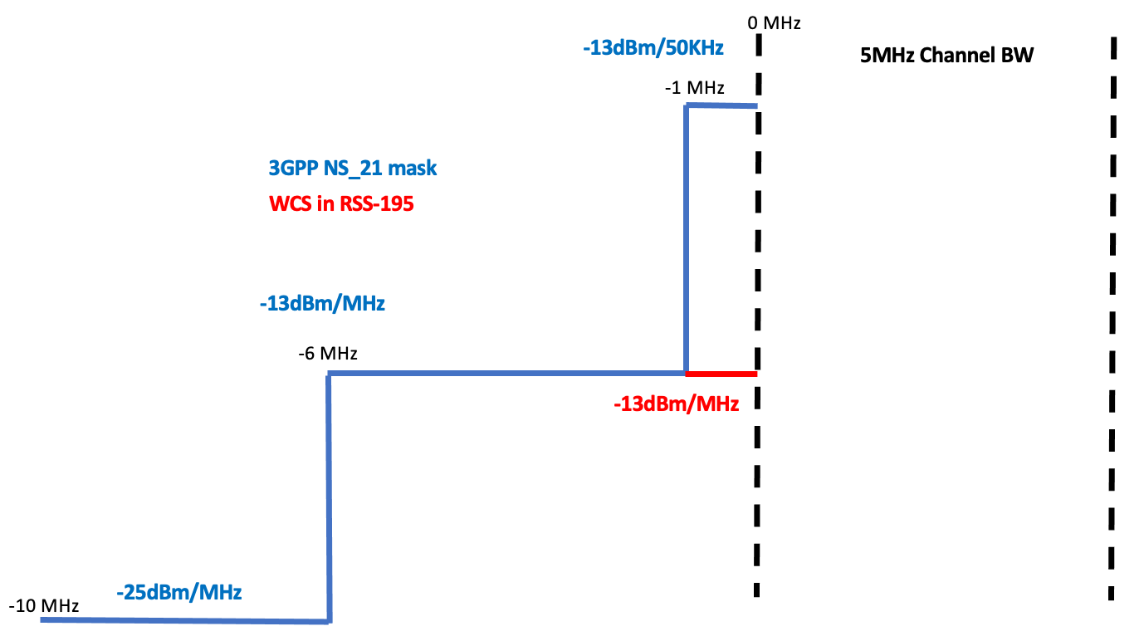

Based on the above analysis, 3GPP is considering whether a new NS flag which is aligned with RSS-195 is needed in the specification, since there is a risk that existing NS_21 emission requirements may not be comptible with Canadian rules.

TSG RAN would like to kindly invite ISED-Canada to provide clarification and any additional guidance of the RSS-195 requirements.

**2. Actions:**

TSG RAN asks ISED-Canada for clarification and feedback as described above..

**3. Date of Next TSG-RAN Meetings:**

TSG-RAN Meeting #96 6. – 9. June 2022 Budapest, TBC

TSG-RAN Meeting #97e 12. – 15. September 2022 Electronic Meeting, TBC