3GPP TSG RAN Meeting #93-e RP-21xxxx
Electronic Meeting, September 13 - 17, 2021

Agenda item: 9.3.4.1
Source: RAN4 Vice-Chair (Samsung)
Title: Moderator's summary for email discussion [93e-24-MIMO-OTA-WI]
Document for: Discussion & Decision

Introduction
This document provides as summary of the following email discussion during RAN#93-e:
[93e-24-MIMO-OTA-WI]
Goal: Seek for the conclusion on the proposals of NR MIMO OTA WID update
Input contributions covered: RP-212028, RP-212080, RP-212122

Background
The following summarizes proposals from different contributions
T-doc | Author | Observations and proposals
RP-212028 | vivo | Proposal 1: Update the NR MIMO OTA WID to add FR1 MU assessment working scope.  The proposed changes as following:  “  - Potential optimization of test methods for FR1 and FR2 is not precluded: e.g.  - Further work is suggested to illustrate the DUT rotations  - For FR2, further work to check if test points rotations are to be implemented per channel model to compensate for channel model rotations  - For FR2, re-positioning of the NR MIMO probes to align the probes with NR FR2 RRM probe configurations.  - For FR2, alternative probe configurations (different locations and different number of probes) regardless of probe implementation.  - Develop the preliminary MU assessment for FR1 MIMO OTA  - Example expanded uncertainty for test method should be defined  During the course of this work item, ongoing communication with 3GPP RAN WG5, CTIA OTA Working Group (MOSG, 5G mm-wave OTA Sub-Working group and MUSG), and CCSA TC9 WG1 shall be maintained to ensure industry coordination on this topic.”
RP-212122  RP-212080 (revised WID) | CAICT | Background:  In 3GPP RAN4#100-e meeting, the issue of MU assessment for FR1 MIMO OTA has been discussed and the agreements captured in the WF [R4-2115756] are as follows.  - RAN4 should discuss the preliminary MU assessment for FR1 MIMO OTA including example expanded uncertainty, final MU and TT will be decided by RAN5.  - WID is suggested to update in Sep RAN plenary meeting, to reflect this working scope extension, for easy tracing the progress in the status report of WI.  Based on the RAN4#100e meeting outcome, it is proposed to make modifications into the WID to reflect the working scope extension on FR1 MIMO OTA MU assessment with the changes as highlight following:  “  The Measurement Uncertainty (MU) aspects, RAN WG4 should discuss the preliminary MU assessment for FR1 MIMO OTA including example expanded uncertainty. During the course of this work item, ongoing communication with 3GPP RAN WG5, CTIA OTA Working Group (MOSG, 5G mm-wave OTA Sub-Working group and MUSG), and CCSA TC9 WG1 shall be maintained to ensure industry coordination on this topic.  “

Initial round

Open issues
Issue 1: Do we need to update the NR MIMO WID to reflect the working scope extension on FR1 MU assessment based on latest RAN4 agreements and suggestions
  - Option 1: Yes, the detailed update as proposed in RP-212028 (vivo)
  - Option 2: Yes, the detailed update as proposed in RP-212080 (CAICT)

Collection of company views
Note: Please share your views whether we need to update the NR MIMO WID with working scope extension or not and also please provide your preference or suggestions on the proposed changes.
Company | Comments
Apple | We see similarities between the proposals in the two options and encourage the proponents to merge the proposed WID revision. In general, we support the RAN4 recommendation to update the WID scope in regards to MIMO OTA preliminary MU assessment.
OPPO | Prefer Option 2, and maybe also keep the original statement of RAN5 responsibility “including potentially test tolerances, and test procedures will be handled in RAN WG5” would be better since it can provide the information of what the RAN4 and RAN5 responsibilities are in this WI.  Suggest as below to align with the agreed WF:  The preliminary Measurement Uncertainty (MU) aspects for FR1 MIMO OTA including example expanded uncertainty will be discussed in RAN4, final MU and TT including potentially test tolerances, and test procedures will be handled in RAN WG5.
Qualcomm | 1). In Rel-15 Testability SI, the preliminary MU was defined in RAN4. But when the final MU was specified in RAN5, the back and forth discussion happened and finally there is a gap between preliminary MU in RAN4 and final MU in RAN5. Given the lesson learnt from prior experience, we’d suggest RAN4 and RAN5 work together on the MU analysis which is the most efficient way. With that, we propose to add RAN5 as the secondary responsibility WG. Then RAN5 could provide the input via LS.  In addition, MU for FR2 MIMO OTA is missing in the revised WID. Both FR1 and FR2 are in the scope of this WI. So FR2 preliminary MU shall be analyzed as well.  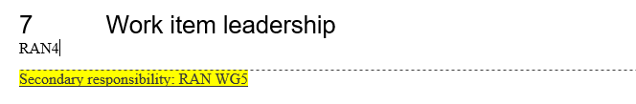  2). We need to discuss which spec to capture the MU work. Our option is to capture the MU analysis in TR38827. With that, we propose to add TR38827 in the impacted existing TS/TR table.  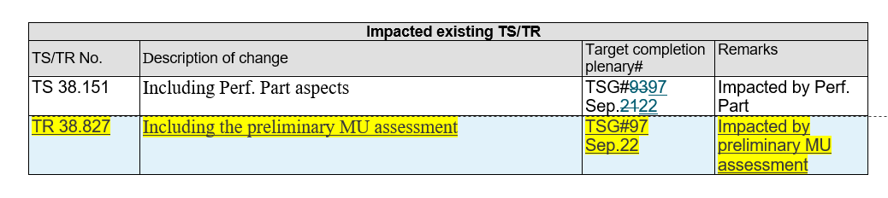  3). Clarifications on the wording for other aspects in WID. In the WID, it says” Define the pass/fail criteria for channel model validation, both FR1 and FR2”. Does it mean to define the pass/fail limt for FR1 and FR2 channel model validation? If so, clarifications in revised WID are needed.
Keysight | We support the addition of RAN4 providing preliminary MU assessment as per the WF in R4-2115756. Both the Vivo and CAICT proposals in RP-212028 and RP-212080 provide the necessary text but both also delete text that was not part of the WF. This deletion introduces ambiguity into the WID. The deleted text stating the ongoing responsibility of RAN5 to define MU, test tolerances and test procedures is a correct statement and does not add to what RAN5 would have done in response to this RAN4 WID.  The history with how MU and test tolerances have been handled is complicated. Originally, RAN5 handled everything. Then when OTA requirements were int4roueced, the MU analysis became very complex and RAN4 provided the initial analysis prior to RAN5 taking this over.  It was observed by Vivo/CAICT in the RAN4 emails discussion R4-2115807:  The definition of LTE TRP/TRS and LTE MIMO OTA performance requirements, preliminary measurement uncertainty assessment and test tolerances is a package which is developed in RAN4, since each component directly impacts the UE RF core requirements. The final values are recommended to RAN5 via LS for OTA test requirements in [7][8]. The definition of LTE TRP/TRS and LTE MIMO OTA performance requirements, preliminary measurement uncertainty assessment and test tolerances is a package which is developed in RAN4, since each component directly impacts the UE RF core requirements. The final values are recommended to RAN5 via LS for OTA test requirements in.  The observation that MU and test tolerances impacts requirements is not correct. They do impact the probability of a UE passing a test which is a different issue. A requirement is a standalone thing. How that requirement is tested is a separate thing. Choices have bene made in RAN5 about how measurement uncertainty is to be taken into account. In most cases, the decision was taken that MU > 0 is that a test tolerance is defined which is used to alter the test requirement, leaving the core requirement unchanged. This is legally a “shared risk” approach since the core requirement is not changed, but in effect is a “never fail a good UE” principle since the MU is used in favour of the UE. For OTA cases where the MU is quite large, only part of the MU may be used for the TT.  So moving forwards it is important for RAN to understand what principle RAN4 and RAN5 plan to apply. It is not helpful or transparent to set a core requirement with the knowledge that the test requirement might be modified based on an MU. He core requirement needs to be set independently of any MU and then decisions made on how that MU is used to develop a TT and test requirement are transparently applied after RAN4 has generated core requirements.  Given the history and current ambiguity, both WID proposals need further modification.
vivo | We do not see the conflict between the two options, a merged version would be better. Given this MIMO OTA WI is pure RAN4 project, generally we should not mention any task of RAN5, so we prefer to remove the original sentence related to next-step’s RAN5 work.  For FR2 preliminary MU assessment, we are open to discuss whether to add it in the extended scope, however, we think this should be RAN4 task.
Huawei, HiSilicon | Support to update the WID to capture agreements in RAN4.  Fine with QC’s suggestion to capture the results in TR38.827.  Regarding the involvement of RAN5, it can be conducted by LS exchange as mentioned in below blue text. (use CAICT text as example)  The Measurement Uncertainty (MU) aspects, RAN WG4 should discuss the preliminary MU assessment for FR1 MIMO OTA including example expanded uncertainty. During the course of this work item, ongoing communication with 3GPP RAN WG5, CTIA OTA Working Group (MOSG, 5G mm-wave OTA Sub-Working group and MUSG), and CCSA TC9 WG1 shall be maintained to ensure industry coordination on this topic.

Summary and recommendation for further discussion

Intermediate round

Open issues

Collection of company views

Summary and recommendation for further discussion

Final round

Open issues

Collection of company views

Summary and recommendation for further discussion

Final comments

Conclusion
Moderator Recommendations:

