3GPP TSG RAN Meeting #93-e RP-21xxxx
Electronic Meeting, September 13 - 17, 2021

Agenda item: 9.3.4.1
Source: RAN4 Vice-Chair (Samsung)
Title: Moderator's summary for email discussion [93e-24-MIMO-OTA-WI]
Document for: Discussion & Decision

Introduction
This document provides as summary of the following email discussion during RAN#93-e:
[93e-24-MIMO-OTA-WI]
Goal: Seek for the conclusion on the proposals of NR MIMO OTA WID update
Input contributions covered: RP-212028, RP-212080, RP-212122

Background
The following summarizes proposals from different contributions
T-doc | Author | Observations and proposals
RP-212028 | vivo | Proposal 1: Update the NR MIMO OTA WID to add FR1 MU assessment working scope.  The proposed changes as following:  “  - Potential optimization of test methods for FR1 and FR2 is not precluded: e.g.  - Further work is suggested to illustrate the DUT rotations  - For FR2, further work to check if test points rotations are to be implemented per channel model to compensate for channel model rotations  - For FR2, re-positioning of the NR MIMO probes to align the probes with NR FR2 RRM probe configurations.  - For FR2, alternative probe configurations (different locations and different number of probes) regardless of probe implementation.  - Develop the preliminary MU assessment for FR1 MIMO OTA  - Example expanded uncertainty for test method should be defined  During the course of this work item, ongoing communication with 3GPP RAN WG5, CTIA OTA Working Group (MOSG, 5G mm-wave OTA Sub-Working group and MUSG), and CCSA TC9 WG1 shall be maintained to ensure industry coordination on this topic.”
RP-212122  RP-212080 (revised WID) | CAICT | Background:  In 3GPP RAN4#100-e meeting, the issue of MU assessment for FR1 MIMO OTA has been discussed and the agreements captured in the WF [R4-2115756] are as follows.  - RAN4 should discuss the preliminary MU assessment for FR1 MIMO OTA including example expanded uncertainty, final MU and TT will be decided by RAN5.  - WID is suggested to update in Sep RAN plenary meeting, to reflect this working scope extension, for easy tracing the progress in the status report of WI.  Based on the RAN4#100e meeting outcome, it is proposed to make modifications into the WID to reflect the working scope extension on FR1 MIMO OTA MU assessment with the changes as highlight following:  “  The Measurement Uncertainty (MU) aspects, RAN WG4 should discuss the preliminary MU assessment for FR1 MIMO OTA including example expanded uncertainty. During the course of this work item, ongoing communication with 3GPP RAN WG5, CTIA OTA Working Group (MOSG, 5G mm-wave OTA Sub-Working group and MUSG), and CCSA TC9 WG1 shall be maintained to ensure industry coordination on this topic.  “

Initial round

Open issues
Issue 1: Do we need to update the NR MIMO WID to reflect the working scope extension on FR1 MU assessment based on latest RAN4 agreements and suggestions
  - Option 1: Yes, the detailed update as proposed in RP-212028 (vivo)
  - Option 2: Yes, the detailed update as proposed in RP-212080 (CAICT)

Collection of company views
Note: Please share your views whether we need to update the NR MIMO WID with working scope extension or not and also please provide your preference or suggestions on the proposed changes.
Company | Comments
Apple | We see similarities between the proposals in the two options and encourage the proponents to merge the proposed WID revision. In general, we support the RAN4 recommendation to update the WID scope in regards to MIMO OTA preliminary MU assessment.
OPPO | Prefer Option 2, and maybe also keep the original statement of RAN5 responsibility “including potentially test tolerances, and test procedures will be handled in RAN WG5” would be better since it can provide the information of what the RAN4 and RAN5 responsibilities are in this WI.  Suggest as below to align with the agreed WF:  The preliminary Measurement Uncertainty (MU) aspects for FR1 MIMO OTA including example expanded uncertainty will be discussed in RAN4, final MU and TT including potentially test tolerances, and test procedures will be handled in RAN WG5.
Qualcomm | 1). In Rel-15 Testability SI, the preliminary MU was defined in RAN4. But when the final MU was specified in RAN5, the back and forth discussion happened and finally there is a gap between preliminary MU in RAN4 and final MU in RAN5. Given the lesson learnt from prior experience, we’d suggest RAN4 and RAN5 work together on the MU analysis which is the most efficient way. With that, we propose to add RAN5 as the secondary responsibility WG. Then RAN5 could provide the input via LS.  In addition, MU for FR2 MIMO OTA is missing in the revised WID. Both FR1 and FR2 are in the scope of this WI. So FR2 preliminary MU shall be analyzed as well.  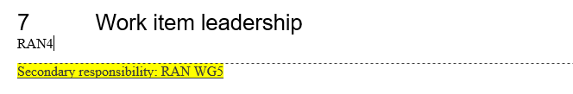  2). We need to discuss which spec to capture the MU work. Our option is to capture the MU analysis in TR38827. With that, we propose to add TR38827 in the impacted existing TS/TR table.  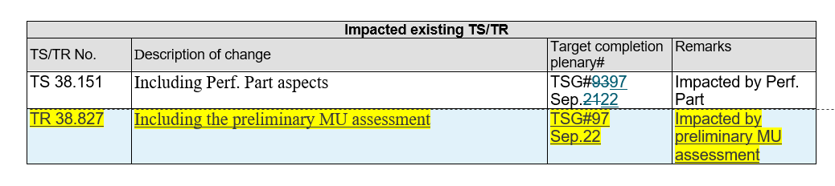  3). Clarifications on the wording for other aspects in WID. In the WID, it says” Define the pass/fail criteria for channel model validation, both FR1 and FR2”. Does it mean to define the pass/fail limt for FR1 and FR2 channel model validation? If so, clarifications in revised WID are needed.
Keysight | We support the addition of RAN4 providing preliminary MU assessment as per the WF in R4-2115756. Both the Vivo and CAICT proposals in RP-212028 and RP-212080 provide the necessary text but both also delete text that was not part of the WF. This deletion introduces ambiguity into the WID. The deleted text stating the ongoing responsibility of RAN5 to define MU, test tolerances and test procedures is a correct statement and does not add to what RAN5 would have done in response to this RAN4 WID.  The history with how MU and test tolerances have been handled is complicated. Originally, RAN5 handled everything. Then when OTA requirements were int4roueced, the MU analysis became very complex and RAN4 provided the initial analysis prior to RAN5 taking this over.  It was observed by Vivo/CAICT in the RAN4 emails discussion R4-2115807:  The definition of LTE TRP/TRS and LTE MIMO OTA performance requirements, preliminary measurement uncertainty assessment and test tolerances is a package which is developed in RAN4, since each component directly impacts the UE RF core requirements. The final values are recommended to RAN5 via LS for OTA test requirements in [7][8]. The definition of LTE TRP/TRS and LTE MIMO OTA performance requirements, preliminary measurement uncertainty assessment and test tolerances is a package which is developed in RAN4, since each component directly impacts the UE RF core requirements. The final values are recommended to RAN5 via LS for OTA test requirements in.  The observation that MU and test tolerances impacts requirements is not correct. They do impact the probability of a UE passing a test which is a different issue. A requirement is a standalone thing. How that requirement is tested is a separate thing. Choices have bene made in RAN5 about how measurement uncertainty is to be taken into account. In most cases, the decision was taken that MU > 0 is that a test tolerance is defined which is used to alter the test requirement, leaving the core requirement unchanged. This is legally a “shared risk” approach since the core requirement is not changed, but in effect is a “never fail a good UE” principle since the MU is used in favour of the UE. For OTA cases where the MU is quite large, only part of the MU may be used for the TT.  So moving forwards it is important for RAN to understand what principle RAN4 and RAN5 plan to apply. It is not helpful or transparent to set a core requirement with the knowledge that the test requirement might be modified based on an MU. He core requirement needs to be set independently of any MU and then decisions made on how that MU is used to develop a TT and test requirement are transparently applied after RAN4 has generated core requirements.  Given the history and current ambiguity, both WID proposals need further modification.
vivo | We do not see the conflict between the two options, a merged version would be better. Given this MIMO OTA WI is pure RAN4 project, generally we should not mention any task of RAN5, so we prefer to remove the original sentence related to next-step’s RAN5 work.  For FR2 preliminary MU assessment, we are open to discuss whether to add it in the extended scope, however, we think this should be RAN4 task.
Huawei, HiSilicon | Support to update the WID to capture agreements in RAN4.  Fine with QC’s suggestion to capture the results in TR38.827.  Regarding the involvement of RAN5, it can be conducted by LS exchange as mentioned in below blue text. (use CAICT text as example)  The Measurement Uncertainty (MU) aspects, RAN WG4 should discuss the preliminary MU assessment for FR1 MIMO OTA including example expanded uncertainty. During the course of this work item, ongoing communication with 3GPP RAN WG5, CTIA OTA Working Group (MOSG, 5G mm-wave OTA Sub-Working group and MUSG), and CCSA TC9 WG1 shall be maintained to ensure industry coordination on this topic.
CAICT | Considering the R-17 timeline and the agreements of the RAN4 #100-e meeting, the preliminary MU assessment should be discussed in RAN4, and the final MU and TT will be decided by RAN5.  As Huawei stated, the current WID has indicated that ongoing communication with RAN5 shall be maintained. RAN4 can send LS to RAN5 simultaneously when discussing the preliminary MU assessment.  From our side, referring to experience of LTE MIMO OTA spec., the MU work should be captured in both TS 38.151 and TR 38.827. For TR 38.827, the output of the MU work can be submitted as R-16 maintenance CRs.  Thus, we think it is better to be consistent with the agreements reached at the RAN4#100-e meeting. We are fine to further improve the wording of the WID, and proposed modifications are as follows.  The Measurement Uncertainty (MU) aspects, RAN WG4 should discuss the preliminary MU assessment for FR1 MIMO OTA including example expanded uncertainty, final MU and TT will be decided by RAN5. During the course of this work item, ongoing communication with 3GPP RAN WG5, CTIA OTA Working Group (MOSG, 5G mm-wave OTA Sub-Working group and MUSG), and CCSA TC9 WG1 shall be maintained to ensure industry coordination on this topic.  For FR2 MU work, we are open to discuss whether to add the FR2 preliminary MU assessment into the extended scope. However, we are not sure this issue should be discussed in RAN plenary or RAN4 meeting.

Summary and recommendation for further discussion
Based on the comments received from companies in 1st round, the observations summarized as below:
- Work scope extension on FR1 MU preliminary assessment: all companies support the working scope extension on FR1 MU assessment based on RAN4 recommendation. No strong preference from companies among two options list above for such objective introduction. From moderator’s point of view, option 1 is more clear as new sub-objective of WID.
- Work scope extension on FR2 preliminary MU: One company proposed to include FR2 preliminary MU into WID as well, and another company suggested to further discuss FR2 part in RAN4.
- Statement on RAN5 responsibility for MU and TT in current WID:
“The Measurement Uncertainty (MU) aspects, including potentially test tolerances, and test procedures will be handled in RAN WG5. During the course of this work item, ongoing communication with 3GPP RAN WG5, CTIA OTA Working Group (MOSG, 5G mm-wave OTA Sub-Working group and MUSG), and CCSA TC9 WG1 shall be maintained to ensure industry coordination on this topic.”
There are different views from companies with following options:
- Option 1: Remove above statement, since this WI is pure RAN4 project and WID already clarified exchanging views with RAN5 still can be done by LS.
- Option 2: Include statement on RAN5 responsibility in WID
  - Option 2a: Keep original statement “The Measurement Uncertainty (MU) aspects, including potentially test tolerances, and test procedures will be handled in RAN WG5.”
  - Option 2b: Make update on the statement to be aligned with RAN4 agreement “ Final MU and TT will be handled in RAN WG5”
- Option 3: Add RAN5 as secondary WG,
From moderator aspect, option 2 seems to be more aligned with current RAN4 agreements and recommendations; which also can be considered as comprised option among option 1 and option 3. Also as captured in current WID, LS can used to exchange views with RAN5. A separate RAN5 led conformance test WI can be introduced after RAN4 finalize core requirements to introduce corresponding test cases with final MU and TT following normal procedure in 3GPP.
- Other aspect
- One company also suggested to capture MU work into TR 38.827
- One company asked clarifications on the wording for other aspects in WID on the sub-objective” Define the pass/fail criteria for channel model validation, both FR1 and FR2”

Respecting the agreements and recommendations in last RAN4 meeting, moderator would like to give below suggestions:
Proposal 1: Update WID to add work scope extension on FR1 MU preliminary assessment and further work on the wording in 2nd round
  - MU work can be captured into TR 38.827
Proposal 2: Work scope extension on FR2 preliminary MU, further discuss following options in 2nd round
  - Option 1: Include FR2 MU preliminary assessment into WID
  - Option 2: Further discuss in RAN4
Proposal 3: Include the statement on RAN5 responsibilities on MU and TT in the WID to avoid confusion with following options and further refinement based on these options not precluded
  - Option 2a: Keep original statement “The Measurement Uncertainty (MU) aspects, including potentially test tolerances, and test procedures will be handled in RAN WG5.”
  - Option 2b: Make update on the statement to be aligned with RAN4 agreement “Final MU and TT will be handled in RAN WG5.”
For the question on clarification of WID objective “Define the pass/fail criteria for channel model validation, both FR1 and FR2” can be further addressed in second round.

Intermediate round

Open issues
Issue 1: Update WID to add work scope extension on FR1 MU preliminary assessment and further work on the wording
  - MU work can be captured into TR 38.827

Issue 2: Work scope extension on FR2 preliminary MU, further discuss following options in 2nd round
  - Option 1: Include FR2 MU preliminary assessment into WID
  - Option 2: Further discuss in RAN4

Issue 3: Include the statement on RAN5 responsibilities on MU and TT in the WID to avoid confusion with following options and further refinement based on these options not precluded
  - Option 2a: Keep original statement “The Measurement Uncertainty (MU) aspects, including potentially test tolerances, and test procedures will be handled in RAN WG5.”
  - Option 2b: Make update on the statement to be aligned with RAN4 agreement “Final MU and TT will be handled in RAN WG5.”
Issue 4: Response to the question for clarification of WID objective “Define the pass/fail criteria for channel model validation, both FR1 and FR2”

Collection of company views
Company | Comments
Verizon | The MU for FR2 MIMO OTA cannot be missed in the revised WID, and it should be reflected in the NR MIMO WID! RAN4 is necessary to do the MU analysis for FR2, otherwise it will create the problem to define the MIMO OTA requirements for FR2 at end.
OPPO | Issue 1: ok  Issue 2: Option 2.  Issue 3: Option 2b.
vivo | Thanks for Moderator’s good summary.  For FR2 preliminary MU assessment, given currently RAN4 is discussing simulation-based approach to define FR2 MIMO OTA requirements, so potential MU value would not have much impact. Prefer further discuss.  For RAN5 work statement, we are OK with option 2b.  For issue 4, we would like to clarify that statement means “Define the pass/fail limits for channel model validation, both FR1 and FR2”.
CAICT | Based on the email discussion and the moderator’s summary, we propose the following modifications.  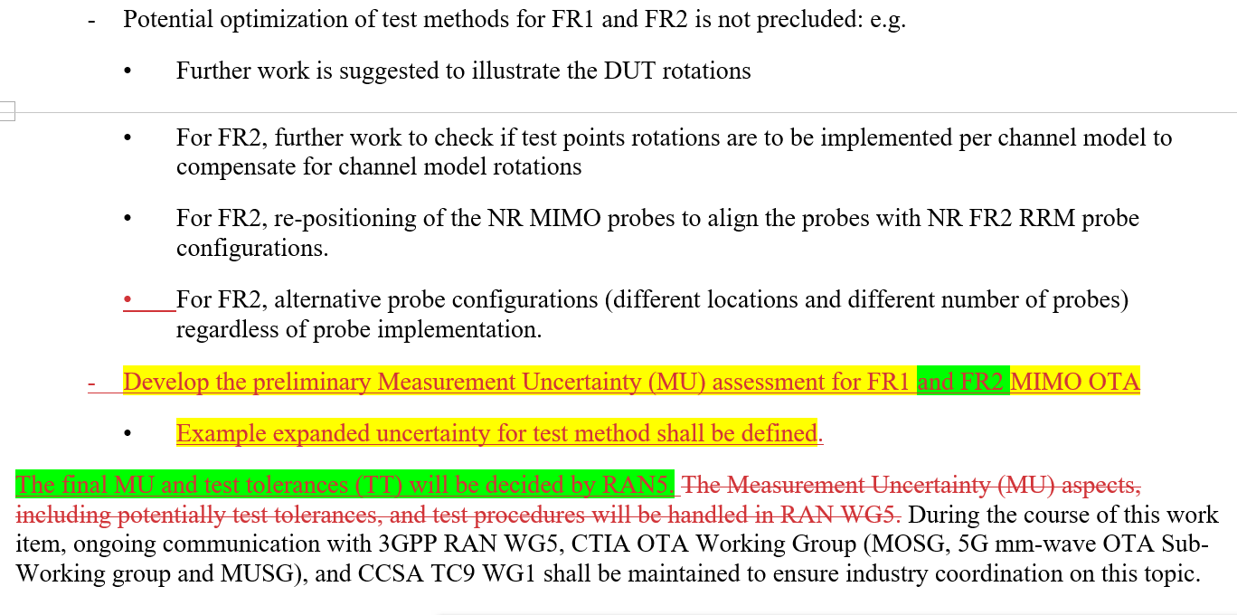  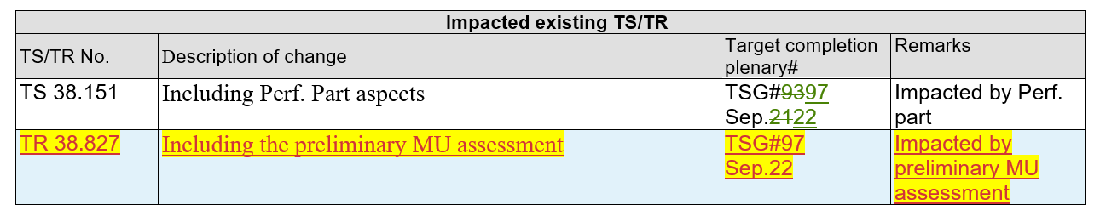  Issue 4: In the WID, “Define the pass/fail criteria for channel model validation, both FR1 and FR2” means to define the pass/fail limit for FR1 and FR2 channel model validation. The wording can be modified as “Define the pass/fail limit for FR1 and FR2 channel model validation.”  We will further revise the WID if the agreement on the modifications is reached.
Qualcomm | Issue 1: OK with proposal.  Issue 2: Option 1. We share the similar view as Verizon. MIMO OTA WI is to specify the requirements for both FR1 and FR2. In the original WID, the MU work including both FR1 and FR2 was assigned to RAN5. If we only add FR1 preliminary MU in the revised WID, we will have the problem to define the FR2 MIMO OTA requirements. The issues without preliminary MU analysis in RAN4 has been identified in FR1 related discussion. We don’t see the difference between FR1 and FR2 in this sense. So, it is reasonable to treat FR1 and FR2 equally and no need to further discuss it in RAN4.  Response to vivo’s comments: for FR2, either simulation-based or measurements-based can be used to develop the requirements. We believe the FR2 preliminary MU analysis is essential at least for measurement-based approach.  Issue 3: OK with option 2b. But we’d like to clarify the following wording in the WID:  “During the course of this work item, ongoing communication with 3GPP WG RAN5… ”  This includes the communication between RAN4 and RAN5 on the MU analysis via LS to avoid the gap of MU values between RAN4 and RAN5 as much as possible. Maybe we could capture this clarification in the meeting notes.  Thanks for CAICT’s efforts. We are fine with the revisions with the clarification on Issue 3.
Huawei, Hisilicon | Issue 2: prefer option 2 “Further discuss in RAN4”  Issue 3: prefer option 2b to align with RAN4 agreement “Final MU and TT will be handled in RAN WG5.”
Telecom Italia | We think that all the proposals present drawbacks and that splitting the responsibility between different WGs is critical.  We therefore propose a modification of option 2B  - Option 2b: Make update on the statement to be aligned with RAN4 agreement “The final values are recommended to RAN5 via LS for OTA test requirements. The definition of LTE TRP/TRS and LTE MIMO OTA performance requirements, preliminary measurement uncertainty assessment and test tolerances is a package which is developed in RAN4, since each component directly impacts the UE RF core requirements. The final values are recommended to RAN5 via LS for OTA test requirements.”
AT&T | Issue 1: OK.  Issue 2: Option 1. We share the similar views as Verizon and Qualcomm. Any new test methodology should have a preliminary MU assessment from RAN4. MIMO OTA FR2 work should follow the same process used for FR2 RF WI where RAN4 developed a preliminary MU assessment. RAN5 needs the preliminary MU assessment from RAN4 since it will identify the key MU terms associated with the methodology.  Issue 3: OK with option 2b.

Summary and recommendation for further discussion
Based on discussion during 2nd round, the observations summarized as below:
- Issue 1(work scope extension on FR1 MU preliminary assessment): All companies fine with the proposal
- Issue 2 (work scope extension on FR2 MU preliminary assessment): Seems all companies OK to discuss FR2 MU preliminary assessment in RAN4 group; meanwhile 2 companies shared concern on the progress for FR2 MIMO OTA. And two operators shared strongly demand to include this into WID together with FR1. For moving forward, moderator suggests to including both FR1 and FR2 MU preliminary assessment into WID. Meanwhile it should be common understanding that the discussion and progress on RAN4 will be contribution driven, and no need to bundle FR1 and FR2 part together in RAN4 discussion.
- Issue 3 (the statement on RAN5 responsibilities on MU and TT): Seems option 2b agreeable for all companies and one company proposed to further refinement on option 2b. Two companies mentioned that the activity includes the communication between RAN5 and RAN4 via LS for MU assessment. It’s moderator’s understanding, with current WID, such action not precluded and LS can be contribution driven. No strong need foreseen for additional clarification. For moving forward, moderator suggests to agree option 2b as it is.
- Issue 4 (clarification): Companies clarified it means “the pass/fail limits”, it can be reflected in revised WID.
Tentative agreements proposed by moderator for moving forward:
Update WID to add work scope extension on FR1 MU preliminary assessment
  - MU work can be captured into TR 38.827
Work scope extension on FR2 preliminary MU:
  - Include FR2 MU preliminary assessment into WID
Include the statement on RAN5 responsibilities on MU and TT in the WID:
  - Make update on the statement to be aligned with RAN4 agreement “Final MU and TT will be handled in RAN WG5.”
  - Note: The communication between RAN4 and RAN5 for preliminary MU assessment and final MU can be done via LS.
Update sub-objective “Define the pass/fail criteria for channel model validation, both FR1 and FR2” as following
  - “Define the pass/fail limit for FR1 and FR2 channel model validation.”
Note: Rapporteur of NR MIMO WID already proposed the modifications on WID as captured in comment table which aligned with above proposed tentative agreements.

Final round

Open issues
Moderator suggests to further confirm the tentative agreements proposed by moderator. And we target to approve the revised WID during this round.
Proposal 1: Update WID to add work scope extension on FR1 MU preliminary assessment
  - MU work can be captured into TR 38.827
Proposal 2: Work scope extension on FR2 preliminary MU:
  - Include FR2 MU preliminary assessment into WID
Proposal 3: Include the statement on RAN5 responsibilities on MU and TT in the WID:
  - Make update on the statement to be aligned with RAN4 agreement “Final MU and TT will be handled in RAN WG5.”
  - Note: The communication between RAN4 and RAN5 for preliminary MU assessment and final MU can be done via LS.
Proposal 4: Update sub-objective “Define the pass/fail criteria for channel model validation, both FR1 and FR2” as following
  - “Define the pass/fail limit for FR1 and FR2 channel model validation.”

Collection of company views
Please provide your comments and feedback on the proposals above if any. We really hope above proposals can be acceptable to moving forward.
Company | Comments

Summary and recommendation for further discussion

Final comments

Conclusion
Moderator Recommendations:

