#3GPP TSG RAN Meeting #93-e RP-21xxxx
Electronic Meeting, September 13 - 17, 2021
______________________________________________________________________Agenda item: 9.2.2
Source: Moderator (LG Electronics)
Title: pCR for TR 38.845: Positioning requirements for V2X and public safety
Document for: Approval

Introduction
This pCR proposes to add the positioning scenarios requirements for V2X and public safety use cases to TR 38.845 following the outcome of email discussion [93e-10-SL-Positioning-TR].

Proposed changes
*** Unchanged text is omitted ***

2 References
The following documents contain provisions which, through reference in this text, constitute provisions of the present document.
- References are either specific (identified by date of publication, edition number, version number, etc.) or non-specific.
- For a specific reference, subsequent revisions do not apply.
- For a non-specific reference, the latest version applies. In the case of a reference to a 3GPP document (including a GSM document), a non-specific reference implicitly refers to the latest version of that document in the same Release as the present document.
[1] 3GPP TR 21.905: "Vocabulary for 3GPP Specifications".
[2] 3GPP RP-201518: "Revised SID on Study on scenarios and requirements of in-coverage, partial coverage, and out-of-coverage positioning use cases".
[3] 3GPP TS 22.261: "Service requirements for the 5G system".
[4] 3GPP TS 22.186 v16.2.0: "Enhancement of 3GPP support for V2X scenarios".
[5] 3GPP RP-210040: "Reply LS to RP-201390 on requirements of in-coverage, partial coverage, and out-of-coverage positioning use cases," (source: 5GAA).
[6] 3GPP RP-210036: "Reply LS to 3GPP TSG RAN on requirements of in-coverage, partial coverage and out-of-coverage positioning use cases," (source: SAE Advanced Applications Technical Committee).
[7] 3GPP TS 22.280: "Mission Critical Services Common Requirements (MCCoRe)".

[8] 3GPP TR 22.872: "Study on positioning use case".
[9] 3GPP TR 37.885: "Study on evaluation methodology of new Vehicle-to-Everything (V2X) use cases for LTE and NR".
[10] 3GPP TR 38.802: "Study on new radio access technology Physical layer aspects".

3 Definitions of terms, symbols and abbreviations

3.1 Terms
For the purposes of the present document, the terms given in 3GPP TR 21.905 [1] and the following apply. A term defined in the present document takes precedence over the definition of the same term, if any, in 3GPP TR 21.905 [1].
absolute position: absolute position is an estimate of the UE position in 2D/3D geographic coordinates (e.g., latitude, longitude, elevation) within a coordinate system
relative position: relative position is an estimate of the UE position relative to other network elements or relative to other UEs
positioning service availability: percentage value of the amount of time the positioning service is delivering the required position-related data within the performance requirements, divided by the amount of time the system is expected to deliver the positioning service according to the specification in the targeted service area.
positioning service latency: time elapsed between the event that triggers the determination of the position-related data and the availability of the position-related data at the system interface.

3.2 Symbols
For the purposes of the present document, the following symbols apply:
<symbol> <Explanation>

3.3 Abbreviations
For the purposes of the present document, the abbreviations given in 3GPP TR 21.905 [1] and the following apply. An abbreviation defined in the present document takes precedence over the definition of the same abbreviation, if any, in 3GPP TR 21.905 [1].
5GAA 5G Automotive Association
SAE AA TC SAE Advanced Applications Technical Committee
TTFF Time To First Fix
HD High Definition
RV Remote vehicle
TOD Tele-Operated Driving
MCX Mission Critical X, with X = PTT or X= Video or X= Data

4 Positioning use cases and requirements

4.1 Introduction
This clause summarizes the positioning use cases and requirements defined for V2X and public safety in 3GPP specifications and input from other organizations. Sources used in this summary are provided in Annex A for information.

4.2 V2X
In 3GPP specifications, V2X positioning requirements can be found in TS 22.261 [3] and TS 22.186 [4]. TS 22.261 [3] specifies the high accuracy positioning requirements for the 5G system and these requirements are summarized in its Clause 7.3.2.2 with a note that these requirements include V2X. Seven different positioning service levels are defined in Table 7.3.2.2-1 [3] in terms of the horizontal and vertical accuracy, positioning service availability, and positioning service latency. TS 22.186 [4] specifies the relative lateral positioning requirement for general V2X use cases and the relative longitudinal positioning requirement for the platooning use case in its Clause 5.1 and 5.2.
5GAA provides positioning requirements for 58 V2X services that were summarized into three groups [5]; the first group with tens of meters accuracy, the second with lane level accuracy, and the third with sub-meter level accuracy. The positioning requirements can be on the 3D/2D coordinates (absolute position) or on the distance and/or angle (relative position) to a reference point, e.g. another UE.
SAE AA TC informs that it is necessary to have a 3GPP positioning technology which supports advanced V2X applications working even in various out-of-coverage scenarios [6].
It is observed that the positioning requirements in V2X depend on the service the UE operates. Also, the requirements are applicable to relative and absolute positioning depending on the use case or the positioning service level. In terms of the horizontal or lateral/longitudinal accuracy, the requirements for the absolute position or relative position can be categorised into three sets as follows by incorporating the requirements from the sources mentioned above:
- Set 1: 10 – 50 m with 68 – 95 % confidence level. This includes Group 1 in [5] and Service level 1 in [3].
- Set 2: 1 – 3 m with 95 – 99 % confidence level. This includes Group 2 in [5], Service level 2, 3, 4 in [3].
- Set 3: 0.1 – 0.5 m with 95 – 99 % confidence level. This includes Group 3 in [5], Service level 5, 6, 7 in [3], the requirements in [4].
It is noted that all the three sets are applicable for absolute positioning and relative positioning.
Requirements for other performance metrics are also defined in a range depending on the positioning service level in TS 22.261 [3]; 2 – 3 m (absolute) or 0.2 m (relative) vertical accuracy, 95 – 99.9% positioning service availability, 10 ms – 1 s positioning service latency.
Positioning service should be provided in indoor, outdoor, tunnel areas. The UE velocity up to 250 km/h needs to be supported for outdoor and tunnel areas. As long as the UE operates a V2X use case having the corresponding positioning requirements, the requirements should be fulfilled when the UE is inside the network coverage as well as when it is outside the network coverage. The requirements should be also fulfilled when the GNSS-based positioning is not available or not accurate enough.

4.3 Public safety
Public safety positioning requirements are defined in TS 22.261 [3] and TS 22.280 [7]. TS 22.261 [3] provides numerical positioning requirements for the "1st responders" use case in Table B.1-1 in TS 22.261 [3]; 1 m horizontal accuracy, 2 m (absolute) or 0.3 m (relative) vertical accuracy, 95 – 98 % positioning service availability. TS 22.280 [7] specifies some qualitative positioning requirements in its Clause 5.11, 6.12, and 7.8. These requirements are applicable to both relative and absolute positioning.
Positioning service should be provided both in indoor and outdoor areas. As long as the UE operates a public safety use case having the corresponding positioning requirements, the requirements should be fulfilled when the UE is inside the network coverage as well as when it is outside the network coverage. The requirements should be also fulfilled when the GNSS-based positioning is not available or not accurate enough.

5 Potential deployment and operation scenarios

5.1 Network coverage
Three network coverage scenarios can be considered when at least two UEs are involved in positioning for V2X and public safety use cases. Taking the case of two UEs as an example, in-coverage scenario refers to the case where both UEs are inside the network. Partial coverage means that one UE remains inside the network coverage but the other UE is outside the network coverage. Out-of-coverage scenario refers to the case where both UEs are outside the network coverage. A UE may transition between in-coverage, partial coverage and out-of-coverage scenarios.
There are V2X and public safety use cases that require positioning when there is no network and no GNSS coverage.
Figures 5.1-1, 5.1-2, and 5.1-3 illustrate the in-coverage, partial coverage and out-of-coverage scenarios, respectively.

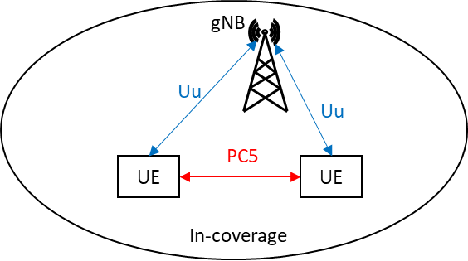
Figure 5.1-1: In-coverage scenario

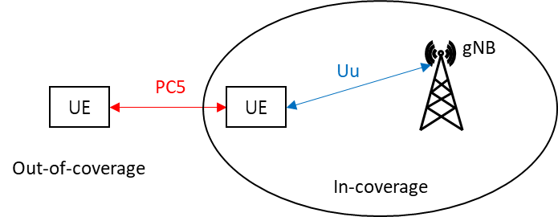
Figure 5.1-2: Partial coverage scenario

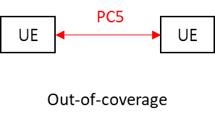
Figure 5.1-3: Out-of-coverage scenario

5.2 Radio link
Uu interface (uplink and downlink), PC5 interface (sidelink), and their combinations can be considered as the radio link for positioning.
Uu interface is available in in-coverage scenario, and also for UEs under network coverage in partial coverage scenario, while PC5 interface is available in in-coverage, partial coverage, out-of-coverage scenarios.
A positioning operation can be called a Uu-based solution if it uses only measurements on Uu interface (i.e., measurements on uplink and/or downlink). An operation can be called a PC5-based solution if it uses only measurements on PC5 interface (i.e., measurements on sidelink). An operation can be called a hybrid solution if it uses measurements on both Uu and PC5 interfaces. In addition to these RAT-dependent solutions, RAT-independent solutions (e.g., GNSS, sensors, etc.) can be used, where various technologies can complement each other, where it is available and applicable.
The necessary information for positioning and the measurements for positioning can be sent using Uu and/or PC5 interface.

5.3 Position calculation entity
Positioning solutions can be categorized by the entity performing the positioning estimation. Network based positioning refers to the solutions where UE position is calculated by a network node. For this network based positioning, the UE may report necessary information to the network for the calculation. UE based positioning refers to the solution where UE position is calculated by a UE.
Which node is the position calculation entity does not limit which interface(s) can be used for the radio link(s) in Section 5.2.

5.4 UE types
For V2X use cases, a UE involved in positioning can be installed in a vehicle, a road side unit, or a device of a vulnerable road user.
A UE in a vehicle or a road side unit can be equipped with a distributed antenna system where multiple antenna panels of a UE are installed in different locations. A relevant antenna model for evaluation can be found in [9].
For public safety use cases, a relevant antenna model can be found in [10].
Different UE types may have different power supply limitations, for example, a UE used by a vulnerable road user may be have limited battery capacity compared to a UE installed in a vehicle or a road side unit.
A UE installed in a device of a vulnerable road user may be more battery limited comparing to UE installed in a vehicle or a road side unit.

5.5 Spectrum
For V2X use case, the ITS-dedicated spectrum can be considered for PC5 interface, and the spectrum licensed to mobile network operators (including FR2) and the unlicensed spectrum can be considered for both Uu and PC5 interfaces, with a note that there is no mechanism corresponding to regulatory requirements to use unlicensed spectrum in Rel-17 NR sidelink.
For public safety use case, the spectrum licensed to mobile network operators (including FR2) can be considered for both Uu and PC5 interfaces.

6 Conclusions
This technical report summarizes the positioning use cases and requirements for V2X and public safety use cases. The V2X and PS requirements in this TR are applicable to absolute and relative positioning. The positioning requirements in V2X depend on the service the UE operates, and this TR categorized the requirements into three sets as summarized in Clause 4.
The main aspects of potential deployment and operation scenarios are provided in Clause 5 including:
• Network coverage:
o In-coverage, partial coverage, out of network coverage scenarios
o When the UE operates a use case having the corresponding positioning requirements, the requirements should be fulfilled when the UE is inside the network coverage as well as when it is outside the network coverage.
• Radio link:
o Measurements on Uu interface (downlink/uplink), PC5 interface (sidelink) and their combinations for UE positioning
o Use of RAT-dependent and RAT-independent solutions
• Position calculation entity:
o Network based and UE based positioning solutions
• UE types:
o V2X: installed in a vehicle, a road-side unit or a device of vulnerable road user, where UE antenna configurations and battery capability can be different in different UE types.
• Spectrum:
o V2X: licensed, unlicensed spectrum for both Uu and PC5 air-interfaces and ITS for PC5 air-interface. NOTE: There is no mechanism corresponding to regulatory requirements to use unlicensed spectrum in Rel-17 NR sidelink.
o Public safety: licensed spectrum for both Uu and PC5 air-interfaces.

*** Unchanged text is omitted ***

Sources in 3GPP TR 22.872 [8]
summarized requirements from TR 22.872 [8]:

*** Unchanged text is omitted ***

