3GPP TSG-RAN #93-e RP-21
Online, 13-17 September 2021

Agenda Item: 5.3
Source: RAN3 Chair (ZTE)
Title: Summary of Offline Discussion - Update to RAN3 TU Planning
Document for: Discussion

Introduction
Some WIs approval/updates with RAN3 scope will bring updates to the endorsed TUs for RAN3 in RAN#92e.

Proposals, Company Comments
According to the RAN3 TU discussion in RAN#92e in RP-211498, pls note that for each RAN3 WG meeting, 0.5 TU overload per meeting should be manageable, further TU addition is not acceptable only if TU cutting is available.

LS in RP-211672 was agreed in RAN3#113e.
RAN3 would like to kindly request RAN to update the work item and allocate to RAN3 proper TU(s) for RAN3 to complete the work on UE Power Saving Enhancements, taking into account the schedule capacity of RAN3 in the remaining meetings of Rel-17.
In RP-212233, RP-212413, it is proposed to update the WID to include RAN3 on paging sub-grouping for reducing unnecessary UE paging reception. However, the detail information of subgroup information to be transferred over backhaul interfaces are highly correlated with solution discussion in RAN2, it seems better to start RAN3 work in Q1 2022.

- UE Power Saving Enhancements WI
If the WI scope update with RAN3 is approved, allocate 0.5 TU at RAN3 #114bis-e.

- New WI “User Plane Integrity Protection support for EPC connected architectures using LTE and NR”
If this WI is approved in RAN#93e, then include it to the basket for "late" Rel-17 WIs as needed (IoT over NTN, Multi SIM, UP Integrity Protection) with 0.5 TU at RAN3 #114bis-e and RAN3#115-e.

In RP-211999, it is proposed to Spreading the allocated 1 TU of RAN3#114e into 0.5 in RAN3#113bis-e and 0.5 in RAN3#114-e for Enhancement for data collection for NR and ENDC SI (R17 AI RAN SI) in order to ensure continuous discussion on technical details.

- AI RAN SI: Spreading the allocated 1 TU of RAN3#114bis-e into 0.5 in RAN3#114e and 0.5 in RAN3#114bis-e.

- TU adjustments as below based on workload estimation:
NB IOT/MTC enh. WI: Accept 0.5 TU reduction at RAN3#115-e.
SON/MDT WI: Accept 0.5 TU reduction at RAN3#114-e.
The above proposal is based on the observation of discussion in RAN3 meetings.

- Allocate 0.5 TU for corrections in RAN3#115-e
The continuous 0.5TU for correction/TEI is needed and only essential corrections are allowed for frozen releases, e.g., R15, R16.

According to the above observations, the updated RAN3 TU allocation is proposed in RP-211741 as below:
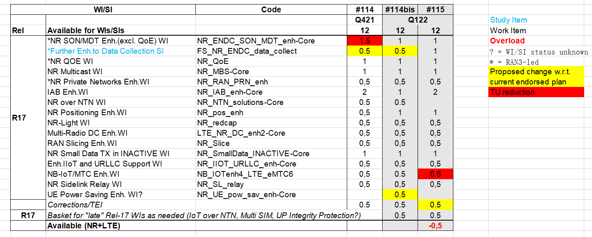

Q:Any comments on the updated RAN3 TU planning as proposed in RP-211741?
Company | Comment
MediaTek | We support the TU plan and will propose WID revision in RAN#93-e.
Ericsson | We have comments on Proposal 3) AI RAN SI: Spreading into two 0.5 TU.  We should keep the time allocation as it is.  We have reached a rather good state with the work on AI. We should wait and work on more concrete enhancements to the use cases, which we could do at the Jan meeting with the 1TU planned.
CMCC | We support to spread AI SI TU into two 0.5TU. AI for NG-RAN is a new topic in 3GPP RAN, although we have achieved some initial agreements on the functional framework, and prioritized Use Cases and Solutions, there still exists many contentious topics, e.g., details in Functional Framework, solutions and standard impacts, which may not be easily converged through e-meeting. Therefore, it is quite important to have a continuous discussion on the technical details.
InterDigital | We support the TU plan
Vodafone | For LTE UPIP, time should be spent in the November RAN 3 meeting and one of the RAN 3 meetings in Q1 2022 (probably the second of the is best). This is so that RAN 3 can raise any questions/proposals with SA3 and SA2 (and possibly RAN 2) and there be time to get answers back.
Futurewei | We support the updated RAN3 TU planning as proposed in RP-211741.  In regard to TU allocation for AI RAN SI, we also think that spreading the allocated 1 TU of RAN3#114bis-e into 0.5 in RAN3#114e and 0.5 in RAN3#114bis-e could help progress discussions of and reach consensus on solutions and standards impact with more checked pace.
Nokia | We support the updated TU plan, including Proposal 3 (AI RAN SI) which avoids what would otherwise be a 5-month break from the topic.
CATT | We support the updated TU plan.
Intel | We also support the updated TU plan.
NEC | For 3) AI RAN SI (Spreading the allocated 1 TU of RAN3#114bis-e into 0.5 in RAN3#114e and 0.5 in RAN3#114bis-e), we think this is reasonable approach, and we would like to support this, in order to keep continuing discussion without breaking.  For 5) Allocate 0.5 TU for corrections in RAN3#115-e, we think it is reasonable.
Samsung | We support the updated TU plan.
Lenovo, Motorola Mobility | We support the updated TU plan including TU allocation for AI SI
Verizon | Support the updated TU plan. For AI RAN SI, spreading of TUs across 2 meetings might help make better progress.

Conclusion1:

Intermediate Round

Final Round

Conclusion

