3GPP TSG-RAN #93-e RP-21
Online, 13-17 September 2021

Agenda Item: 5.3
Source: RAN3 Chair (ZTE)
Title: Summary of Offline Discussion - Update to RAN3 TU Planning
Document for: Discussion

Introduction
Some WIs approval/updates with RAN3 scope will bring updates to the endorsed TUs for RAN3 in RAN#92e.

Proposals, Company Comments
According to the RAN3 TU discussion in RAN#92e in RP-211498, pls note that for each RAN3 WG meeting, 0.5 TU overload per meeting should be manageable, further TU addition is not acceptable only if TU cutting is available.

LS in RP-211672 was agreed in RAN3#113e.
RAN3 would like to kindly request RAN to update the work item and allocate to RAN3 proper TU(s) for RAN3 to complete the work on UE Power Saving Enhancements, taking into account the schedule capacity of RAN3 in the remaining meetings of Rel-17.
In RP-212233, RP-212413, it is proposed to update the WID to include RAN3 on paging sub-grouping for reducing unnecessary UE paging reception. However, the detail information of subgroup information to be transferred over backhaul interfaces are highly correlated with solution discussion in RAN2, it seems better to start RAN3 work in Q1 2022.

- UE Power Saving Enhancements WI
If the WI scope update with RAN3 is approved, allocate 0.5 TU at RAN3 #114bis-e.

- New WI “User Plane Integrity Protection support for EPC connected architectures using LTE and NR”
If this WI is approved in RAN#93e, then include it to the basket for "late" Rel-17 WIs as needed (IoT over NTN, Multi SIM, UP Integrity Protection) with 0.5 TU at RAN3 #114bis-e and RAN3#115-e.

In RP-211999, it is proposed to Spreading the allocated 1 TU of RAN3#114e into 0.5 in RAN3#113bis-e and 0.5 in RAN3#114-e for Enhancement for data collection for NR and ENDC SI (R17 AI RAN SI) in order to ensure continuous discussion on technical details.

- AI RAN SI: Spreading the allocated 1 TU of RAN3#114bis-e into 0.5 in RAN3#114e and 0.5 in RAN3#114bis-e.

- TU adjustments as below based on workload estimation:
NB IOT/MTC enh. WI: Accept 0.5 TU reduction at RAN3#115-e.
SON/MDT WI: Accept 0.5 TU reduction at RAN3#114-e.
The above proposal is based on the observation of discussion in RAN3 meetings.

- Allocate 0.5 TU for corrections in RAN3#115-e
The continuous 0.5TU for correction/TEI is needed and only essential corrections are allowed for frozen releases, e.g., R15, R16.

According to the above observations, the updated RAN3 TU allocation is proposed in RP-211741 as below:
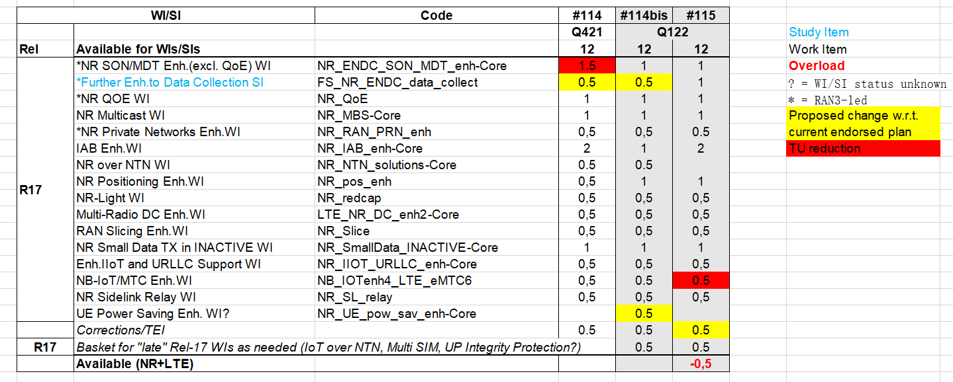

Q:Any comments on the updated RAN3 TU planning as proposed in RP-211741?
Company | Comment
MediaTek | We support the TU plan and will propose WID revision in RAN#93-e.
Ericsson | We have comments on Proposal 3) AI RAN SI: Spreading into two 0.5 TU.  We should keep the time allocation as it is.  We have reached a rather good state with the work on AI. We should wait and work on more concrete enhancements to the use cases, which we could do at the Jan meeting with the 1TU planned.
CMCC | We support to spread AI SI TU into two 0.5TU. AI for NG-RAN is a new topic in 3GPP RAN, although we have achieved some initial agreements on the functional framework, and prioritized Use Cases and Solutions, there still exists many contentious topics, e.g., details in Functional Framework, solutions and standard impacts, which may not be easily converged through e-meeting. Therefore, it is quite important to have a continuous discussion on the technical details.
InterDigital | We support the TU plan
Vodafone | For LTE UPIP, time should be spent in the November RAN 3 meeting and one of the RAN 3 meetings in Q1 2022 (probably the second of the is best). This is so that RAN 3 can raise any questions/proposals with SA3 and SA2 (and possibly RAN 2) and there be time to get answers back.
Futurewei | We support the updated RAN3 TU planning as proposed in RP-211741.  In regard to TU allocation for AI RAN SI, we also think that spreading the allocated 1 TU of RAN3#114bis-e into 0.5 in RAN3#114e and 0.5 in RAN3#114bis-e could help progress discussions of and reach consensus on solutions and standards impact with more checked pace.
Nokia | We support the updated TU plan, including Proposal 3 (AI RAN SI) which avoids what would otherwise be a 5-month break from the topic.
CATT | We support the updated TU plan.
Intel | We also support the updated TU plan.
NEC | For 3) AI RAN SI (Spreading the allocated 1 TU of RAN3#114bis-e into 0.5 in RAN3#114e and 0.5 in RAN3#114bis-e), we think this is reasonable approach, and we would like to support this, in order to keep continuing discussion without breaking.  For 5) Allocate 0.5 TU for corrections in RAN3#115-e, we think it is reasonable.
Samsung | We support the updated TU plan.
Lenovo, Motorola Mobility | We support the updated TU plan including TU allocation for AI SI
Verizon | Support the updated TU plan. For AI RAN SI, spreading of TUs across 2 meetings might help make better progress.
Huawei | Remove 0.5 TU on NB-IoT/MTC Enh. WI is acceptable for us as rapporteur  The LTE UP IP Integrity protection should start early in Q4, RAN3#114 due to dependency with SA2/SA3 and liaison triggering by RAN3 more than possible  Why do UE power saving with 0.5 TU, late WI as special treatment compare other late and low TU items? The LS from RAN3 should not preclude to put UE power saving item in the Basket. The overall Basket TU could be increase over 0.5 … It seems also a bit un usual to open and close a WI in single meeting in RAN3 for such topic …. That’s make also more sense for Basket application …  We are not keen on TU manipulation between SON and AI/ML this will ensure full SI discussion. We noted over 1 TU discussion on SI last meeting. Particularly when WI have pressure of completion, see line above as example. Say that we will not go again a majority view by compromised spirit.  We also wondering if the discussion on IAB and possible down selection will not have impact on RAN3 which will free some TU for Basket as example.
ZTE | We support the updated TU plan.
Qualcomm | First, we recognize that the reductions of SON/MDT and NB-IOT are feasible, and can also accept the TU spreading for AI/ML. We also fully agree that some work is needed in RAN3 for UE Power Savings, and (possibly more) for UP IP, assuming approval.  However, we do not understand why Power Savings has a specific allocation, rather than be placed in the basket as e.g. UP IP. This should be clarified. In our view, there seem to be two approaches: (1) place all new items in the basket and try to dimension the basket accordingly, or (2) extract all items out of the basket and plan TUs for these, accepting that RAN3 is overloaded according to existing metrics. Since option 2 seems difficult at this stage, we would expect option 1 to be the way forward - but certainly not a mixed approach.

Intermediate Round
Feedback on the comments received:
- For the new approved LTE UP IP Integrity protection WI, we can observe from the Email#[93e-07-UserPlane-Integrity], the work in RAN3 seems much clear and limited, therefore, I suggest to add this into the basket item, while for the possible early co-ordination with SA2/SA3, I noticed that there is an LSin RP-212494 (cc RAN3) which will be received in next RAN3 meeting. If needed (contribution driven on this topic), we can treat it in AI8.1 in RAN3#114e.
- For UE Power Saving WI, as I explained in last meeting, 2~3 items (each item with limited RAN3 impact) to be treated in this basket with 0.5 TU seems bearable, we’ve already had multi-SIM and IoT over NTN in this basket item, if we add LTE UP IP Integrity protection WI to this basket item as well, there are 3 items, endless list expansion is not allowed, abuse of this basket item is definitely should be avoided. Therefore, since this UE Power Saving WI already has its own WID, and we already had the common understanding in RAN3#113e to work on paging subgroups information transmission over backhaul interfaces, e.g., what’s the definition of paging subgroups information, NAS/AS solution progress in RAN2, signalling and procedures support, it obviously has more technical details to be discussed in RAN3, therefore, I think 0.5TU allocation in RAN3#114bis-e is reasonable for this WI.
- Since majority companies are fine with spreading of TU for AI RAN SI, I would suggest to keep the update as it is.
- If there is a clear conclusion on TU reduction based on down scope for current ongoing RAN3 WI/SIs, we may accept new late R17 WI work in RAN3, else, RAN3 TU allocation is fully booked, and I propose to keep the endorsed TU update in this meeting unchanged till the end of R17 timeline, March, 2022.
- It's highly appreciated for companies to take potential R18 RAN3 work load into account in advance when discussing the objectives for R18 WI/SIs, else RAN3 will face the same situation that the load of RAN3 will blow up at the end of release.

Proposal1: With above clarifications, the updated RAN3 TU planning as proposed in RP-211741 can be endorsed.
Q:Any further comments on Proposal1 as above?
Company | Comment

Final Round

Conclusion

