**3GPP TSG RAN WG1 email discussion [5G-ACIA]**

**February 22-26, 2021**

**Source: Huawei, HiSilicon**

**Title: Simulation results for 5G-ACIA in the second round**

**Document for: Discussion and decision**

# Introduction

AT RAN#89, the following was agreed in [RP-202069](https://protect2.fireeye.com/v1/url?k=41a5db26-1f051960-41a59bbd-86fc6812c361-73f443258ff773bf&q=1&e=bc078f84-983d-45f3-ab31-19e60d911036&u=https%3A%2F%2Fwww.3gpp.org%2Fftp%2Ftsg_ran%2FTSG_RAN%2FTSGR_89e%2FDocs%2FRP-202069.zip) on providing evaluations for 5G-ACIA:

|  |
| --- |
| * Start an offline email-based activity to provide evaluation results for 5G-ACIA * One company volunteers as moderator * Proposes a work plan to follow * Ericsson is willing do this * Discussions are on the RAN1_NR reflector * Email activity only during short periods (< week) distributed across the time allocated to the activity * No email activity in weeks before/during/after RAN1 meetings or RAN defined inactive periods * All companies should strive to limit email activity as much as possible * Outcome of the offline discussion will directly go to RAN without need for discussion in RAN1 nor need for LS from RAN1 to RAN * Target completion by RAN#91 * At RAN#91, RAN will decide on a response LS to 5G-ACIA |

The moderator made the following proposal on a timeline:

|  |
| --- |
| 1. 12-16 October 2020  * Discussion on which URLLC features to include in the evaluations and simulation assumptions  1. 14-18 December 2020  * First round of simulation results  1. 22-26 February 2021  * Second round of simulation results  1. 8-12 March 2021  * Finalization of the report to RAN#91 |

In this paper we present our simulation assumptions and results for the second round of simulation.

# Simulation assumptions

During the discussion before submitting the first round of results, an agreement was achieved for setting the simulation assumptions [1]. During the email discussion of the first round, further agreements were made [2] and [3]. Based on these combined agreements, the final assumptions used in our simulations are given in Table 2 below.

Table 1- Simulation assumptions used in this paper

|  |  |  |
| --- | --- | --- |
| **Parameters from 5G-ACIA LS or agreements** | | |
| **Parameters** | **Value from Agreement** | **Note** |
| Factory hall size | 120x50 m |  |
| Room height | 10 m |  |
| Layout – BS/TRP deployment | 12 TRPs within area with the same 2D placement as in TR 38.901 and TR 38.824. |  |
| Inter-BS/TRP distance | According to proposed layout below | ISD = 20 m |
| BS/TRP antenna height | 8m for InF-DH | 1.5 m for InF-SL and InF-DL, and 8m for InF-SH |
| Channel model | Mandatory: InF-DH  Optional: InD-DL, InF-SH, InF-SL |  |
| Channel estimation | Realistic | From TR 38.824 |
| Carrier frequency and simulation bandwidth | TDD  4 GHz: 100 MHz  30 GHz: 160 MHz |  |
| SCS | 30 kHz for 4GHz and 120 kHz for 30GHz | From TR 38.824 |
| Number of UEs per service area | Up to 50 per service area, e.g., 10, 20, 40, and 50 | That is, up to 600 (50 per service area * 12 service areas) in the factory |
| UE distribution | All UEs randomly distributed within the respective service area. |  |
| Message size | 48 bytes |  |
| DL traffic model | Option 1 as mandatory and Option 3 if time permits |  |
| UL traffic model | UL traffic is symmetric with DL, and DL-UL traffic arrival time relationship with Option 1 as mandatory and Option 3 if time permits |  |
| CSA requirements | UC-#2: 99.9999% |  |
| Performance metrics / results for input | 1) CSA: single CDF of CSA distribution of all UEs in factory hall  2) Latency: single CDF of latency distribution of all UEs in factory hall  3) Percentage of UEs satisfying requirements (low priority)  4) resource utilization (low priority) | The following results are recommended   * CDF of packet error rate for UL and DL * CDF of CSA for UL and DL * Tabulated values for percentage of UEs satisfying 1ms latency and 99.9999% reliability/CSA requirement for each simulated case * CDF for coupling loss and geometry for calibration |
| E2E latency & air interface latency | E2E latency: 1 ms for UC#2  Air interface latency: 1ms |  |
| HARQ/repetition | One shot for FR1 |  |
| BS antenna mount | Option 1 (1 sector per BS) from 38.824 is used |  |
| BS Tx power | * For 4 GHz   23 dBm per 20MHz, i.e., 31dBm for 100 MHz   * For 30 GHz   23 dB per 80MHz, i.e., 26 dBm for 160 MHz | From TR 38.824 |
| BS receiver noise figure | * For 4 GHz, 5dB * For 30 GHz, 7dB | From TR 38.824 |
| BS antenna element gain + connector loss | 5 dBi |  |
| BS antenna configuration | * For 4 GHz  Tx/4 Rx antenna ports (M, N, P, Mg, Ng; Mp, Np) = (1, 2, 2, 1, 1; 1, 2) 8 Tx/8 Rx antenna ports (M, N, P, Mg, Ng; Mp, Np) = (2, 2, 2, 1, 1; 2, 2)  dH = dV = 0.5 λ   * For 30 GHz  2 Tx/Rx antenna ports (M, N, P, Mg, Ng; Mp, Np) = (4, 4, 2, 1, 1; 1, 1)  dH = dV = 0.5 λ  Note: Other antenna configurations are not precluded |  |
| BS receiver | MMSE-IRC |  |
| UE TX power | 23dBm | From TR 38.824  Revised from 23 dBm per 20MHz in the first round |
| UE receiver noise figure | * For 4 GHz, 9 dB * For 30 GHz, 10 dB |  |
| UE antenna gain | * For 4 GHz, 0 dBi * For 30 GHz, 5 dBi |  |
| UE antenna configuration | * For 4 GHz, 2 Tx/4 Rx antenna ports  Panel model 1: Mg = 1, Ng = 1, P = 2, dH = 0.5 (M, N, P, Mg, Ng; Mp, Np) = (1, 2, 2, 1, 1; 1, 2) for 4 Rx(M, N, P, Mg, Ng; Mp, Np) = (1, 1, 2, 1, 1; 1, 1) for 2 Tx  * For 30 GHz, 2 Tx/Rx antenna ports  (M, N, P, Mg, Ng; Mp, Np) = (2, 4, 2, 1, 2; 1, 1)(dH, dV) = (0.5, 0.5) λStatic panel selection Note: Other antenna configurations are not precluded |  |
| UE antenna height | 1.5m |  |
| UE speed | Linear movement: 75 km/h  No explicit UE mobility (nor handovers) are modeled in the evaluations. |  |
|  | | |
| **Parameters reported by companies** | | |
| **Parameters** | **Value from Agreement** | **Note** |
| Inter-gNB coordination | Both with and without coordination | For cell coordination, joint transmission (JT) is used. |
| UE power control | P0=-60dBm, alpha=0.6 |  |
| MIMO | SU MIMO: Max. layer = 1  MU MIMO: Fixed layer number = 2 or 4 |  |
| Packets simulated | 10e8 per drop |  |

# Calibration

The coupling loss and DL geometry for the case of non-cell-coordination are presented below for calibration purposes. For the case of cell coordination, the geometry is very high and, hence, it is omitted here.

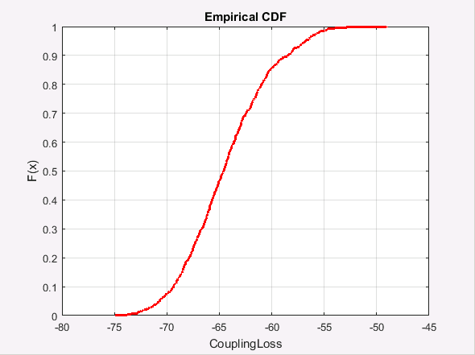 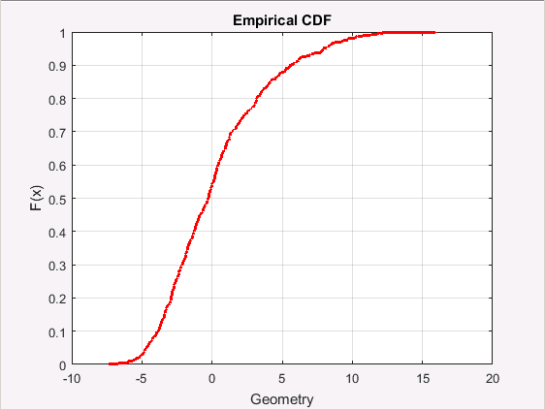

1. Coupling loss (b) DL geometry

Figure 1 - Distribution of the coupling loss and DL geometry

# Simulation setting and results

## Overall description of the simulation schemes

### Deployment

The agreed layout shown in Figure 2 is assumed for the simulations. The simulation assumptions are used from the Table 1 above. Results will be presented for SU MIMO without cell-cooperation and with cell cooperation. In addition we also provide simulation results for cell-cooperation with MU-MIMO.

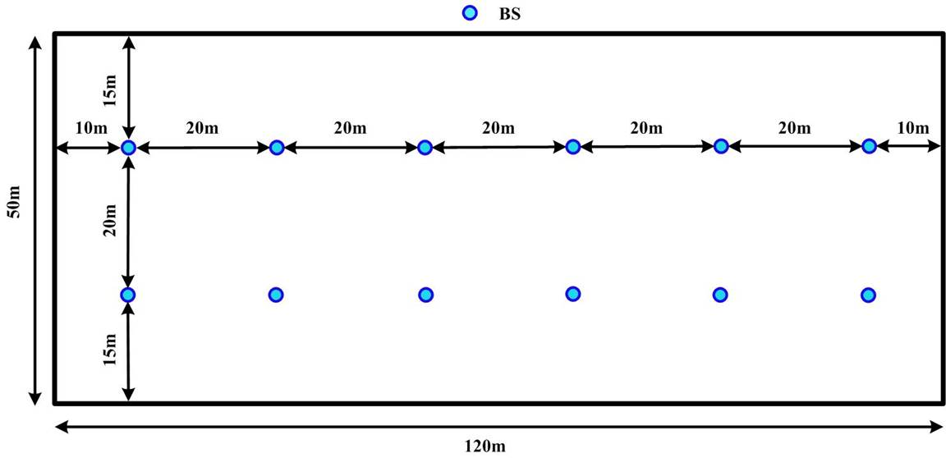

**Figure 2 -** Simulation scenario and BS layout

### Cell coordination

In our view, for the given scenario, cell cooperation can and should be implemented to further improve the performance. That is, the 12 BSs are treated as remote radio units (RRUs) that are connected to one baseband unit (BBU) through fibers to enable coordinated signal processing and transmission. This deployment, named as *distributed MIMO (D-MIMO)*, can provide significant SINR improvement and gives a great performance gain due to either coordinated or coherent transmissions from different BSs.

***Observation: In the given environment, the BSs can be treated as RRUs and cell cooperation should be assumed for the simulations.***

### Pre-scheduling

Since the packet arrival is deterministic, pre-scheduling is employed both at the gNB and UE side to remove the time for the transmission and the processing of DCIs from the latency budget for a packet. Specifically, for downlink transmission, the scheduling is done in advance to guarantee the DL DCI as well as the PDSCH can be transmitted on the first available TTI starting not earlier than $T_{1}$ after the packet arrival, where $T_{1}$ denotes the necessary time for DL data processing, including the TB assembling in the higher layer, the coding, modulation and precoding processes at base band, and the preparation for transmitting at the RF side. Similarly, for the UL transmission, the process of SR is omitted and the BS sends an UL grant to the UE prior to the packet arrival. Then upon the packet arrival, the UE immediately processes the data and transmits the PUSCH in the first available UL TTI starting not earlier than $T_{2}$ after the packet arrival, where $T_{2}$ denotes the necessary time for UL data processing, including the TB assembling in the higher layer, the coding, modulation and precoding processes at base band, and the preparation for transmitting at the RF side.

In the simulations, $T_{1}$ and $T_{2}$ are set to 3OS in case of 30 kHz SCS, this corresponds to nearly 55% of $N_{2}$ for the aggressive processing time Capability #2. Meanwhile, the data decoding at the BS and the UE are also set to 3OS, which corresponds to nearly 65% of $N_{1}$ for Capability #2.

***Scheduling mode: Dynamic scheduling is used both for UL and DL. But due to the deterministic characteristic of the data arrival, pre-scheduling is performed which reduces the latency in uplink and downlink processing.***

### Performance metric

In the following simulations, three metrics are evaluated, i.e. reliability, CSA and latency. During the simulations, a total number of $N_{T}$ packets are generated for every UE.

**The reliability** of one UE is computed as the “1 – PER” and $PER=N_{error}/N_{T}$ with $N_{error}$ denoting the number of packets that are blocked out of transmission or are unsuccessfully decoded at the receiver within the latency deadline.

**The CSA** of one UE is calculated according to the formula in the LS from 5G-ACIA, as shown below:

$$CSA=1-\sum_{n=2}^{∞}{P_{E}(n)\frac{nT_{I}-T_{s}}{nT_{I}}}$$

A survival time of one transfer interval, i.e. $T_{s}=T_{I}$ is assumed. Further $P_{E}(n)$ is computed as $P_{E}\left(n\right)=\frac{N_{E}(n)}{N_{T}/n}=\frac{n×N_{E}(n)}{N_{T}}$ with $N_{E}(n)$ denotes the number of occurrences that *n* consecutive packets are wrongly delivered. Note, that 1 occurrence of 3 consecutive wrongly delivered packets cannot be deemed as two occurrences of 2 consecutive wrongly delivered packets.

**The E2E latency** of a packet, if the packet is transmitted and successfully decoded at the receiver, includes the necessary *processing time* and *alignment delay at the transmitter*, the *transmission time*, and the necessary *processing time at the receiver*. Specifically, the components from Table 5.7.1.1.1-1 in 37.910 are used for latency computation of the DL transmission, and the components from Table 5.7.1.1.2-1 in 37.910 are used for latency computation of the UL transmission. Since only one-shot transmission is assumed, the setting of the component values is as shown in Table 2 and 3 below.

Table 2 - Latency for DL transmission

|  |  |  |  |
| --- | --- | --- | --- |
| ID | Component | Notations | Value |
| 1 | DL data transfer | *T*DL = (*t*BS,tx + *t*FA,DL) + *t*DL_duration + *t*UE,rx |  |
| 1.1 | BS processing delay | *t*BS,tx  The time interval between the data has arrived, and packet is generated. | $T_{1}$ as analyzed above with a value of 3OS, nearly 55% of Tproc,2/2, with d2,1= d2,2= d2,3=0 and UE capability #2 |
| 1.2 | DL Frame alignment (transmission alignment) | *t*FA,DL  It includes frame alignment time, and the waiting time for next available DL slot | The slot format is 6D : 2S : 6U, and the TTI length is 6OS for both DL and UL. The specific value of the alignment delay depends on the time instance of the packet arrival. |
| 1.3 | TTI for DL data packet transmission | *t*DL_duration | TTI is of 6OS |
| 1.4 | UE processing delay | *t*UE,rx  The time interval between the PDSCH is received and the data is decoded; | 3 OS as analyzed above, nearly 65% of Tproc,1 with d1,1 = d1,2 = 0 and UE capability #2 in case of No additional PDSCH DM-RS configured |

Table 3 - Latency for UL transmission

|  |  |  |  |
| --- | --- | --- | --- |
| ID | Component | Notations | Value |
| 2 | UL data transfer | *T*UL = (*t*UE,tx + *t*FA,UL)+ *t*UL_duration + *t*BS,rx |  |
| 2.1 | UE processing delay | *t*UE,tx  The time interval between the data is arrived, and packet is generated; | $T_{2}$ as analyzed above with a value of 3OS, nearly 55% of Tproc,2/2, with d2,1= d2,2= d2,3=0 and UE capability #2 |
| 2.2 | UL Frame alignment (transmission alignment) | *t*FA,UL  It includes frame alignment time, and the waiting time for next available UL slot | The slot format is 6D : 2S : 6U, and the TTI length is 6OS for both DL and UL. The specific value of the alignment delay depends on the time instance of the packet arrival. |
| 2.3 | TTI for UL data packet transmission | *t*UL_duration | TTI is of 6OS |
| 2.4 | BS processing delay | *t*BS,rx  The time interval between the PUSCH is received and the data is decoded; | 3 OS as analyzed above, nearly 65% of Tproc,1 with d1,1 = d1,2 = 0 and UE capability #2 in case of No additional PDSCH DM-RS configured |

Note, that the alignment delay is the time gap between the time instance at which the transmitter finishes the signal processing and the beginning of the next available transmission TTI, and is computed for each UE (with a fixed packet arrival time) during the simulation. Meanwhile, if the packet transmission is blocked or unsuccessfully decoded at the receiver within the latency deadline, the E2E latency is set to 1ms.

**Assumptions on overhead:** The overhead for DCI in the downlink TTI and the overhead of SRS in the uplink TTI are set to 20%, and Type-2 DMRS is considered, leading to a DMRS overhead of about 6% in each TTI.

## Results and performance analysis

In addition to the geometry and coupling loss used for calibration, the following three results are recommended in [2] to be presented for the purpose of comparison and calibration across companies.

* Tabulated values for percentage of UEs satisfying 1ms latency and 99.9999% reliability/CSA requirement for each simulated case
* CDF of packet error rate for UL and DL
* CDF of CSA for UL and DL

In the following sections, the *CDF of the E2E latency* is also provided.

### Simulation results for single-layer SU transmission with uncoordinated cells

In the simulations, the simulation time is 1e5 s and hence $N_{T}=$ 1e8 packets are generated for every UE. The performance of different scheduling strategies is investigated:

#### Orthogonal frequency reusing among TRPs

For simulation, the CSA requirement is 99.9999%, i.e., the probability of two consecutive packet errors should be less than 1e-6. Due to this extremely high reliability requirement, an extreme scheme (*orthogonal frequency reusing among TRPs)*, is employed to completely remove the inter-cell interference for guaranteeing the transmission reliability. This comes of course at the cost of reduced spectrum utilization. In the simulation, each TRP occupies 22 RBs out of the totally available bandwidth, and different TRPs use different RBs. Meanwhile, in each DL/UL TTI, all active UEs would be evenly distributed between the 12 TRPs to match the resource allocation. Since there is no interference, the transmission SINR is very high and the reliability can be guaranteed even with the highest possible MCS which is (772/1024, 64QAM). As a result, at most 12*(22/2) = 132 UEs can be served in each TTI with the transmission to/from each UE occupying 2 RBs. Since there are two TTIs available per millisecond, at most 264 UEs can satisfy the latency and reliability requirements. These numbers are also obtained in the simulations with the results shown in Table 4 below: when we drop 264 UEs randomly in the factory, all UEs achieve the target 1ms latency and 99.9999% reliability requirement.

Table 4 - Percentage of UEs satisfying 1ms E2E latency and 99.9999% reliability/CSA requirement for orthogonal frequency reusing in case of single SU with cell coordination

|  |  |  |  |  |
| --- | --- | --- | --- | --- |
| Number of UEs in the factory | Reliability | | CSA | |
| DL | UL | DL | UL |
| 264 | 100% | 100% | 100% | 100% |

The CDF of the PER and CDF of the CSA are omitted since all UEs can achieve a PER smaller than 1e-6 and a CSA larger than 99.9999%.

The E2E latency distribution is shown in the following figure. Since the pre-scheduling method is used and the processing times at the BS and at the UE are the same, the DL and UL transmissions also have the same E2E latency distribution. All packets can be successfully received by the UE or gNB and hence have an E2E latency smaller than 1ms. Differences in the E2E latency come from the alignment delays, which depend on the random time instance of the packet arrival.

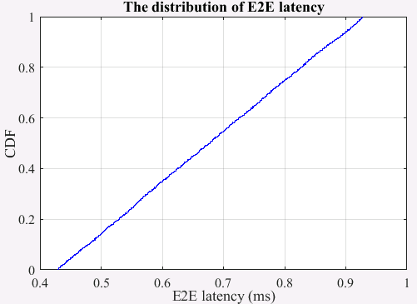

**Figure 3 -** Distribution of the E2E latency for DL and UL transmissions

#### Extremely conservative resource allocation

In case of no cell coordination and non-orthogonal frequency reusing, another extremely conservative resource allocation (RA) is employed to protect the transmission from possible inter-cell interference. Specifically, we firstly allocate the resources for different UEs according to their CSI feedback, and then if there are some resources left, we allocate the remaining resources in this TTI proportionally to the UEs to provide redundancy that is used for protecting the transmissions as much possible. Note, that this extremely conservative RA strategy may lead to non-negligible inter-cell interference and hence may not be the best solution, but it is useful as a baseline, easy for implementation and without any increase on the simulation burden.

The performance in terms of percentage of UEs satisfying 1ms latency and 99.9999% reliability/CSA requirement is shown in Table 5 below. For DL, the URLLC capacity is about 75 UEs in the factory when all UEs can satisfy the 1ms latency and 99.9999% CSA requirement. For UL, the performance is a little better, and the URLLC capacity is about 100 UEs in the factory. This performance gain over the DL is due to a better interference management in the UL due to the power control strategy.

Table 5 - Percentage of UEs satisfying 1ms E2E latency and 99.9999% reliability/CSA requirement for extremely conservative RA strategy in case of single SU without cell coordination

|  |  |  |  |  |
| --- | --- | --- | --- | --- |
| Number of UEs in factory | Reliability | | CSA | |
| DL | UL | DL | UL |
| 50 | 100% | 100% | 100% | 100% |
| 75 | 100% | 100% | 100% | 100% |
| 100 | 75% | 100% | 80% | 100% |
| 125 | -- | 80% | -- | 96% |

The CDF of PER and CDF of CSA are shown in the Figure 4 below.

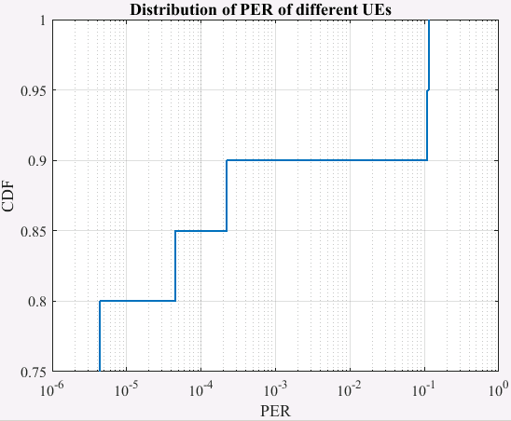 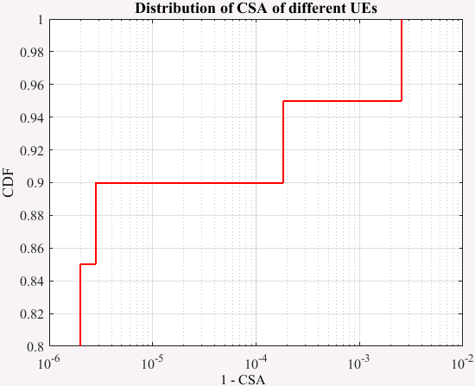

(a) Reliability of DL (b) CSA of DL

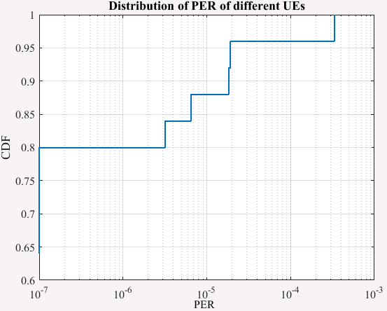 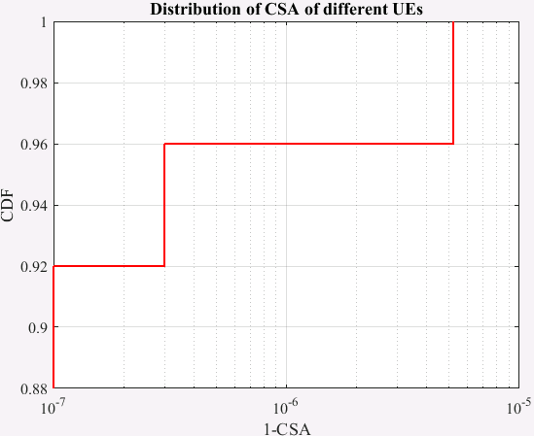

(a) Reliability of UL (b) CSA of UL

Figure 4 - CDF of CSA and CDF of reliability

The E2E latency distribution is shown in Figure 5 below. Since the pre-scheduling method is used and the processing time at the BS and UE is the same, the DL and UL transmissions also have the same E2E latency distribution. Note, that although some packets cannot be successfully received by the UE or the gNB and hence get an E2E latency of 1ms asserted, their ratio is very small and cannot be seen in the figures.

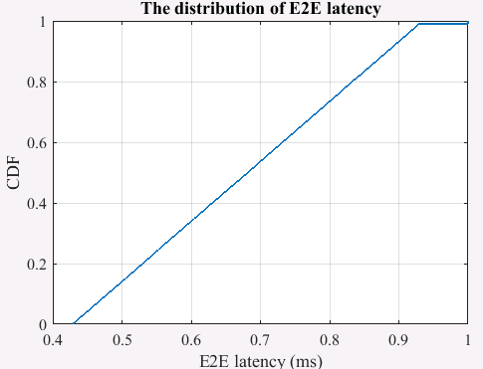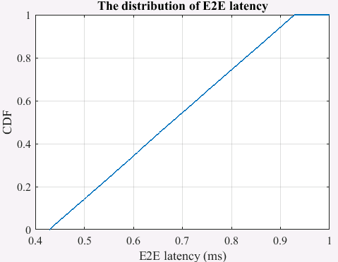

**Figure 5** Distribution of the E2E latency for DL and UL transmissions

#### Other resource allocation strategies.

From the results obtained above, it is found that the conservative RA strategy is not capacity optimal since it can result in quite significant inter-cell interference. The number of supported UEs depends on the selected scheduling strategy.

***For comparison of results across companies, companies should describe the selected resource allocation strategy.***

For a scheme that balances between protection through redundancy and interference alleviation, the number of supported UEs might be higher than for the 2 schemes simulated above. Simulation results on further approaches are intended to be provided in an updated version of this document.

### Simulation results for single-layer SU transmission with cell coordination

The performance in terms of percentage of UEs satisfying the 1ms latency and 99.9999% reliability/CSA requirement is shown in Table 6 below. Similar to the orthogonal frequency allocation scheme, the performance is very good since there is no inter-cell interference and the achieved SINR is very large. In the simulation, the highest possible MCS is (772/1024, 64QAM) and one packet occupies at least 2 PRBs in the simulation, limiting the maximum number of supported UEs to 273/2*2 = 272 with 273 being the maximum number of PRBs in 100MHz bandwidth in case of 30 kHz SCS. These numbers are also obtained in the simulations, with the results shown in Table 6 below.

Table 6 - Percentage of UEs satisfying 1ms E2E latency and 99.9999% reliability/CSA requirement in case of single SU with cell coordination

|  |  |  |  |  |
| --- | --- | --- | --- | --- |
| Number of UEs in the factory | Reliability | | CSA | |
| DL | UL | DL | UL |
| 272 | 100% | 100% | 100% | 100% |

The CDF of PER and CDF of CSA are omitted since all UEs can achieve a PER smaller than 1e-6 and a CSA larger than 99.9999%.

The E2E latency distribution is similar to Figure 5, in which the DL and UL transmissions also have the same E2E latency distribution and their value is random depending on the arrival time of each packet.

### Simulation results for MU transmission with cell coordination

For MU transmission, the maximum number of transmission layers for one UE is set to 1 and the number of layers of paired UEs on one resource is set to *L*.

#### Performance of DL transmission

The performance in terms of percentage of UEs satisfying 1ms latency and 99.9999% reliability/CSA requirement is shown in Table 7 below. For *L* = 2, the resulting SINR is very high due to the presence of only one inter-layer interference and also because there are enough antennas at the UE side for interference cancellation. As a result, the target reliability can be guaranteed even when a packet transmission occupies 2 RBs, i.e., using the highest MCS. But for *L* = 4, it becomes difficult for the UE to always perfectly cancel the three layers of inter-UE interference especially when the UE has a large moving velocity (75 Km/h). As a result, a larger number of RBs should be allocated to enable smaller coding rates and hence to provide a better error correction capability. Comparing the case of 544 UEs, the performance of *L* = 2 is better than performance of *L* = 4, implying that it is better to set a small rank, but still being larger than one, for spatial multiplexing in URLLC applications.

Due to that 1ms survival time is considered, the performance of CSA is very good, and a minimum of 2 RBs is sufficient to guarantee the 99.9999% CSA requirements in case of *L* = 4. This can also be derived from the detailed distribution of PER and 1-CSA in Figure 6. It is shown that all users can achieve a PER smaller than 1e-3 even although no users can achieve a PER of 1e-6 in case of 1088 UEs, while all UEs can achieve a CSA larger than 1-1e-7 in the same case.

Table 7 Percentage of UEs satisfying 1ms E2E latency and 99.9999% reliability/CSA requirement in the DL transmission

|  |  |  |  |
| --- | --- | --- | --- |
| MU-MIMO  Number of users | Reliability | | CSA |
| *L* = 4 | *L* = 2 | *L* = 4 |
| 525 | 100% | 100% | 100% |
| 544 | 87.5% | 100% | 100% |
|  |  |  |  |
| 900 | 0% | / | 100% |
| 1000 | 0% | / | 100% |
| 1088 | 0% | / | 100% |

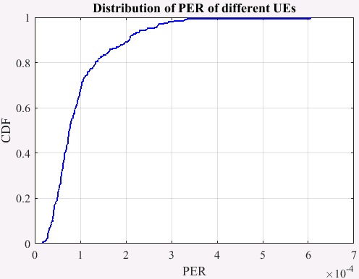 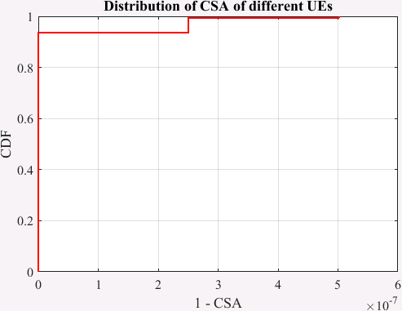

(a) PER (b) CSA

**Figure 6** Distribution of achieved BLER and 1-CSA in the DL transmission for *L*=4 and 1088 UEs

The distribution of the E2E latency for DL transmission in case of *L*=4 and 1088 UEs is shown in the following Figure 7. It can be found that for successfully decoded packets, the E2E latency depends on the alignment delay at the transmitter, and there is a very small part of packets which is unsuccessfully decoded and hence their E2E latency is set to 1ms.

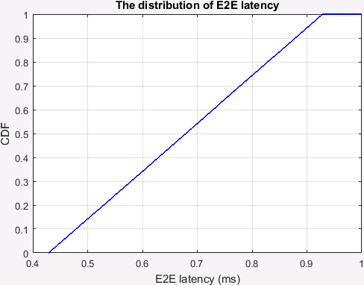 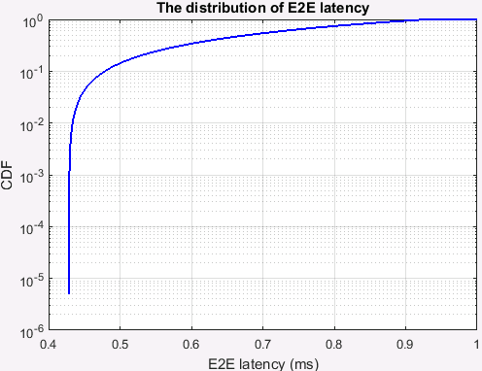

**Figure 7** Distribution of the E2E latency in the DL transmission for *L*=4 and 1088 UEs

# Conclusion

In this paper we presented the simulation results for the 4GHz carrier frequency.

For SU MIMO with no cell cooperation, at least for the orthogonal frequency reusing, up to 264 UEs can be supported, while still fulfilling the E2E latency, reliability and CSA requirements. For comparison across companies, it would be good if companies would describe the resource allocation that has been used in their simulations.

For SU MIMO with cell cooperation, at least for the single-layer case, up to 272 UE can be supported, while still fulfilling the E2E latency, reliability and CSA requirements.

For MU schemes, at least for DL, more UEs can be supported. Allowing spatial multiplexing of 2 UEs, a maximum of 544 UEs still meet the latency, reliability and CSA requirements. Allowing 4 UEs to be multiplexed, 1088 UE can be supported while still fulfilling CSA and latency requirements. However, the reliability requirement cannot be met for these cases.

In general in can be concluded that at least for DL, the MU transmission is better than the SU scheme due to enhanced spectrum efficiency even though some inter-layer interference would be incurred, especially when a survival time of one transfer interval is considered in CSA.

# References

[1] “Final proposals on URLLC features and simulation assumptions”, Ericsson, 3GPP RAN 5G-ACIA Evaluations Week 1, October 12th-16th, 2020

[2] “Summary of discussion in Week 2”, Ericsson, 3GPP RAN 5G-ACIA Evaluations Week 2, December 14th-18th, 2020

[3] “Simulation assumptions for calibration Final,”