**3GPP TSG RAN Meeting #90-e RP-202803**

**Electronic Meeting, December 7-11, 2020**

**Agenda Item:**  **9.2.2**

**Source: Samsung**

**Title:** **Summary for WI:** **Enhancement on MIMO for NR**

**WI code(s): NR_eMIMO**

**leading WG: RAN1**

**Release: Rel-16**

### 1 Introduction

This work item (WI) introduced enhanced specification support for several key aspects on multi-input multi-output (MIMO) operation where Rel.15 NR was found deficient in terms of spectral efficiency, downlink/uplink transmit power efficiency, signalling latency, and signalling overhead.

**First**, although high-resolution downlink (DL) channel state information (CSI) can be made available to the gNB by the Type-II CSI (thereby facilitating high DL spectral efficiency), the associated uplink (UL) reporting overhead is prohibitively high. This would burden the system since such high-resolution DL CSI is typically used with large number of users per cell.

**Second**, Rel.15 mainly focuses on single-TRP-based transmission/reception with ideal backhaul from UE perspective. Enhancements for Multi-TRP/panel transmission are to further improve DL data rate and spectral efficiency by fully utilizing multi-TRP/panel simultaneously with non-coherent joint transmission (NCJT) in ideal/non-backhaul conditions, or further exploit spatial diversity with time/frequency domain repetition to improve transmission reliability.

**Third**, although Rel.15 supports flexible beam management (BM) functionality to accommodate various implementation and usage scenarios, Rel.15 BM signaling framework could require a large amount of signaling for updating beam RS and pathloss reference RS for respective DL and UL signals when the best DL-UL beam pair is changed frequently due to UE mobility, rotation, or beam blockage. Therefore, in Rel.16, five features were introduced for the purpose of BM signaling overhead and latency reduction. Additionally, in Rel.15, L1-RSRP-based beam measurement and reporting are supported. To facilitate interference-aware beam selection, L1-SINR-based beam measurement and reporting were introduced. Finally, in Rel.15, beam failure recovery (BFR) is supported only for spCell. To improve the performance and reliability for SCell, BFR for SCell was introduced.

**Fourth**, a high peak to average power ratio (PAPR) issue identified for Rel.15 DM-RS for PDSCH, PUSCH and PUCCH format 3 and 4 was corrected by defining new Rel.16 DM-RS which have the same PAPR as its associated data/control channel.

**Fifth**, in Rel.15 UL codebook-based transmission, the non-coherent and partial-coherent codebook subsets –especially with lower rank transmission– cannot reach the maximum output power (declared by the UE) with power scaling mechanism. Three modes of UL full-power transmission and three UE capabilities are specified to accommodate different power amplifier (PA) architectures.

### 2 Description

2.1 MU-MIMO CSI

For MU-MIMO transmission, the PMI codebook is designed to represent dominant channel eigenvectors for multiple SBs with high-resolution. In matrix form, this corresponds to an $N×K$*channel matrix $H_{N,K}$* as shown in Figure 1, where $K$ is number of SBs, and the *k*-th column of $H_{N,K}$ corresponds to channel eigenvector for SB *k*.



**Figure 1** Channel matrix.

The Rel. 15 Type II CSI is based in compressing (columns of) $H_{N,K}$ in spatial domain (SD) by performing linear combination (LC) of $L>1$ SD basis vectors that comprise columns of matrix $W_{1}$. In particular, an eigenvector ***e*** of the channel is expressed as a LC of *L* Discrete Fourier Transform (DFT) vectors: $e≈\sum_{i=0}^{L-1}{c_{i}b_{i}}$. This is illustrated in Figure 2. The PMI codebook is used to report the following components:

* $W_{1}$: DFT vectors ${\left\{b_{i}\right\}}_{i=0}^{L-1}$ reported common for all SBs (WB reporting); and
* $W_{2}$: amplitude and phase of coefficients ${\left\{c_{i}\right\}}_{i=0}^{L-1}$ reported independently for each SB (SB reporting).



**Figure 2**Linear combination based Rel. 15 Type II CSI feedback.

Although Rel. 15 Type II CSI can offer large performance gain, the overhead (number of bits) to report Type II CSI is $O(L×K×Rank)$ which can be excessively large (cf. Table 1).

Table 1 Rel. 15 Type II CSI reporting payload (bits) for 10 SBs

|  |  |  |  |  |  |  |
| --- | --- | --- | --- | --- | --- | --- |
| *L* | W1 (bits) | | W2 (bits) | | Total (bits) | |
| Rank 1 | Rank 2 | Rank 1 | Rank 2 | Rank 1 | Rank 2 |
| 2 | 22 | 33 | 12 | 24 | 142 | 273 |
| 4 | 39 | 63 | 24 | 48 | 279 | 543 |

The Rel.15 Type II CSI compresses (columns of) $H_{N,K}$ in SD by performing LC using SD basis matrix $W_{1}$, and there is no compression across rows of $H_{N,K}$ in frequency domain (FD). The LC coefficients that combine columns of $W_{1}$ matrix is given by columns of matrix $W_{2}=pseudo_inv\left(W_{1}\right)H_{N,K}=W_{1}^{H}H_{N,K}$. It is well-known that each row of $W_{2}$ matrix (that corresponds to $K$ FD components such as frequency SBs) comprises LC coefficients that are correlated. This correlation in FD can be exploited to reduce Type II CSI payload without significant impact on throughput performance.

In the Rel.16 enhanced Type II CSI, $H_{N,K}$ is compressed in both SD and FD by performing LC using *L* SD DFT basis vectors, i.e. columns of $W_{1}$ for SD compression, and *M* FD DFT basis vectors, i.e. columns of $W_{f}=\left[f_{0}…f_{M-1}\right]$ for FD compression. This is illustrated in Figure 3, wherein the SD compression is performed using $W_{1}$, and the resultant $W_{2}$ matrix is compressed in FD domain using $W_{f}$. The $2L×M$ coefficient matrix after SD/FD compression is ${\tilde{W}}_{2}=W_{2}W_{f}$ .

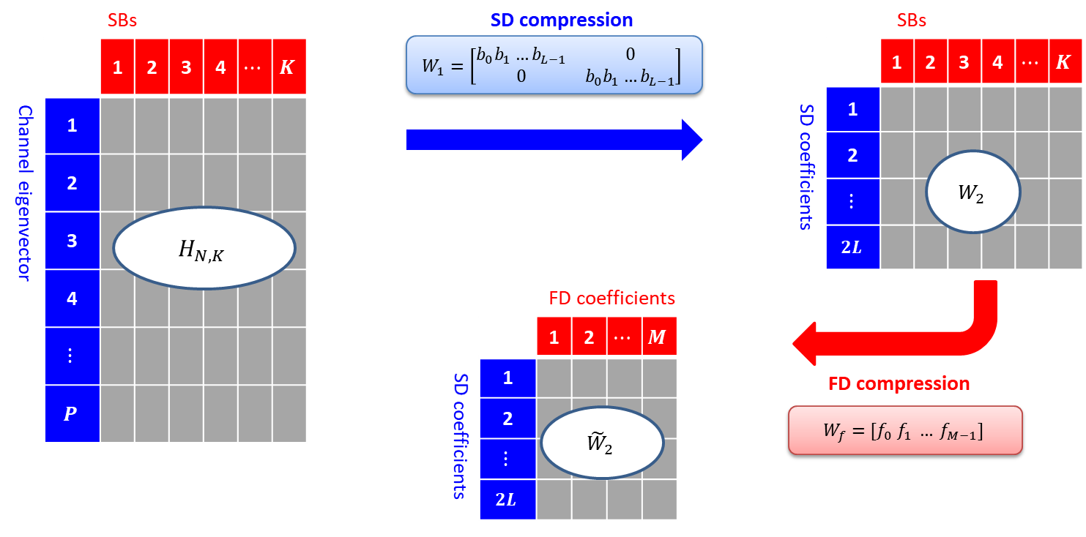

**Figure 3** Frequency compression of $H_{N,K}$.

The PMI codebook parameterized by $\left(L,M,K_{0}\right)$ is used to report the following components:

* $W_{1}$: SD DFT vectors ${\left\{b_{i}\right\}}_{i=0}^{L-1}$ reported common for all SBs (WB reporting);
* $W_{f}$: FD DFT vectors ${\left\{f_{m}\right\}}_{m=0}^{M-1}$ reported independently for each SBs (SB reporting), where $M=\left\lceil p×K\right\rceil$; and
* ${\tilde{W}}_{2}$: comprises following components
  + Non-zero subset selection: $K_{0}$ out of $2LM$ non-zero (NZ) coefficients of ${\tilde{W}}_{2}$ are selected, and remaining $2LM-K_{0}$ coefficients are set to 0, where $K_{0}=\left\lceil β×2LM\right\rceil$
    - Restriction: to ensure that the overhead is not too large, the following restriction is applied $K^{NZ}≤2K_{0}$ and $K^{NZ,l}≤K_{0}$ where $K^{NZ,l}$ is a number of NZ coefficients for layer $l$ and $K^{NZ}$ is a total number of NZ coefficients across all layers
  + Strongest coefficient: 1 out of $K_{0}$ NZ coefficients is selected and is set to 1
  + Quantization: amplitude and phase of remaining $K_{0}-1$ NZ coefficients $\left\{c_{i,m}\right\}$ is reported.

The following add-on features are also supported:

* Amplitude restriction: for each SD index $i$, the average power of the NZ coefficients $c_{i,m}$ is restricted to be within a threshold
* $R$: for improved performance, the number of precoding matrices reported in each SB can be up to $R$ where $R∈\{1,2\}$; hence, the total number of precoding matrices can be up to $N_{3}=R×K$
* Two-step FD basis selection: to reduce overhead of FD basis selection, when $N_{3}>19$, the FD DFT vectors ${\left\{f_{m}\right\}}_{m=0}^{M-1}$ are selected from an intermediate basis set as shown in Figure 4, where the intermediate basis set comprises a window of $N_{3}^{'}$ FD bases and is reported common for all layers.

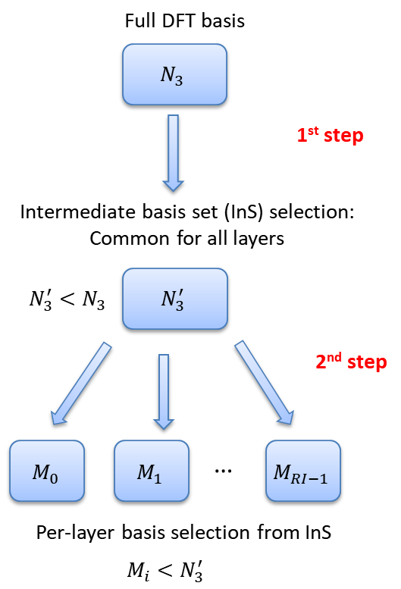 

**Figure 4**Two-step FD basis selection

The support of the following features is subject to separate UE capability signalling: rank > 2, R=2, L=6, and amplitude restriction.

2.2 Multi-TRP

Enhancements of Multi-TRP/panel transmission intends to improve DL data rate/spectral efficiency and transmission reliability with both ideal and non-ideal backhaul by fully utilizing multi-TRP/panel simultaneously since Rel.15 specification mainly focus on single TRP based transmission/reception, from the UE perspective.

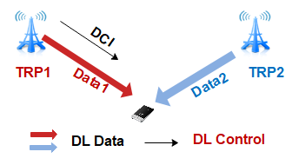

**Figure 5**Two-TRP (DL) transmission/reception

To improve DL date rate, both single-DCI and multi-DCI based non-coherent joint transmission (NCJT) are supported.

* For multi-DCI-based NCJT transmission, up to 4 transmission layers per PDSCH, a UE may expect to receive two PDCCHs scheduling two fully/partially/non-overlapped PDSCHs respectively in time and frequency domain with same/different PDSCH scrambling ID(s). When the UE is scheduled with fully or partially overlapping PDSCHs, the UE is not expected to assume DM-RS ports in a CDM group indicated by two TCI states. Some configurations related to two received PDSCHs, e.g. active BWP, etc are expected to be same from UE perspective. The UE can be expected to rate match around configured CRS patterns which are associated with the value of CORESETPoolIndex, i.e. per TRP basis, and applied to the corresponding PDSCH.

For PDCCH monitoring, two TRPs are implicitly associated with two CORESET groups, i.e. up to 3 CORESETs per TRP, respectively each of which can be identified by the value of CORESETPoolIndex. The maximum number of BD/CCE in a serving cell can be doubled for two TRPs but the maximum number of BD/CCE per TRP remains to be same as Rel.15.

Scheduling timeline can be relaxed to support out-of-ordered PDCCH to PDSCH, PDSCH to HARQ-ACK, and PDCCH to PUSCH depending on UE capability considering different backhaul conditions between two TRPs.

Both intra-slot separated HARQ-ACK (per TRP basis) and joint HARQ-ACK feedback (across two TRPs) are supported and specified for type-1 and type-2 HARQ-ACK codebook in order to facilitate different backhaul conditions.

Last but not least, the maximum number of active TCI states in a serving cell can be doubled by independent activation from two TRPs but the maximum number of active TCI states per TRP remains the same as Rel.15.

* For single-DCI-based NCJT transmission, up to 8 transmission layers, each TCI code point can correspond to one or two TCI states (so as to 2-port PTRS if applicable) activated by MAC-CE. When 2 TCI states are indicated by DCI, the first TCI state corresponds to the CDM group of the first antenna port indicated by the antenna port indication table (e.g. the first TRP), and the second TCI state corresponds to the other CDM group (e.g. the second TRP). Additional new DMRS entry {0,2,3} with two CDM groups without data is supported to improve the flexibility of NCJT scheduling.

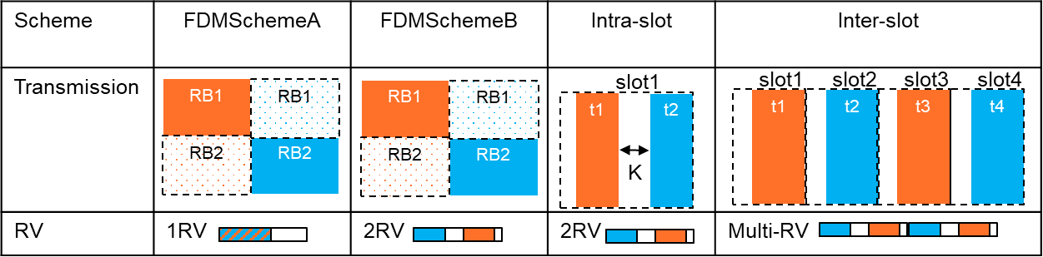

**Figure 6**Single-DCI-based NCJT

To improve DL transmission reliability with multi-TRP/panel, following transmission schemes are supported with single DCI and configured by higher layer signalling:

* 'FDMSchemeA': When two TCI states, i.e. two TRPs, are indicated in a DCI and the UE is set to 'FDMSchemeA', the UE shall receive single PDSCH transmission occasion of the TB with each TCI state associated to a non-overlapping frequency domain resource allocation in a manner of comb-like PRGs allocation (or half/half for wideband).
* 'FDMSchemeB': When two TCI states, i.e. two TRPs, are indicated in a DCI and the UE is set to 'FDMSchemeB', the UE shall receive two PDSCH transmission occasions of the same TB with each TCI state associated to non-overlapping frequency domain resource allocation in a manner of comb-like PRGs allocation (or half/half for wideband).
* 'TDMSchemeA' (Intra-slot): When two TCI states are indicated in a DCI and the UE is set to 'TDMSchemeA', the UE shall receive two PDSCH transmission occasions of the same TB with each TCI state associated to a PDSCH transmission occasion which has non-overlapping time domain resource allocation with respect to the other PDSCH transmission occasion. Both PDSCH transmission (corresponding to two TRPs respectively) occasions with mapping Type B only shall be received within a given slot with a symbol-level gap configured by StartingSymbolOffsetK.
* “repetitionNumber-r16” (Inter-slot): When a UE is configured by the higher layer parameter repetitionNumber-r16 in PDSCH-TimeDomainResourceAllocation-r16, the UE may expect to be indicated with one or two TCI states in a codepoint of the TCI field. When two TCI states are indicated in a DCI, the UE may expect to receive multiple slot level PDSCH transmission occasions of the same TB with two TCI states associated to repetitionNumber-r16 consecutive slots (up to 16). Each PDSCH transmission occasion is expected to have the same SLIV. The UE may be configured with either cyclicMapping or sequentialMapping for given TCI state mapping pattern.

Each PDSCH transmission occasion is limited to up to two transmission layers for above transmission schemes targeting at reliability improvement and indicated DMRS port(s) are expected to within one CDM group. The redundancy version for PDSCH transmission occasions associated with the second TCI state is shifted with respect to the value of ${rv}_{s}$ by sequenceOffsetforRV-r16 if applicable.

Additionally, default beam assumptions for FR2 are specified for receiving PDSCH, CSI-RS and PDCCH/PDSCH overlapping in case of single-DCI and multi-DCI based multi-TRP/panel transmission.

2.3 Multi-beam operation

For the purpose of BM signaling overhead/latency reduction, the following features were introduced:

* Default spatial relation/pathloss reference RS
  + Default spatial relation/pathloss reference RS for dedicated PUCCH
  + Default spatial relation/pathloss reference RS for PUSCH
  + Default spatial relation/pathloss reference RS for SRS
* Simultaneous TCI/spatial relation update across multiple CCs
  + Simultaneous TCI state ID activation for CORESET
  + Simultaneous TCI state ID(s) activation for PDSCH
  + Simultaneous spatial relation activation for aperiodic/semi-persistent SRS
* PUCCH spatial relation activation/deactivation per PUCCH resource group
* MAC CE based spatial relation indication for aperiodic/semi-persistent SRS
* MAC CE based pathloss reference RS update for aperiodic/semi-persistent SRS and PUSCH

First, the feature of default spatial relation/pathloss reference RS was introduced to reduce/omit UL specific beam/pathloss reference RS indication signaling, mainly targeting single beam UE that meets DL/UL beam correspondence requirement. In this mode of operation, spatial relation RS, i.e. UL beam RS, and pathloss reference RS does not need to be signalled to UE, and UE shall use a specific DL beam RS, e.g. the DL beam RS for the lowest ID CORESET, as for the spatial relation RS and the pathloss reference RS. Above operation can be enabled for dedicated PUCCH, SRS, and/or PUSCH scheduled by DCI format 0_0 by respective RRC enablers.

Second, simultaneous update of DL/UL beam RS across multiple CCs was introduced. Up to two CC lists can be configured by RRC for DL and UL, respectively. Once a DL beam RS ID is activated for a CORESET in a CC by MAC CE, the RS(s) with the same RS ID are activated in other CC(s) in the same CC list. Once one or more DL beam RS ID(s) are activated for PDSCH in a CC by MAC CE, the RS(s) with the same RS ID(s) are activated in other CC(s) in the same CC list. Once a spatial relation RS is activated for an aperiodic or semi-persistent SRS resource in a CC by MAC CE, the same RS is activated as spatial relation RS for the SRS resource(s) with the same resource ID in other CC(s) in the same CC list.

Third, in Rel.15, PUCCH spatial relation can be activated/deactivated per resource level, meaning that 128 MAC CEs may need to be signalled to UE for updating spatial relation for all PUCCH resources in the worst case. Based on above motivation, resource grouping based PUCCH spatial relation activation/deactivation was introduced. Up to four PUCCH resource groups can be configured by RRC per BWP, and one MAC CE can activate/deactivate a common spatial relation RS for all the PUCCH resources in the same group.

Fourth, in Rel.15, spatial relation for aperiodic SRS is configured by RRC only, which may lead to unnecessary RRC overhead for configuring a sufficient number of SRS resources or large latency for RRC reconfiguration. Based on above motivation, MAC CE based spatial relation indication for aperiodic/semi-persistent SRS was introduced. One MAC CE can update spatial relation(s) of one SRS resource set, where different spatial relation can be indicated per resource within the resource set.

Fifth, in Rel.15, pathloss reference RSs for UL power control for PUSCH and SRS can only be configured by RRC. Since up to four pathloss RSs can be configured in Rel.15, it could often require RRC reconfiguration according to UE mobility and considering gNB/UE beamforming. Based on above motivation, MAC CE based pathloss reference RS update for aperiodic/semi-persistent SRS and PUSCH was introduced. For this operation, the maximum configurable number of pathloss reference RSs by RRC was increased to 64, and the new MAC CE can activate up to four pathloss reference RSs among them. Two MAC CEs were introduced for SRS and PUSCH, respectively.

To facilitate interference-aware beam selection, L1-SINR-based beam measurement and reporting were introduced. The gNB can configure UE to measure and report L1-SINR based on SSB/CSI-RS. The following resource settings for L1-SINR measurement have been supported:

* L1-SINR measurement based on CSI-RS configured for beam management (BM) as channel measurement resource (CMR) and interference measurement resource (IMR)
* L1-SINR measurement based on SSB as CMR and CSI-IM
* L1-SINR measurement based on CSI-RS configured for BM as CMR and CSI-IM
* L1-SINR measurement based on SSB as CMR and non-zero-power (NZP) interference measurement resource (IMR)
* L1-SINR measurement based on CSI-RS configured for BM as CMR and NZP-IMR

In addition, to improve performance and reliability for SCell, BFR for SCell was introduced. The procedure for SCell BFR is illustrated in Figure 7 below.

* The beam failure detection (BFD) is based on periodic 1-port CSI-RS for BM, and the procedure is the same as spCell BFD.
* The candidate beam detection (CBD) is based on SSB and CSI-RS for BM, and the procedure is similar to spCell BFD, where cross-CC CBD is supported.
* The BFRQ report can include two steps
  + Step 1: UE sends a SR over PUCCH for BFR (which is dedicatedly configured) to indicate beam failure and request resource for BFR MAC CE report
    - If the SR is not configured, contention based PRACH can be used
    - gNB’s response is the same as normal SR procedure
  + Step 2: UE sends a BFR MAC CE to gNB, which conveys the following information
    - Failed CC index
    - Whether a new beam is identified or not
    - RS resource ID representing identified new beam
* After receiving the BFR MAC CE, gNB can send a PDCCH to schedule a new transmission for the same HARQ process used to transmit BFR MAC CE
  + After 28 symbols after UE receives the response, UE can apply the newly identified beam to all CORESETs and PUCCH resources in the CC reported by BFR MAC CE



**Figure 7**SCell BFR procedure

2.4 Low PAPR RS

It was identified that Rel.15 DM-RS for the PDSCH/PUSCH using non-transform precoded (CP-) OFDM waveform has a high PAPR issue, for transmissions of rank-2 and above. The issue occurs when DM-RS ports from different DM-RS CDM groups are linearly combined through the same power amplifier. The root cause of the issue was identified to be the use of the same DMRS sequence for all DMRS ports. In addition, for transform precoded OFDM, it was identified that when pi/2-BPSK modulation is used, then the PAPR of the PUSCH or PUCCH is lower than for the associated DM-RS which is a problem as different OFDM symbols will have different PAPR.

In Rel.16, the above issues were resolved as follows:

* For CP-OFDM PDSCH and PUSCH by letting the DM-RS sequence, $r\left(m\right)$, depend on the antenna port association to the CDM group index . This ensured that antenna ports in different CDM groups have different DM-RS sequences and this effectively removes the PAPR issue.
* For transform precoded PUSCH or PUCCH format 3 and 4, in all cases with pi/2-BPSK modulation, the Rel-16 low PAPR DM-RS sequences are introduced by applying a DFT-spread before being mapped to the time-frequency resource grid. In this case, pseudo-random (PRBS) or computer generated based pi/2-BPSK or 8-PSK sequences are used instead of the Rel.15 direct use of (i.e. non-DFT precoded) Zadoff-Chu sequences (see Figure 8). This means that Rel.16 DMRS will have similar sequence characteristics as the associated pi/2-BPSK modulated data/control and by then have similar PAPR, which resolves the high PAPR issue.



**Figure 8**pi/2-BPSK/8-PSK low PAPR DM-RS formation

* Four related UE capabilities were introduced:
  + FG 16-4 Low PAPR DMRS for PDSCH
  + FG 16-6a Low PAPR DMRS for PUSCH without transform precoding
  + FG 16-6b Low PAPR DMRS for PUCCH format 3 and 4 with transform precoding and with pi/2 BPSK
  + FG 16-6c Low PAPR DMRS for PUSCH with transform precoding and with pi/2 BPSK

2.5 Uplink (UL) full-power transmission

Three modes of operation are specified in Rel.16 as optional UE capabilities: fullpower, fullpowerMode1, fullpowerMode2. The UE can report one of the supported modes.

* fullpower: This mode targets the UEs with full-rated PAs. Using a 2-Tx PC3 non-coherent UE as an example, the UE is equipped with two 23dBm PAs. As shown in Figure 9, the UE transmits UL PUSCH using 1 antenna when the indicated TPMI is {1 0} with Rel.16 power scaling factor s=1. This implies that the transmit power is equally split among non-zero PUSCH antenna(s) thereby enabling the UE to deliver maximum output power.



**Figure 9**‘fullpower’ operation

* fullpowerMode1: A new TPMI subset is added. For a UE supporting non-coherent capability, a non-antenna selection TPMI is added with the same power scaling as in Rel.15. Figure 10 shows an example of a 2-Tx PC3 UE where each PA cannot deliver maximum output power. A new codebook subset for rank=1 includes {1 0}, {0 1}, {1 1}. With precoder {1 1}, the PC3 UE can transmit with total maximum output power of 23dBm on PUSCH. However, similar to Rel.15, precoders {1 0} and {0 1} do not deliver maximum output power.



**Figure 10**‘fullpowerMode1’ operation

* fullpowerMode2: To deliver maximum output power through TPMI reporting and antenna virtualization:
  + With multiple SRS resources configured in a set with different number of SRS ports (up to 4 SRS resources can be configured in a set): Using a 2 Tx non-coherent UE as an example, the gNB configures 2 SRS resources in a set where one SRS resource is configured with 1 port and another SRS resource is configured with 2 ports. The gNB indicates SRI corresponding to 1-port SRS while scheduling single layer transmission, and SRI corresponding to 2-port SRS while scheduling two-layer transmission.
  + 2) UE indicating full power TPMI/TPMI groups: Using as an example a 2-Tx non-coherent PC3 UE with PA architecture shown in Figure 11 where one PA is 23dBm and another 20dBm. The UE indicates TPMI=0 (i.e. precoder {1 0}) as full-power TPMI. When the gNB indicates full-power TPMI while scheduling PUSCH, the UE assumes power scaling factor s=1; when the gNB indicates non-full-power TPMI while scheduling PUSCH, the UE assumes Rel.15 power scaling mechanism. For 2Tx UE, UE can report 2 bits, bit-map on {TPMI=0, TPMI=1}. For a 4-Tx UE, to support non-coherent and partial-coherent implementations, seven TPMI groups {G0, G1, G2, G3, G4, G5, G6} are specified. A 4-Tx non-coherent UE can report capability to indicate 2-port TMPIs using 2-bit bitmap and one of 4-port non-coherent TPMI groups from G0~G3. A 4-Tx partial coherent UE can report capability to indicate 2-port TMPIs using 2-bit bitmap, one of 4-port non-coherent TPMI groups from G0~G3, and one of 4-port partial-coherent TPMI groups from G0~G6.. The TPMI groups G0~G6 are defined in TS 38.306.

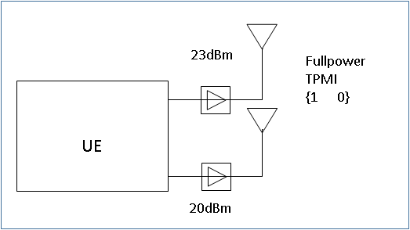

**Figure 11**‘fullpowerMode2’ operation

### 3 References

[1] RP-192271, Samsung, Revised WID: Enhancements on MIMO for NR

[2] R1-1913604, Samsung, RAN1 agreements for NR_eMIMO