3GPP TSG-RAN WG Meeting #90 Electronic RP-20xxxx
Online, 7 – 11 December 2020

Agenda item: 14
Source: Nokia (rapporteur)
Title: Summary of [90E][40][BWCS_reporting]
WID/SID: NR_NewRAT-Core - Release 15
Document for: Discussion and Decision

1 Introduction
This discussion handles the following document:
Tdoc | Title | Source
RP-202514 | BWCS reporting of intra-band parts of inter-band EN-DC | TELUS, Bell Mobility, Samsung

The document content which is related to the RAN2#112 discussion on the same subject:

New Input
R2-2011044 Clarification on BWCS for inter-ENDC BC with intra-ENDC band combination Bell Mobility, Telus, Nokia, Nokia Shanghai Bell
DISCUSSION
- Oppo wonder if the problem is that UEs in the field don’t apply the CR. Is that the issue? Nokia confirms, and have some additional questions. Oppo winder if this is mandatory for the UE. Yes this is how Nokia understands the R2 TS, but think this understanding is not for everyone.
- Ericsson wonder if we really need to clarify, the field descr seems to indicate that the UE shall report. Ericsson think we might need to check wider.
- ZTE wonders if there is other cases than 3A 3A. Nokia think this is one example, not sure there are more. ZTE are also ok to postpone.
- Apple are ok with email, but also ok to just postpone.
- Huawei are ok with intention, but need time to check ok to postpone,
- vivo wonder if UE doesn't support 3A 3A what to report. Nokia think we need to check UL configuration,
- Nokia suggest 1 week email to clarify the intentions, maybe no CR is needed.

- [Post112-e][052][NR15] BWCS for inter-ENDC BC with intra-ENDC band combination (Nokia)
Scope: Based on R2-2011044, collect comments, determine agreeable clarifications.
Intended outcome: Report, possibly draft CR, (unclear what ambition level can be possible).
Deadline: short email discussion (not for RP).
=> Postponed

As per the guidance, the goal of this disucssion is generate an agreeable way forward. To that end, section 2 first summarizes the technical background of RP-202514, whereas the section 3 is used for the questions and company responses that are used to generate the way forward.

2 Background
The discussion in RP-202514 boils down to a simple question: Does what UE supports for UL for an EN-DC band combination determine whether the band combination can be characterized as an intra-band EN-DC?
More specifically, the document highlights the example band combination DC_2A-7A-7A-66A-n66A, which is shown below:

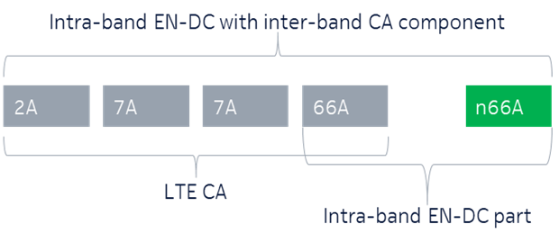
Figure 1: Illustration of example intra-band EN-DC band combination with additional inter-band NR/LTE CA component

As is typical with such EN-DC band combinations (with multiple bands), the support of UL can be on multiple parts. In particular, the above example requires UE to support UL on either 2A+n66A, 7A+66A or 66A+n66A, but NOT necessarily on all of those, as per the figure below (illustrating how to interpret the excerpt from 38.101-3):
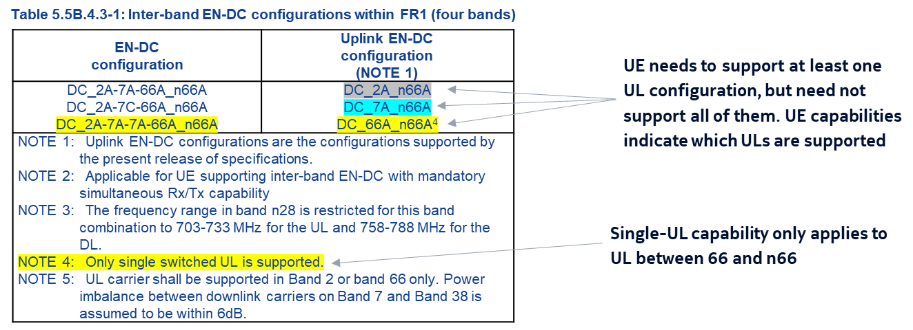
Figure 2: Illustration of possible UL capabilities for the example band combination
According to RAN2 fallback BC definition, if UE supports BC DC_2A-7A-7A-66A-n66A(with UL support using shown with bolding), UE shall support also all band combinations that arise from dropping away SCell, UL part of an SCell or SCG. Since RAN2 agreed CRs R2-2002390 & R2-2002127 mandate the reporting of the capability supportedBandwidthCombinationSetIntraENDC for band combinations involving intra-band EN-DC with additional inter-band NR/LTE CA component, it needs to be clear whether a UE indication BC DC_2A-7A-7A-66A-n66A is counted as intra-band EN-DC with additional inter-band NR/LTE CA component or not when UE does NOT support
Finally, we note (for discussion reference) that the document RP-202514 makes the following observations and one proposal based on those:
Observation 1: The reporting of the supportedBandwidthCombinationSetIntraENDC is mandatory for an intra-band EN-DC combination with an additinal inter-band NR/LTE CA component.
Observation 2: The current RAN2 CRs unnecessarily impose constraints on deployed UE’s only supporting the inter-band EN-DC and future UEs which do not intend to support the intra-band EN-DC portion of the bigger combination.
Proposal 1: Only if the UE supports the intra-band EN-DC and can additionally support the larger inter-band EN_DC, then the UE and the NW can view the DC combination as an intra-band EN-DC with inter-band components. The network assumes the intra-band EN-DC is not supported if the IE:supportedBandwidthCombinationSetIntraENDC is not reported, and the network is allowed to configure the larger inter-band EN-DC part (including the fallback BCs) for this band combination. .

3 Discussion
The discussion in this section focuses on attempting to find out how to characterize the intra-band EN-DC band combinations, and what are the implications of the decision.
Question 1 (concrete example band combination): If UE supports the band combination DC_2A-7A-7A-66A_n66A, so that UL (for DC) is only supported for 2A and n66A (i.e. UE does NOT support UL on 66A and n66A). Should UE indicate the capability supportedBandwidthCombinationSetIntraENDC (which is mandatory for intra-band EN-DC band combinations) in its capabilities for that band combination?
Answers to Question 1
Company | Yes/No | Technical Arguments
Apple | No | With no uplink on 66A, the UE cannot do intra-band EN-DC with 66A_n66A. So supportedBandwidthCombinationSetIntraENDC is not applicable and so requiring the UE to mandatorily report the BWCS is ambiguous. When the mandatory requirement was introduced in RAN2, it was RAN2 assumption that UE is expected to support intra-band EN-DC in a combination that has same LTE and NR bands, but this assumption is not valid anymore with some RAN4 inter-band DC combinations that can have some intra-band components where the support of intra-band EN-DC for these is not mandatory at the UE.
TELUS | No | This is the root cause of the problems we have in the field. The network expects the EN-DC combo to be intra-band band type simply because of the string parsing and ignores the fact that the intra-band non-mandatory UL combo does not work at all. Agree with Apple’s view.
AT&T |  | AT&T Response: We acknowledge the concern with the recent RAN2 CRs dealing with BWCS. We therefore recommend that this issue be resolved in RAN2 at the working group level.
T-Mobile USA |  | We agree with AT&T - This is a fairly complex problem that is best addressed by RAN2 and RAN4 before plenary decides on a solution.
vivo |  | Generally we agree with Apple, however we should discuss this issue in RAN2 group.
Huawei, HiSilicon | No and See comments | We understand supportedBandwidthCombinationSetIntraENDC does not differ UL and DL, it is a per BC reporting.  We are fine that in this case the UE does not report BWCS for intra-band EN-DC part, but then in this case we should clarify this means the DL for the intra-band EN-DC part is not supported as well, i.e. the fall back of intra-band EN-DC DC_66A_n66A is not supported in the higher order DC band combination for the example combination in Q1.
Bell Mobility | No | The UE should report supportedBandwidthCombinationSetIntraENDC only if it does support the intra-band EN-DC portion of the combination.  Agree with Apple
OPPO |  | In our understanding, the core problem here is for these type of UE, even though they do not support UL on 66A and n66A, in case they do support DL on 66A and n66A, how for the network to derive the bandwidth combination, if supportedBandwidthCombinationSetIntraENDC is not reported.  We are fine to handle this in WG level, as commented above.
Futurewei | No | Given the discrepancy between RAN2’s assumption when signalling was designed and current RAN4’s agreement of allowing optionality of intra-band components in inter-band DC combinations, the meaning of supportedBandwidthCombinationSetIntraENDC should be revisited in RAN2.
Samsung | No | We think the top level principle should be keeping the fallback definition which is defined in RAN2 specifications i.e. intra-band EN-DC without supporting uplink would not be the exception.  Agree with Apple.
Qualcomm Incorporated | No | Under the current specification, supportedBandwidthCombinationSetIntraENDC indeed indicates BWCSs of intra-band EN-DC band combination as defined in RAN4 specification.
Nokia | Unclear, see comments | Agree with Huawei that the RAN2 discussions did not comprehensively touch upon the dependency of the UL in the intra-band EN-DC discussion introducing the new capability. That implies that the terminology is rather unclear and needs further discussion in WG’s.  From our point of view, i.e. network, it is important to just have all the UE vendors align to a common understanding of the terminology, that is unambiguous, so that the network may be able to align to that understanding for the future.

Summary 1: TBD.
Proposal 1: TBD.

Question 2 (general definition): Does the support of UL on intra-band parts determine whether UE considers a band combination as "intra-band EN-DC with additional inter-band NR/LTE CA component"?
​
Answers to Question 2
Company | Yes/No | Technical Arguments
Apple | No and we are open to views | We think we do not have to associate UL capability as a clear indication of support of intra-band EN-DC. We like to see it the other-way around, in that UEs reporting supportedBandwidthCombinationSetIntraENDC indicate that they support intra-band EN-DC, and essentially view the DC combination as intra-band EN-DC with inter-band components. Our assumption is that RAN4 DC combinations where intra-band EN-DC is possible, will have BWCS defined in RAN4 spec (and we can request this be ensured). This way, there is no need to change the spirit of the current RAN2 spec 38.306.  If the UE does not report supportedBandwidthCombinationSetIntraENDC, the UE views/supports the DC combination as inter-band EN-DC with some same LTE and NR bands and the BWCS for these is taken from the RAN4 spec: union of LTE and NR CA BWCS.
TELUS | No | Agree with Apple’s view that only if the supportedBandwidthCombinationSetIntraENDC is reported, a combination should be considered "intra-band EN-DC with additional inter-band NR/LTE CA component". This way, the intra-band support is explicitly signalled, rather than being assumed.
T-Mobile USA |  | This should be sent to RAN2 and RAN4 for comment/resolution before Plenary adopts a technical solution.
vivo |  | We agree with T-Mobile USA.
Huawei, HiSilicon | No and See comments | As we explained above, if the UE reports support of BWCS for intra-band ENDC part, the network would assume the UE supports intra-band ENDC. Otherwise, in our understanding this can be interpreted as not supported for both UL and DL. We want to confirm this is the common understanding so that there is no inter-operability issue in the future. In any case, we think the network is still allowed to configure the inter-band ENDC part irrespective whether the intra-band ENDC is supported or not, and the BCS for the DC band combination relies on the bandwidth combinations by LTE inter/intra CA BCS as well as NR intra-CA BCS.  What we also want to mention here is that the support of UL is not only dependent on the BWCS reporting. We understand DC_2A-7A-7A-66A_n66A and DC_2A-7A-7A-66A_n66A are two different BCs as their UL combination is different, and would lead to different UL fallback BCs.
Bell Mobility | No | Agree with Apple. If supportedBandwidthCombinationSetIntraENDC is reported the combination is considered intra-band EN-DC with additional inter-band NR/LTE CA component. If supportedBandwidthCombinationSetIntraENDC is not reported the combination is inter-band EN-DC.
OPPO |  | As replied to Q1, in our understanding, the root problem is how to handle the DL part. After that is answered, we can come back to check the terminology / definition of intra-band EN-DC.
Futurewei | No | RAN2 should look into the signalling to allow the differentiation of UL capabilities in DC_2A-7A-7A-66A_n66A and DC_2A-7A-7A-66A_n66A.
Samsung | No | Agree with Apple and TELUS.
Qualcomm Incorporated |  | The wording was introduced by RAN2, and we do not think the lack of UL support in both RATs in intra-band EN-DC was not carefully considered by RAN2.
Nokia | Needs further discussion | Precisely same understanding as Qualcomm and what we already said for Q1.  From network point of view, as long as we have a consistent understanding of how to interpret the BC with intra-band EN-DC part in the DL (as the problem scenario) we are open to discuss, even if that means a change in terminology of what exactly an intra-band EN-DC means and if it is conditional to the support of single UL.
Summary 2: TBD.
Proposal 2: TBD.

Question 3 (field issue): If UE doesn't indicate supportedBandwidthCombinationSetIntraENDC for a band combination that is intra-band EN-DC with additional inter-band NR/LTE CA component, how is the UE support of BCS for the intra-band EN-DC downlink band entries determined?
Company | Explanation
Apple | Pls see comments to Q2. We think that we should not run into cases where the UE actually supports intra-band EN-DC but does not provide supportedBandwidthCombinationSetIntraENDC. We had quite a bit of discussion in RAN2 when the CRs were introduced and so any NBC issues then were not flagged by companies in RAN2. We expect all UEs to have implemented the CRs which require the UE which supports intra-band EN-DC to report supportedBandwidthCombinationSetIntraENDC. We can discuss this if we see companies believe that some UE implementations exist without the CR.
TELUS | Agree with Apple’s view.
T-Mobile USA | This should be sent to RAN2 and RAN4 for comment/resolution before Plenary adopts a technical solution.
vivo | We agree with T-Mobile USA.
Huawei, HiSilicon | See our answer in Q2. In general if companies want to more time to check in WG meetings, we think RAN plenary should mainly task RAN2 to have an agreeable solution as this is relevant to signalling reporting and interpretation, and the agreeable solution should be done by RAN#91e as this seems an urgent requirement from operators.
Bell Mobility | See answer to Q2. Agree with Apple’s view. The case where an UE in fact does support "intra-band EN-DC with additional inter-band NR/LTE CA component" the IE must be reported and there should be no NBC issues.
OPPO | As replied in Q1, this is exactly the root problem (maybe the problem can be reformulated, to avoid coupling with the terminology issue of “intra-band EN-DC with additional inter-band NR/LTE CA component”)
Futurewei | RAN should task RAN2 to work on this issue with the goal of providing solution by RAN#91.
Samsung | Agree with Apple’s view.  Suggested way forward from Huawei and Futurewei seems reasonable.
Qualcomm Incorporated | One possibility is to rely on the following requirements in 38.101-3, section 4.2.  A terminal which supports an EN-DC configuration shall support:  - If any subsets of the EN-DC configuration do not specify its own bandwidth combination sets in 5.3B, then the terminal shall support the same E-UTRA bandwidth combination sets it signals the support for in E-UTRA CA configuration part of E-UTRA – NR DC and shall support the same NR bandwidth combination sets it signals the support for in NR CA configuration part of E-UTRA – NR DC.  Additional clarification will be necessary when the NR side of the EN-DC band combination is non-CA, where the NR bandwidth combination sets are not signalled.
Nokia | There seems to be, at least, two solution directions proposed at least now,  - Solution 1 would be to consider the intra-band EN-DC in the DL part of a super set inter-band EN-DC BC and in that way the legacy NR BCS is used  - Solution 2 would be to have a default BCS understanding at network to workaround the issue that the network does not know the BCS of the intra-band EN-DC DL part  We need some time to discuss in the WG and the best thing would be to request RAN plenary to task the WG to come up with a consistent terminology and resolve the RAN2 signalling aspects if needed.

Summary 3: TBD.
Proposal 3: TBD.

4 Conclusion
TBA

Annex – Contact Points
Respondents to the email discussion are kindly asked to fill in the following table.
Company | Name | Email Address
Discussion moderator | Tero Henttonen | tero.henttonen@nokia.com
Apple | Naveen Palle | naveen_palle@apple.com
TELUS | Ivo Maljevic | ivo.maljevic@telus.com
AT&T | Don Zelmer | don.zelmer@att.com
T-Mobile USA | John Humbert | John.humbert2@T-Mobile.com
Huawei, HiSilicon | Yang Zhao | zhaoyang@huawei.com
Bell Mobility | Melissa Pinheiro | Melissa.pinheiro@bell.ca
Samsung | Seungri Jin | seungri.jin@samsung.com

