3GPP TSG-RAN WG Meeting #90 Electronic RP-20xxxx
Online, 7 – 11 December 2020

Agenda item: 14
Source: Nokia (rapporteur)
Title: Summary of [90E][40][BWCS_reporting]
WID/SID: NR_NewRAT-Core - Release 15
Document for: Discussion and Decision

1 Introduction
This discussion handles the following document:
Tdoc | Title | Source
RP-202514 | BWCS reporting of intra-band parts of inter-band EN-DC | TELUS, Bell Mobility, Samsung

The document content which is related to the RAN2#112 discussion on the same subject:

New Input
R2-2011044 Clarification on BWCS for inter-ENDC BC with intra-ENDC band combination Bell Mobility, Telus, Nokia, Nokia Shanghai Bell
DISCUSSION
- Oppo wonder if the problem is that UEs in the field don’t apply the CR. Is that the issue? Nokia confirms, and have some additional questions. Oppo winder if this is mandatory for the UE. Yes this is how Nokia understands the R2 TS, but think this understanding is not for everyone.
- Ericsson wonder if we really need to clarify, the field descr seems to indicate that the UE shall report. Ericsson think we might need to check wider.
- ZTE wonders if there is other cases than 3A 3A. Nokia think this is one example, not sure there are more. ZTE are also ok to postpone.
- Apple are ok with email, but also ok to just postpone.
- Huawei are ok with intention, but need time to check ok to postpone,
- vivo wonder if UE doesn't support 3A 3A what to report. Nokia think we need to check UL configuration,
- Nokia suggest 1 week email to clarify the intentions, maybe no CR is needed.

- [Post112-e][052][NR15] BWCS for inter-ENDC BC with intra-ENDC band combination (Nokia)
Scope: Based on R2-2011044, collect comments, determine agreeable clarifications.
Intended outcome: Report, possibly draft CR, (unclear what ambition level can be possible).
Deadline: short email discussion (not for RP).
=> Postponed

As per the guidance, the goal of this disucssion is generate an agreeable way forward. To that end, section 2 first summarizes the technical background of RP-202514, whereas the section 3 is used for the questions and company responses that are used to generate the way forward.

2 Background
The discussion in RP-202514 boils down to a simple question: Does what UE supports for UL for an EN-DC band combination determine whether the band combination can be characterized as an intra-band EN-DC?
More specifically, the document highlights the example band combination DC_2A-7A-7A-66A-n66A, which is shown below:

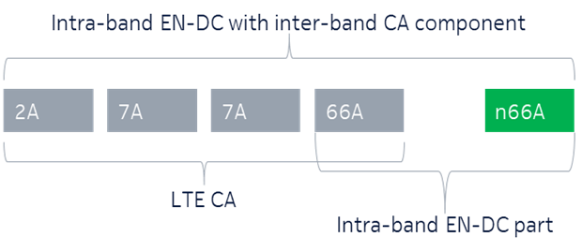
Figure 1: Illustration of example intra-band EN-DC band combination with additional inter-band NR/LTE CA component

As is typical with such EN-DC band combinations (with multiple bands), the support of UL can be on multiple parts. In particular, the above example requires UE to support UL on either 2A+n66A, 7A+66A or 66A+n66A, but NOT necessarily on all of those, as per the figure below (illustrating how to interpret the excerpt from 38.101-3):
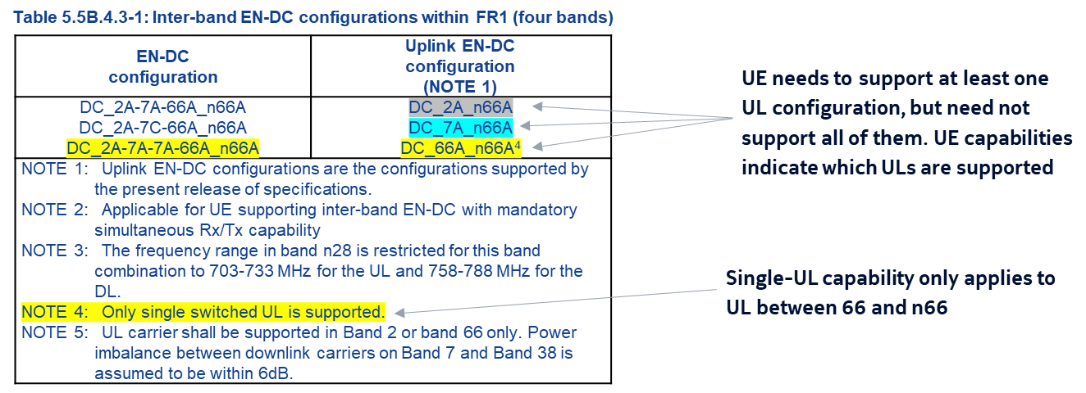
Figure 2: Illustration of possible UL capabilities for the example band combination
According to RAN2 fallback BC definition, if UE supports BC DC_2A-7A-7A-66A-n66A(with UL support using shown with bolding), UE shall support also all band combinations that arise from dropping away SCell, UL part of an SCell or SCG. Since RAN2 agreed CRs R2-2002390 & R2-2002127 mandate the reporting of the capability supportedBandwidthCombinationSetIntraENDC for band combinations involving intra-band EN-DC with additional inter-band NR/LTE CA component, it needs to be clear whether a UE indication BC DC_2A-7A-7A-66A-n66A is counted as intra-band EN-DC with additional inter-band NR/LTE CA component or not when UE does NOT support
Finally, we note (for discussion reference) that the document RP-202514 makes the following observations and one proposal based on those:
Observation 1: The reporting of the supportedBandwidthCombinationSetIntraENDC is mandatory for an intra-band EN-DC combination with an additinal inter-band NR/LTE CA component.
Observation 2: The current RAN2 CRs unnecessarily impose constraints on deployed UE’s only supporting the inter-band EN-DC and future UEs which do not intend to support the intra-band EN-DC portion of the bigger combination.
Proposal 1: Only if the UE supports the intra-band EN-DC and can additionally support the larger inter-band EN_DC, then the UE and the NW can view the DC combination as an intra-band EN-DC with inter-band components. The network assumes the intra-band EN-DC is not supported if the IE:supportedBandwidthCombinationSetIntraENDC is not reported, and the network is allowed to configure the larger inter-band EN-DC part (including the fallback BCs) for this band combination. .

3 Discussion
The discussion in this section focuses on attempting to find out how to characterize the intra-band EN-DC band combinations, and what are the implications of the decision.
Question 1 (concrete example band combination): If UE supports the band combination DC_2A-7A-7A-66A_n66A, so that UL (for DC) is only supported for 2A and n66A (i.e. UE does NOT support UL on 66A and n66A). Should UE indicate the capability supportedBandwidthCombinationSetIntraENDC (which is mandatory for intra-band EN-DC band combinations) in its capabilities for that band combination?
Answers to Question 1
Company | Yes/No | Technical Arguments
Apple | No | With no uplink on 66A, the UE cannot do intra-band EN-DC with 66A_n66A. So supportedBandwidthCombinationSetIntraENDC is not applicable and so requiring the UE to mandatorily report the BWCS is ambiguous. When the mandatory requirement was introduced in RAN2, it was RAN2 assumption that UE is expected to support intra-band EN-DC in a combination that has same LTE and NR bands, but this assumption is not valid anymore with some RAN4 inter-band DC combinations that can have some intra-band components where the support of intra-band EN-DC for these is not mandatory at the UE.
TELUS | No | This is the root cause of the problems we have in the field. The network expects the EN-DC combo to be intra-band band type simply because of the string parsing and ignores the fact that the intra-band non-mandatory UL combo does not work at all. Agree with Apple’s view.
AT&T |  | AT&T Response: We acknowledge the concern with the recent RAN2 CRs dealing with BWCS. We therefore recommend that this issue be resolved in RAN2 at the working group level.

Summary 1: TBD.
Proposal 1: TBD.

Question 2 (general definition): Does the support of UL on intra-band parts determine whether UE considers a band combination as "intra-band EN-DC with additional inter-band NR/LTE CA component"?
​
Answers to Question 2
Company | Yes/No | Technical Arguments
Apple | No and we are open to views | We think we do not have to associate UL capability as a clear indication of support of intra-band EN-DC. We like to see it the other-way around, in that UEs reporting supportedBandwidthCombinationSetIntraENDC indicate that they support intra-band EN-DC, and essentially view the DC combination as intra-band EN-DC with inter-band components. Our assumption is that RAN4 DC combinations where intra-band EN-DC is possible, will have BWCS defined in RAN4 spec (and we can request this be ensured). This way, there is no need to change the spirit of the current RAN2 spec 38.306.  If the UE does not report supportedBandwidthCombinationSetIntraENDC, the UE views/supports the DC combination as inter-band EN-DC with some same LTE and NR bands and the BWCS for these is taken from the RAN4 spec: union of LTE and NR CA BWCS.
TELUS | No | Agree with Apple’s view that only if the supportedBandwidthCombinationSetIntraENDC is reported, a combination should be considered "intra-band EN-DC with additional inter-band NR/LTE CA component". This way, the intra-band support is explicitly signalled, rather than being assumed.
Summary 2: TBD.
Proposal 2: TBD.

Question 3 (field issue): If UE doesn't indicate supportedBandwidthCombinationSetIntraENDC for a band combination that is intra-band EN-DC with additional inter-band NR/LTE CA component, how is the UE support of BCS for the intra-band EN-DC downlink band entries determined?
Company | Explanation
Apple | Pls see comments to Q2. We think that we should not run into cases where the UE actually supports intra-band EN-DC but does not provide supportedBandwidthCombinationSetIntraENDC. We had quite a bit of discussion in RAN2 when the CRs were introduced and so any NBC issues then were not flagged by companies in RAN2. We expect all UEs to have implemented the CRs which require the UE which supports intra-band EN-DC to report supportedBandwidthCombinationSetIntraENDC. We can discuss this if we see companies believe that some UE implementations exist without the CR.
TELUS | Agree with Apple’s view.

Summary 3: TBD.
Proposal 3: TBD.

4 Conclusion
TBA

Annex – Contact Points
Respondents to the email discussion are kindly asked to fill in the following table.
Company | Name | Email Address
Discussion moderator | Tero Henttonen | tero.henttonen@nokia.com
Apple | Naveen Palle | naveen_palle@apple.com
TELUS | Ivo Maljevic | ivo.maljevic@telus.com
AT&T | Don Zelmer | don.zelmer@att.com

