3GPP TSG-CT WG1 Meeting #138-e C1-225860

E-Meeting, 10th – 14th October 2022
CR-Form-v12.2
CHANGE REQUEST
 | 24.554 | CR | 0187 | rev | - | Current version: | 17.2.1
For HELP on using this form: comprehensive instructions can be found at
http://www.3gpp.org/Change-Requests.

Proposed change affects: | UICC apps |  | ME | X | Radio Access Network |  | Core Network

Title: | Add broadcast communication security related content
Source to WG: | vivo
Source to TSG: | CT1
Work item code: | 5G_ProSe |  |  |  |  |  | Date: |  |  | 2022-09-22
Category: | F |  |  |  |  |  | Release: |  |  | Rel-17
 | Use one of the following categories:  F (correction)  A (mirror corresponding to a change in an earlier release)  B (addition of feature),  C (functional modification of feature)  D (editorial modification)  Detailed explanations of the above categories can  be found in 3GPP TR 21.900. |  |  |  |  |  |  |  | Use one of the following releases:  Rel-8 (Release 8)  Rel-9 (Release 9)  Rel-10 (Release 10)  Rel-11 (Release 11)  …  Rel-16 (Release 16)  Rel-17 (Release 17)  Rel-18 (Release 18)  Rel-19 (Release 19)
Reason for change: |  | Per SA3 agreements on broadcast communication security related content (see TS 33.503):  6.4.2 Security requirements  There are no requirements for securing the broadcast mode 5G ProSe Direct Communication.  The 5G System shall protect against linkability and trackability attacks on Layer-2 ID and IP address for broadcast mode.  6.4.3 Security procedures  There are no particular procedures defined for securing the broadcast mode 5G ProSe Direct Communication.  The broadcast mode security mechanism to randomise the UE’s source Layer-2 ID and source IP address including IP prefix (if used), as defined in clause 5.5 of TS 33.536 [6], is reused in 5G ProSe to provide broadcast mode 5G ProSe Direct Communication security.  The above should be reflected in stage-3 spec as well.  Besides, the following NOTE was discussed and agreed in CT1#135e (see C1-223149):  NOTE: The UE implementation ensures that the value of the self-assigned source layer-2 ID is different from any other self-assigned source layer-2 ID(s) in use for 5G ProSe direct discovery as specified in clause 6.2.14, clause 6.2.15 and clause 8.2.1 and is different from any other provisioned destination layer-2 ID(s) as specified in clause 5.2.  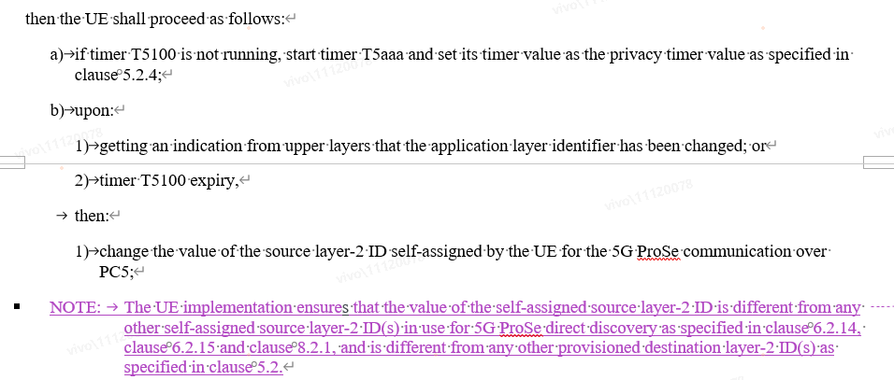  However, the NOTE was put in a worng place (i.e. not aligned with C1-223149 by editorial mistake). It is proposed to move it to the correct place.
Summary of change: |  | 1. Add a NOTE to state how to change and randomise the UE’s source Layer-2 ID and source IP address including IP prefix (if used) is specified in clause 5.5 of 3GPP TS 33.536.  2. move the NOTE 1 to a correct place.
Consequences if not approved: |  | Missing stage-3 requirement on broadcast communication security.
Clauses affected: |  | 7.3.2.4
 |  | Y | N
Other specs |  |  | X | Other core specifications |  |  |  | TS/TR ... CR ...
affected: |  |  | X | Test specifications |  |  |  | TS/TR ... CR ...
(show related CRs) |  |  | X | O&M Specifications |  |  |  | TS/TR ... CR ...
Other comments:
This CR's revision history:

* * * First Change * * * *

7.3.2.4 Privacy of 5G ProSe transmission over PC5
Upon initiating transmission of 5G ProSe communication over PC5, if:
a) the ProSe identifier of a ProSe application requesting transmission of 5G ProSe communication over PC5 is in the list of ProSe applications which require privacy for 5G ProSe communication over PC5 as specified in clause 5.2.4; and
b) the UE is located in a geographical area in which this ProSe application requires privacy for 5G ProSe communication over PC5 as specified in clause 5.2.4, or the UE is not provisioned any geographical areas in which this ProSe applications requires privacy for 5G ProSe communication over PC5,
then the UE shall proceed as follows:
a) if timer T5100 is not running, start timer T5100 and set its timer value as the privacy timer value as specified in clause 5.2.4;
b) upon:
1) getting an indication from upper layers that the application layer identifier has been changed; or

2) timer T5100 expiry,
then:
1) change the value of the source layer-2 ID self-assigned by the UE for the 5G ProSe communication over PC5;
NOTE 1: The UE implementation ensures that the value of the self-assigned source layer-2 ID is different from any other self-assigned source layer-2 ID(s) in use for 5G ProSe direct discovery as specified in clause 6.2.14, clause 6.2.15 and clause 8.2.1 and is different from any other provisioned destination layer-2 ID(s) as specified in clause 5.2.
2) if the data unit(s) contains IP data, change the value of the source IP address self-assigned by the UE for 5G ProSe communication over PC5;
NOTE X: How to change and randomise the UE's source layer-2 ID and source IP address including IP prefix (if used) is specified in clause 5.5 of 3GPP TS 33.536 [37] with the change of replacing V2X with 5G ProSe.
3) provide an indication to upper layers that the source layer-2 ID, or the source IP address, or both the source layer-2 ID and the source IP address are changed;
4) pass the changed source layer-2 ID and destination layer-2 ID, along with the corresponding PQFI down to the lower layer;
5) restart timer T5100; and
6) upon stopping transmission of the 5G ProSe communication over PC5, stop timer T5100.
* * * End of Changes * * * *

