3GPP TSG-CT WG1 Meeting #136-e C1-223415

E-Meeting, 12th – 20th May 2022
CR-Form-v12.1
CHANGE REQUEST
 | 23.122 | CR | 0932 | rev | - | Current version: | 17.6.0
For HELP on using this form: comprehensive instructions can be found at
http://www.3gpp.org/Change-Requests.

Proposed change affects: | UICC apps |  | ME | X | Radio Access Network |  | Core Network

Title: | UE without RPLMN
Source to WG: | Ericsson
Source to TSG: | C1
Work item code: | MINT |  |  |  |  |  | Date: |  |  | 2022-05-05
Category: | F |  |  |  |  |  | Release: |  |  | Rel-17
 | Use one of the following categories:  F (correction)  A (mirror corresponding to a change in an earlier release)  B (addition of feature),  C (functional modification of feature)  D (editorial modification)  Detailed explanations of the above categories can  be found in 3GPP TR 21.900. |  |  |  |  |  |  |  | Use one of the following releases:  Rel-8 (Release 8)  Rel-9 (Release 9)  Rel-10 (Release 10)  Rel-11 (Release 11)  ...  Rel-15 (Release 15)  Rel-16 (Release 16)  Rel-17 (Release 17)  Rel-18 (Release 18)
Reason for change: |  | 1) When the UE powers up for the 1st time, the UE has no RPLMN.  2) When the UE attempts to register with a PLMN and receives certain causes (e.g. 5GMM cause #11 "PLMN not allowed") according to TS 23.122 table 1 (see below), the UE also has no RPLMN.  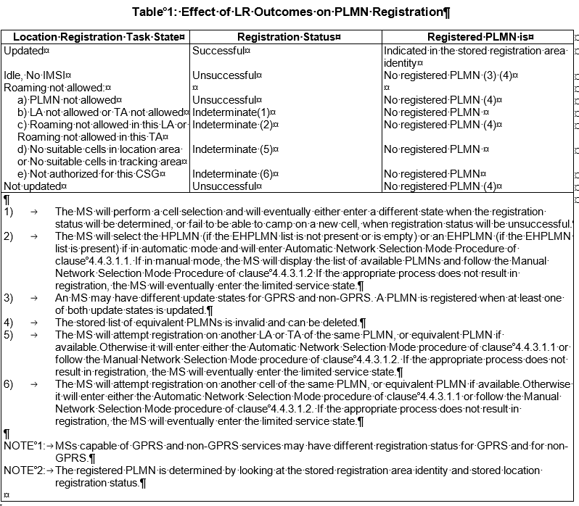  Such UE should also be able to obtain disaster roaming service as TS 22.261 states "UEs may obtain service in the event of a disaster, if there are PLMN operators prepared to offer service.".
Summary of change: |  | The UE can select a PLMN for disaster roaming even when the UE does not have RPLMN.
Consequences if not approved: |  | UE which does not have RPLMN cannot obtain disaster roaming service.
Clauses affected: |  | 4.4.3.1.1
 |  | Y | N
Other specs |  |  | X | Other core specifications |  |  |  | TS/TR ... CR ...
affected: |  |  | X | Test specifications |  |  |  | TS/TR ... CR ...
(show related CRs) |  |  | X | O&M Specifications |  |  |  | TS/TR ... CR ...
Other comments:
This CR's revision history:

***** change *****

4.4.3.1.1 Automatic Network Selection Mode Procedure
The MS selects and attempts registration on other PLMN/access technology combinations, if available and, for bullets i, ii, iii, iv, v, allowable, in the following order:
i) either the HPLMN (if the EHPLMN list is not present or is empty) or the highest priority EHPLMN that is available (if the EHPLMN list is present) ;
ii) each PLMN/access technology combination in the "User Controlled PLMN Selector with Access Technology" data file in the SIM (in priority order);
iii) each PLMN/access technology combination in the "Operator Controlled PLMN Selector with Access Technology" data file in the SIM (in priority order) or stored in the ME (in priority order);
iv) other PLMN/access technology combinations with received high quality signal in random order;
NOTE 1: High quality signal is defined in the appropriate AS specification.
v) other PLMN/access technology combinations in order of decreasing signal quality.
vi) PLMN/NG-RAN combinations for any forbidden PLMNs matching the below conditions:
a) if the indication of 'applicability of "lists of PLMN(s) to be used in disaster condition" provided by a VPLMN' is set to true:
- each PLMN in the "list of PLMN(s) to be used in disaster condition" stored in the ME which is associated with the PLMN ID of the determined PLMN with disaster condition, if any, ordered based on this list; otherwise
- if the ME does not have a stored "list of PLMN(s) to be used in disaster condition" associated with the PLMN ID of the determined PLMN with disaster condition, each PLMN in the "list of PLMN(s) to be used in disaster condition" stored in the ME which is associated with the PLMN ID of the HPLMN, if any, ordered based on this list.
b) if the indication of 'applicability of "lists of PLMN(s) to be used in disaster condition" provided by a VPLMN' is set to false:
- each PLMN in the "list of PLMN(s) to be used in disaster condition" stored in the ME which is associated with the HPLMN, if any, ordered based on this list.
vii) PLMN/NG-RAN combinations for other forbidden PLMNs, in random order.
When following the above procedure the following requirements apply:
a) An MS with voice capability shall ignore PLMNs for which the MS has identified at least one GSM COMPACT.
b) In A/Gb mode or GSM COMPACT, an MS with voice capability, or an MS not supporting packet services shall not search for CPBCCH carriers.
c) In ii and iii, the MS should limit its search for the PLMN to the access technology or access technologies associated with the PLMN in the appropriate PLMN Selector with Access Technology list (User Controlled or Operator Controlled selector list).
An MS using a SIM without access technology information storage (i.e. the "User Controlled PLMN Selector with Access Technology" and the "Operator Controlled PLMN Selector with Access Technology" data files are not present) shall instead use the "PLMN Selector" data file, for each PLMN in the "PLMN Selector" data file, the MS shall search for all access technologies it is capable of. The priority ordering amongst the access technologies is implementation dependent.
d) In iv, v, vi and vii, the MS shall search for all access technologies it is capable of, before deciding which PLMN to select.
e) In ii, and iii, a packet only MS which supports GSM COMPACT, but using a SIM without access technology information storage (i.e. the "User Controlled PLMN Selector with Access Technology" and the "Operator Controlled PLMN Selector with Access Technology" data files are not present) shall instead use the "PLMN Selector" data file, for each PLMN in the "PLMN Selector" data file, the MS shall search for all access technologies it is capable of and shall assume GSM COMPACT access technology as the lowest priority radio access technology.
f) In i, the MS shall search for all access technologies it is capable of. No priority is defined for the preferred access technology and the priority is an implementation issue, but "HPLMN Selector with Access Technology" data file on the SIM may be used to optimise the procedure.
g) In i, an MS using a SIM without access technology information storage (i.e. the "HPLMN Selector with Access Technology" data file is not present) shall search for all access technologies it is capable of. The priority ordering amongst the access technologies is implementation dependent. A packet only MS which supports GSM COMPACT using a SIM without access technology information storage shall also assume GSM COMPACT access technology as the lowest priority radio access technology.
NOTE 2: For f) and g), the MS in automatic network selection mode can end the PLMN search procedure once the HPLMN or the highest priority EHPLMN is found on an access technology.
NOTE 3: For i, ii and iii, the MS can use location information to determine which PLMNs can be available in its present location.
h) In v, the MS shall order the PLMN/access technology combinations in order of decreasing signal quality within each access technology. The order between PLMN/access technology combinations with different access technologies is an MS implementation issue.
NOTE 4: Requirements a) and b) apply also to requirement d), so a GSM voice capable MS should not search for GSM COMPACT PLMNs, even if capable of GSM COMPACT.
NOTE 5: Requirements a) and b) apply also to requirement f), so a GSM voice capable MS should not search for GSM COMPACT PLMNs, even if this is the only access technology on the "HPLMN Selector with Access Technology" data file on the SIM.
i) In i to vii, the MS shall not consider PLMNs where voice service was not possible as PLMN selection candidate, unless such PLMN is available in GERAN or UTRAN or no other allowed PLMN is available.
j) In i to v, if the MS only supports EMM-REGISTERED without PDN connection (see 3GPP TS 24.301 [23A]), the MS shall not consider PLMNs which do not advertise support of EMM-REGISTERED without PDN connection.
k) In i to v, if the MS only supports control plane CIoT EPS optimization (see 3GPP TS 24.301 [23A]) and the MS camps on a E-UTRA cell which is not NB-IoT cell (see 3GPP TS 36.304 [43], 3GPP TS 36.331 [42]), the MS shall not consider PLMNs which do not advertise support of EPS services with control plane CIoT EPS optimization.
l) In i to vii, if the MS is in eCall only mode, the MS shall not consider PLMNs which do not advertise support for eCall over IMS, unless such PLMNs are available in GERAN or UTRAN.
NOTE 6: As an implementation option, an MS in eCall only mode that was not able to select any PLMN according to l) can perform a second iteration of i to v with no restriction.
m) In i to vii, if the MS supports CAG and:
1) is provisioned with a non-empty "CAG information list", the MS shall consider a PLMN indicated by an NG-RAN cell only if:
A) the cell is a CAG cell and broadcasts a CAG-ID for the PLMN such that there exists an entry with the PLMN ID of the PLMN in the "CAG information list" and the CAG-ID is included in the "Allowed CAG list" of the entry; or
B) the cell is not a CAG cell and:
- there is no entry with the PLMN ID of the PLMN in the "CAG information list"; or
- there exists an entry with the PLMN ID of the PLMN in the "CAG information list" but the "indication that the MS is only allowed to access 5GS via CAG cells" is not included in the entry; or
2) is provisioned with an empty "CAG information list" or is not provisioned with a "CAG information list", the MS shall consider a PLMN indicated by an NG-RAN cell only if the cell is not a CAG cell.
n) In i to vii, if the MS only supports control plane CIoT 5GS optimization (see 3GPP TS 23.501 [62]) and the MS camps on an E-UTRA cell connected to 5GCN, which is not NB-IoT cell (see 3GPP TS 36.304 [43], 3GPP TS 36.331 [42]), the MS shall not consider PLMNs which do not advertise support of 5GS services with control plane CIoT 5GS optimization.
o) In i to vii, if the MS supports CIoT 5GS optimizations, the MS shall not consider the PLMN/access technology combinations for which the MS preferred CIoT network behaviour is not advertised as supported by the PLMN/access technology combination (see 3GPP TS 24.501 [64]).
NOTE 7: As an implementation option, the MS supporting CIoT 5GS optimizations that was not able to select any PLMN according to o) can perform a second iteration of i to v with no restriction.
p) In iii, the MS shall use the PLMN/access technology combination in the "Operator Controlled PLMN Selector with Access Technology" stored in the ME, if the last update of the "Operator Controlled PLMN Selector with Access Technology" was due to receiving steering of roaming information containing the "list of preferred PLMN/access technology combinations" (see annex C) and storing it in the ME. Otherwise, the MS shall use the "Operator Controlled PLMN Selector with Access Technology" list retrieved from the SIM.
q) for vi and vii, the MS shall determine the PLMN with disaster condition from PLMNs:

- in the "list of one or more PLMN(s) with disaster condition for which disaster roaming is offered by the available PLMN" broadcast by any NG-RAN cell; and
- which are allowable;
in the following order:
- either the registered PLMN or equivalent PLMN (if it is available);
- the HPLMN (if the EHPLMN list is not present or is empty) or the highest priority EHPLMN that is available (if the EHPLMN list is present);
- each PLMN in the "User Controlled PLMN Selector with Access Technology" data file in the SIM (in priority order);
- each PLMN in the "Operator Controlled PLMN Selector with Access Technology" data file in the SIM (in priority order) or stored in the ME (in priority order);
- other PLMNs.
r) The MS shall perform vi and vii to select a PLMN for disaster roaming only if:
1) the MS supports MINT;
2) the indication of whether disaster roaming is enabled in the UE stored in the ME is set to "Disaster roaming is enabled in the UE";
3) there is no available PLMN which is allowable;
4) the MS is not in 5GMM-REGISTERED state and 5GMM-CONNECTED mode over non-3GPP access (see 3GPP TS 24.501 [64]);
4a) the MS does not have a PDN connection via an ePDG connected to EPC; and
5) an NG-RAN cell of the PLMN:
A) broadcasts the disaster related indication; or
Editor's note: (WI:MINT, CR#0734) it is FFS whether the disaster related indication indicates (a) solely that the available PLMN is accessible for disaster inbound roamers or (b) that the available PLMN is accessible for disaster inbound roamers and all other PLMNs have disaster condition.
Editor's note: (WI:MINT, CR#0841) PLMN Selection aspects for disaster related indication is FFS.
B) broadcasts a "list of one or more PLMN(s) with disaster condition for which disaster roaming is offered by the available PLMN" which includes the determined PLMN with disaster condition.
s) In i to vii, if the MS only supports NR RedCap and the MS camps on an NR cell connected to 5GCN, the MS shall not consider PLMNs which do not advertise support of NR RedCap.
t) In i to vii, if the MS detects a PLMN in satellite NG-RAN access technology which fulfils the conditions related to the list of "PLMNs not allowed to operate at the present UE location" as defined in clause 3.1, it shall not consider the PLMN as PLMN selection candidate for satellite NG-RAN access technology.
If successful registration is achieved, the MS indicates the selected PLMN.
If registration cannot be achieved because no PLMNs are available and allowable, and the MS does not support access to RLOS, the MS indicates "no service" to the user, waits until a new PLMN is available and allowable and then repeats the procedure.
If there were one or more PLMNs which were available and allowable, but an LR failure made registration on those PLMNs unsuccessful or an entry in any of the lists "forbidden location areas for roaming", "forbidden tracking areas for roaming", "5GS forbidden tracking areas for roaming", "forbidden location areas for regional provision of service", "forbidden tracking areas for regional provision of service", "5GS forbidden tracking areas for regional provision of service", "CAG information list", or "PLMNs not allowed to operate at the present UE location" prevented a registration attempt, the MS selects the first such PLMN again and enters a limited service state.
If:
- the MS supports access to RLOS;
- either the UICC containing the USIM is not present in the MS, or the UICC containing the USIM is present in the MS and the MCC part of the IMSI in the USIM is present in the RLOS allowed MCC list configured in the USIM (see 3GPP TS 31.102 [40]) or in the ME (see 3GPP TS 24.368 [50]);
- one or more PLMNs offering access to RLOS has been found;
- registration cannot be achieved on any PLMN; and
- the MS is in limited service state,
the MS shall select a PLMN offering access to RLOS as follows:
a) if at least one preferred PLMN exists based on the RLOS preferred PLMN list configured in the USIM (see 3GPP TS 31.102 [40]) or in the ME (see 3GPP TS 24.368 [50]) and the MCC part of the preferred PLMN ID is present in the RLOS allowed MCC list configured in the USIM (see 3GPP TS 31.102 [40]) or in the ME (see 3GPP TS 24.368 [50]), the MS shall select the preferred PLMN offering access to RLOS and indicate the selected preferred PLMN for access to RLOS; and
b) if none of the preferred PLMNs for access to RLOS is available, the MS shall evaluate the remaining PLMNs offering access to RLOS that are not in the RLOS preferred PLMN list. If the MCC part of a PLMN ID is present in the RLOS allowed MCC list configured in the USIM (see 3GPP TS 31.102 [40]) or in the ME (see 3GPP TS 24.368 [50]), the MS shall select this PLMN and indicate the selected PLMN for access to RLOS.
If registration cannot be achieved because no PLMNs are available and allowable, and if no PLMN offering access to RLOS has been found, or none of the PLMNs offering access to RLOS is allowed to be accessed according to the RLOS allowed MCC list configured in the USIM (see 3GPP TS 31.102 [40]) or in the ME (see 3GPP TS 24.368 [50]), or the MS does not support access to RLOS, the MS indicates "no service" to the user, waits until a new PLMN is available and then repeats the procedure.

