3GPP TSG-CT WG1 Meeting #136-e C1-223738

E-Meeting, 12th – 20th May 2022
CR-Form-v12.1
CHANGE REQUEST
 | 24.501 | CR | 4370 | rev | - | Current version: | 17.6.1
For HELP on using this form: comprehensive instructions can be found at
http://www.3gpp.org/Change-Requests.

Proposed change affects: | UICC apps |  | ME | X | Radio Access Network |  | Core Network

Title: | Clarify the purpose of UE-initiated UE state indication procedure
Source to WG: | vivo
Source to TSG: | C1
Work item code: | 5GProtoc17 |  |  |  |  |  | Date: |  |  | 2022-05-04
Category: | F |  |  |  |  |  | Release: |  |  | Rel-17
 | Use one of the following categories:  F (correction)  A (mirror corresponding to a change in an earlier release)  B (addition of feature),  C (functional modification of feature)  D (editorial modification)  Detailed explanations of the above categories can  be found in 3GPP TR 21.900. |  |  |  |  |  |  |  | Use one of the following releases:  Rel-8 (Release 8)  Rel-9 (Release 9)  Rel-10 (Release 10)  Rel-11 (Release 11)  …  Rel-15 (Release 15)  Rel-16 (Release 16)  Rel-17 (Release 17)  Rel-18 (Release 18)
Reason for change: |  | Based on the statement in TS 24.501:  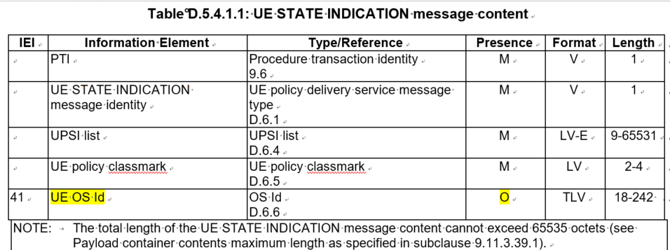  When the UE initiate the UE-initiated UE state indication procedure, the UE OS ID is an optional IE, which is different with the UPSI list and the UE policy classmark.  Hence, for the statement about the purpose of UE-initiated UE state indication procedure, we prefer to mark “to deliver the UE's one or more OS IDs” as optional.
Summary of change: |  | It’s proposed to mark “to deliver the UE's one or more OS IDs” as optional.
Consequences if not approved: |  | Misleading about the purpose of UE-initiated UE state indication procedure.
Clauses affected: |  | D 2.2.1
 |  | Y | N
Other specs |  |  | X | Other core specifications |  |  |  | TS/TR ... CR ...
affected: |  |  | X | Test specifications |  |  |  | TS/TR ... CR ...
(show related CRs) |  |  | X | O&M Specifications |  |  |  | TS/TR ... CR ...
Other comments:
This CR's revision history:

*******
* * * First Change * * * *

D.2.2.1 General
The purpose of the UE-initiated UE state indication procedure is:
a) to deliver the UPSI(s) of the UE policy section(s) which are:
- identified by a UPSI with the PLMN ID part indicating the HPLMN or the selected PLMN; and
- stored in the UE;
to the PCF if the UE has one or more stored UE policy sections identified by a UPSI with the PLMN ID part indicating the HPLMN or the selected PLMN; and
b) to indicate whether UE supports ANDSP; and
c) to deliver the UE's one or more OS IDs, if the OS ID(s) is included in the UE STATE INDICATION message.

* * * End of Changes * * * *

