3GPP TSG-CT WG1 Meeting #133e-bis C1-22XXXX

E-meeting, 17-21 January 2022
CR-Form-v12.1
CHANGE REQUEST
 | 24.193 | CR | 0074 | rev | 1 | Current version: | 17.3.0
For HELP on using this form: comprehensive instructions can be found at
http://www.3gpp.org/Change-Requests.

Proposed change affects: | UICC apps |  | ME | X | Radio Access Network |  | Core Network | X

Title: | Clarification on PLR measurement procedure abnormal handling
Source to WG: | Mediatek Inc.
Source to TSG: | C1
Work item code: | ATSSS_Ph2 |  |  |  |  |  | Date: |  |  | 2022-01-19
Category: | F |  |  |  |  |  | Release: |  |  | Rel-17
 | Use one of the following categories:  F (correction)  A (mirror corresponding to a change in an earlier release)  B (addition of feature),  C (functional modification of feature)  D (editorial modification)  Detailed explanations of the above categories can  be found in 3GPP TR 21.900. |  |  |  |  |  |  |  | Use one of the following releases:  Rel-8 (Release 8)  Rel-9 (Release 9)  Rel-10 (Release 10)  Rel-11 (Release 11)  ...  Rel-15 (Release 15)  Rel-16 (Release 16)  Rel-17 (Release 17)  Rel-18 (Release 18)
Reason for change: |  | Based on current 24.193, the PLR measurement procedure includes 2 sub-procedures: the PLR count procedure and the PLR report procedure, for example:  5.4.6 UE-initiated PLR measurement procedure  5.4.6.2 UE-initiated PLR count procedure  5.4.6.2.3 Abnormal cases in the UE  The following abnormal cases can be identified:  a) Expiration of the timer T103  Upon expiration of the timer T103, the UE shall abort the procedure.  5.4.6.3 UE-initiated PLR report procedure  5.4.6.3.3 Abnormal cases in the UE  The following abnormal cases can be identified:  a) Expiration of the timer T104  Upon expiration of the timer T104, the UE shall abort the procedure.  Based on current 24.193 5.4.6 UE-initiated PLR (Packet Loss Rate) measurement procedure, one example is given below:  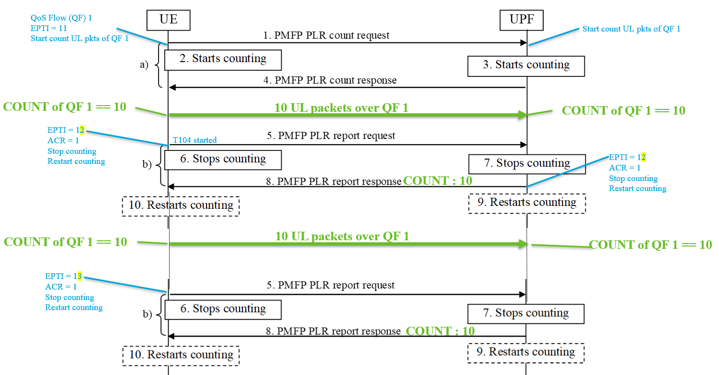  To measure the PLR of the QoS Flow 1, the UE  - use ETPI 11 for the PLR count procedure,  - use ETPI 12 for the PLR report procedure (with ACR set to 1),  - use ETPI 13 for the PLR report procedure.  However if there is anormal, the counting may be wrong, for example:  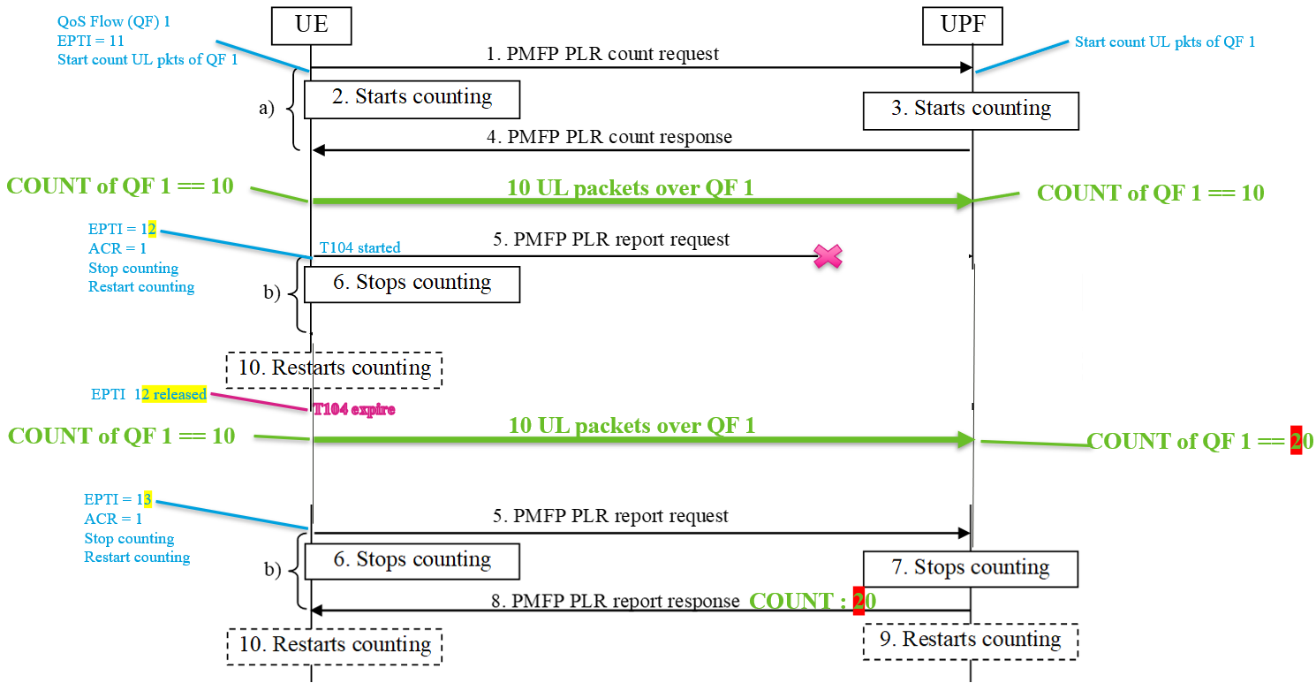  Considering the above abnormal case, if the first PMFP PLR report request is not received by the UPF, when T104 expires, according to 24.193 the UE "abort the procedure" per 5.4.6.3.3, because the UPF does not restart counting thus if the UE initiate the UE-initiated PLR report procedure again, the number counted by the UPF can be wrong, e.g., the COUNT is 20 on UPF side even though that there are only 10 UL packets sent by the UE after T104 expires.  In order to solve this problem, it is proposed that  - upon expiration of T104, the UE abort the whole "UE-initiated PLR measurement procedure", not just abort the sub "procedure".  - similaryly, upon expiration of T204, the NW abort the whole "network-initiated PLR measurement procedure", not just abort the sub "procedure".
Summary of change: |  | Handle abnormal scenario for PLR measurement procedure
Consequences if not approved: |  | Abnormal scenario for PLR measurement procedure is not handled properly
Clauses affected: |  | 5.4.6.2.2, 5.4.6.3.3, 5.4.7.2.2, 5.4.7.3.3
 |  | Y | N
Other specs |  |  | X | Other core specifications |  |  |  | TS/TR ... CR ...
affected: |  |  | X | Test specifications |  |  |  | TS/TR ... CR ...
(show related CRs) |  |  | X | O&M Specifications |  |  |  | TS/TR ... CR ...
Other comments:
This CR's revision history:

*** change ***

5.4.6.2.2 UE-initiated PLR count procedure completion
Upon receiving the PMFP PLR COUNT REQUEST message, the UPF shall:
- create a PMFP PLR COUNT RESPONSE message;
- set the EPTI IE of the PMFP PLR COUNT RESPONSE message to the EPTI value of the received PMFP PLR COUNT REQUEST message;
- send the PMFP PLR COUNT RESPONSE message over the access of the MA PDU session via which the PMFP PLR COUNT REQUEST message was received; and
- set the counted received UL packets, if any, to zero, and start counting the received UL packets over the QoS flow on the same access which the PMFP PLR COUNT REQUEST message is received.
Upon receiving PMFP PLR COUNT RESPONSE message with the same EPTI as the allocated EPTI value of the sent PMFP PLR COUNT REQUEST message, the UE shall stop the timer T103 and consider that the counting has started.
*** change ***

5.4.6.3.3 Abnormal cases in the UE
The following abnormal cases can be identified:
a) Expiration of the timer T104
Upon expiration of the timer T104, the UE shall abort the UE-initiated PLR measurement procedure.
*** change ***

5.4.7.2.2 Network-initiated PLR count procedure completion
Upon receiving the PMFP PLR COUNT REQUEST message, the UE shall:
- create a PMFP PLR COUNT RESPONSE message;
- set the EPTI IE of the PMFP PLR COUNT RESPONSE message to the EPTI value of the received PMFP PLR COUNT REQUEST message;
- send the PMFP PLR COUNT RESPONSE message over the access of the MA PDU session via which the PMFP PLR COUNT REQUEST message was received; and
- set the counted received DL packets, if any, to zero, and start counting the received DL packets over the QoS flow on the same access which the PMFP PLR COUNT REQUEST message is received.
Upon receiving PMFP PLR COUNT RESPONSE message with the same EPTI as the allocated EPTI value of the sent PMFP PLR COUNT REQUEST message, the UPF shall stop the timer T203 and consider that the counting has started.
*** change ***

5.4.7.3.3 Abnormal cases in the UPF
The following abnormal cases can be identified:
a) Expiration of the timer T204
Upon expiration of the timer T204, the UE shall abort the network-initiated PLR measurement procedure.
*** end of change ***

