3GPP TSG-CT WG1 Meeting #127-e C1-207097-r02

Electronic meeting; 13-20 November 2020

Source: OPPO
Title: Correction to Deployment Scenario D and its challenges to PLMN Selection
Spec: 3GPP TR 24.821 v0.1.0
Agenda item: 17.2.4
Document for: Agreement

1. Introduction
TR 24.821 has a clause for statellite deployment scenarios that is menat to aid studies on PLMN selection for satellite access and descriptions to that effect should be as accurate as possible.
2. Reason for Change
The TR 24.821 is meant to document the study related to PLMN selection for satellite access. In Clause 4 of that TR, a number of satellite network/system deployment scenarios are provided to aid the study on PLMN selection under satellite access. However, under deployment scenario D, the presently indicated challeneges of that scenario has no relationship to PLMN selection.
3. Conclusions
<Conclusion part (optional)>
4. Proposal
It is proposed to agree the following changes to 3GPP TR24.821 v0.1.0

* * * First Change * * * *

4.4 Scenario D
In Scenario D, shown in Figure 4.4-1, a satellite access cell is dedicated to the coverage of international areas. There may be leakage into Country A or its contiguous area.

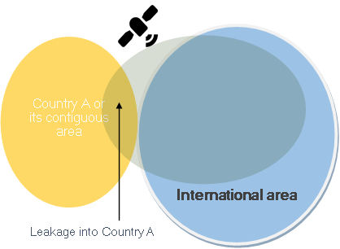
Figure 4.3-1: Deployment scenario D
There are the following options for the PLMN ID broadcast in the cell:
Scenario D1: The PLMN ID broadcast in the cell is a global/shared PLMN ID (with MCC 9xx)
Scenario D2: The PLMN ID broadcast in the cell is the PLMN ID of the operator of the PLMN. The MCC will be the MCC of the home country of the PLMN.
This scenario presents several (non-exhaustive) challenges:
1) frequency band used in international areas: according to ITU Radio Regulations [7], the frequency bands allocated to maritime mobile-satellite services is small relative to other types of mobile satellite services;
2) interference management;
3) low power efficiency, due to beaming satellite signals into vast areas with very low subscriber density; and

Due to the above challenges, it needs to be determined whether this deployment scenario should be considered. However, it should be noted that item1), 2) and 3) are not related to PLMN selection for satellite access.

* * * End of Change * * * *

