3GPP TSG-CT WG1 Meeting #138-e C1-225535

E-Meeting, 10th – 14th October 2022
CR-Form-v12.2
CHANGE REQUEST
 | 24.193 | CR | 0098 | rev | - | Current version: | 17.6.0
For HELP on using this form: comprehensive instructions can be found at
http://www.3gpp.org/Change-Requests.

Proposed change affects: | UICC apps |  | ME |  | Radio Access Network |  | Core Network | X

Title: | Resolution of editor's note on optional backoff timer for PMFP UAD
Source to WG: | Huawei, HiSilicon, Ericsson
Source to TSG: | CT1
Work item code: | ATSSS_Ph2 |  |  |  |  |  | Date: |  |  | 2022-09-27
Category: | F |  |  |  |  |  | Release: |  |  | Rel-17
 | Use one of the following categories:  F (correction)  A (mirror corresponding to a change in an earlier release)  B (addition of feature),  C (functional modification of feature)  D (editorial modification)  Detailed explanations of the above categories can  be found in 3GPP TR 21.900. |  |  |  |  |  |  |  | Use one of the following releases:  Rel-8 (Release 8)  Rel-9 (Release 9)  Rel-10 (Release 10)  Rel-11 (Release 11)  …  Rel-16 (Release 16)  Rel-17 (Release 17)  Rel-18 (Release 18)  Rel-19 (Release 19)
Reason for change: |  | The specification contains an editor’s note on optional backoff timer for PMFP UAD under clause 6.2.1.13.1, quote:  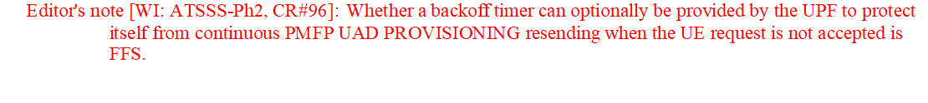CT1 sent an LS to SA2 (in C1-223974), quote:  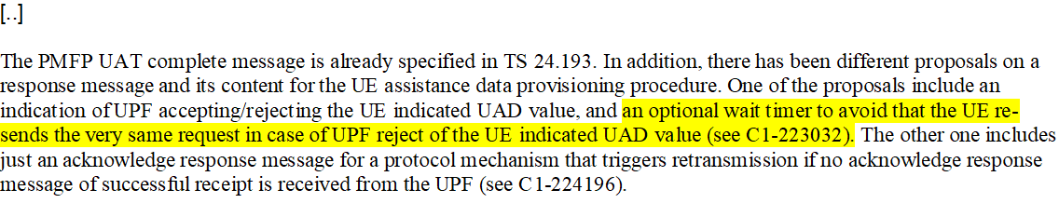  The reply LS from SA2 (in S2-2207696) does not provide answer about the optional wait timer . However, since Rel-17 has become frozen it is proposed to remove the editor’s note on optional backoff timer for PMFP UAD.
Summary of change: |  | The editor’s note on optional backoff timer for PMFP UAD is removed.
Consequences if not approved: |  | Editor’s note remains in the Rel-17 version of the specification when it can be resolved by removing it.
Clauses affected: |  | 6.2.1.13.1
 |  | Y | N
Other specs |  |  | X | Other core specifications |  |  |  | TS/TR ... CR ...
affected: |  |  | x | Test specifications |  |  |  | TS/TR ... CR ...
(show related CRs) |  |  | x | O&M Specifications |  |  |  | TS/TR ... CR ...
Other comments:
This CR's revision history:

* * * First Change * * * *

6.2.1.13.1 Message definition
The PMFP UAD PROVISIONING COMPLETE message is sent by the UPF to the UE as response to PMFP UAD PROVISIONING message.
See table 6.2.1.13.1-1.
Message type: PMFP UAD PROVISIONING COMPLETE
Significance: dual
Direction: network to UE
Table 6.2.1.13.1-1: PMFP UAD PROVISIONING COMPLETE message content
IEI | Information Element | Type/Reference | Presence | Format | Length
 | PMFP UAD provisioning complete message identity | Message type  6.2.2.1 | M | V | 1
 | EPTI | Extended procedure transaction identity  6.2.2.2 | M | V | 2

Editor's note [WI: ATSSS-Ph2, CR#96]: Whether an indication of whether the UPF aligns the DL traffic distribution based on the UE request is provided in the message is FFS.
* * * End of Changes * * * *

