Source: MCC
Title: Status Report As at January 21, 2003
Agenda item: 3.1

Document for:
Decision
Discussion
Information | X

This report provides detailed information on financial matters concerning the Mobile Competence Centre for year. For completeness and understanding, it contains information relating to the support provided to 3GPP as well as the support provided by MCC to other non-3GPP related bodies.
The figures used throughout this report are based on those available on 22 February 2003.

Table of Contents

1 Year 2002 MCC Expenditure 3
1.1 MCC Staff Expenditure (Officers and Assistants) 3
1.1.1 Additional Staff 3
1.2 MCC Contracted Support Experts Expenditure 4
1.2.1 MCC Contracted Support Experts Expenditure including non remunerated experts 4
1.2.2 MCC Contracted Support Experts Expenditure excluding non remunerated experts 5
1.2.3 MCC Contracted Experts Expenditure Detailed Breakdown by Activity 6
1.3 MCC Travel and Subsistence 11
2 Year 2002 Expenditure for 3GPP Task Forces 11
2.1 MCC Task Force 160 - 3GPP ATSs and PIXIT for UE R99 11
3 MCC Subcontracts 12
3.1 S14 & S15 - Adaptive Multi-Rate Wide Band (AMR-WB) (History) 12
Contact Person 12
LISTENING Laboratories 12
Contact Person 12
3.2 A5/3 Algorithm Development (Task S18) 13
3.3 Performance Characterisation of default Codecs for Packet Switched conversational multimedia applications 13
4 Contingency 13
5 Year 2002 Partner Contributions 14
5.1 Breakdown of Partner Contributions expected for 2002 14
5.1.1 ARIB 14
5.1.2 CWTS 14
5.1.3 ETSI 14
5.1.4 T1 15
5.1.5 TTA 15
5.1.6 TTC 15
5.1.7 GSM Association 15
5.1.8 Total income expected from Partners 15
5.2 Invoices and credit notes issued in 2002 16
5.3 Payments received in year 2002 from 3GPP Partners 17

1 Year 2002 MCC Expenditure

MCC Staff Expenditure (Officers and Assistants)
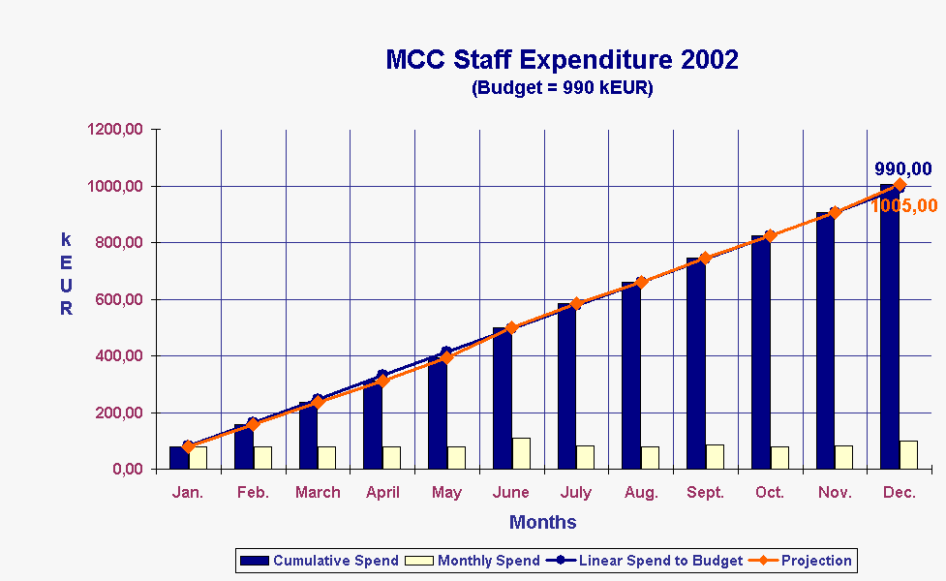
The chart given above shows the year 2002 expenditure for MCC staff (i.e. the permanently employed ETSI Secretariat Staff employed within the Mobile Competence Centre). The staff complement has not changed throughout this year and remains as 4 Support Officers, 5 Assistants, and one Department Head as follows:
David BOSWARTHICK, John MEREDITH, Maurice POPE, Adrian ZOICAS, Marlène FORINA, Karen HUGHES, Susanna KOOISTRA, Florence RAVOIRE, Emmanuelle WURFFEL, Adrian SCRASE
It should be noted that:
i) One staff member (Susanna Kooistra) has been on maternity leave for part of this period but no replacement has been sought for her. She is due to return to work in March 2003.
ii) Emmanuelle Wurffel has worked part of her time for an activity that is outside of MCC. The value of the days used for that purpose have been deducted from the year end expenditure figures.
The total year end expenditure for this budget line is 1005 kEUR (including 35kEUR for non-3GPP related activities) against a budget of 990 kEUR.
The slight overspend is a result of unused holiday allocation (which represents a financial liability), increased social charges and contractual seniority payments.

1.1.1 Additional Staff
An additional budget line had been included in the 2002 budget entitled “Additional Staff” to represent the full time employment of Shicheng Hu for the management of TTCN development within MCC. (Shicheng Hu is part of another ETSI Secretariat Department but currently works full time on MCC matters). The year end expenditure for this additional budget line is 145 kEUR against a budget of 144 kEUR.

1.2 MCC Contracted Support Experts Expenditure

MCC Contracted Support Experts Expenditure including non remunerated experts
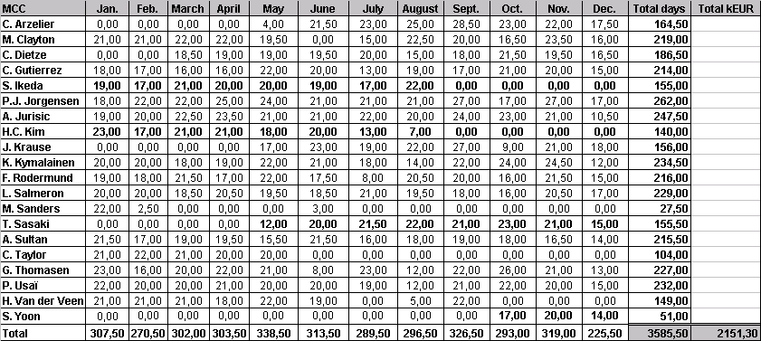
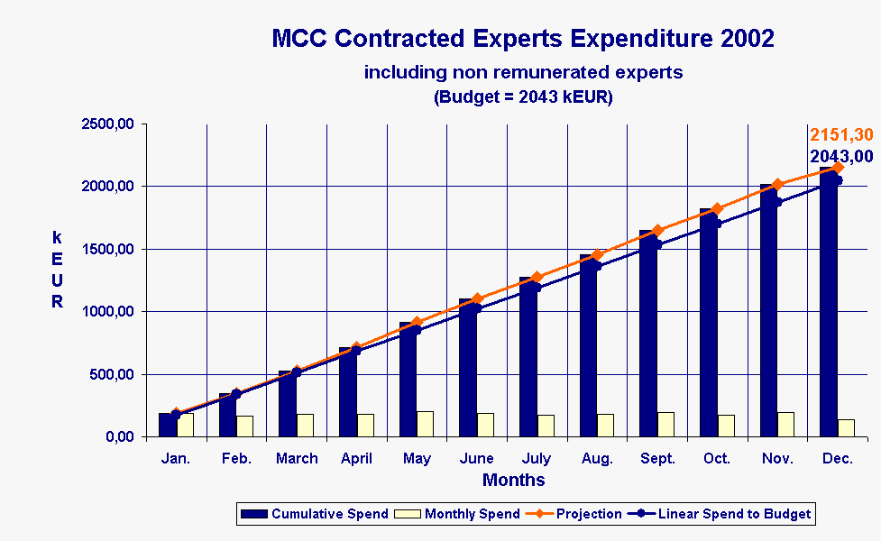
This chart includes the equivalent monetary value of the experts provided by ARIB and TTA
This chart shows the year 2002 expenditure for all Contractors employed within MCC, including the non remunerated experts provided by ARIB and TTA. It can be seen that the year end expenditure for this budget line is 2151,30 kEUR against a budget of 2043 kEUR.
The slight overspend is explained by the number of new contractors that arrived during the year and the need for them to undergo training. This was achieved by periods of parallel working which of course had an associated cost.

MCC Contracted Support Experts Expenditure excluding non remunerated experts
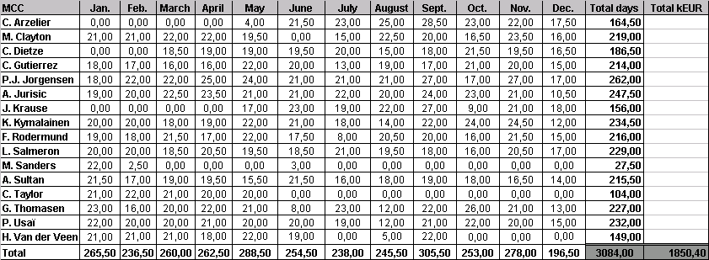
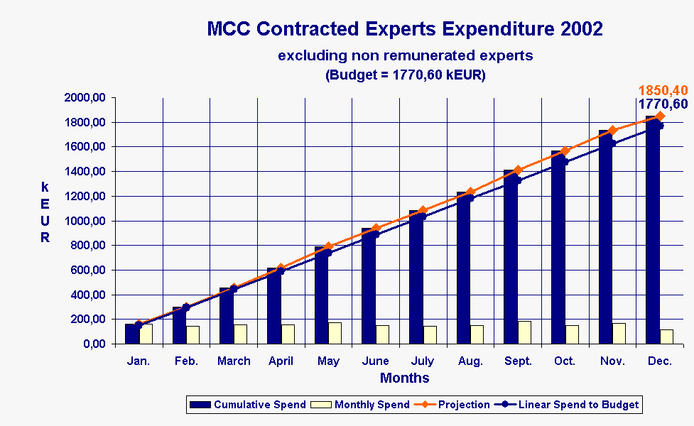
This chart excludes the equivalent monetary value of the experts provided by ARIB and TTA
The chart above shows the accumulated expenditure for MCC Contractors but excludes the value of the non-remunerated experts provided by ARIB and TTA. It can be seen that the year end expenditure was 1850,40 kEUR against a budget of 1770,60 kEUR.

1.2.3 MCC Contracted Experts Expenditure Detailed Breakdown by Activity

3GPP (RAN, CN, T, SA)
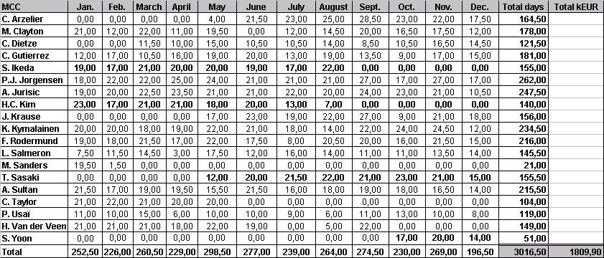
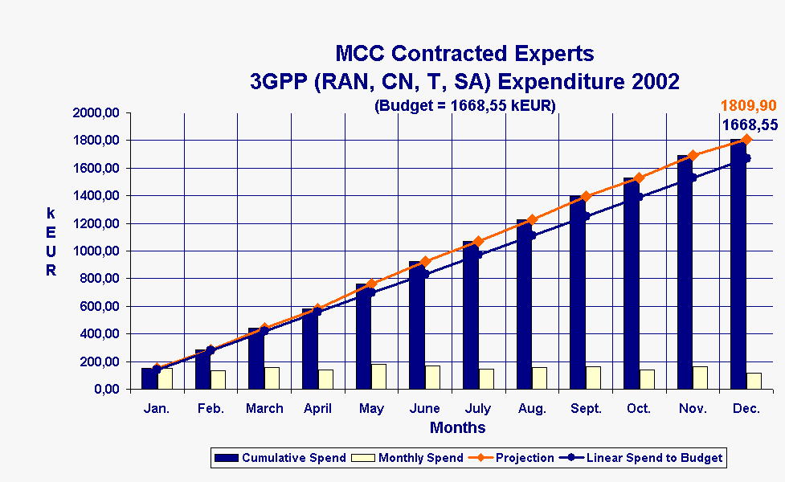

This chart shows the use of Contractor resources for the support of 3GPP TSGs SA, CN, RAN and T, but excluding those Contractor resources used for the support of TSG GERAN. It can be seen that the support cost under this budget line is greater than was originally expected and results in a year end expenditure of 1809,90 kEUR against a budget of 1668,55 kEUR.

3GPP (GERAN)
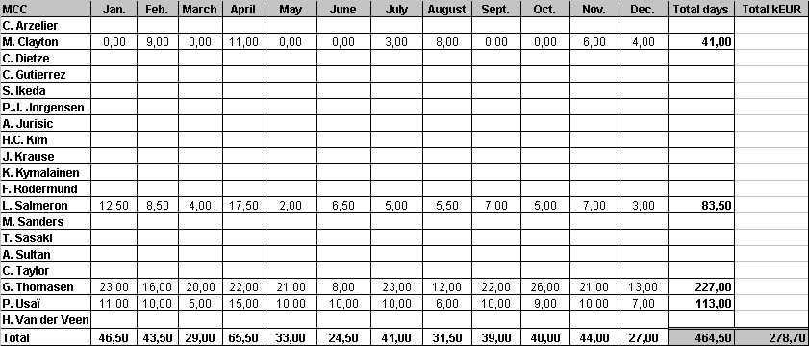
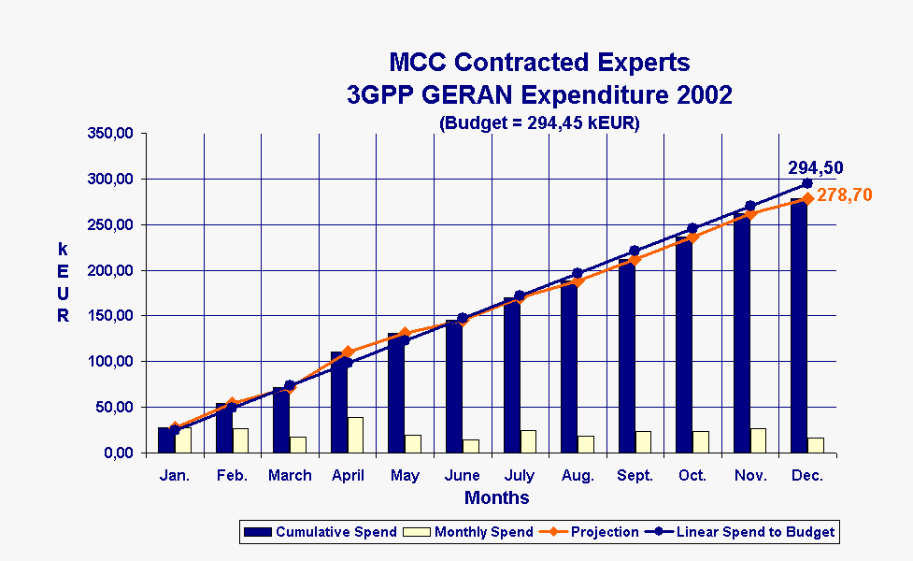

This chart shows the Contractor resources used for the support of TSG GERAN. It can be seen that the year end expenditure was less that originally predicted at 278,70 kEUR against a budget line of 294,50 kEUR.

ETSI EP SCP
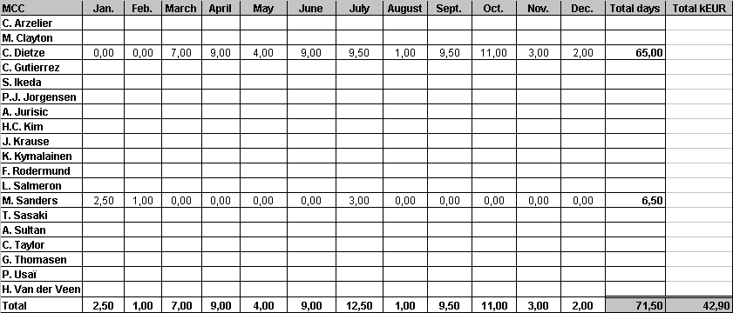
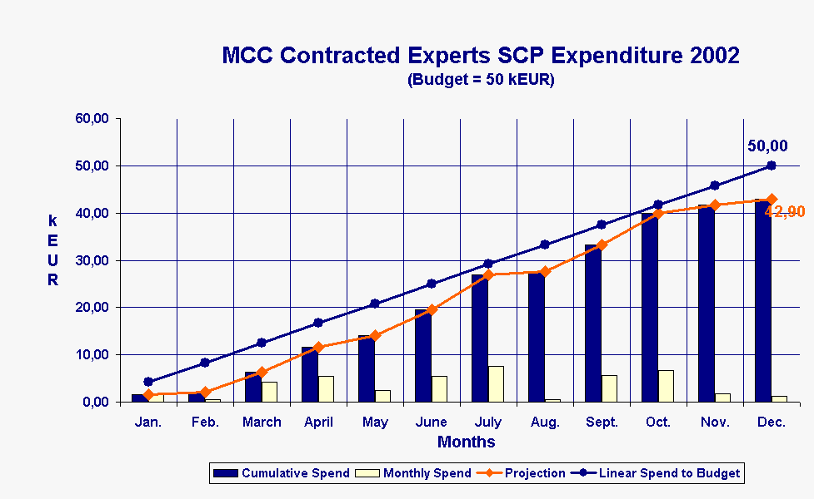

This chart shows the resources used for the support of ETSI SCP (Smart Card Platform).
It should be noted that this activity is currently 100% funded by ETSI.

ETSI TC MSG
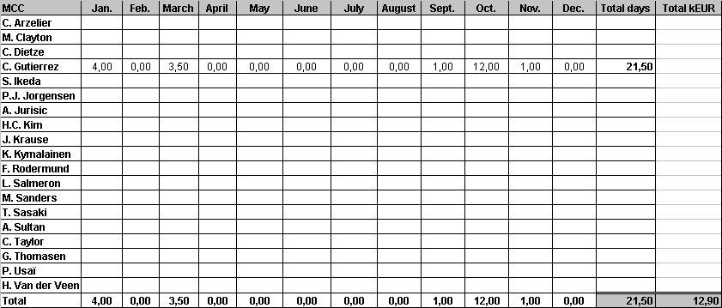
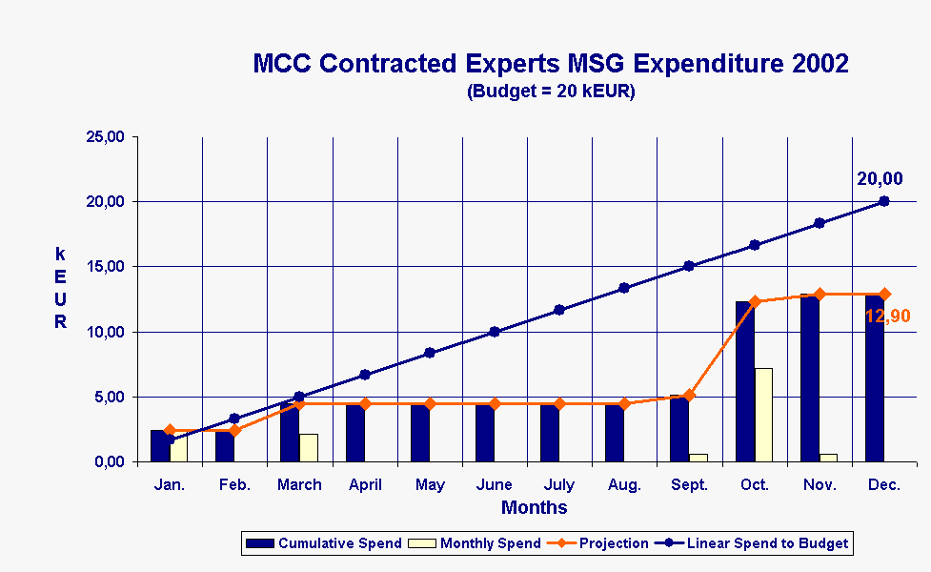

This chart shows the resources used for the support of the ETSI MSG activity.
It should be noted that this activity is currently 100% funded by ETSI.

ETSI RT
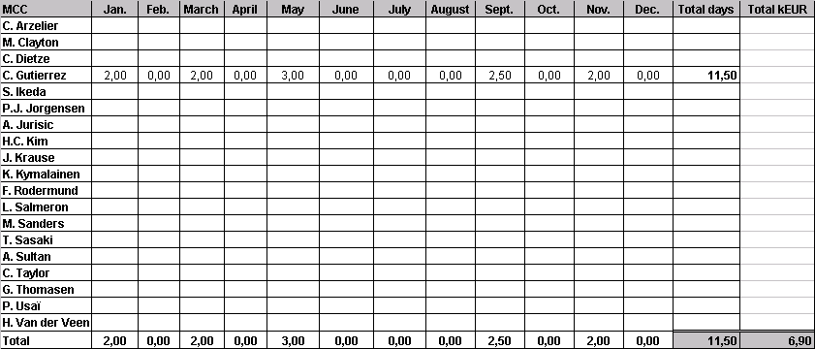
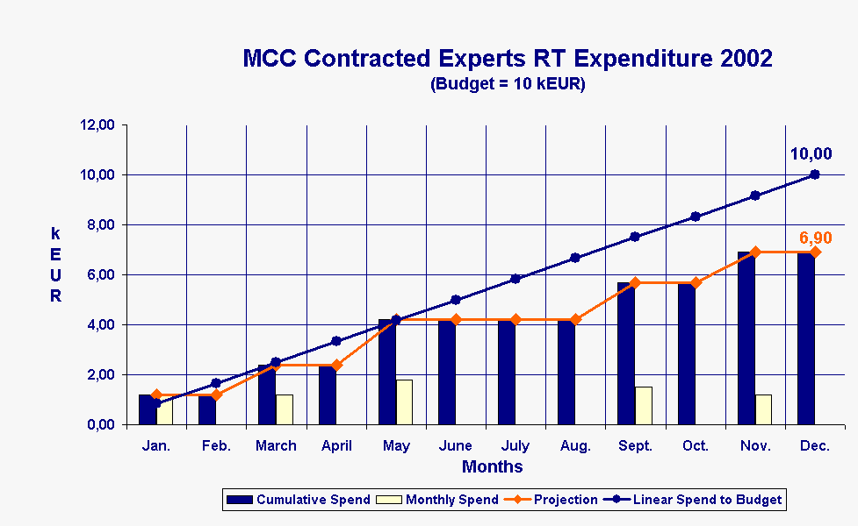

This chart shows the resources used for the support of the ETSI RT activity.
It should be noted that this activity is currently 100% funded by ETSI.

1.3 MCC Travel and Subsistence
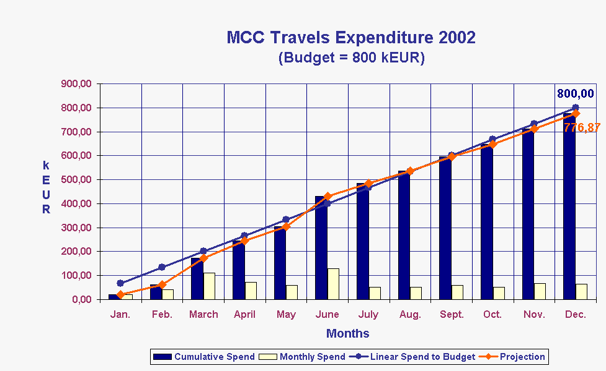

This chart shows the travel and subsistence expenditure for MCC in year 2002.
It can be seen that the year end expenditure is 776,87 kEUR (including 19kEUR for non-3GPP activities) against a budget of 800 kEUR.

2 Year 2002 Expenditure for 3GPP Task Forces

MCC Task Force 160 - 3GPP ATSs and PIXIT for UE R99

The budget for this activity comprises of three parts :
754 000 EUR provided by the 3GPP Partners.
143 000 EUR provided by the GSM Association as a voluntary payment
30 984,48 EUR provided as a voluntary payment made manufacturers (via the GCF)

Total 2002 budget therefore = 927 984,48 EUR.

Total of resources used:

The table given below shows the total value of the resources used for the development of TTCN tests for 3GPP. The shaded (green) rows show those resources which were provided voluntarily and for which payment has not been made.

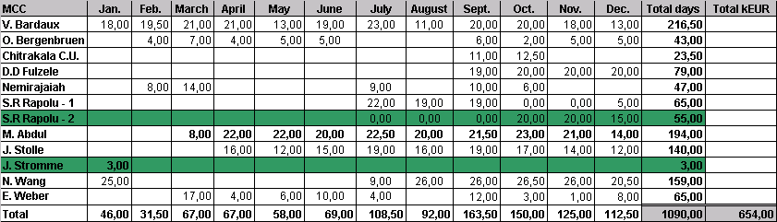
Resources paid from MCC budget
The table given below shows the resources for which payment has been made (i.e. the voluntary experts have been removed).

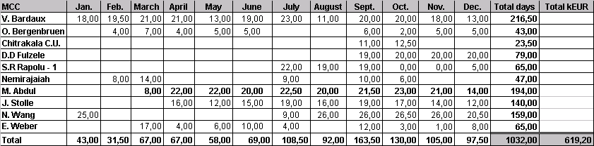
Voluntary Resources provided by 3GPP Individual members
The table given below shows the monetary value of resources for which payment has not been made (i.e. the expertise has been provided on a voluntary basis).

MCC Subcontracts

3.1 S14 & S15 - Adaptive Multi-Rate Wide Band (AMR-WB) (History)
250 kEUR of Voluntary funding was provided during 2001 for the characterisation of the AMR Wideband Codec.
The tables given below show how that money was used:
HOST Laboratories (22,50 kEUR/experiment)
Company’s name | Contract No. | Contact Person | Amount contracted
ARCON - USA | S14/01 | Mr. J.E. Brunelle | 22,50
COMSAT LMGT – USA | S14/02 | Mr. D.W. Utley | 22,50
Total in kEUR |  |  | 45,00

LISTENING Laboratories
Company’s name | Contract No. | Contact Person | Amount contracted
ARCON - USA | S15/01 | Mr. J.E. Brunelle | 12,00
BT Plc - UK | S15/02 | Mr. P.J. Arden | 22,00
T-Nova DT Berkom -DE | S15/03 | Ms. I. Islami | 22,00
Dynastat, Inc. - USA | S15/04 | Mr. I. Panzer | 23,00
France Télécom - FR | S15/05 | Mr. J.L. Courbon  & Mr. D. Pascal | 22,00
COMSAT LMGT – USA | S15/06 | Mr. D. Utley | 23,00
NTT-AT Corp. – JP | S15/07 | Mr. I. Irii | 12,00
Nokia Research - FIN | S15/08 | Mr. D. Tallroth | 23,00
Nortel Networks Ltd - CA | S15/09 | Mr. A. Patrick | 12,00
Total in kEUR |  |  | 171,00

From the allocated funding (250 kEUR), a total amount of 216 kEUR (45 + 171) has been contracted.
Following a discussion in SA WG4, and subsequent discussion within the PCG/OP it was decided to carry forward the unused money and to use it for partial funding of the “Performance Characterisation of default Codecs for Packet Switched conversational multimedia applications” (subject to approval of the contributors). See section 3.3 below for further details.

3.2 A5/3 Algorithm Development (Task S18)
Task S18 was for the development of a new GSM algorithm to replace A5/2. It was agreed that the development cost would be shared equally by ETSI, Committee T1 and the GSM Association. It was initially expected that the task would require 127 kEUR but due to the addition of a further task (Milenage for 2G) the resulting cost was 143,4 kEUR as indicated in the table below.
Contract No. | Name of expert(s) | Company’s name | Number of days | Estimated Amount (k€)
S18/01 | G. Roelofsen, B. Gelbord | KPN Valley | 21 | 12 600
S18/02 | P. Christoffersson | Telia Promotor AB | 16 | 9 600
S18/03 | D. Parkinson | BT Group Plc | 32 | 19 200
S18/04 | T. Martin, T. Schneider | T-Nova DT | 32 | 19 200
S18/05 | H. Gilbert | FT | 16 | 9 600
S18/06 | H. Handschuh | Gemplus SA | 16 | 9 600
S18/07 | M. Matsui | Mitsubishi Electric Group | 16 | 9 600
S18/08 | K. Nyberg | Nokia Research Center | 16 | 9 600
S18/09 | L. Nilsen | Thales Communications AS | 32 | 19 200
S18/10 | S. Babbage, N. Bone | Vodafone Group Plc | 42 | 25 200
 |  | TOTAL | 239 | 143 400

3.3 Performance Characterisation of default Codecs for Packet Switched conversational multimedia applications
The PCG/OP agreed the funding of a new task for the “Performance Characterisation of default Codecs for Packet Switched conversational multimedia applications”. The exact funding requirements were not clear but initial funding of 160 kEUR was allocated from the 2002 contingency. To this will be added the 34 kEUR carried forward from the previous codec selection task (see section 3.1 above). This gives a total budget allocation of 194 kEUR.
The work has not yet started since the technical details are still being prepared by SA WG4.

4 Contingency
Contingency | Contingency Allocated
563 kEUR | 160 kEUR (Performance Characterisation of default Codecs for Packet Switched conversational multimedia applications)

5 Year 2002 Partner Contributions

5.1 Breakdown of Partner Contributions expected for 2002
The following tables provide a breakdown of the contributions that were expected to be provided by the Organizational Partners for 3GPP funding in year 2002. (Note: this section shows income expected at the beginning of year 2002. In the case of the GSM Association more income was received throughout the year than was originally expected.)

5.1.1 ARIB
Budget category | Amount (k€)
Equal division of Support budget (RAN, T, SA, CN) | 500,15
Proportional division of Support budget (RAN, T, SA, CN) | 172,86
Equal division of Specific tasks budget (shared between ARIB and TTC) | 94,25
Total | 767,26
Deduction for provision of human resources | 136,20
Amount due | 631,06

5.1.2 CWTS
Budget category | Amount (k€)
Single payment for 3GPP funding | 260,00
Amount due | 260,00

5.1.3 ETSI
Budget category | Amount (k€)
Equal division of Support budget (RAN, T, SA, CN) | 500,15
Proportional division of Support budget (RAN, T, SA, CN) | 2068,59
Equal division of Support budget (GERAN) | 232,13
Proportional division of Support budget (GERAN) | 374,66
Equal division of Specific tasks budget | 188,50
Amount due | 3364,03

5.1.4 T1
Budget category | Amount (k€)
Equal division of Support budget (RAN, T, SA, CN) | 500,15
Proportional division of Support budget (RAN, T, SA, CN) | 121,00
Equal division of Support budget (GERAN) | 232,13
Proportional division of Support budget (GERAN) | 89,59
Equal division of Specific tasks budget | 188,50
Amount due | 1131,37

5.1.5 TTA
Budget category | Amount (k€)
Equal division of Support budget (RAN, T, SA, CN) | 500,15
Proportional division of Support budget (RAN, T, SA, CN) | 63,38
Equal division of Specific tasks budget | 188,50
Total | 752,03
Deduction for provision of human resources | 136,2
Amount due | 615,83

5.1.6 TTC
Budget category | Amount (k€)
Equal division of Support budget (RAN, T, SA, CN) | 500,15
Proportional division of Support budget (RAN, T, SA, CN) | 74,91
Equal division of Specific tasks budget (shared between ARIB and TTC) | 94,25
Amount due | 669,31

5.1.7 GSM Association
Budget category | Amount (k€)
Contribution to A5/3 Algorithm development | 47,80
Amount due | 47,80

5.1.8 Total income expected from Partners
TOTAL CONTRIBUTION EXPECTED FROM PARTNERS (INC HUMAN RESOURCES) = 6 991,80 kEUR
TOTAL PAYMENT EXPECTED FROM PARTNERS (EXCL HUMAN RESOURCES) = 6719,40 kEUR

5.2 Invoices and credit notes issued in 2002
The following credit notes and invoices were addressed to 3GPP Partners during 2002.

ARIB (Japan)
CREDIT NOTE | dated 26/04/2002 | 19 000 EUR
INVOICE | dated 26/04/2002 | 631 060 EUR

CWTS (China)
INVOICE | dated 26/04/2002 | 260 000 EUR

ETSI (France)
CREDIT NOTE | dated 26/04/2002 | 204 000 EUR
INVOICE | dated 26/04/2002 | 3 364 030 EUR

T1 (USA)
CREDIT NOTE | dated 26/04/2002 | 39 000 EUR
INVOICE | dated 26/04/2002 | 1 131 370 EUR

TTA (Korea)
CREDIT NOTE | dated 26/04/2002 | - 6 000 EUR
INVOICE | dated 26/04/2002 | 615 830 EUR

TTC (Japan)
CREDIT NOTE | dated 26/04/2002 | 12 000 EUR
INVOICE | dated 26/04/2002 | 669 310 EUR

GSM Association
INVOICE (S18) | dated 08/10/02 | 48 000 EUR
INVOICE (Task 160) | dated 28/10/02 | 30 984,48 EUR
INVOICE (Task 160) | dated 28/10/02 | 143 000 EUR

5.3 Payments received in year 2002 from 3GPP Partners
The following payments have been received from 3GPP Organizational Partners during year 2002.

ARIB (Japan)
Amount due 631 060 EUR
- paid on 19 000 EUR 22.04.02
- paid on 612 060 EUR 25.06.02

CWTS (China)
Amount due 260 000 EUR
paid on 260 000 EUR 25.06.02

ETSI
Amount due 3 364 030 EUR
- paid on 26/04/2002 3 364 030 EUR 26.04.02

T1 (USA)
Amount due 1 131 370 EUR
- paid on 39 000 EUR 22.04.02
- paid on 849 979,50 EUR 16.07.02
- paid on 180 000 EUR 15.11.02
- paid on 44 000 EUR 23.12.02
- Total paid 1 112 979,50 EUR (18 390,50 EUR outstanding)

TTA (Korea)
Amount due 615 830 EUR
- paid on 310 894 EUR 08.07.02
- paid on 294 072 EUR 08.10.02
- paid on 16 864 EUR 13.12.02

TTC (Japan)
Amount due 669 310 EUR
- paid on 12 000 EUR 22.04.02
- paid on 406 318,75 EUR 08.07.02
- paid on 250 991,25 EUR 02.09.02

Total received from Organizational Partners: 6 653 209,50 at 31.12.02
Amount outstanding from Organizational Partners: 18 390,50 at 31.12.02

The following payments have been received from other Partners during year 2002.

GSM Association
Amount due (S18) 48 000 EUR 04.11.02
- paid on (Task 160) 38 984,48 EUR 29.11.02
- paid on (Task 160) 143 000 EUR 29.11.02

Total received from other Partners: 229 984,48 at 31.12.02

