3GPP TSG-WG SA2 Meeting #164 S2-2408971

Maastricht, Netherlands, August 19 – 23, 2024 (was S2-2408591)
CR-Form-v12.2
CHANGE REQUEST
 | 23.316 | CR | 2136 | rev | 01 | Current version: | 18.5.0
For HELP on using this form: comprehensive instructions can be found at
http://www.3gpp.org/Change-Requests.

Proposed change affects: | UICC apps |  | ME | x | Radio Access Network |  | Core Network | x

Title: | Identifying non-3GPP devices behind 5G-RG
Source to WG: | CableLabs, Nokia
Source to TSG: | SA2
Work item code: | UIA_ARC |  |  |  |  |  | Date: |  |  | 2024-08-09
Category: | B |  |  |  |  |  | Release: |  |  | Rel-19
 | Use one of the following categories:  F (correction)  A (mirror corresponding to a change in an earlier release)  B (addition of feature),  C (functional modification of feature)  D (editorial modification)  Detailed explanations of the above categories can  be found in 3GPP TR 21.900. |  |  |  |  |  |  |  | Use one of the following releases:  Rel-8 (Release 8)  Rel-9 (Release 9)  Rel-10 (Release 10)  Rel-11 (Release 11)  …  Rel-16 (Release 16)  Rel-17 (Release 17)  Rel-18 (Release 18)  Rel-19 (Release 19)
Reason for change: |  | To specify the support for identifying non-3GPP devices connecting behind a 5G-RG based on the conclusions in clause 8.4 of TR 23.700-32
Summary of change: |  | Specifying conclusions on identification of non-3GPP device for wireline access
Consequences if not approved: |  | New feature not implemented in the specification
Clauses affected: |  | 4.10x
 |  | Y | N
Other specs |  |  | x | Other core specifications |  |  |  | TS/TR ... CR ...
affected: |  |  | x | Test specifications |  |  |  | TS/TR ... CR ...
(show related CRs) |  |  | x | O&M Specifications |  |  |  | TS/TR ... CR ...
Other comments:
This CR’s revision history:

* * * * First change * * * *

4.10x Differentiated services for non-3GPP devices behind 5G-RG

4.10x.1 General
This clause defines the support of idenitifying the traffic of individual non-3GPP devices behind a 5G-RG.
TS 23.501 [2] clause 5.x applies to the 5G-RG with the following deltas:
- The UE is replaced by the 5G-RG.
The overall architecture is illustrated in Figure 4.10x-1. For 5G-RG, non-3GPP devices mapped to a PDU Session based on Connectivity Group IDs can be further differentiated based on Device IDs.

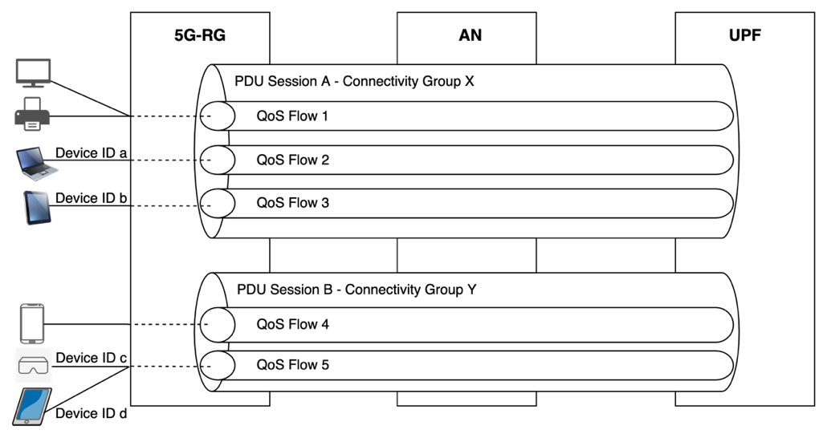
Figure 4.10x.1-1: Example scenario for mapping traffic from individual non-3GPP devices behind 5G-RG to a PDU Session

4.10x.2 Session management for identifying the traffic of individual non-3GPP devices behind 5G-RG
This clause describes a procedure to enable 5GS to identify the traffic of individual non-3GPP devices behind a 5G-RG.
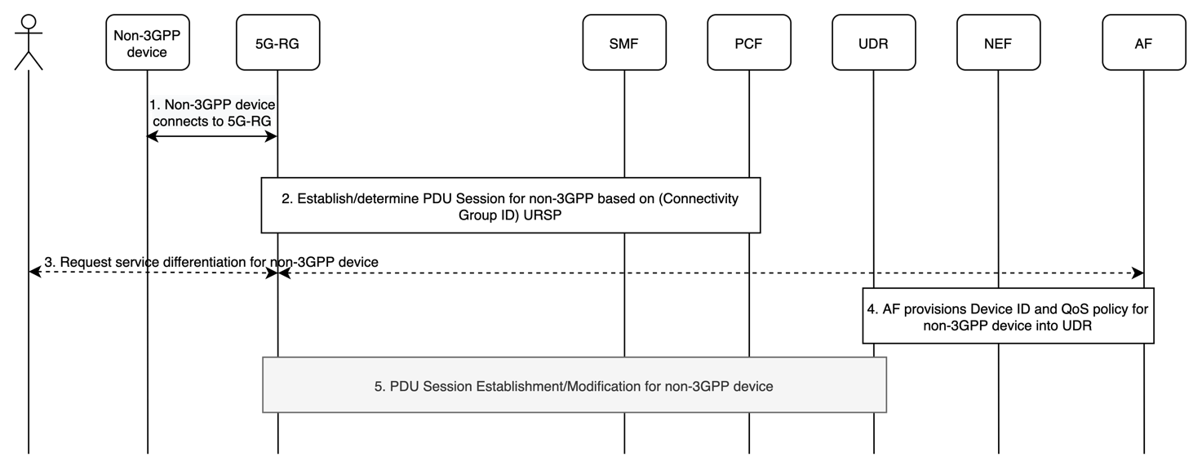
Figure 4.10x.2-1: Example procedure for identifying traffic of individual non-3GPP devices behind 5G-RG
1. The non-3GPP device is connected to the 5G-RG.
2. To provide connectivity to the non-3GPP device, the 5G-RG implements the existing behaviour of either using the URSP rule containing the Connectivity Group ID or based on local configurations to map the traffic of the non-3GPP device to a PDU Session.
3. The 5G-RG subscription owner, using mechanisms out of scope of 3GPP, requests differentiated QoS for the non-3GPP device.
4. The above step enables the AF to provision the Device ID and the QoS policy for the non-3GPP device into the UDR.
5. Based on the 5G-RG implementation, the 5G-RG requests using the PDU Session procedures (Establishment or Modification) enablement of differentiated QoS for the required non-3GPP device. The PDU Session Modification or PDU Session Establishment requests include the Device ID and the User Plane Address. The PCF may consider the QoS Policy when forming PCC Rules for the Device ID and the corresponding User Plane Address.
Alternatively, the AF may use an AF session with required QoS procedure for the corresponding Device ID identified by the User Plane Address.
Editor Note: It is FFS to determine who (5G-RG and/or AF and/or network) decides to request for change of QoS Flows.
Editor Note: It is FFS on describing the Device ID to be used as a traffic descriptior in URSP rules for the 5G-RG.

* * * End of changes * * * *

