3GPP TSG-WG SA2 Meeting #164 S2-2409136

Maastricht, Netherlands, 19th Aug 2024 - 23rd Aug 2024 revision of S2-2409088
CR-Form-v12.2
CHANGE REQUEST
 | 23.288 | CR | 1171 | rev | 2 | Current version: | 18.6.0
For HELP on using this form: comprehensive instructions can be found at
http://www.3gpp.org/Change-Requests.

Proposed change affects: | UICC apps |  | ME |  | Radio Access Network |  | Core Network | X

Title: | Registration and Discovery procedure for Vertical Federated Learning among NWDAF(s) and/or AF(s) with NWDAF as the VFL server
Source to WG: | ICS, OPPO, InterDigital, Lenovo, Vivo, NTT DOCOMO, Huawei, ZTE, LG Electronics, KDDI, Ericsson, Nokia, ETRI, MediaTek Inc., Samsung
Source to TSG: | SA2
Work item code: | AIML_CN |  |  |  |  |  | Date: |  |  | 2024-08-09
Category: | B |  |  |  |  |  | Release: |  |  | Rel-19
 | Use one of the following categories:  F (correction)  A (mirror corresponding to a change in an earlier release)  B (addition of feature),  C (functional modification of feature)  D (editorial modification)  Detailed explanations of the above categories can  be found in 3GPP TR 21.900. |  |  |  |  |  |  |  | Use one of the following releases:  Rel-8 (Release 8)  Rel-9 (Release 9)  Rel-10 (Release 10)  Rel-11 (Release 11)  …  Rel-16 (Release 16)  Rel-17 (Release 17)  Rel-18 (Release 18)  Rel-19 (Release 19)
Reason for change: |  | Introducing a new FL variant (i.e. Vertical Federated Learning) in 5GC.
Summary of change: |  | [1st Change] Adding a new subsection to describe required procedures to perform VFL Registration and Discovery when NWDAF(s) and/or AF(s) are the VFL client with a VFL Server NWDAF.
Consequences if not approved: |  | The new feature that was concluded in the study phase will not be adopted in the related specs.
Clauses affected: |  | 6.2X (new), 6.2X.1 (new), 6.2X.2 (new), 6.2X.2.1 (new)
 |  | Y | N
Other specs |  |  | X | Other core specifications
affected: |  |  | X | Test specifications |  |  |  | TS/TR ... CR ...
(show related CRs) |  |  | X | O&M Specifications |  |  |  | TS/TR ... CR ...
Other comments:
This CR's revision history:

* * * * 1st change * * * *

6.2X Vertical Federated Learning among NWDAFs and AFs

6.2X.1 General
This clause specifies how NWDAF as a VFL server can register and also discover other NWDAFs and/or AFs via NRF.

6.2X.2 Procedures

6.2X.2.1 Registration and Discovery procedure for Vertical Federated Learning among NWDAFs and/or AFs with NWDAF as the VFL server

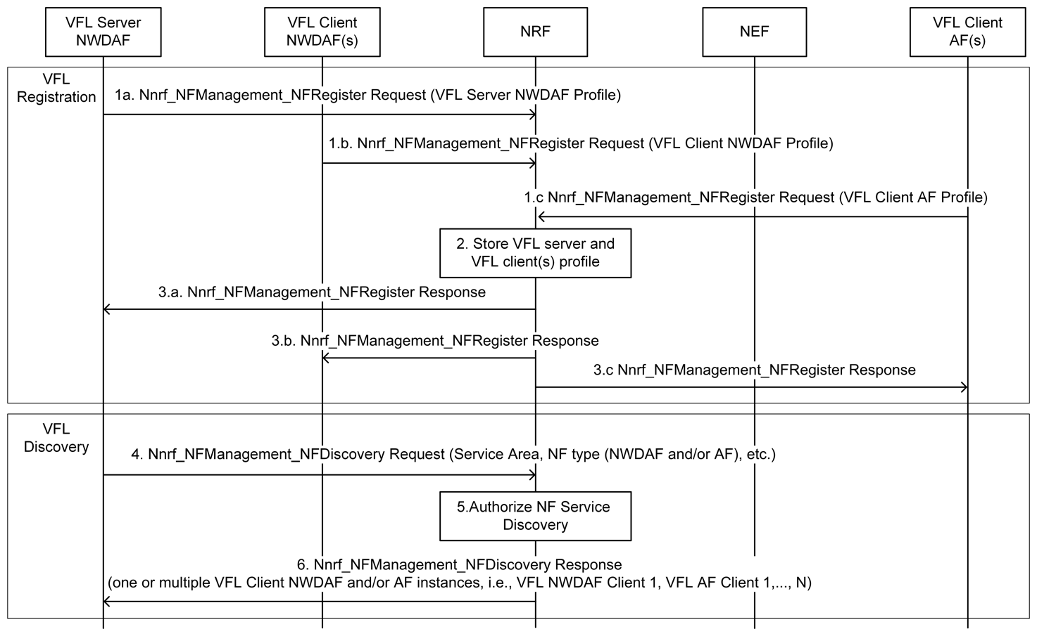
Figure 6.2X.2.1-1: Registration and Discovery procedure for Vertical Federated Learning when NWDAF is the VFL server and NWDAF(s) and/or AF(s) are the VFL client.
Steps 1 to 3 are the NWDAF and AF Registration procedures when the VFL server is NWDAF.
1-3. VFL Server/Client NWDAF and VFL Client AF register to NRF with its NF profile, which includes NF Type (as defined in clause 5.2.7.2.2 of TS 23.502 [3]), Analytics ID(s), Address information of NWDAF/AF, Service Area, Time interval supporting FL as described in clause 5.2.
Editor’s note: Whether the FL capability will be extended or a new VFL capability will be defined is FFS.
Editor’s note: Whether the VFL server/client needs to register into NRF any interoperability information is FFS.
Editor’s note: Whether to use Vendor ID(s) or introduce new identifiers for interoperability among NWDAF and AFs is FFS.
For an untrusted AF, the NEF registers at the NRF within its NF profile information about the AF as specified in clause 6.2.2.3 and includes other information related to the AF capabilities.
Editor’s note: the content of the AF VFL-related capability is FFS.
Steps 4 to 6 are the NWDAF and AF Discovery procedures when the VFL server is NWDAF.
4-6. NWDAF as the VFL server determines that the ML Model requires VFL based on operator policy, Analytics ID, and Service Area/DNAI.
NOTE: Step 4 in Figure 6.2X.2.1-1 may be triggered at the VFL Server NWDAF by VFL server NWDAF itself or a request from a consumer.
If the NWDAF can not perform as VFL Server, it first discovers and selects another VFL Server NWDAF from NRF by invoking the Nnrf_NFDiscovery_Request service operation. The following criteria might be used: Analytics ID, Time Period of Interest, and Service Area.
Once the VFL Server NWDAF is determined, the VFL Server NWDAF discovers other NWDAF(s) and/or AF(s) as VFL Client from NRF by invoking the Nnrf_NFDiscovery_Request service operation. The following criteria might be used: Analytics ID, and Service Area.

* * * * End of changes * * *

