3GPP TSG-RAN WG2 #127 R2-240xxxx

Maastricht, Netherlands, 19th - 23rd Aug 2024

Agenda Item: 7.7.2
Source: OPPO
Title: Report of [AT127][303][R18 NR NTN] Stage 2 text for trigger conditions (OPPO)
Document for: Discussion and Decision

Introduction
This document is to kick off the following offline discussion.
- [AT127][303][R18 NR NTN] Stage 2 text for trigger conditions (Oppo)
Scope: Continue the discussion on the actual wording of the change for the Stage 2 description on trigger conditions without RSRP-based trigger conditions.
Intended outcome: report of offline discussion
Deadline for companies' feedback: Thursday 2024-08-22 20:00
Deadline for rapporteur's summary (in R2-2407614): Friday 2024-08-23 08:00

2. Contact information
Company | Delegate contact
COMPANY_NAME | NAME (email@address.com)

Discussion
For time or location-based CHO trigger conditions, below is the proposed change by Ericsson in R2-2407238.
Time-based or location-based trigger conditions may be configured independently from RRM measurement-based condition in some scenarios. One such example scenario is a service link switch with a zero or negligible service discontinuity gap time length.

During online discussion, following comments were noted.
R2-2407238 Remaining open issues for NR NTN enhancements Ericsson discussion NR_NTN_enh-Core
Proposal 1 Satellite switch with resync related capabilities (softSatelliteSwitchResyncNTN and hardSatelliteSwitchResyncNTN) are defined per UE.
Proposal 2 Adopt the following clarification to Stage 2 related to the independent configuration of time or location-based CHO trigger conditions from RSRP-based trigger conditions.
- HW agrees we could fix this but the current proposal is also misleading
- vivo thinks the current spec is ok
- QC also thinks we can live with the existing text (saying “at least...”)
- Oppo and Nokia think that some clarification is needed
- RAN2 agrees that a correction to the existing Stage 2 description is needed and continue in offline 303 to discuss the actual change

The main point in capturing in stage-2 spec is that time or location-based trigger condition can be configured independently from the RRM-based condition. If companies think Ericsson’s TP is still misleading, maybe another alternative and compromise is to not list any example scenario at all in the spec, although this is not fully aligned with the RAN2#122 meeting agreements “We add a description/note saying in which scenarios this is reasonable, e.g. at least hard-switch case where gap is assumed to be zero/negligible”.
As a compromise, the below wording is proposed.
Time-based or location-based trigger conditions may be configured independently from the RRM measurement-based trigger conditions for CHO in NTN in some scenarios.

Question 1: Companies please indicate which wording is preferred/acceptable?
Company | Wording in R2-2407238?  or  Compromised wording suggested by rapporteur? | Any other comments?
Apple | Compromised wording with some change | Time-based or location-based trigger conditions may be configured independently from the RRM measurement-based trigger conditions for CHO in NTN in some scenarios (e.g. satellite switch scenario as specified in clause 16.14.3.2)  >>Rapp: referring to 16.14.3.2 is not correct. CHO is still L3 mobility, however 16.14.3.2 avoids L3 mobility.  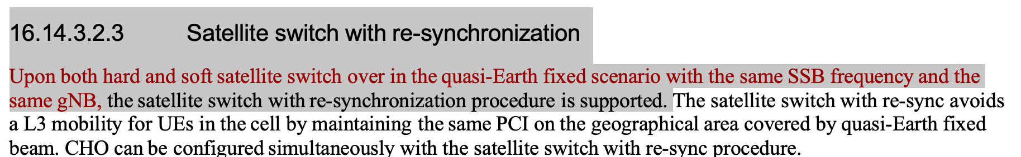
Lenovo | Compromised wording suggested by rapporteur with some clarification. | “Some scenarios” seems not very clear to us and additional clarification could be useful like “(e.g., when the service discontinuity gap time length is zero or negligible)”
Ericsson | Agree with rapporteur´s proposal. | Also fine with Lenovo’s suggestion.
Nokia | Disagree with Apple’s suggestion, OK to adopt Rapp’s proposal with Lenovo’s change | If we end the statement with “in some scenarios” then it is not a very solid information. So OK to clarify as Lenovo suggests.

4. Summary and Proposals
This section summarizes the main proposals:

