3GPP TSG-RAN2 Meeting #127 R2-240xxxx

Maastricht, Netherlands, 19th August 2024 - 23rd August 2024

Agenda Item: 7.15.2
Source: OPPO
Title: Discussion on LS R1-2405530
Document for: Discussion, Decision

- Introduction
This is to discuss the offline as follows.
- Discussion on 6265
R2-2406265 Miscellaneous correction on R18 SL Evolution OPPO CR Rel-18 38.331 18.2.0 4863 - F NR_SL_enh2

Change-1:
Reason for Change | There are both “Additional RLC bearer” and “Additional sidelink RLC bearer” terms in the spec, while on the former has been defined.
Summary of change: | Align the terminology as “Additional sidelink RLC bearer”
CR | 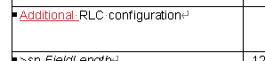

Change-2:
Reason for Change | In 5.8.9.1a.4, it is specified that RRC layer indicate “carrier(s)”, as indicated in sl-FreqInfoList / sl-PreconfigFreqInfoList, to lower layer, but neither sl-FreqInfoList nor sl-PreconfigFreqInfoList will include more than one carrier.
Summary of change: | Remove the plural form of the “carrier(s)” in 5.8.9.1a.4
CR | 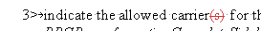

Change-3:
Reason for Change | In 5.8.9.1a.6.1, one of the duplication configuration initiation condition is “for unicast, for sidelink SRB 1/2/3, if UE decides to use PDCP duplication after receiving RRCReconfigurationCompleteSidelink”, which comes from R2#123bis agreement that  Agreements on SRBs  1. SL PDCP duplication can be applied to SL-SRB3 only after receiving RRCReconfigurationCompleteSidelink.  2. SL PDCP duplication can be applied to SL-SRB1/2 only after receiving RRCReconfigurationCompleteSidelink.  The real intention was to restrict the timing to “apply” the duplication, which has already been reflected in 5.8.9.1a.6.2, “for unicast, for SRB, after receiving the RRCReconfigurationCompleteSidelink message, if the additional Sidelink RLC bearer addition was decided by UE:”, and it is obvious that the duplication decision has to be done before the transmission of the RRCReconfiguratIonSidelink.
Summary of change: | Remove the restriction of “after receiving RRCReconfigurationCompleteSidelink”, and add the condition of UE capability, to align with DRB case.
CR

Change-4:
Reason for Change | In 9.1.1.4/5, for the RLC and MAC configuration of additional SL RLC bearer, terminologies are not aligned.
Summary of change: | Align the terms, to be “Additional RLC configuration”, and “MAC configuration associated to additional RLC configuration”
CR | 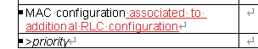

Q1: Do you agree with the 4 changes proposed by 6265? If no, please clarify which changes is not agreeable and why
Company | Yes/No | Comment (e.g., which change is not agreeable and why)

- Discussion on 7372
R2-2407372 Correction on setuprelease type sidelink fields handling Google CR Rel-18 38.331 18.2.0 4821 1 F NR_SL_enh2 R2-2405322

Change-1:
Reason for Change | Section 5.8.13.2:  When the sl-DiscConfig is “not set to setup” in the RRCReconfiguration; and the frequency used for NR sidelink discovery is not included in sl-FreqInfoList included in SIB12 or not sl-DiscConfigCommon is included in SIB12, the UE should pefrom the actions as specifed in the bullet “1> else”. Current UE behaviour is not correct.
Summary of change: | In section 5.8.13.2, add the sentence “and set to setup” in the first bullet 1>.
CR | 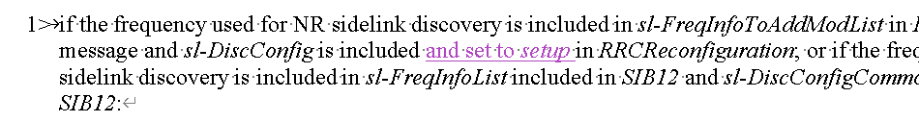

Change-2:
Reason for Change | Section 5.8.9.1.3:  When the receiving PCsl-DRX-ConfigUC-PC5 is set to release, the UE should configure lower layer to cancel the sidelink DRX operation associated to the PC5-RRC connection.  When the sl-MeasConfig is set to release, the UE should release all the stored sidelink measurement object, sidelink reporting configuration, the sidelink quantity configuration and sidelink measurement identity;
Summary of change: | In section 5.8.9.1.3:  Add a bullet to specify the cancel behaviours after receiving the PCsl-DRX-ConfigUC-PC5;  Add the bullet to specify the UE behaviours related to release all the stored sidelink measurement object, sidelink reporting configuration, the sidelink quantity configuration and sidelink measurement identity;
CR | 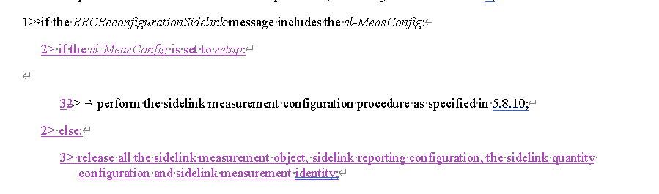  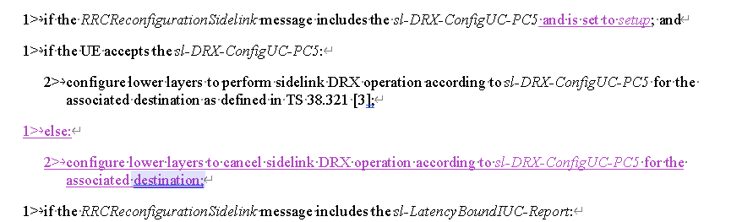

Change-3:
Reason for Change | Section 5.3.5.14:  The field sl-UE-SelectedConfig should not be configured simultaneously with sl-ScheduledConfig. In current procedural text, there is no UE behaviors related to release sl-UE-SelectedConfig and sl-ScheduledConfig. If the request from the NW is to release the stored sl-UE-SelectedConfig and setup sl-ScheduledConfig, the UE will keep both configurations according to current procedural text.
Summary of change: | In section 5.3.5.14, add the bullets to specify the UE actions related to release sl-ScheduledConfig and sl-UE-SelectedConfig.
CR | 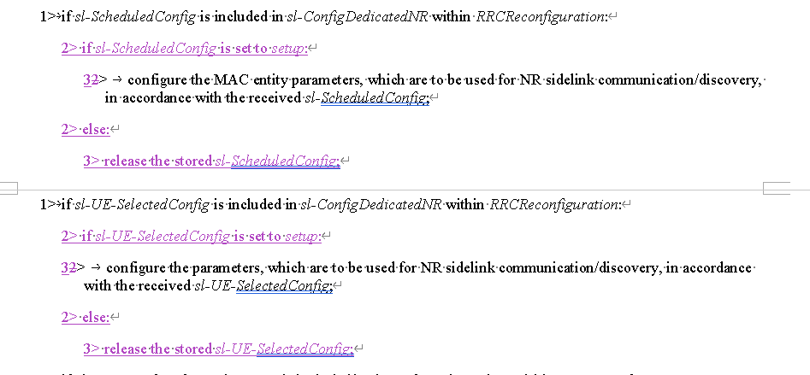

Change-4:
Reason for Change | Section 5.3.5.3 and 5.3.13.4:  When the sl-ConfigDedicatedNR is set to release, the UE should release the stored sidelink configurations.  5.8.9.1b.1.1 Sidelink Carrier Release Condition  For NR sidelink communication, sidelink carrier release is initiated in the following cases:  1> for unicast, if sl-Carrier-Id of the sidelink carrier is received in sl-CarrierToReleaseList in the RRCReconfigurationSidelink; or  1> for unicast, if a sidelink carrier failure has been indicated by MAC layer; or  1> for unicast, if the sidelink carrier release was triggered due to the configuration received within the sl-ConfigDedicatedNR, SIB12, SidelinkPreconfigNR or upper layer; or
Summary of change: | In 5.3.5.3 and 5.3.13.4, specify that the UE releases the sl-ConfigDedicatedNR according to section 5.8.9.1b.1.
CR | 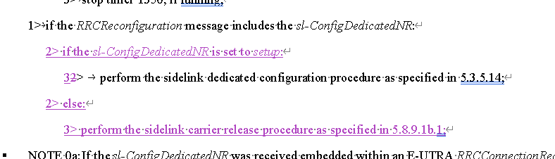  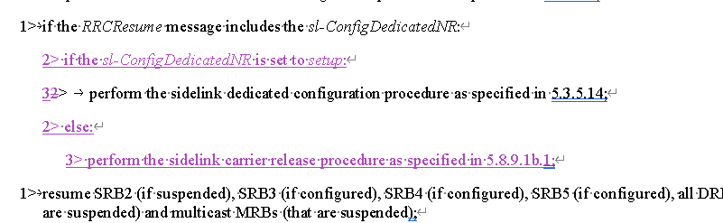

Q2: Do you agree the 4 changes proposed by 7372? If no, please clarify which changes is not agreeable and why
Company | Yes/No | Comment (e.g., which change is not agreeable and why)
OPPO | No | Considering this part in the spec  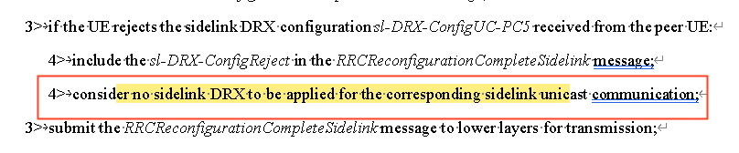  There is no need for this change (within change-2) at least  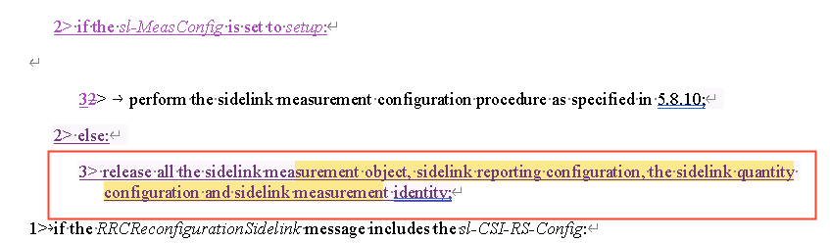  For the other changes, considering RRC Rapp proposal in  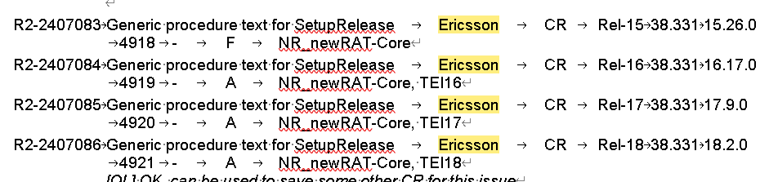  We lean towards negative for the other changes.  But we are open to hear views from others.

