**3GPP TSG-RAN WG2 #127 *R2-24xxxx***

**Maastricht Netherlands August 19th – 23th, 2024**

Agenda Item: 8.3.1

Source: OPPO

Title: Draft summary of [AT127][026][AI Mob] Simulation assumptions (OPPO)

Document for: Discussion, Decision

# Introduction

During Wednesday session on AI mobility, RAN2 agreed to continue to discuss some simulation assumptions as following:

* [AT127][026][AI Mob] Simulation assumptions (OPPO)

Intended outcome: discuss simulation assumptions

Deadline: 08-22-24

And the relevant assumptions are:

***Need to further discuss simulation assumptions [CB]***

* *UE RX and TX numbers*
* *For temporal domain prediction to consider some candidates for prediction and observation window*
* *L1 filtering*
* *L3 filtering (clarify how L3 filtering is done – e.g. sliding window/non-sliding window) [CB to see if we can agree to non-sliding window]*
* *How is model trained and what is used for inference*
* Beam level Filter co-efficient

# Discussion

## L1/L3 filtering

Two L1/L3 filtering methods are discussed in [1] [3].



Figure 2.1-1 L1/L3 filtering option 1

In L1/L3 filtering option 1, basically there 3 steps:

Step 1: L1 samples within one measurement period (e.g. 00~04) is filtered into one L1 filtered RSRP (e.g.04)

Step 2: One L3 RSRP (e.g. 04) is then generated correspondingly by taking this new L1 filtered RSRP into account

Step 3: When one more L1 sample (05) is collected, then the measurement period slides from {00~04} to be {01~05}, and then go to step 1 and on



Figure 2.1-2 L1/L3 filtering option 2

In L1/L3 filtering option 1, basically there 3 steps:

Step 1: L1 samples within one measurement period (e.g. 00~04) is filtered into one L1 filtered RSRP (e.g.04)

Step 2: One L3 RSRP (e.g. 04) is then generated correspondingly by taking this new L1 filtered RSRP into account

Step 3a: When L1 samples within next measurement period (05~09) are collected, then the measurement period slides from {00~04} to be {05~09}, and then go to step 1 and on

**Observation 1: filtered L1 and L3 RSRP are produced per sample period in option 1**

**Observation 2: filtered L1 and L3 RSRP are produced per measurement period in option 2**

**Issue 1: Between option 1 and option 2, which one(s) are selected as L1/L3 filtering option?**

The Figure 4 in [1] suggests that the “real” sample period of FR2 is the agreed sample period for FR2 * the number of RX. Since RAN2 agreed that sampling period of FR2 is 20ms, it means the “real” sample period is 20*N, where N is the number of RX. Note this issue is also related to the assumption of number of RX in section 2.3. Assuming the number of oversampling is M, then it means M*N= 400/20=20. If we strictly follow this rule, it also means the number of RX should be {1,2,4,5}. On the other hand, the configured number of RX from company in this meeting is {1,4,8} for FR2. Another approach is that we define one sample period e.g. 80ms and leave the detail sampling to company i.e. to define one FR2 sampling period for all cases by decoupling these two issues.

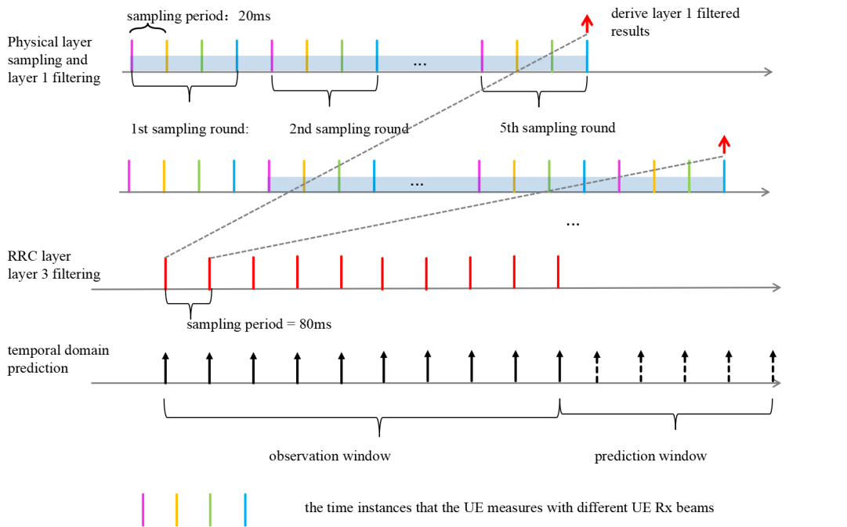

**Issue 2: Is it necessary to introduce such “real” sampling period for L1/L3 filtering option 1? If yes, can it be defined as one fixed value e.g. 80 ms ?**

In the endorsed TP [4], there is definition of RRM sub use case as following:

3 sub-use cases are considered for cell-level RRM measurement prediction:

Sub-use case 1: L1 beam-level measurement result(s) is predicted based on actual L1 beam-level measurement result(s) and then cell-level measurement result is generated

Sub-use case 2: Cell-level measurement result(s) is predicted based on actual cell-level measurement result(s)

Sub-use case 3: Cell-level measurement result(s) is predicted based on actual L1 beam-level measurement result(s)

Editor Note 1: The RRM measurement refers to L3 cell/beam level measurement and/or L1 beam level measurement

Table 2.1-1

In the definition it is not crystal clear whether “cell-level measurement” is L1 or L3 cell level measurement. Based on simulation results from company, the cell-level measurement result should be L3 filtered cell level measurement result. In addition, contribution [2][4][5] also clarify it could be also L1 cell level measurement results for the input of sub-use case 2.

**Issue 3: In the definition of sub-cases, all cell level measurement result(s) refers to L3 filtered cell level measurement. In addition, it could be also L1 cell level measurement result for the input of sub-case 2.**

At last meeting RAN2 agrees that the input L1 beam level measurement in sub-case 1 or 3 could be either L1 filtered or raw L1 sample and it is up to company to report. Now based on the understand of two L1/L3 filtering options and company’s contribution, it is necessary to clarify the relationship between filtering option and input L1 beam level measurement. For temporal domain case B, because of the sliding window scheme, once a raw L1 sample is skipped, then related L1 filtered beam level measurement result can’t be an actual measurement result. Because input L1 measurement result supposes to be an actually measurement result. So technically it will be difficult to skip L1 filtered measurement result in temporal domain and hence difficult to save the measurement result. While L1/L3 filtering doesn’t have such problem. Note there is no such problem for temporal domain case A because the measurement results in observation window are always actual measurement result.

**Issue 4: For temporal domain case B, the mapping between L1/L3 filtering options and input measurement result of sub cases could be:**

|  |  |  |
| --- | --- | --- |
| Input measurement result | L1/L3 filtering option 1 | L1/L3 filtering option 2 |
| Sub case 1 | Raw L1 beam level measurement result | L1 filtered beam level measurement result |
| Sub case 2 | L1 cell level measurement result without L1 filtering | L1 or L3 cell level measurement result |
| Sub case 3 | Raw L1 beam level measurement result | L1 filtered beam level measurement result |

Table 2.1-1

## Observation and predication window

First of all, we need clarify what is temporal domain case A and case B. And what does observation window (OW) and prediction window (PW) mean for case A and case B.

For case A, the model predicts L1 or L3 RSRP within prediction window based on L1 or L3 RSRP in observation window. Then the observation window and prediction window move forward with either sampling period (L1/L3 filtering option 1) or measurement period (L1/L3 filtering option 2).



Figure 2.2-1

For temporal domain case B, the detail pattern could still be flexible. What is agreed now:

**Agreements**

=> companies are encouraged to considers both prediction from low-frequency cell to high-frequency cell and prediction from high-frequency cell to low-frequency cell, but only low to high is expected.

=> For the agreed frequencies for inter-frequence case, only one UE speed is considered for inter-frequency prediction in simulation, e.g., 30km/h. Companies can consider other speeds for other frequencies if they chose to simulate them.

=> **For temporal domain case B prediction the input is historical measurement values and the output is the values at the subsequent time instances that measurement is skipped, i.e., the prediction is always after the measurement and is at future time instance(s).**



Figure 2.2-2



Figure 2.2-3

For both case A and case B, the observation window means the window covering historical L1 or L3 RSRP to predict future L1 or L3 RSRP, while prediction window means the window covering future L1 or L3 RSRP to be predicted. And the essential difference between case A and case B is whether the predicted L1 or L3 RSRP will be actually measured or skipped.

**Issue 5: Clarification temporal domain case A and case B:**

**Recommended definition:**

**Intra-frequency temporal domain case A:**

**In case A, L1 or L3 measurement result(s) covered by prediction window is(are) predicted by L1 or L3 measurement result(s) in observation window. Then observation window and prediction window slides with either sampling period or measurement period when one more L1 or L3 measurement result is actually measured.**

**Intra-frequency temporal domain case B:**

**In case B, L1 or L3 measurement result(s) covered by prediction window is(are) predicted by L1 or L3 measurement result(s) in observation window. Then observation window and prediction window slides with either sampling period(s) or measurement period(s) by skipping one prediction window.**

The prediction window and observation window should be the multiple times of period to produce L1 or L3 filtered RSRP. Based on observation 1 and 2, they are different between L1/L3 filtering options. In addition, Based on the submitted simulation results from company, it seems that the ratio between observation window and prediction window matters. Furthermore for temporal domain case B, technically the ratio between prediction window and observation window can be easily translated into MRRT i.e. MRRT = prediction window/(observation window + prediction window). Here are examples of the potential observation window vs prediction window:

|  |  |  |
| --- | --- | --- |
| OW vs PW | Filtering option 1 | Filtering option 2 |
| Ratio | N=80,120,160,200 | N=400,800,1200 |
| 3N:N |  |  |
| 2N:N |  |  |
| N:N |  |  |

Table 2.2-1 example of observation window vs prediction for FR2 temporal domain case A

|  |  |  |  |
| --- | --- | --- | --- |
| OW vs PW | | Filtering option 1 | Filtering option 2 |
| Ratio | MRRT | N=80,120,160,200 | N=200,400,600 |
| 4N:N | 20% |  |  |
| 3N:N | 25% |  |  |
| 2N:N | 33% |  |  |
| N:N | 50% |  |  |
| N:2N | 66% |  |  |
| N:3N | 75% |  |  |
| N:4N | 80% |  |  |

Table 2.2-2 example of observation window vs prediction for FR1 temporal domain case B

**Issue 6: Observation window (OW) vs Prediction window (PW)**

## TX and RX numbers

From the contributions of this meeting, for FR2 here are the current chosen values:

TX: {8,12,32,64}, RX {1,4,8}.

For FR1 here are the current chosen values:

TX: {1,4,8,12,32}, RX {1,2,4}.

**Issue 7: which one should be dropped?**

## Filtering co-efficient for Beam level prediction

Filtering co-efficient for cell level prediction is 4 i.e. k=4.

Issue 6: Same for beam level prediction? If not, which one? Note the value range is {0,1,4} is recommended by 36.839.

## How is model trained and what is used for inference

During offline discussion, Huawei want to clarify the number of UE trajectories used for training, test and inference. Since it can be expressed by “Data Size (Number of Samples)” in the agreed template, so there is no more issue to be discussed.

# Conclusion

# Reference

[1] R2-2406423 Discussion on RRM measuremnet prediction ZTE Corporation discussion Rel-19

[2] R2-2406499 AIML mobility RRM measurement prediction NEC discussion Rel-19 FS_NR_AIML_Mob

[3] R2-2406311 Discussion on open issue of RRM measurement use case OPPO discussion Rel-19 FS_NR_AIML_Mob

[4] R2-2406309 Text proposal of 38.744 OPPO draft TR Rel-19 38.744 0.0.3 FS_NR_AIML_Mob

[5] R2-2406704 Discussion on cell and beam RRM prediction Xiaomi discussion