**3GPP TSG-SA5 Meeting #157 *S5-245982***

Hyderabad, India, 14 - 18 October 2024 was S5-245847

**Source: Vodafone, Ericsson**

**Title: DP on Signalling Traffic Monitoring**

**Document for: Endorsement**

**Agenda Item: 6.2.3**

# 1 Decision/action requested

***The group is asked to discuss and endorse the proposal.***

# 2 References

[1] S5-244686 Discussion paper on signalling monitoring activation

# 3 Discussion

External monitoring systems are often used by mobile network operators (MNOs) to track network activity for analysis and troubleshooting purposes, and subsequently to perform diagnosis and fault analysis of their system. Such monitoring system(s) are fully under the control of the MNOs, and the monitoring is performed at signalling level. Due to the introduction of encryption of the signalling exchanged between network functions in 5G Core, there is no standardized secure interface to share signalling traffic between the 5G network and the monitoring system(s) of an MNO. For MNOs, standard monitoring capabilities are thus essential to continue performing health checks and troubleshooting of networks without additional integration costs, and without the need to standardise, in 3GPP, the internal implementation of the Network Functions.

This work was triggered by the GSMA which expressed their concerns about the monitoring of encrypted signalling traffic, looking for a mechanism that allows a copy of this traffic to be sent to a monitoring system. This concern was reflected in a Liaison Statement sent from the GSMA to 3GPP (WGs SA2, SA3 and SA5) explaining that the current encryption mechanism sending the information with (m)TLS prevents the operators of doing proper troubleshooting for operation and management procedures.

SA WG1 has agreed the feature level requirements needed for monitoring of signalling traffic in a secure way.

SA WG5 is required to fulfil the following requirement from SA1:

* + The 5G network shall enable the MNO to configure network monitoring, e.g., switching on/off per network element, selecting what type of elements and what type of signalling from these elements is the target for monitoring.

A discussion paper (S5-244686 [1]) has been endorsed by the group endorsing the creation of a new functionality to cover this requirement

A new WID has been submitted for this meeting with the following objective:

To define the use case, requirements and procedures for a new enable/disable functionality that permits an external monitoring system to request to a network function to send a secured copy of their signalling traffic, implying:

WT1 -To define the mechanism of switching on/off per network function.

WT2 -To define the Network function procedure when the Signalling Monitoring Traffic function is enabled.

WT3 -To define the report mechanism.

Additionally, this work may consider additional topics, and coordinate with other WGs (SA3) as needed basis.

In the following figure the scenario with the different actors and their interactions is represented:

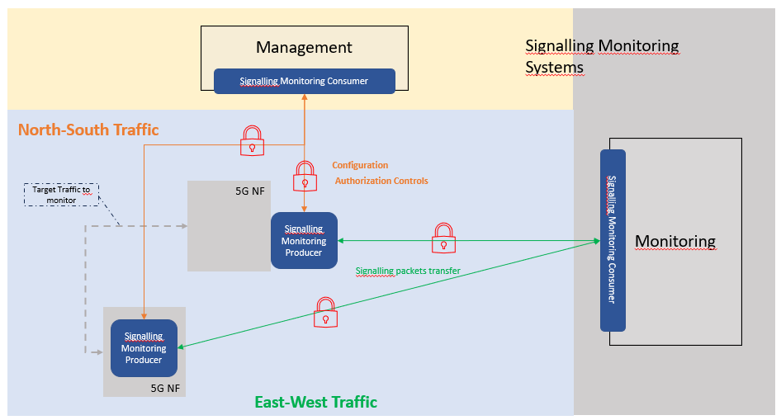

Due to the flexibility of the SA5 specifications there can be more than one approach to define the stage 2 procedure needed to achieve the above-mentioned objectives. A new TS will be created for this WID so it makes sense to have the new procedure in this new TS. For doing so this approach is proposed:

To create a new solution that creates, enable, disable and remove the object instance(s).

-Once this object is created and is enabled, the signalling monitoring function shall be active on the selected NF(s).

-This solution will make it possible to set parameters to configure the Signalling Monitoring (e.g. string target URI for defining the destination of the streaming).

# 4 Detailed proposal

The group is asked to discuss and endorse the following proposal:

To specify the signalling traffic monitoring management in a new TS with stage 1&2&3.

To create a new solution that creates, enable, disable and remove the object instance(s).

-Once this object is created and is enabled, the signalling monitoring function shall be active on the selected NF(s).

-This solution will make it possible to set parameters to configure the Signalling Monitoring (e.g. string target URI for defining the destination of the streaming).