3GPP TSG-SA5 Meeting #157 S5-246257
Hyderabad, India, 14 - 18 October 2024

Source: Huawei, Nokia, ZTE

Title: Rel-19 pCR TR 28.858 add use cases, requirements for conflict management of reinforcement learning

Document for: Approval
Agenda Item: 6.19.1

1 Decision/action requested
The group is asked to discuss and agree on the proposal.

2 References
[1] TR 28.858 " Study on Artificial Intelligence / Machine Learning (AI/ML)" management Phase 2.

3 Rationale
The UC of reinforcement learning has been defined in TR 28.858[1], where the scenario of RL performing the training process through the interaction between RL agent and RL environment has been discussed. However, when multiple training processes of RL share a same RL environment at the same time, the training conflict will happen. That is to say, when two RL agents make actions to a common RL environment, the environmental state changes of each action will be difficult to distinguish, resulting in both the training processes will be affected. Therefore, the MnS consumer may want to manage this kind of training conflict for RL.
This contribution proposes to add the use case and requirements for Training Conflict in Reinforcement Learning.

4 Detailed proposal
Start of First change

5 AI/ML management use cases and requirements

5.1 ML model training

5.1.7 Management of Reinforcement Learning

5.1.7.1 Description
Reinforcement Learning (RL) is a type of machine learning where an agent learns to make decisions by taking actions in an environment to achieve a goal. The agent learns from the consequences of its actions, rather than from being explicitly taught and it selects its actions based on its past experiences (exploitation) and also by new choices (exploration), which is essentially a trial-and-error approach. In RL, an agent interacts with the environment in discrete time steps. At each time step, the agent receives the current state of the environment and selects an action. The environment, in turn, provides a reward and the new state. As illustrated in Figure 5.1.6.1, suppose RL is applied for coverage problem analysis use case, the RL agent actions are used to optimize the coverage problem and the RL environment can be the simulation environment. The actions can be changes to the values of network adjustable parameters (e.g. change the transmission power of the NR sector carrier, see TS 28.104 [3]). The states can be the network PMs/KPIs like RSRP distribution etc. The reward can be the score of an RL performance metric to evaluate the PMs/KPIs. The goal of the agent is to learn a policy, which tells it what action to take under what circumstances, that maximizes the sum of rewards. The main advantage of this approach is in the ability to automatically adapt to the characteristics of the environment, making it suitable approach for handling dynamic environments such as mobile networks.

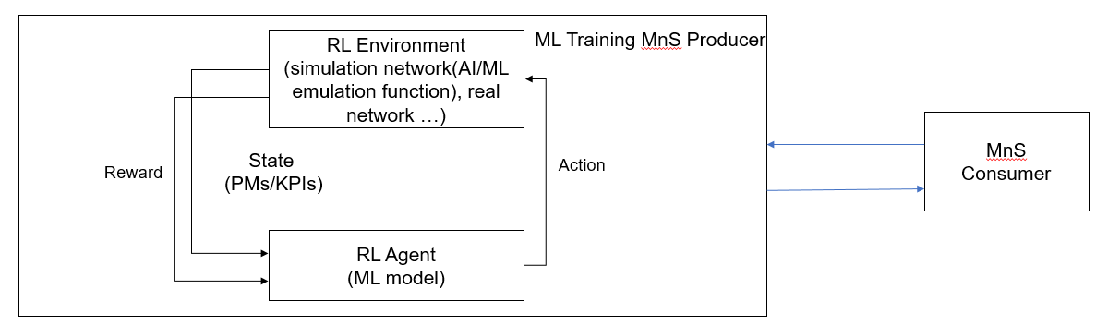
Figure 5.1.6.1: Reinforcement Learning in Domain Management Function

5.1.7.2 Use cases

5.1.7.2.1 Exploration in Reinforcement Learning
Reinforcement Learning (RL) has the ability to learn and adapt itself to dynamic environments and thus finds the near optimal solution to the problem. This makes the RL-based approaches very interesting for applications in the mobile networks. However, the potential negative impact to the mobile network caused by RL is still the main drawback. In particular, during the exploration step performing trials and learning from errors may have an impact on the operational network and may result in unsafe operations causing network performance degradations. Therefore, the exploration step in RL needs to be under a controlled environment that are not supposed to violate system performance requirements. If the RL agent behaves in an unexpected manner, there needs to be a set of fall-back actions in place, e.g., to switch from RL-based solution to non-RL-based solution.
For RL management, the MnS consumer can query the ML Training MnS producer to discover if RL is supported. When RL is supported, a consumer may want to provide a scope (e.g., geographical area, time window) that can aid the producer to select/create the environment when performing RL. In the event RL is supported, the consumer may also want to state their preference for environment type for RL during training i.e. simulated environment or real network.
NOTE: Support for both environment types can be considered optional in the RL training.

5.1.7.2.1 Training Conflict in Reinforcement Learning
The training process of RL is realized by the actions with their impacts to the RL environment. In the online training, if there are multiple RL training processes (of multiple ML models for different AI/ML inference functions) sharing a same RL environment, simultaneously, they will interfere with each other, which may cause the training conflict. To be specific, if multiple ML training processes of RL have conflicts, their agents may make actions at the same time, then the state of the RL environment will be affected by these actions. This kind of training error will result in the performance loss of the trained ML models, even cause the training process difficult to converge.
For example, for the training processes whose related inference functions are load balancing optimization (LBO) and mobility robustness optimization (MRO), their RL environment states both include the cell load while the actions from the two RL agents both include the cell individual offset (CIO) adjustment to optimize the handover decisions. If these two RL training processes are processed at the same time with a same environment for an MnS producer, the loads of the adjacent cells will be affected by both training processes, thus causing the training conflict.
For control the conflict of reinforcement learning, the MnS consumer should know whether there are conflicts during the RL training. The producer should determine the conflict and provide the training conflict indication in RL training to authorized MnS consumer. The MnS consumer may specify the conflict resolution requirements to producer. For example, the consumer can cancel/suspend some training processes or configure conflict resolution requirements in advance.

5.1.7.3 Potential Requirements
REQ-RL_MGMT-01: The ML training MnS producer should have a capability allowing an authorized MnS consumer to query if RL training is supported.
REQ-RL_MGMT-02: The ML training MnS producer should have a capability allowing an authorized MnS consumer to specify the preferred RL environment type.
REQ-RL_MGMT-03: The ML training MnS producer should have a capability to allow an authorized MnS consumer to specify the preferred RL environment scope.
REQ-RL_MGMT-04: The ML training MnS producer should have a capability to provide the training conflict indication during RL online training to authorized MnS consumer.
REQ-RL_MGMT-05: The ML training MnS producer should have a capability allowing an authorized MnS consumer to specify the conflict resolution requirements during RL online training.

End of First change

