3GPP TSG-SA5 Meeting #157 S5-246124
Hyderabad, India, 14 - 18 October 2024

Source: Nokia, Ericsson

Title: Rel-19 pCR TR 28.869 Resolve editor's note in Annex E by updating the content and the related figure

Document for: Approval
Agenda Item: 6.19.6

1 Decision/action requested
In this box give a very clear / short /concise statement of what is wanted.

2 References
[1] 3GPP TR 28.869, " Study on cloud aspects for management and orchestration."

3 Rationale
This pCR resolves the editor’s note in Annex E of TR 28.869 [1] by updating the content and Figure E-1 to show the interactions between the 3GPP management system and the orchestration and management entity for the modification of the NF deployment. In addition, this pCR replaces the term cloud-native NF with NF deployment as agreed.

4 Detailed proposal
It is proposed that the following changes be made to Annex E of TR 28.869 [1].

Begin Change

Annex <E>: Example scenario using interactions with orchestration and management entity for modification of NF deployment instances
Figure E-1 depicts an example scenario for interaction with orchestration and management entity for modification of an instance of aNF deployment.

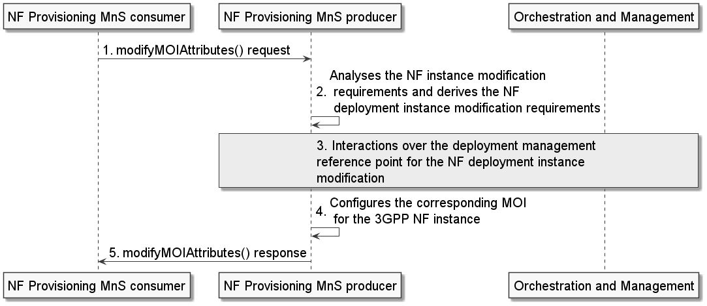
Figure E-1: Example scenario for interaction with orchestration and management entity for modification of an instance of a NF deployment
An authorized NF provisioning MnS Consumer requests modification of a 3GPP NF instance from the NF provisioning MnS producer by sending a modifyMOIAttributes request with DN of the MOI for ManagedFunction and the network function related modification requirements. The NF provisioning MnS producer analyses the 3GPP NF instance modification requirements and derives the NF deployment modification requirements.
The NF provisioning MnS producer invokes interactions with an orchestration and management entity for the modification of the NF deployment instance. Following the completion of the required interactions with the orchestration and management entity, the NF provisioning MnS producer reconfigures the corresponding MOI for the 3GPP NF instance and sends the modifyMOIAttributes response to the NF provisioning MnS Consumer.
Note: If the orchestration and management entity is ETSI NFV MANO, the interactions over deployment management reference point are as specified in clause 7.11 of 28.531 [7].

End Change

