**3GPP TSG-SA5 Meeting #157 *S5-246093***

**Hyderabad, India, 14-18 October 2024**

**Source: Huawei**

**Title: pCR TR 28.874 Add plan management solution for NTN scenarios**

**Document for: Approval**

**Agenda Item: 6.19.15**

# 1 Decision/action requested

***The group is asked to discuss and agree on the proposal.***

# 2 References

[1] 3GPP TR 28.874: Study on management aspects of NTN – Phase 2

# 3 Rationale

This contribution proposes to add potential solutions using plan management corresponding to discussion paper S5-xxxxxx for following use cases:

5.1.1 Use case #1: Connections between RAN node on-board satellite and CN (regenerative mode)

5.1.2 Use case #2: Associations between SectorEquipmentFunction on-board satellite and the RAN nodes (gNB/eNB) on ground (transparent mode)

5.2.1 Use case #1: NTN neighbour cell management

5.2.2 Use case #2: NTN Tracking area management

5.4.1 Use case #1: UE-Satellite-UE Communication via UPFs on-board the satellites

5.5.1 Use case #1: Connectivity between non-terrestrial network node and security gateway

# 4 Detailed proposal

This document proposes the following changes in TR 28.874 [1]

|  |
| --- |
| **1st Change** |

#### 5.1.1.3.X Potential solution #<x>: Pre-configuration based on plan

Management of planned configurations is described in TR 28.872 [1] to provide the capability to support creating, reading, updating, and deleting planned configurations for managed systems. A planned configuration may include only the configuration for the part of the managed system that shall be reconfigured. A planned configuration is represented by a data node tree. The data node tree is compliant to the existing NRM schema. The values of the configuration data nodes in the data node tree are those values with which the managed system shall be reconfigured. Many management problems would benefit from the possibility of creating planned configurations that are not active yet and that can be manipulated without changing the current configuration of the managed system. When ready, the planned configurations can be activated. The capability of conditional activation of planned configurations also is described in TR 28.872 [1], which allow MnS consumer to specify when planned configurations are activated.

Following is one example to illustrate different plans are created for one gNB for different time windows. The plan X for time window X only contain the configuration parameters which are different with those for time window X-1.

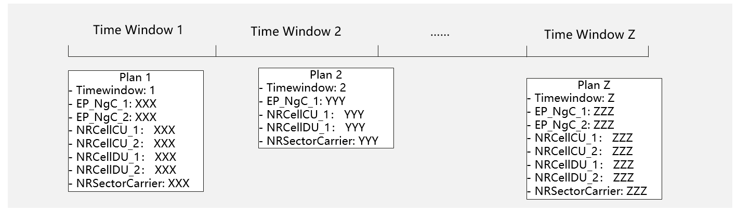

**Figure 5.1.1.3.x-1: Example to illustrate different plans are created for one gNB for different time windows.**

In this use case, instances of EP_NgC, EP_N2, EP_RP_EPS, NRCellCU, NRCellDU can be configured into different plans which validate during different time windows.

|  |
| --- |
| **Next Change** |

#### 5.1.2.3.y Potential solution #<y>: Pre-configuration based on plan

The solution for NTN pre-configuration based on plan can refer to description in clause 5.1.1.3.X.

In this use case, instances of NRSectorCarrier can be configured into different plans which validate during different time windows.

|  |
| --- |
| **Next Change** |

#### 5.2.1.3.z Potential solution #<z>: Pre-configuration based on plan

The solution for NTN pre-configuration based on plan can refer to description in clause 5.1.1.3.X.

In this use case, instances of NRCellRelation can be configured into different plans which validate during different time windows.

|  |
| --- |
| **Next Change** |

#### 5.2.2.3.a Potential solution #<a>: Pre-configuration based on plan

The solution for NTN pre-configuration based on plan can refer to description in clause 5.1.1.3.X.

In this use case, instances of nTNTAClist can be configured into different plans which validate during different time windows.

|  |
| --- |
| **Next Change** |

#### 5.4.1.3.c Potential solution #<c>: Pre-configuration based on plan

The solution for NTN pre-configuration based on plan can refer to description in clause 5.1.1.3.X.

In this use case, instances of EP_N4 can be configured into different plans which validate during different time windows.

|  |
| --- |
| **Next Change** |

#### 5.5.1.3.b Potential solution #<b>: Pre-configuration based on plan

The solution for NTN pre-configuration based on plan can refer to description in clause 5.1.1.3.X.

In this use case, IP connections can be configured into different plans which validate during different time windows.

|  |
| --- |
| **End of changes** |