**3GPP TSG-SA5 Meeting #157S5-245414**

**14 - 18 October 2024, Hyderabad, India**

**Source: Nokia**

**Title: Rel-19 DP 28.915 NDT Normative work scope**

**Document for: Approval**

**Agenda Item: 6.19.3**

# 1 Decision/action requested

***The group is asked to discuss and agree on the proposal.***

# 2 References

[1] 3GPP TR 28.915 -101 “Study on management aspects of Network Digital Twin”.

# 3 Discussion

## 3.1 Outcomes of the NDT study

The study on network digital twins has defined and scoped the NDT as an entity responsible for modelling the behavior of the network. The scope goes further to highlight that the NDT is not responsible for and should **NOT** replace existing automation functionality (such as MDA, SON, closed control loops, etc.). Accordingly, if the NDT does not include automation functionality, it should support those services and capabilities as would be expected from a real network, i.e. enabling a consumer to configure the network (here the NDT) and providing information about events and performance of the network (here NDT). Instead, the NDT work should be coordinated with work on existing automation functionality avoid overlap in standards.

**Observation 1: The NDT is responsible for modelling the network behavior, supporting those capabilities that would be asked to or received from the network, i.e., fault, performance and configuration management.**

**Proposal 1: The NDT work should be coordinated with work on existing automation functionality avoid overlap in standards**

Several use cases have been agreed in the study. The use cases are related typically **requiring the same behavioral-modeling** **functionality for different network performance metrics**. For example, consider the use cases on:

1) “Signaling storm analysis” with a requirement to “to model the behavior of signaling storm” ;

2) “Visualization of network topology and traffic” requiring to “report the visualization information of the network”;

3) “Measuring customer satisfaction” requiring to “simulate end-user’s network usage behaviour”

All three wish to answer the question: “What happened in a certain network scope and how?”. The three differ in the way the question is asked: e.g. in (1) as “How did the signalling storm happen?”; in (2) “how do I see what happened in the network?” and in (3) as “how did user xyz use the network resources?”.

But these are questions that cannot be asked to the network but are asked to automation functions. They can be supported by the same question towards the NDT, i.e. “what happened in network scope S”. The NDT provides the data to the automation functions which then answer the respective questions – see Figure 3.1-1.

The scope of NDT specification should be steps (3) to (8) of Figure 3.1-1. The “NDT application” use cases focussing on the same “network-related question”, but different automation or operations related questions should be grouped into a single NDT “network modelling” use case for the normative work. Any remaining gaps in the standards regarding intelligent capabilities should then be filled in by the automation intelligence specifications, including MDA, CCL, SON etc.

**Observation 2: There are several use cases that have been agreed but are related, in many cases that they attempt to accomplish the same functionality for different network performance metrics**

**Observation 3: To realize the use cases, the NDT needs functionality that is responsible for the intelligence aspects of the use case.**

**.**

**Observation 4: The realizable differences among the use cases is the automation capabilities.**

**Proposal 2: The solutions for these use cases should separate the aspects to be fulfilled by an automation function from those to be fulfilled by an entity that models network behavior (i.e., the NDT)**

**Proposal 3: the use cases and solutions should be grouped into a set of logical groupings which require the same NDT solution, even when differing in the automation capability.**

**Proposal 4: Gaps in the standards regarding intelligent capabilities on NDT use cases should then be filled in by the automation intelligence specifications, including MDA, CCL, SON etc.**

@startuml – nDT for CSP traffic-event analysis

skinparam monochrome true

!pragma teoz true

skinparam BackgroundColor white

skinparam sequenceGroupBackgroundColor white

skinparam defaultFontSize 11

autonumber

skinparam maxMessageSize 200

collections “Operators” as CS #white

participant “Automation/ MnS Consumer \n (NDT MnS Consumer)” as AF #white

participant “NDT \n & NDT MnS producer” as DT #white

Note over CS, DT: NDT has been instantiated

CS -> AF: Tell me what happened (in network scope S given this data D)

Note over CS, AF: Request can be asked in many differnet ways for many different events. E.g.,: \n “Was there a signalling storm, a handover failure, a cell outage, …”\n “How did the signalling storm happen?”, \n“Show me what happened in the network?” \n“how did user xyz use the network resources?

AF -> AF: drive NDT scenario and configuration from the given data

Note over AF: If exact scenario and config are given, \nno special action is requiren

group NDT interaction

AF -> DT: Create scenario (matching network scope S or data D)

AF -> DT: Configure scenario (e.g. KPI list K to monitor and report)

AF -> DT: Execute scenario (for time y from D)

DT -> DT: Runs scenario

DT -> AF: Delivers KPI list K with values

AF -> AF: discover event: correlate KPI list with events in D

End group

AF -> CS: Inform consumer about what happened

Note over CS, AF: Answers provided specific to the diffeent forms in which the questions was raised.

@enduml

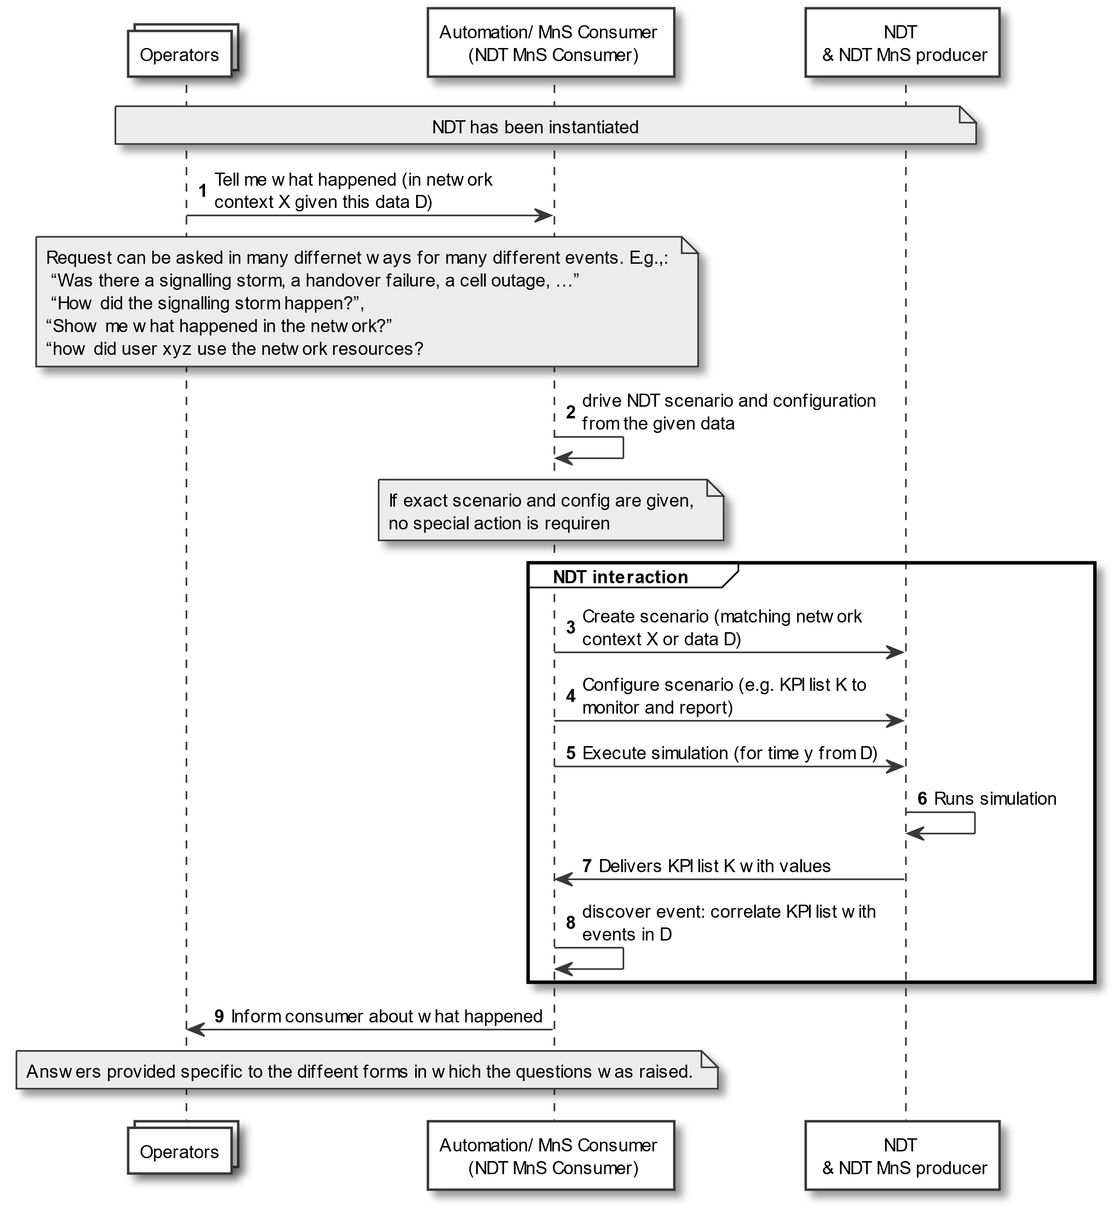

In general, the following questions can be posed to the network (not to automation functions):

**1) What happened in network scope S and how?** This can be expanded as: “I have the data network scope S, and I need the NDT to run it and show me what happened”. This would provide data to address several automation and operations related questions including: (1) How did the signalling storm happen in network scope S?”; (2) how do I see what happened in network scope S? (3) how did user xyz use the network resources? (4) If a network event X were to happen, what are the conditions under which it could happen?

**2) How would network scope S respond to an event?** This can be expanded as: “Something could happen in network scope S, e.g., a signalling storm, a failure, a bad config, a natural disaster, etc, so I need the NDT to show me details about it including how it would happen or progress, how the subsystems would respond, etc”.

**3) How does a configuration c impact a network scope S**? This can be expanded as: “I have a scenario which I need to configure, and I want the NDT to tell me the impact of that configuration on that network scope”. This includes requirements as “evaluating a configuration, getting the differences among alternative configs, evaluating a policy, evaluating a software version upgrade, evaluating board switching...]. This also includes use cases that require to loop through different network scenarios and configurations, e.g. the generation ML training data.

|  |  |
| --- | --- |
| NDT network modelling use case | NDT application use case agreed in the study |
| **1) What happened in network scope S and how?** | Use cases 5: NDT support to network automation – checking what happened  Use case 8: Visualization of network topology and traffic  Use case 11: measuring customer satisfaction with the network services |
| **2) How would a network scope S respond to an event?** | Use case 1: Network management RAN ES policy verification using NDT  Use case 2: Signaling storm analysis – replicating Signaling storm  Use case 3: Emergency preparedness  Use case 4: Network failure and risk prediction  Use case10: Network issue inducement |
| **3) How does a configuration c impact a network scope S** | Use case 2: Signaling storm analysis - check if a given solution resolves the storm  Use cases 5: NDT support to network automation – checking a proposed configuration  Use case 6: Using NDT to generate ML training data  Use case 9: Configuration verification |

Note: “Use case 7: Nested NDTs” is an “NDT network modelling” and not “NDT application” use case, so should be independently pursued.

The NDT normative work should focus on the “NDT network modelling” use cases and leave the automation use cases to be fulfilled by automation functions. The automation use cases can be used descriptively as example of applications that can be fulfilled by the NDT if it supports the said “NDT network modelling” use cases.

**Observation 5: The agreed “NDT application” use cases can be grouped into following three “NDT network modelling”** **use case:**

- Use case 1: NDT to provide information on What happened and how it happened

- Use case 2: NDT to provide information on How would network scope S respond to an event

- Use case 3: NDT to provide information on How does a configuration c impact a network scopeS

**Proposal 5: The NDT normative work should address the “NDT network modelling” use cases with the “NDT application” use cases descriptively documented to motivate the “NDT network modelling” use cases**

## 3.2 Proposed way forward for SA5

It is proposed to endorse the observations and proposals in clause 3.1 above.

# Detailed proposal

It is requested to endorse the following observations and OAM requirements:

* **Observation 1:** The NDT is responsible for modelling the network behavior, supporting those capabilities that would be asked to or received from the network, i.e., fault, performance and configuration management.
* **Proposal 1:** The NDT work should be coordinated with work on existing automation functionality avoid overlap in standards
* **Observation 2:** There are several use cases that have been agreed that are related, but in many cases they attempt to accomplish the same functionality for different network performance metrics
* **Observation 3:** To realize the use cases, the NDT needs functionality (e.g., between the NDT and the operator) that is responsible for the intelligence aspects of the use case.
* **Observation 4:** The realizable differences among the use cases is the automation capabilities supported by the NDT.
* **Proposal 2:** The solutions for these use cases should separate the aspects to be fulfilled by an intelligent/ automation function from those to be fulfilled by the NDT
* **Proposal 3:** the use cases and solutions should be grouped into a small set of logical groupings which require the same NDT solution, even when differing in automation capability.
* **Observation 5:** The agreed “NDT application” use cases can be grouped into following three “NDT network modelling” use case:
  + Use case 1: NDT to provide information on What happened and how it happened
  + Use case 2: NDT to provide information on How would network scope S respond to an event
  + Use case 3: NDT to provide information on How does a configuration c impact a network scope S
* **Proposal 4:** The 3GPP SA5 R19 NDT normative work shouldaddress the “NDT network modelling” use cases with the “NDT application” use cases descriptively documented to motivate the “NDT network modelling” use cases
* **Proposal 5:** Gaps in the standards regarding intelligent capabilities on NDT use cases should then be filled in by the automation intelligence specifications, including MDA, CCL, SON etc.