**3GPP TSG-SA5 Meeting #157S5-245411**

**14 - 18 October 2024, Hyderabad, India**

**Source: Nokia**

**Title:** **pCR 28.867 Clarify Solution for CCL scope management**

**Document for: Approval**

**Agenda Item: 6.19.4**

# 1 Decision/action requested

***The group is asked to discuss and agree on the proposal.***

# 2 References

[1] 3GPP TR 28.867-041 “Closed control loop management”.

# 3 Rationale

The CCL scope management solution have been described with textual descriptions. This pCR adds procedure flows to the CCL scope management solution to illustrated procedures described in text

# 4 Detailed proposal

|  |
| --- |
| **Start of modification** |

## 5.7 Use case 7: CCL scope management

### 5.7.1 Description

Each CCL should have specific scopes for which it is responsible.

The network may be assumed to be a p-dimensional space *SP* from which subregions d*P* Є D maybe created. Accordingly, *SP* is the full scope space whose dimension may include time, geography, etc. as showed in Table 5.7.1‑1 while d*p* Є D can be CCL's scope. In that respect, scope assignment is the mapping of CCLs to regions dЄD that are part of the network's full scope S. There may be 2 types of scopes - the measurement scope where related measurements are collected and the impact or control scope which is the scope to which the CCL's actions may have impact. The scopes for the different CCLs can be managed by the MnS consumer.

Table 5.7.1-1: Example scope-space map from which the scope of CCL may be derived

|  |  |  |
| --- | --- | --- |
| Scope dimension | Granularity | Example values to be assigned |
| Time | Seconds, minutes, days | Every hour,  Every Saturday at 2:00 hours |
| Network domains |  | Radio  Core |
| Geography | Region/City | City x  Street y in City x |
| Network Elements | gNB | gNB X |
| Cells | Cell A on gNB X |
| Terminals, e.g. types of users | users |
| Resources | Slices |  |
| Network Function | Virtual Network Function A  Physical Network Function B |
| Transport containers (links, flows, etc.) | an identifiable link,  a specific flow |
| Target Purpose | The purpose of the CCL target | Coverage Targets, Performance Targets, Energy Efficiency Targets, Fault Management Targets, UE specific Targets |

NOTE: Table 5.7.1-1 is not complete and can be improved and/or extended as needed.

### 5.7.2 Potential Requirements

**REQ-CCL-COORD-1:** The 3GPP management system should support a capability enabling the MnS consumer to configure the scopes of a CCL, including the measurement scope, the control scope , and the impact scope.

NOTE: Measurement scope is where the related measurements are collected, the control scope is where the CCL acts and the impact scope is where the CLL actions causes effects.

**REQ-CCL-COORD-2:** The 3GPP management system should support a capability to detect, avoid and resolve conflicts among the scopes of multiple CCLs, including the measurement scope, the control scope and the impact scope.

### 5.7.3 Potential Solutions

#### 5.7.3.1 Required capabilities and interactions

To coordinate scope assignments, a CCL coordination functionality, say in Coordination CCL, needs a capability to coordinate the scope assignment across multiple CCLs, say called the scope assignment coordination capability. The scope assignment coordination capability considers a defined full scope space *Sp* and a set of scope rules to define the best scope to be assigned to each CCL. An example rule may be that the defined CCL scope should not overlap. The rules may for example be defined by an operator or can be implementation specific depending on the types of CCLs that are to be configured.

To support detection and avoidance of potential scope conflicts:

- Each CCL has a scope, e.g. the assuranceScope for the ACCL. The scope may be defined by an operator. Alternatiely, the CCL Coordination entity may derive the required scope and configure it onto the CCL.

- The CCL may register its scopes with the coordinationCCL (e.g., for the case where the scope is not defined by the CCL Coordination entity). The notification of the CCL scope to the CCL Coordination entity triggers an evaluation of potential conflict, i.e. whether those scopes are likely to conflict with the scopes of another CCL.

- Applying the rules, the scope assignment coordination capability divides the scope space into regions such that each region is matched to a CCL in a way that maximizes fulfilment of the assignment rules defined in the scope assignment coordination capability. The For example, if the benefit is to avoid overlaps, the subregions are assigned to the different CCLs in a way that ensures no overlaps and that all the scope space has been assigned.

- A CCL may have four scopes - the measurement scope, target scope, control scope and impact scope with different rules applied for each scope. The selection of subregions of the scope space should consider the different rules for each type of scope.

- In case of a potential conflict, the new optimized subregions are selected and assigned to the individual CCLs. The scope assignment coordination capability should be enabled to configure the scopes of the CCLs.

Scope conflicts are only considered actual if their use results in negative outcomes. To support detection and resolution of actual scope conflicts:

- The CCLs should monitor changes in their scope and if the scope is changed, the CCL should be able to inform the scope assignment coordination capability of any observed changes in the scope.

- The CCL should notify differences between what was configured and the actual scopes e.g. if the considered scope for taking measurement data are affected by the actions of another CCL.

- The scope assignment coordination capability may subsequently trigger scope conflict evaluation based on the actual scope that is notified by the CCL.

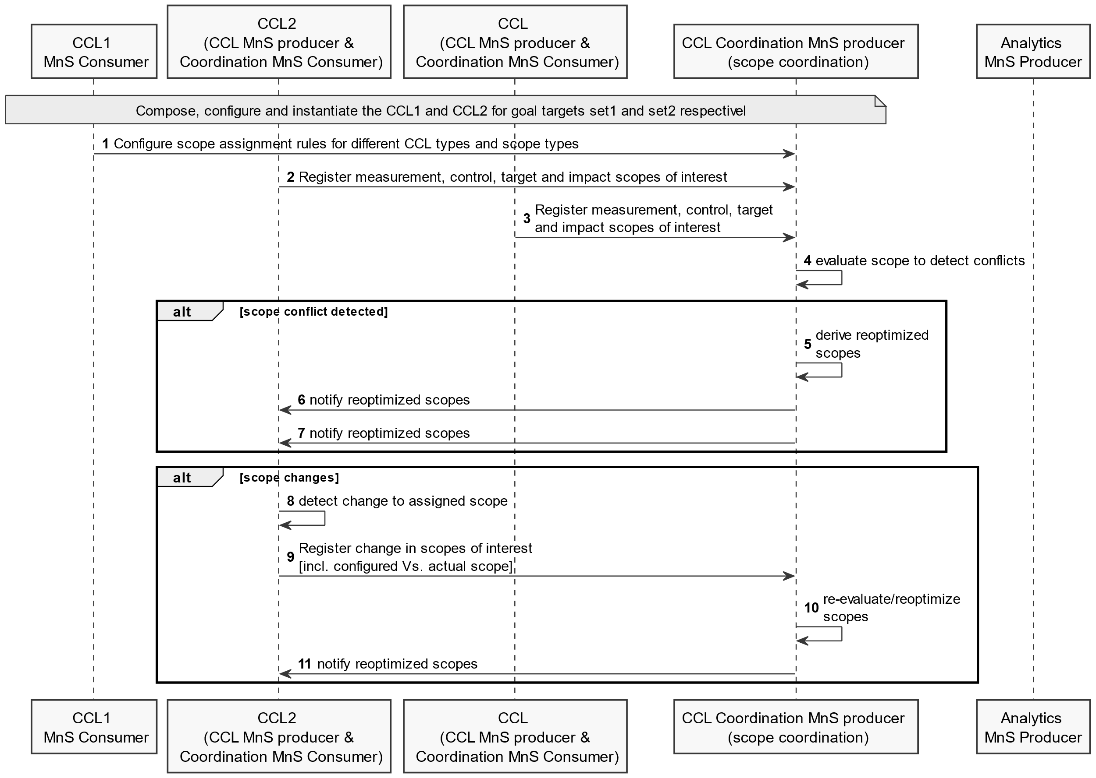Figure 5.7.3.1-1: Example flow for detection and avoidance of scope conflicts

#### 5.7.3.2 Information objects to realize required capabilities and interactions

Introduce on the CoordinationCCL a profile for the capabilities to coordinate different scopes across multiple CCLs, say as a datatype, say called CCLScopeCoordination:

- It collects all the functionality and capabilities related to coordinating scopes among multiple CCLs to detect, avoid or resolve potential and real conflicts.

- Introduce a datatype and corresponding attribute on the CCLScopeCoordination to represent the scope space which is to be considered by the CCLScopeCoordination to select allocations to different CCL instances.

Introduce a dataType and corresponding attribute on the CCL to represent the scope of the CCL. The datatype may be called CCLScope. A CCL instance can have 4 scopes, which may be called measurementScope, target scope, controlScope and impactScope. The cCLScope should be configurable by the MnS consumer:

- The CCLScope may include an indication as to whether the assigned scope is exclusive or not. An exclusive scope implies that not other function or CCL should have impacts in that scope apart from the CCL to which it has been assigned.

- The scope should be an extension of the assuranceScope of the ACCL.

Introduce a dataType and corresponding attribute on the CCL to represent misalignments in any of the scopes of the CCL. The datatype may be called ScopeMissalignmentInfo. The ScopeMissalignmentInfo allows the CCL to indicate mis alignments in its scope and adjust the scope to remove conflicts:

- The ScopeMissalignmentInfo includes information on the type of scope in which there are misalignments and an indication of which one is smaller - the assigned or the required scope.

- The ScopeMissalignmentInfo may include information on scope conflicts, e.g. indication that the CCL has observed that its allocated scope being changed by another CCL or function.

### 5.7.4 Evaluation of solutions

The solution in clause 5.7.3 provides the procedures and information objects for CCL scope coordination, enabling interactions for detection, avoidance and resolution of CCL scope conflicts. No conflicting solution for handling CCL scope conflicts is provided. it is recommended to apply the solution in in clause 5.7.3 as the solution for CCL scope management.

|  |
| --- |
| **Next modifications** |

Annex A:  
PlantUML Code for figures

# A.2 Procedures for CCL Management

## A.2.x10 Detection and avoidance of scope conflicts (Figure 5.7.3.1-1)

@startuml Detection and avoidance of scope conflicts

skinparam Shadowing false

autonumber

skinparam monochrome true

participant "CCL1 \n MnS Consumer" as CX

participant "CCL2 \n (CCL MnS producer & \n Coordination MnS Consumer)" as CL1

participant "CCL \n (CCL MnS producer & \n Coordination MnS Consumer)" as CL2

participant "CCL Coordination MnS producer \n (scope coordination)" as xCL

participant "Analytics \nMnS Producer" as ANL

Note over CX, xCL: Compose, configure and instantiate the CCL1 and CCL2 for goal targets set1 and set2 respective

CX -> xCL: Configure scope assignment rules for different CCL types and scope types

CL1 -> xCL: Register measurement, control, target and impact scopes of interest

CL2 -> xCL: Register measurement, control, target \nand impact scopes of interest

xCL -> xCL: evaluate scope to detect conflicts

alt scope conflict detected

xCL -> xCL: derive reoptimized \nscopes

xCL -> CL1: notify reoptimized scopes

xCL -> CL1: notify reoptimized scopes

end

alt scope changes

CL1 -> CL1: detect change to assigned scope

CL1 -> xCL: Register change in scopes of interest \n[incl. configured Vs. actual scope]

xCL -> xCL: re-evaluate/reoptimize \nscopes

xCL -> CL1: notify reoptimized scopes

end

@enduml

|  |
| --- |
| **End of modifications** |