3GPP TSG-WG SA2 Meeting #165 *S2-241xxxx*

**Hyderabad, India, October 14 – 18, 2024 (was *S2-2410296*)**

|  |  |  |  |  |  |  |  |  |
| --- | --- | --- | --- | --- | --- | --- | --- | --- |
| *CR-Form-v12.2* | | | | | | | | |
| **CHANGE REQUEST** | | | | | | | | |
|  | | | | | | | | |
|  | **23.316** | **CR** | **2136** | **rev** | **5** | **Current version:** | **18.6.0** |  |
|  | | | | | | | | |
| *For* [***HE******LP***](http://www.3gpp.org/3G_Specs/CRs.htm#_blank)*on using this form: comprehensive instructions can be found at* [*http://www.3gpp.org/Change-Requests*](http://www.3gpp.org/Change-Requests)*.* | | | | | | | | |
|  | | | | | | | | |

|  |  |  |  |  |  |  |  |  |
| --- | --- | --- | --- | --- | --- | --- | --- | --- |
| ***Proposed change affects:*** | UICC apps |  | ME | **x** | Radio Access Network |  | Core Network | **x** |

|  |  |  |  |  |  |  |  |  |  |  |
| --- | --- | --- | --- | --- | --- | --- | --- | --- | --- | --- |
|  | | | | | | | | | | |
| ***Title:*** | Identifying non-3GPP devices behind 5G-RG | | | | | | | | | |
|  |  | | | | | | | | | |
| ***Source to WG:*** | CableLabs, Nokia, InterDigital, Charter Communications | | | | | | | | | |
| ***Source to TSG:*** | SA2 | | | | | | | | | |
|  |  | | | | | | | | | |
| ***Work item code:*** | UIA_ARC | | | | |  | ***Date:*** | | | 2024-10-04 |
|  |  | | | |  | |  | | |  |
| ***Category:*** | B |  | | | | | ***Release:*** | | | Rel-19 |
|  | *Use one of the following categories:* ***F*** *(correction)* ***A*** *(mirror corresponding to a change in an earlier release)* ***B*** *(addition of feature),* ***C*** *(functional modification of feature)* ***D*** *(editorial modification)*  Detailed explanations of the above categories can be found in 3GPP [TR 21.900](http://www.3gpp.org/ftp/Specs/html-info/21900.htm). | | | | | | | | *Use one of the following releases: Rel-8 (Release 8) Rel-9 (Release 9) Rel-10 (Release 10) Rel-11 (Release 11) … Rel-16 (Release 16) Rel-17 (Release 17) Rel-18 (Release 18) Rel-19 (Release 19)* | |
|  |  | | | | | | | | | |
| ***Reason for change:*** | | To specify the support for identifying non-3GPP devices connecting behind a 5G-RG based on the conclusions in clause 8.4 of TR 23.700-32 | | | | | | | | |
|  | |  | | | | | | | | |
| ***Summary of change:*** | | Specifying conclusions on identification of non-3GPP device for wireline access | | | | | | | | |
|  | |  | | | | | | | | |
| ***Consequences if not approved:*** | | New feature not implemented in the specification | | | | | | | | |
|  | |  | | | | | | | | |
| ***Clauses affected:*** | | 4.10x, 7.3.x | | | | | | | | |
|  | |  | | | | | | | | |
|  | | **Y** | **N** |  | | | |  | | |
| ***Other specs*** | |  | **x** | Other core specifications | | | | TS/TR ... CR ... | | |
| ***affected:*** | |  | **x** | Test specifications | | | | TS/TR ... CR ... | | |
| ***(show related CRs)*** | |  | **x** | O&M Specifications | | | | TS/TR ... CR ... | | |
|  | |  | | | | | | | | |
| ***Other comments:*** | |  | | | | | | | | |
|  | |  | | | | | | | | |
| ***This CR’s revision history:*** | |  | | | | | | | | |

* * * * First change * * * *

## 4.10x Differentiated QoS for non-3GPP devices behind 5G-RG

This clause defines the support of identifying the traffic of individual non-3GPP devices behind a 5G-RG and providing them differentiated QoS.

TS 23.501 [2] clause 5.x applies to the 5G-RG with the following deltas:

- The UE is replaced by 5G-RG.

Figure 4.10x-1 illustrates an example scenario for the mapping of traffic from individual non-3GPP devices behind 5G-RG to a PDU Session. Non-3GPP devices associated with the same PDU Session can be further differentiated using their Device IDs. As in this example, two non-3GPP devices mapped to PDU Session A initially used the default QoS Flow (QFI 1); when differentiated QoS is requested for one device, the 5G-RG binds its traffic to a Device ID and its traffic is mapped to a separate QoS Flow (QFI 2). Four non-3GPP devices mapped to PDU Session B based on their Connectivity Group ID X initially used the default QoS Flow (QFI 3); when differentitated QoS is requested for two of those four devices, the 5G-RG binds their traffic to Device IDs and their traffic is mapped to separate QoS Flows (QFI 4 and QFI 5). Similarly, three non-3GPP devices mapped to PDU Session C based on their Connectivity Group ID Y initially used the default QoS Flow (QFI 6); when differentiated, but the same, QoS is requested for two of those three devices, the 5G-RG binds their traffic to Device IDs and their traffic is mapped to a separate QoS Flow (QFI 7).

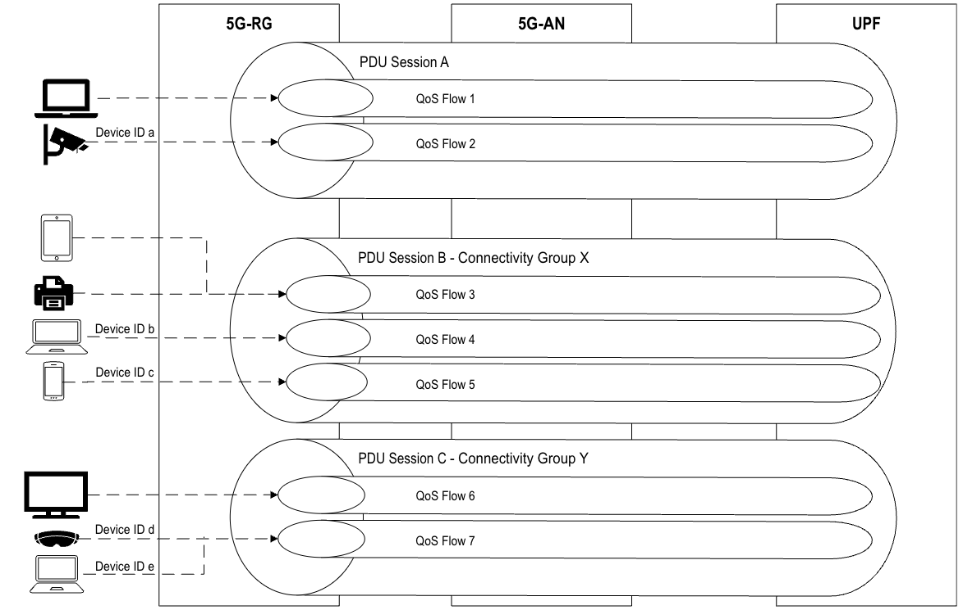

Figure 4.10x-1: Example scenario for mapping traffic from individual non-3GPP devices behind 5G-RG to a PDU Session

* * * * Second change * * * *

### 7.3.x Session management for identifying the traffic of individual non-3GPP devices behind 5G-RG

This clause describes a procedure to enable the 5GS to identify the traffic of individual non-3GPP devices behind a 5G-RG and provide differentiated QoS.

Figure 7.3.x-1: Example procedure for identifying traffic of individual non-3GPP devices behind 5G-RG

0a. Non-3GPP device A is connected to the 5G-RG.

0b. To provide connectivity to the non-3GPP device A, the 5G-RG implements the existing behaviour of either using the URSP rule containing the Connectivity Group ID as described in clause 4.10b, or based on local configurations, maps the traffic of the non-3GPP device A to a PDU Session.

0c. Non-3GPP device B is connected to the 5G-RG.

0d. To provide connectivity to the non-3GPP device B, the 5G-RG implements the existing behaviour of either using the URSP rule containing the Connectivity Group ID as described in clause 4.10b, or based on local configurations, maps the traffic of the non-3GPP device B to a PDU Session.

1. The 5G-RG subscription owner or an authorized user, using mechanisms out of scope of 3GPP, requests differentiated QoS for the non-3GPP device B through the AF.

NOTE 1: The request for differentiated service can be made through an operator portal hosted either on the 5G-RG or in the AF. The AF is assumed to be in sync with the 5G-RG on the currently connected devices.

2. The above step triggers the AF to provision the Device ID of the non-3GPP device B and the requested QoS policy into the UDR.

NOTE 2: Even if the operator portal is hosted on the 5G-RG, provisioning of the Device ID and the QoS policy associated with the non-3GPP device into the UDR is done through the AF.

NOTE 3: Provisioning of Device ID and QoS policy into the UDR is done only for the non-3GPP devices that require differentiated QoS.

3. Based on the network configuration, either a 5G-RG requested PDU Session Establishment/Modification (based on 5G-RG implementation or URSP rules) or network requested PDU Session Modification procedure is triggered.

3a. (5G-RG requested PDU Session Modification) Clause 7.3.2 applies with following additions: 5G-RG includes the Device ID and the User Plane Address of the non-3GPP device B that requires differentiated QoS in the N1 SM Container. The SMF includes the Device ID in the Npcf_SMPolicyControl_Update service operation. The PCF includes the Device ID in the Nudr_DM_Query service operation to request the QoS policy for the non-3GPP device and creates PCC Rules for the corresponding User Plane address.

3b. (Network requested PDU Session Modification) Clause 7.3.2 applies with following additions: The PCF is notified about a new QoS policy for the Device ID by the UDR using the Nudr_DM_Notify service operation. The PCF performs a PCF initiated SM Policy Association Modification procedure to notify SMF about the modification of policies for the Device ID.

Editor’s note: How the User Plane address is determined and how the PCF determines which PDU Session to modify is FFS.

3c. (5G-RG requested PDU Session Establishment) Clause 7.3.1 applies with following additions: 5G-RG includes the Device ID of the non-3GPP device B that requires differentiated QoS in the N1 SM Container. The SMF includes the Device ID in the Npcf_SMPolicyControl_Create service operation. The PCF includes the Device ID in the Nudr_DM_Query service operation to request the QoS policy for the non-3GPP device and creates PCC Rules for the corresponding User Plane address.

4. The operator portal returns a response to the user about the completion of the differentiated QoS request for non-3GPP device B.

* * * * End of changes * * * *