3GPP TSG-WG SA2 Meeting #165 *S2-2410756*

**Hyderabad, India, October 14 – 18, 2024 (was *S2-2410296*)**

|  |  |  |  |  |  |  |  |  |
| --- | --- | --- | --- | --- | --- | --- | --- | --- |
| *CR-Form-v12.2* | | | | | | | | |
| **CHANGE REQUEST** | | | | | | | | |
|  | | | | | | | | |
|  | **23.316** | **CR** | **2136** | **rev** | **5** | **Current version:** | **18.6.0** |  |
|  | | | | | | | | |
| *For* [***HE******LP***](http://www.3gpp.org/3G_Specs/CRs.htm#_blank)*on using this form: comprehensive instructions can be found at* [*http://www.3gpp.org/Change-Requests*](http://www.3gpp.org/Change-Requests)*.* | | | | | | | | |
|  | | | | | | | | |

|  |  |  |  |  |  |  |  |  |
| --- | --- | --- | --- | --- | --- | --- | --- | --- |
| ***Proposed change affects:*** | UICC apps |  | ME | **x** | Radio Access Network |  | Core Network | **x** |

|  |  |  |  |  |  |  |  |  |  |  |
| --- | --- | --- | --- | --- | --- | --- | --- | --- | --- | --- |
|  | | | | | | | | | | |
| ***Title:*** | Identifying non-3GPP devices behind 5G-RG | | | | | | | | | |
|  |  | | | | | | | | | |
| ***Source to WG:*** | CableLabs, Nokia, InterDigital, Charter Communications | | | | | | | | | |
| ***Source to TSG:*** | SA2 | | | | | | | | | |
|  |  | | | | | | | | | |
| ***Work item code:*** | UIA_ARC | | | | |  | ***Date:*** | | | 2024-10-04 |
|  |  | | | |  | |  | | |  |
| ***Category:*** | B |  | | | | | ***Release:*** | | | Rel-19 |
|  | *Use one of the following categories:* ***F*** *(correction)* ***A*** *(mirror corresponding to a change in an earlier release)* ***B*** *(addition of feature),* ***C*** *(functional modification of feature)* ***D*** *(editorial modification)*  Detailed explanations of the above categories can be found in 3GPP [TR 21.900](http://www.3gpp.org/ftp/Specs/html-info/21900.htm). | | | | | | | | *Use one of the following releases: Rel-8 (Release 8) Rel-9 (Release 9) Rel-10 (Release 10) Rel-11 (Release 11) … Rel-16 (Release 16) Rel-17 (Release 17) Rel-18 (Release 18) Rel-19 (Release 19)* | |
|  |  | | | | | | | | | |
| ***Reason for change:*** | | To specify the support for identifying non-3GPP devices connecting behind a 5G-RG based on the conclusions in clause 8.4 of TR 23.700-32 | | | | | | | | |
|  | |  | | | | | | | | |
| ***Summary of change:*** | | Specifying conclusions on identification of non-3GPP device for wireline access | | | | | | | | |
|  | |  | | | | | | | | |
| ***Consequences if not approved:*** | | New feature not implemented in the specification | | | | | | | | |
|  | |  | | | | | | | | |
| ***Clauses affected:*** | | 4.10x(new) | | | | | | | | |
|  | |  | | | | | | | | |
|  | | **Y** | **N** |  | | | |  | | |
| ***Other specs*** | |  | **x** | Other core specifications | | | | TS/TR ... CR ... | | |
| ***affected:*** | |  | **x** | Test specifications | | | | TS/TR ... CR ... | | |
| ***(show related CRs)*** | |  | **x** | O&M Specifications | | | | TS/TR ... CR ... | | |
|  | |  | | | | | | | | |
| ***Other comments:*** | | ‘Clause 5.x’ in this CR’s clause 4.10x refers to the clause 5.x in CR 5750 of TS 23.501  ‘Clause 5.9.x’ in this CR’s clause 4.10x refers to the clause 5.9.x in CR 5749 of TS 23.501 | | | | | | | | |
|  | |  | | | | | | | | |
| ***This CR’s revision history:*** | |  | | | | | | | | |

* * * * First change * * * *

## 4.10x Differentiated QoS for non-3GPP devices behind 5G-RG

This clause defines the support for identifying the traffic of individual non-3GPP devices behind a 5G-RG and providing them differentiated QoS.

TS 23.501 [2] clauses 5.9.x and 5.x apply to the 5G-RG with the following deltas:

- The UE is replaced by 5G-RG.

Figure 4.10x-1 illustrates an example scenario for the mapping of traffic from individual non-3GPP devices behind 5G-RG to a PDU Session. Non-3GPP devices associated with the same PDU Session can be further differentiated using their Non-3GPP Device Identifiers. As in this example, two non-3GPP devices mapped to PDU Session A initially used the default QoS Flow (QFI 1); when differentiated QoS is requested for one device, the 5G-RG binds its traffic to a Non-3GPP Device Identifier and its traffic is mapped to a separate QoS Flow (QFI 2). Four non-3GPP devices mapped to PDU Session B based on their Connectivity Group ID X initially used the default QoS Flow (QFI 3); when differentitated QoS is requested for two of those four devices, the 5G-RG binds their traffic to Non-3GPP Device Identifiers and their traffic is mapped to separate QoS Flows (QFI 4 and QFI 5). Similarly, three non-3GPP devices mapped to PDU Session C based on their Connectivity Group ID Y initially used the default QoS Flow (QFI 6); when differentiated, but the same, QoS is requested for two of those three devices, the 5G-RG binds their traffic to Non-3GPP Device Identifiers and their traffic is mapped to a separate QoS Flow (QFI 7).

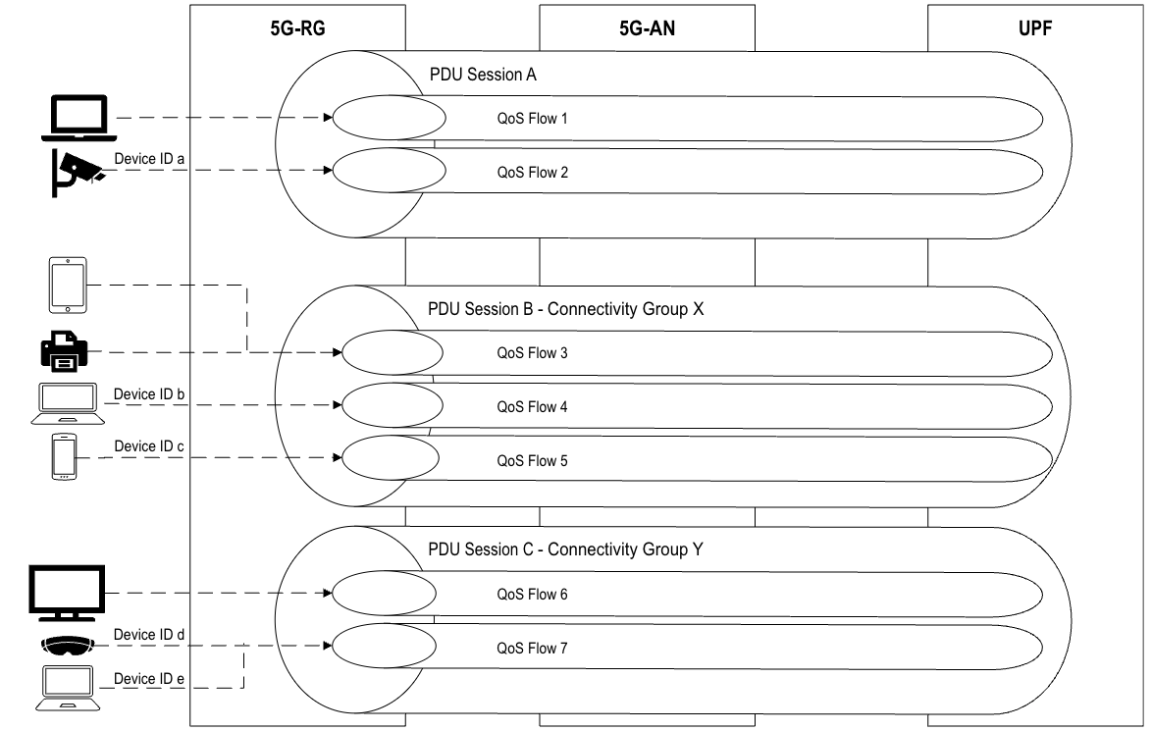

Figure 4.10x-1: Example scenario for mapping traffic from individual non-3GPP devices behind 5G-RG to a PDU Session* * * * End of changes * * * *