3GPP TSG RAN WG4 Meeting #112bis R4-2417189
Hefei, Anhui, China, 14th – 18th October, 2024
Agenda item: 6.17.4.1
Source: vivo, NTU, Nokia, Ericsson, Qualcomm, Xiaomi, Huawei, Hisilicon, Mediatek, OPPO, APPLE, Rohde & Schwarz, CATT, Samsung, Intel
Title: Link-level simulation assumptions for AI/ML based BM
Document for: Approval

Introduction
In this contribution, the link-level simulation assumption for AI/ML based BM case-1 is captured. Companies are encouraged to provide simulation results to evaluate the impact of the measurement error based on the performance metric in section 4.

Simulation assumptions
Link level simulation (LLS) assumptions for evaluation of measurement error on AI/ML based BM case-1 performance are defined in Table 1-5.
Table 1 Baseline Link Level Simulation assumptions for AI/ML in beam management evaluations
Parameter | Value
Carrier frequency | 30GHz.
Subcarrier spacing | 120kHz
Channel model | NLOS channel: option 1: CDL-C , option 2: TDL-C,  DS = 100ns  Other channel models are not precluded.
BS antenna configurations | Option 1:  One panel: (M, N, P, Mg, Ng) = (4, 8, 2, 1, 1), (dV, dH) = (0.5, 0.5) λ as baseline.  Number of Tx beams is 32 is baseline  Other number of Tx beams is not precluded  Option 2:  1 Tx antenna  Number of TX beams: N/A
BS antenna element radiation pattern | Option1: Table 2  Option 2: N/A
BS antenna height and antenna array down-tilt angle, if needed (Option 1 above) | Option1: 25m, 110°  Option 2: N/A
Beamforming characteristic of the BS pattern | Option 1 [corresponding to BS antenna configurations option 1]:  32 beams with grid of 4 elevation angles from [-25° to 25°] and 8 azimuth angles from [-60° to 60°]  Option 2:  N/A
UE antenna configurations | Option 1: Panel structure: (M, N, P) = (1, 4, 2),  - 2 panels (left, right) with (Mg, Ng) = (1, 2) as baseline  - 1 panel as optional\  Number of Rx beams is up to UE  Option 2: 2 Rx
UE antenna element radiation pattern | Option 1: Table 3  Option 2: N/A
UE moving speed | 3km/h
Reference signal | SSB as baseline, CSI-RS (optional)
DRX | No
Number of samples in L1 averaging | 1 as baseline, other number of samples are not precluded
Note 1: TXRU weights mapping for BS and UE is up to company.

Table 2 BS antenna radiation pattern
Parameter | Values
Antenna element vertical radiation pattern (dB)
Antenna element horizontal radiation pattern (dB)
Combining method for 3D antenna element pattern (dB)
Maximum directional gain of an antenna element G_{E,max} | 8dBi
Table 3 UE antenna radiation pattern model
Parameter | Values
Antenna element radiation pattern in dim (dB)
Antenna element radiation pattern in dim (dB)
Combining method for 3D antenna element pattern (dB)
Maximum directional gain of an antenna element G_{E,max} | 5dBi
Note: are in local coordinate system.
Table 4 Cell-specific parameters
Parameter | Unit | Value
PBCH and DMRS power offset with respect to NR-PSS and NR-SSS | dB | 0
Data and control PSD relative to NR-PSS and NR-SSS | dB | 0
SSB periodicity | ms | 20
SSB bandwidth | RB | 20
SSB SCS | kHz | 120
RB Utilization | % | 100
Data Modulation | - | QPSK
CP Length | - | Normal
Frequency Offset relative to UE frequency reference | Hz | 0
Relative Delay of 1st Path (synchronous) | µs | 0
SNR | dB | [-3, 0, 3]  Note: Simulation with other SNR levels are not precluded, e.g., for determining the SNR for ideal measurement.
Note: When analog beamforming is used in LLS, SNR value of above row represents the post beamforming SNR of the strongest Tx-Rx beam pair.
For other Tx-Rx beam pairs, there are two options.
Option 1: Apply error distribution from the post beamforming SNR of the strongest Tx-Rx beam pair to all Tx-Rx beam pair’s measurements in the SLS
Option 2: Generate error distribution separately for each individual Tx-Rx beam pair’s SNRs and apply to the corresponding Tx-Rx beam pair measurement in the SLS.

When analog beamforming is not used in LLS,
Apply error distribution based on the SNR of above row to the strongest Tx-Rx beam pair’s measurements in the SLS
Option 1: Apply error distribution from the SNR of above row to all Tx-Rx beam pairs’ measurements in the SLS
Option 2: Generate error distribution separately for each individual Tx-Rx beam pairs’ SNR values and apply to the corresponding Tx-Rx beam pair measurements in the SLS.
Table 5 CSI-RS configuration parameters
Parameter | Value
CSI-RS bandwidth | 48 PRBs;
CSI-RS SCS | 120 kHz
Periodicity | 5 ms (optional); 40 ms
CSI-RS configuration:  <X,D,N,CDM>, where:  X=number of CSI-RS ports,  D=density [RE/RB/port],  N=number of OFDM symbols in the same slot | <32,1,4,FD-CDM2>

Reference model
For better alignment of the performance between companies, it would be better to perform simulations based on a reference model. The model description in Fig. 1 is an example of reference model for BM-case 1 performance evaluation, while it is not the intention to preclude other reference models.
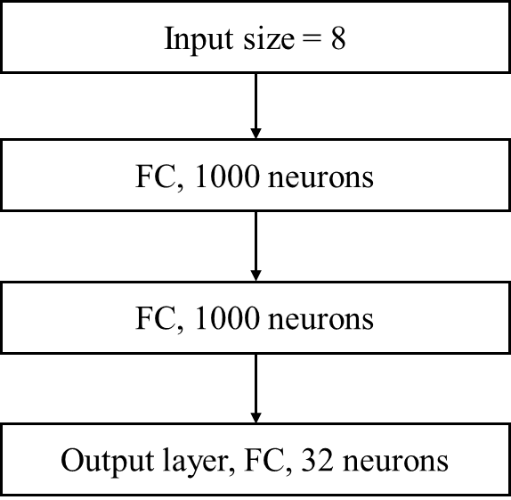
Fig. 1 Reference model description

Performance metrics
At least the following performance characteristics are to be provided
- Top-K/1 and Top-1/K prediction accuracy, where K = 1, 2, 3, 4, 5
  - with considering measurement errors
  - without considering measurement errors
- 90%-tile L1-RSRP difference between the maximum RSRP of the Top-1/Top-5 predicted beam(s) and the RSRP of the genie aided strongest beam
  - with considering measurement errors
  - without considering measurement errors
- 90%-tile L1-RSRP difference between the predicted L1-RSRP of the Top-1/Top-5 predicted beam(s) and the ideal L1-RSRP of the same beams
  - with considering measurement errors
  - without considering measurement errors
Note:
90%-tile L1-RSRP difference = max(abs(95%-tile L1-RSRP), abs(5%-tile L1-RSRP))

Simulation procedures (For information)
We provide the following procedures for companies to perform simulations to evaluate the impact of measurement error in BM prediction Sceanario-1: spatial domain prediction with 32 beams in Set A, Set B is subset of Set A and contains 8 beams for measurement as a baseline.
- Companies to generate ideal L1-RSRP dataset from the SLS assumption defined in TR 38.843 Table 6.3.1-1.
- Use subset samples of the ideal dataset generated from the 1st step for training models.
Approach a:
- Use the other subset samples of the ideal dataset (none overlap samples with the subset dataset in 2nd step) as the ideal dataset for inference and to evaluate the performance metric without considering measurement errors.
- Use the LLS simulation assumptions defined in Table 1-5 to generate L1-RSRP difference as the baseband errors.
- Add the baseband errors generated from LLS into the ideal SLS dataset to derive the dataset with measurement errors.
- If RF errors are modelled, then they should be added into the ideal SLS dataset in addition to baseband errors.
- Use the dataset with measurement errors for inference and to evaluate the performance metric with considering measurement errors.
Approach b:
4. Use the L1-RSRP dataset generated from LLS for inference and to evaluate the performance metric with considering measurement errors.
- Power of Tx beams: companies to report the Tx power used in LLS.
- If RF errors are modelled, then they should be added into the ideal SLS dataset in addition to baseband errors
Companies are encouraged to report the mapping of error distributions from LLS to SLS.

References
- TR 38.843 Study on Artificial Intelligence (AI)/Machine Learning (ML) for NR air interface (Release 18)

Annex
In addition, the impact of RF errors should also be considered. ±4.5dB RF error is considered. Following options can be used to generate RF errors.
- Option 1: Uniform distribution
- Option 2: Gaussian distribution
- Other options are not precluded
  - Companies are requested to provide details of other options.
Companies are encouraged to provide simulation results with and without considering RF errors.

