3GPP TSG-RAN WG4 Meeting#112bis R4-24XXXXX

Hefei, Anhui, 14 – 18 October 2024
CR-Form-v12.3
CHANGE REQUEST
 | 38.101-1 | CR | CRNum | rev | - | Current version: | 18.7.0
For HELP on using this form: comprehensive instructions can be found at
http://www.3gpp.org/Change-Requests.

Proposed change affects: | UICC apps |  | ME | X | Radio Access Network |  | Core Network

Title: | Power enhancement for Scenario 2 within one serving cell
Source to WG: | Ericsson
Source to TSG: | R4
Work item code: |  |  |  |  |  |  | Date: |  |  | 2024-
Category: | B |  |  |  |  |  | Release: |  |  | Rel-19
 | Use one of the following categories:  F (correction)  A (mirror corresponding to a change in an earlier release)  B (addition of feature),  C (functional modification of feature)  D (editorial modification)  Detailed explanations of the above categories can  be found in 3GPP TR 21.900. |  |  |  |  |  |  |  | Use one of the following releases:  Rel-8 (Release 8)  Rel-9 (Release 9)  Rel-10 (Release 10)  Rel-11 (Release 11)  …  Rel-17 (Release 17)  Rel-18 (Release 18)  Rel-19 (Release 19)  Rel-20 (Release 20)
Reason for change: |  | Reduce MPR for Scenario 2  [Beneficial for UEs not supporting the full BW, but also useful for avoiding increased MPR in case a UE is configured with a smaller BW.]
Summary of change: |  | Change the mapping for RBs within a UE BW to that of the BS BW, outer for the UE-specific CHBW (configured by ServingCellConfig) becomes inner within the wider BS CHBW  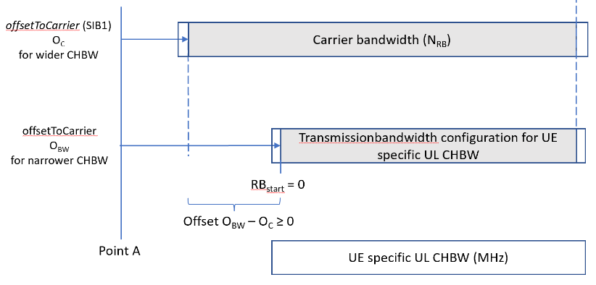  and the applicability of the SEM and the ACLR  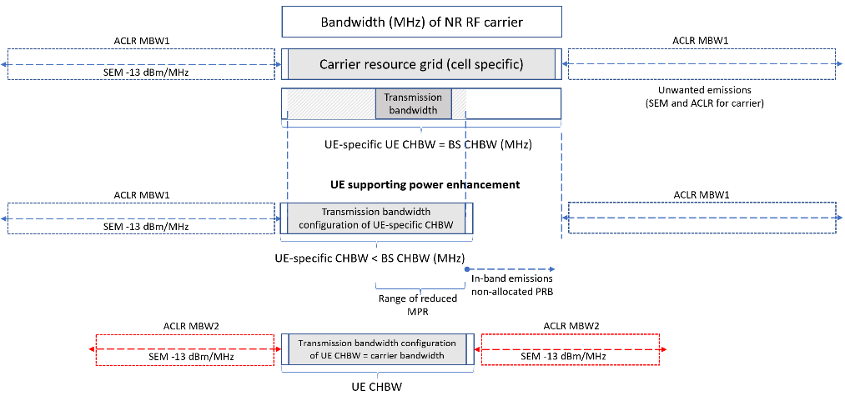  in case the BS CHBW > UE CHBW and the UE supports the new capability.  (The UE shall still meet the requirement for a supported UE CHBW with carrier bandwidth = transmission bandwidth configuration of this UE CHBW as used in existing conformance testing, the bottom part of the figure.)
Consequences if not approved:
Clauses affected:
 |  | Y | N
Other specs |  |  | X | Other core specifications
affected: |  |  | X | Test specifications |  |  |  | .
(show related CRs) |  |  | X | O&M Specifications
Other comments:
This CR's revision history:

< start of changes
Table 6.2.2-5 Maximum power reduction (MPR) for power class 1 for Band n14
Modulation |  | MPR (dB)
 |  | Edge RB allocations | Outer RB allocations | Inner RB allocations
DFT-s-OFDM | Pi/2 BPSK | ≤ 0.5 | ≤ 0.5 | 0
 | Pi/2 BPSK w Pi/2 BPSK DMRS | ≤ 0.5 | 0 | 0
 | QPSK | ≤ 1 |  | 0
 | 16 QAM | ≤ 2 |  | ≤ 1
 | 64 QAM | ≤ 2.5
 | 256 QAM | ≤ 4.5
CP-OFDM | QPSK | ≤ 3 |  | ≤ 1.5
 | 16 QAM | ≤ 3 |  | ≤ 2
 | 64 QAM | ≤ 3.5
 | 256 QAM | ≤ 6.5

Where the following parameters are defined to specify valid RB allocation ranges for Outer and Inner RB allocations:
N_{RB} is the maximum number of RBs for a given Channel bandwidth and sub-carrier spacing defined in Table 5.3.2-1. RB_{Start,Low} = max(1, floor(L_{CRB}/2))
where max() indicates the largest value of all arguments and floor(x) is the greatest integer less than or equal to x.
RB_{Start,High} = N_{RB} – RB_{Start,Low} – L_{CRB}
The RB allocation is an Inner RB allocation if the following conditions are met
RB_{Start,Low} ≤ RB_{Start} ≤ RB_{Start,High}, and
L_{CRB} ≤ ceil(N_{RB}/2)
where ceil(x) is the smallest integer greater than or equal to x.
An Edge RB allocation is the one for which the RB(s) is (are) allocated at the lowermost or uppermost edge of the channel L_{CRB} ≤ 2 RBs, except for PC1 UE supporting other bands than n14.
For a UE supporting [capability] and configured with a UE channel bandwidth within a carrier with a bandwidth greater than the transmission bandwidth configuration of the UE channel bandwidth, the condition for an inner RB allocation is modified to
RB_{Start,Low} ≤ RB_{Start} + O_{BW} – O_{C} ≤ RB_{Start,High}
with N_{RB} = N´_{RB} the bandwidth of the said carrier as indicated by carrierBandwidth in [SIB1], where RB_{Start} = 0 coincides with the first common RB index within the transmission bandwidth configuration of the UE channel bandwidth while O_{BW} and O_{C} are the offsets configured by the offsetToCarrier in the IE ServingCellConfig and [SIB1], respectively.
And for PC1 UE supporting other bands than n14 RB allocation is an Edge RB allocation if
< text omitted >

6.5.2.2 Spectrum emission mask
The spectrum emission mask of the UE applies to frequencies (Δf_{OOB}) starting from the ± edge of the assigned NR channel bandwidth. For frequencies offset greater than Δf_{OOB}, the spurious requirements in clause 6.5.3 are applicable.
NOTE: For measurement conditions at the edge of each frequency range, the lowest frequency of the measurement position in each frequency range should be set at the lowest boundary of the frequency range plus MBW/2. The highest frequency of the measurement position in each frequency range should be set at the highest boundary of the frequency range minus MBW/2. MBW denotes the measurement bandwidth defined for the protected band.
The power of any UE emission shall not exceed the levels specified in Table 6.5.2.2-1 for the specified channel bandwidth.
Table 6.5.2.2-1: General NR spectrum emission mask
Δf_{OOB}  (MHz) | Channel bandwidth (MHz) / Spectrum emission limit (dBm) |  |  |  | Measurement bandwidth
 | 3 | 5 | 10, 15, 20, 25, 30, 35, 40, 45 | 50, 60, 70, 80, 90, 100
± 0-1 | -13 | -13 | -13 |  | 1 % of channel BW
± 0-1 |  |  |  | -24 | 30 kHz
± 1-5 | -10 | -10 | -10 |  | 1 MHz
± 5-6 | -25 | -13
± 6-10 |  | -25
± 5-BW_{Channel} |  |  | -13
± BW_{Channel}-(BW_{Channel}+5) |  |  | -25

A UE supporting [capability] and configured with a UE channel bandwidth within a carrier with a bandwidth greater than the transmission bandwidth configuration of this UE channel bandwidth shall meet the emission levels in Table 6.5.2.2-1 for the channel bandwidth with transmission bandwidth configuration equal to the carrier bandwidth indicated by carrierBandwidth in [SIB1], Δf_{OOB} measured from the edges of the said channel bandwidth.

6.5.2.3 Additional spectrum emission mask
< text omitted >

6.5.2.4.1 NR ACLR
NR Adjacent Channel Leakage power Ratio (NR_{ACLR}) is the ratio of the filtered mean power centred on the assigned NR channel frequency to the filtered mean power centred on an adjacent NR channel frequency at nominal channel spacing.
The assigned NR channel power and adjacent NR channel power are measured with rectangular filters with measurement bandwidths specified in Table 6.5.2.4.1-1.
If the measured adjacent channel power is greater than –50 dBm then the NR_{ACLR} shall be higher than the value specified in Table 6.5.2.4.1-2.
When the IE [powerBoostPi2BPSKRel18] or [powerBoostQPSKRel18] is set to 1 for a UE supporting the capability of [powerBoostRel18] or capability of [powerBoostTSRel18], for power class 2 UE, the ACLR requirement of PC2 applies. For power class 3 UE, the ACLR requirement of PC3 applies.

Table 6.5.2.4.1-1: NR ACLR measurement bandwidth
Channel bandwidth | (MHz) | 3,5,10,15,20,25,30,35,40,45,50 | 60,70,80,90,100
REF_SCS | (kHz) | 15 | 30
NR ACLR measurement bandwidth | (MHz) | MBW=REF_SCS*(12*N_{RB}+1)/1000
NOTE : “N_{RB}” in the formula is the maximum transmission bandwidth configuration as defined in Table 5.3.2-1.
NOTE 2: For a UE supporting [capability] and configured with a UE channel bandwidth within a carrier with a bandwidth greater than the transmission bandwidth configuration of this UE channel bandwidth, “N_{RB}” in the formula is the maximum transmission bandwidth configuration as indicated by carrierBandwidth in [SIB1] with a value specified in Table 5.3.2-1.

Table 6.5.2.4.1-2: NR ACLR requirement
 | Power class 1 | Power class 1.5 | Power class 2 | Power class 3
NR ACLR | 37 dB | 31 dB | 31 dB | 30 dB
NOTE 1: Void

< end of changes >

