**3GPP TSG-RAN WG4 Meeting #112bis Rev R4-2414982  
Hefei, Anhui, China, 14th – 18th October, 2024**

**Title: R19 AMPR for n28 40MHz**

**Source: OPPO**

**Agenda item: 5.20.2**

**Document for: Approval**

# Introduction

This paper discusses the NS_18 AMPR for n28 40MHz for both PC3 and PC2 per WF [1].

# Discussion

## AMRP for PC3 with 1Tx

### 2.1.1 AMRP region definition

The AMPR simulation configurations are:

* power class PC3
* One PC3 low band PA
* 40MHz CBW with 30khz scs (figure 1)
* CP-OFDM / DFT-S-OFDM
* Modulation pi/2 bpsk, qpsk, 16qam, 64qam, 256qam
* AMPR-MPR results are shown in annex A
* AMPR results are shown in annex B

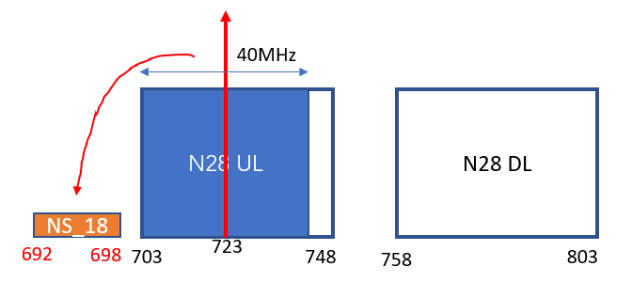

Figure 1 40MHz CBW location and NS_18 emission region

The AMPR-MPR results can be found in **annex A**.

Following similar region definition in 30MHz, below figure 2 shows AMPR-MPR results (where AMPR is larger than MPR) and gives the region definition for 40MHz PC3.

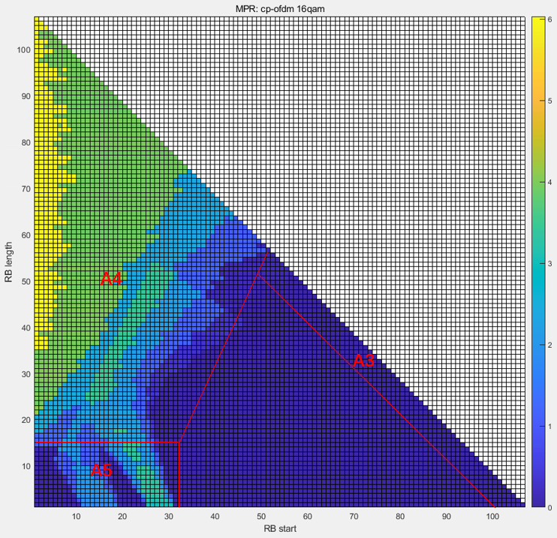

Figure 2 Shown of AMPR region definition (30khz scs, CP-OFDM 16QAM AMPR-MPR results)

The region definition is in table 1.

Table 1 AMPR region definition for 1T PC3

|  |  |  |  |  |
| --- | --- | --- | --- | --- |
| CBW, MHz | Tx BW, MHz | Regions | | A-MPR |
| RBstart *12*SCS (MHz) | LCRB *12*SCS (MHz) |
| 40MHz | 703-743 | >(LCRB*12*SCS)/2+8.46 | ≥Max (0, 12*SCS*NRB – 1.8 – RBstart*12*SCS) | A3 |
| ≤(LCRB*12*SCS)/2+8.46 | ≥5.4 | A4 |
| ≤11.16 | <5.4 | A5 |

### 2.1.2 AMRP requirements

Based on above AMPR region definition and the AMPR simulation results in **Annex B**, the AMPR requirements are summarized in table 2 for DFT-S-OFDM and CP-OFDM with 1dB implementation margin considered.

Table 2 AMPR for 1T PC3

|  |  |  |  |  |  |  |
| --- | --- | --- | --- | --- | --- | --- |
|  | DFT-S-OFDM | | | CP-OFDM | | |
|  | A3 | A4 | A5 | A3 | A4 | A5 |
| Pi/2 BPSK | 1 | 8 | 5 |  |  |  |
| QPSK | 4 | 8 | 5 | 6 | 10 | 7 |
| 16QAM | 6 | 10 | 6 | 6 | 10 | 7 |
| 64QAM | 6 | 10 | 6 | 6 | 10 | 7 |
| 256QAM | 6 | 10 | 6 | 6 | 10 | 7 |

**Proposal 1: Consider Table 1 as the AMPR region definition and Table 2 as the AMPR requirements for 1T PC3.**

## AMRP for PC2

### 2.1.1 AMRP region definition

The AMPR simulation configurations are:

* Power class 2 with 1*PC2 PA or 2*PC3 PA
* 40MHz CBW with 30khz scs (figure 1)
* CP-OFDM / DFT-S-OFDM
* Modulation pi/2 bpsk, qpsk, 16qam, 64qam, 256qam
* AMPR-MPR results are shown in annex A
* AMPR results are shown in annex B

Below figure 3 and 4 gives the AMPR region status for **1T PC2**. It can be seen most of PC3 region definition can be reused except for QPSK with DFT and CP-OFDM where MPR might be needed for the yellow highlighted region. And this new region is marked with A6.

Similar issue can be found also in **2T PC2** QPSK and 16QAM simulation results (Annex A).

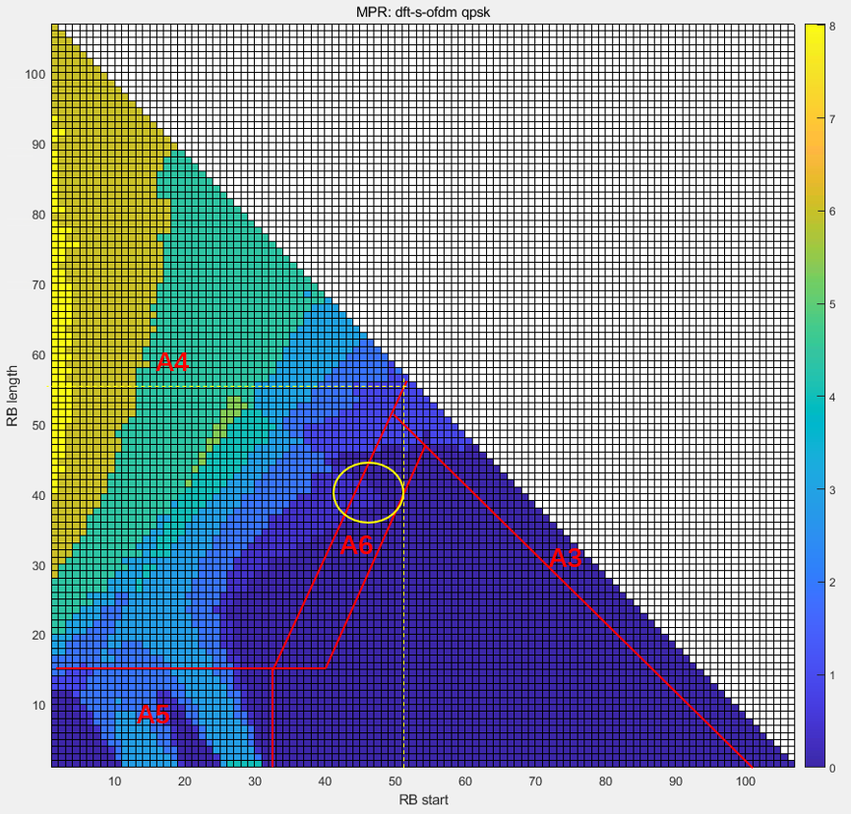

Figure 3 Shown of AMPR region definition for PC2 1Tx (30khz scs, DFT QPSK AMPR-MPR results)

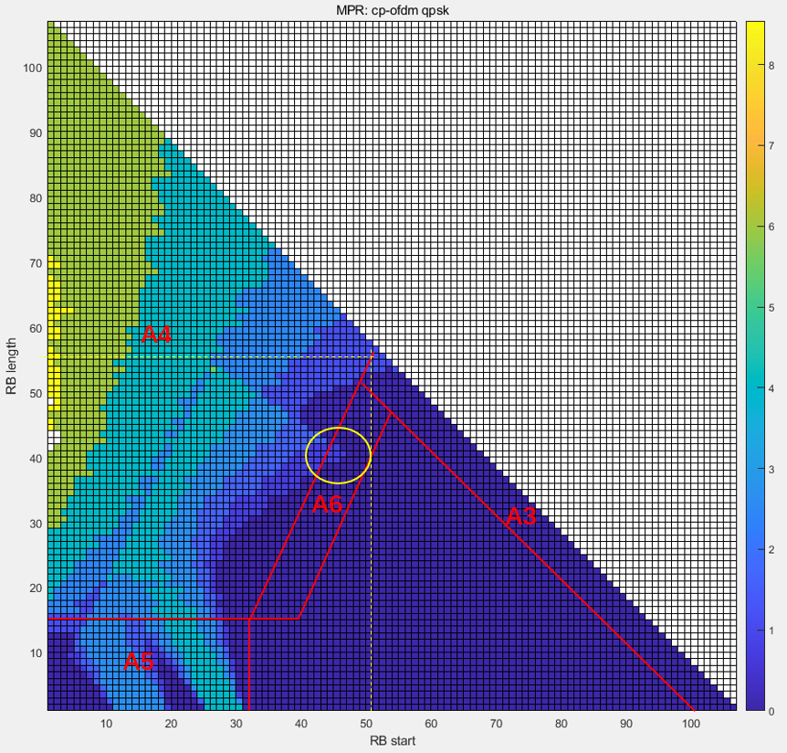

Figure 4 Shown of AMPR region definition for PC2 1Tx (30khz scs, CP-OFDM QPSK AMPR-MPR results)

**Proposal 2: Consider Table 3 as the AMPR region definition for PC2 with 1Tx or 2Tx.**

Table 3 AMPR region definition for PC2 with 1Tx or 2Tx

|  |  |  |  |  |
| --- | --- | --- | --- | --- |
| CBW, MHz | Tx BW, MHz | Regions | | A-MPR |
| RBstart *12*SCS (MHz) | LCRB *12*SCS (MHz) |
| 40MHz | 703-743 | >(LCRB*12*SCS)/2+8.46 | ≥Max (0, 12*SCS*NRB – 1.8 – RBstart*12*SCS) | A3 |
| ≤(LCRB*12*SCS)/2+8.46 | ≥5.4 | A4 |
| ≤11.16 | <5.4 | A5 |
| >(LCRB*12*SCS)/2+8.46  ≤(LCRB*12*SCS)/2+11.7 | <Max (0, 12*SCS*NRB – 1.8 – RBstart*12*SCS)  ≥5.4 | A6 |

### 2.2.1 1T PC2 results

The AMPR simulation results for 1T PC2 can be found in **annex B**.

Below table 4 summarizes the AMPR results for 1T PC2 with 1dB margin based on the region definition in Table 3.

Table 4 AMPR for 1T PC2

|  |  |  |  |  |  |  |  |  |
| --- | --- | --- | --- | --- | --- | --- | --- | --- |
|  | DFT-S-OFDM | | | | CP-OFDM | | | |
|  | A3 | A4 | A5 | A6 | A3 | A4 | A5 | A6 |
| Pi/2 BPSK | 2 | 8 | 5 | 2 |  |  |  |  |
| QPSK | 4 | 10 | 5 | 4 | 6 | 13 | 8 | 6 |
| 16QAM | 5 | 10 | 6 | 5 | 6 | 13 | 8 | 6 |
| 64QAM | 5 | 10 | 6 | 5 | 6 | 14 | 8 | 6 |
| 256QAM | 5 | 10 | 6 | 5 | 6 | 14 | 8 | 6 |

### 2.2.2 2T PC2 results

Similar as 1T PC2, the AMPR results for 2T PC2 can be found in **annex B**.

Below table 5 summarizes the AMPR results for 2T PC2 with 1dB margin based on the region definition in Table 3.

Table 5 AMPR for 2T PC2

|  |  |  |  |  |  |  |  |  |
| --- | --- | --- | --- | --- | --- | --- | --- | --- |
|  | DFT-S-OFDM | | | | CP-OFDM | | | |
|  | A3 | A4 | A5 | A6 | A3 | A4 | A5 | A6 |
| Pi/2 BPSK | 3 | 10 | 5 | 3 |  |  |  |  |
| QPSK | 5 | 13 | 7 | 5 | 6 | 13 | 8 | 6 |
| 16QAM | 6 | 13 | 7 | 6 | 6 | 13 | 8 | 6 |
| 64QAM | 6 | 13 | 7 | 6 | 6 | 13 | 8 | 6 |
| 256QAM | 6 | 13 | 7 | 6 | 6 | 13 | 8 | 6 |

### 2.2.3 AMRP requirements

From table 4 and table 5, it can be seen the difference between 1T and 2T are around 0-2dB. If one AMPR table for 1Tx and 2Tx, then AMPR table 6 can be used.

Table 6 AMPR for both 1T and 2T PC2

|  |  |  |  |  |  |  |  |  |
| --- | --- | --- | --- | --- | --- | --- | --- | --- |
|  | DFT-S-OFDM | | | | CP-OFDM | | | |
|  | A3 | A4 | A5 | A6 | A3 | A4 | A5 | A6 |
| Pi/2 BPSK | 3 | 10 | 5 | 3 |  |  |  |  |
| QPSK | 5 | 13 | 7 | 5 | 6 | 13 | 8 | 6 |
| 16QAM | 6 | 13 | 7 | 6 | 6 | 13 | 8 | 6 |
| 64QAM | 6 | 13 | 7 | 6 | 6 | 14 | 8 | 6 |
| 256QAM | 6 | 13 | 7 | 6 | 6 | 14 | 8 | 6 |

**Proposal 3: If separate AMPR tables for PC2 with 1Tx and 2Tx, then AMPR table 4 and 5 can be used.**

**Proposal 4: If one AMPR table for PC2 with 1Tx and 2Tx, then AMPR table 6 can be used.**

# Conclusion

This paper shared the AMPR simulation results for NS_18 with 40MHz CBW in n28 and got below observations and proposals.

**Proposal 1: Consider Table 1 as the AMPR region definition and Table 2 as the AMPR requirements for 1T PC3.**

Table 1 AMPR region definition for 1T PC3

|  |  |  |  |  |
| --- | --- | --- | --- | --- |
| CBW, MHz | Tx BW, MHz | Regions | | A-MPR |
| RBstart *12*SCS (MHz) | LCRB *12*SCS (MHz) |
| 40MHz | 703-743 | >(LCRB*12*SCS)/2+8.46 | ≥Max (0, 12*SCS*NRB – 1.8 – RBstart*12*SCS) | A3 |
| ≤(LCRB*12*SCS)/2+8.46 | ≥5.4 | A4 |
| ≤11.16 | <5.4 | A5 |

Table 2 AMPR for 1T PC3

|  |  |  |  |  |  |  |
| --- | --- | --- | --- | --- | --- | --- |
|  | DFT-S-OFDM | | | CP-OFDM | | |
|  | A3 | A4 | A5 | A3 | A4 | A5 |
| Pi/2 BPSK | 1 | 8 | 5 |  |  |  |
| QPSK | 4 | 8 | 5 | 6 | 10 | 7 |
| 16QAM | 6 | 10 | 6 | 6 | 10 | 7 |
| 64QAM | 6 | 10 | 6 | 6 | 10 | 7 |
| 256QAM | 6 | 10 | 6 | 6 | 10 | 7 |

**Proposal 2: Consider Table 3 as the AMPR region definition for PC2 with 1Tx or 2Tx.**

Table 3 AMPR region definition for PC2 with 1Tx or 2Tx

|  |  |  |  |  |
| --- | --- | --- | --- | --- |
| CBW, MHz | Tx BW, MHz | Regions | | A-MPR |
| RBstart *12*SCS (MHz) | LCRB *12*SCS (MHz) |
| 40MHz | 703-743 | >(LCRB*12*SCS)/2+8.46 | ≥Max (0, 12*SCS*NRB – 1.8 – RBstart*12*SCS) | A3 |
| ≤(LCRB*12*SCS)/2+8.46 | ≥5.4 | A4 |
| ≤11.16 | <5.4 | A5 |
| >(LCRB*12*SCS)/2+8.46  ≤(LCRB*12*SCS)/2+11.7 | <Max (0, 12*SCS*NRB – 1.8 – RBstart*12*SCS)  ≥5.4 | A6 |

**Proposal 3: If separate AMPR tables for PC2 with 1Tx and 2Tx, then AMPR table 4 and 5 can be used.**

Table 4 AMPR for 1T PC2

|  |  |  |  |  |  |  |  |  |
| --- | --- | --- | --- | --- | --- | --- | --- | --- |
|  | DFT-S-OFDM | | | | CP-OFDM | | | |
|  | A3 | A4 | A5 | A6 | A3 | A4 | A5 | A6 |
| Pi/2 BPSK | 2 | 8 | 5 | 2 |  |  |  |  |
| QPSK | 4 | 10 | 5 | 4 | 6 | 13 | 8 | 6 |
| 16QAM | 5 | 10 | 6 | 5 | 6 | 13 | 8 | 6 |
| 64QAM | 5 | 10 | 6 | 5 | 6 | 14 | 8 | 6 |
| 256QAM | 5 | 10 | 6 | 5 | 6 | 14 | 8 | 6 |

Table 5 AMPR for 2T PC2

|  |  |  |  |  |  |  |  |  |
| --- | --- | --- | --- | --- | --- | --- | --- | --- |
|  | DFT-S-OFDM | | | | CP-OFDM | | | |
|  | A3 | A4 | A5 | A6 | A3 | A4 | A5 | A6 |
| Pi/2 BPSK | 3 | 10 | 5 | 3 |  |  |  |  |
| QPSK | 5 | 13 | 7 | 5 | 6 | 13 | 8 | 6 |
| 16QAM | 6 | 13 | 7 | 6 | 6 | 13 | 8 | 6 |
| 64QAM | 6 | 13 | 7 | 6 | 6 | 13 | 8 | 6 |
| 256QAM | 6 | 13 | 7 | 6 | 6 | 13 | 8 | 6 |

**Proposal 4: If one AMPR table for PC2 with 1Tx and 2Tx, then AMPR table 6 can be used.**

Table 6 AMPR for both 1T and 2T PC2

|  |  |  |  |  |  |  |  |  |
| --- | --- | --- | --- | --- | --- | --- | --- | --- |
|  | DFT-S-OFDM | | | | CP-OFDM | | | |
|  | A3 | A4 | A5 | A6 | A3 | A4 | A5 | A6 |
| Pi/2 BPSK | 3 | 10 | 5 | 3 |  |  |  |  |
| QPSK | 5 | 13 | 7 | 5 | 6 | 13 | 8 | 6 |
| 16QAM | 6 | 13 | 7 | 6 | 6 | 13 | 8 | 6 |
| 64QAM | 6 | 13 | 7 | 6 | 6 | 14 | 8 | 6 |
| 256QAM | 6 | 13 | 7 | 6 | 6 | 14 | 8 | 6 |

# Reference

[1] [R4-24142](http://10.10.10.10/ftp/RAN/RAN4/Inbox/R4-2414287.zip)74 WF on introduction of PC2 and 40MHz CBW in NR band n28, CMCC, #112 2024-08

# Annex A: AMPR-MPR simulation results

## Annex A.1 1T PC3 DFT-S-OFDM

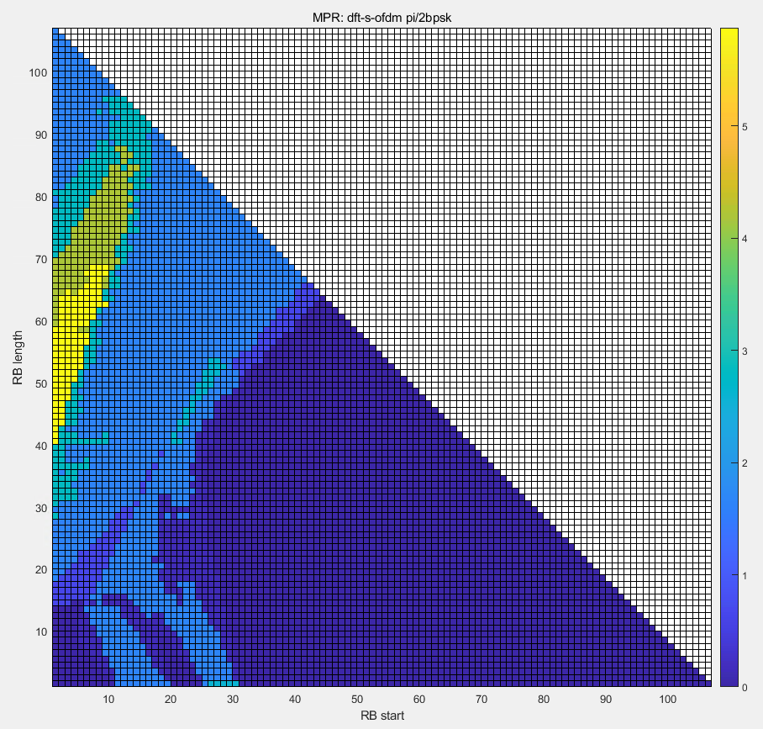 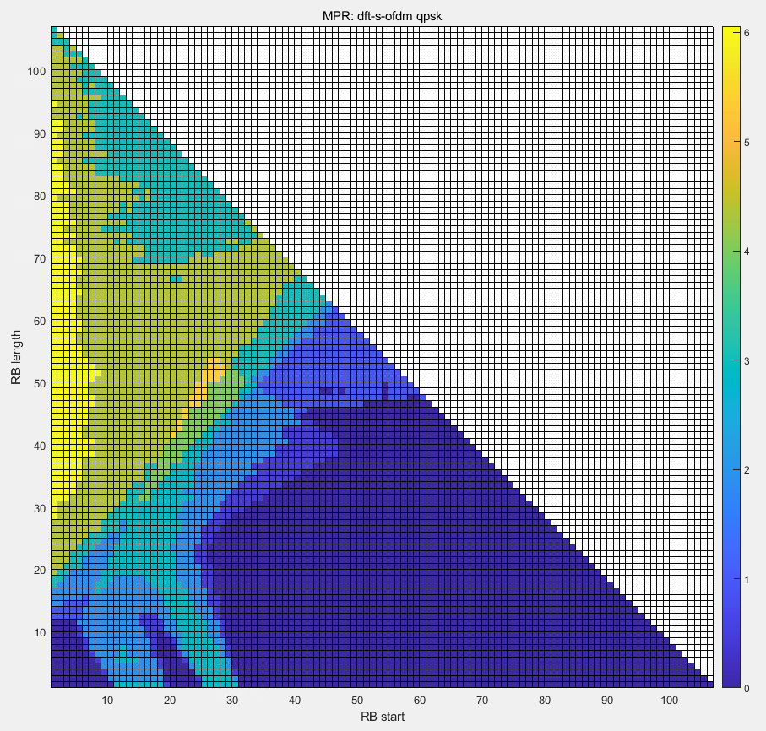

[pi/2 BPSK] [QPSK]

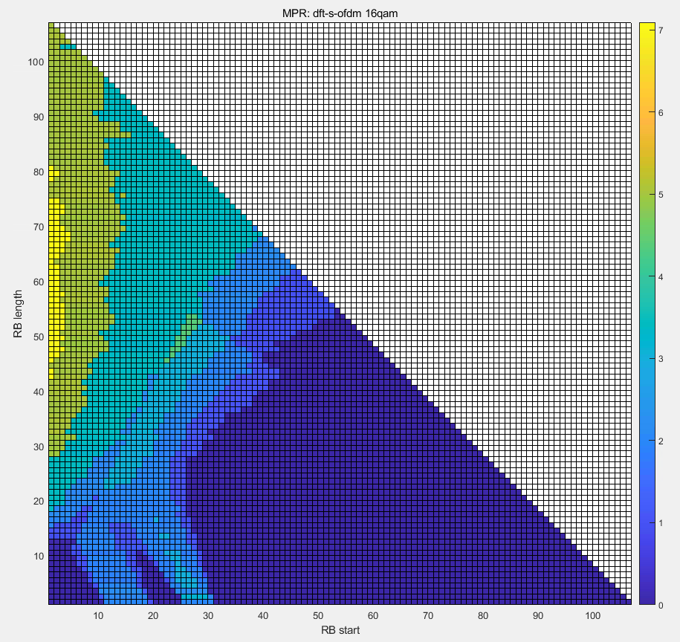 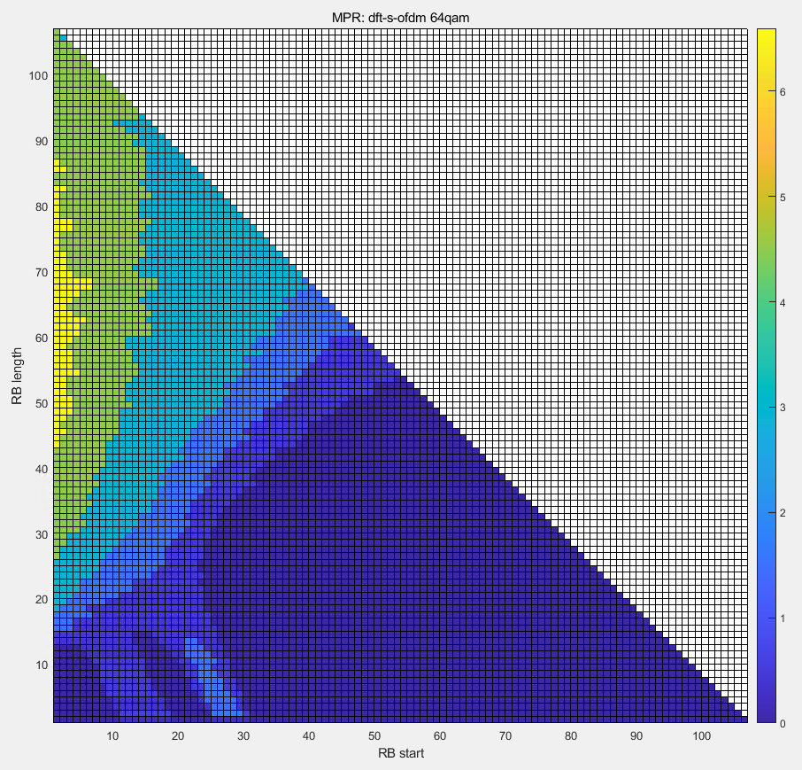

[16QAM] [64QAM]

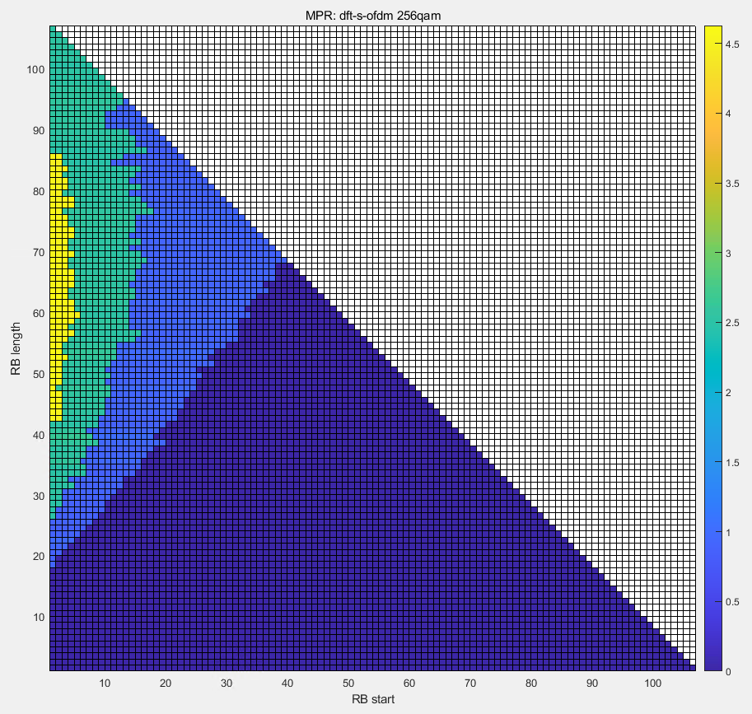

[256QAM]

## Annex A.2 1T PC3 CP-OFDM

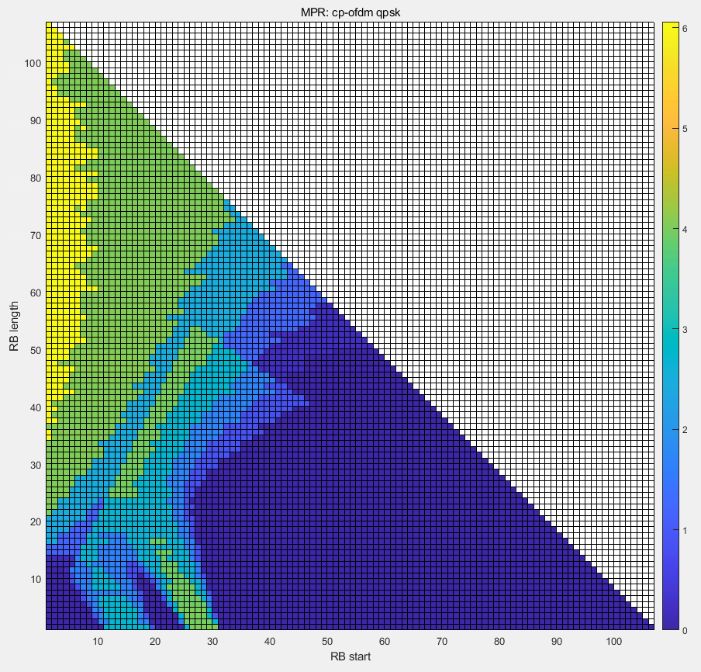 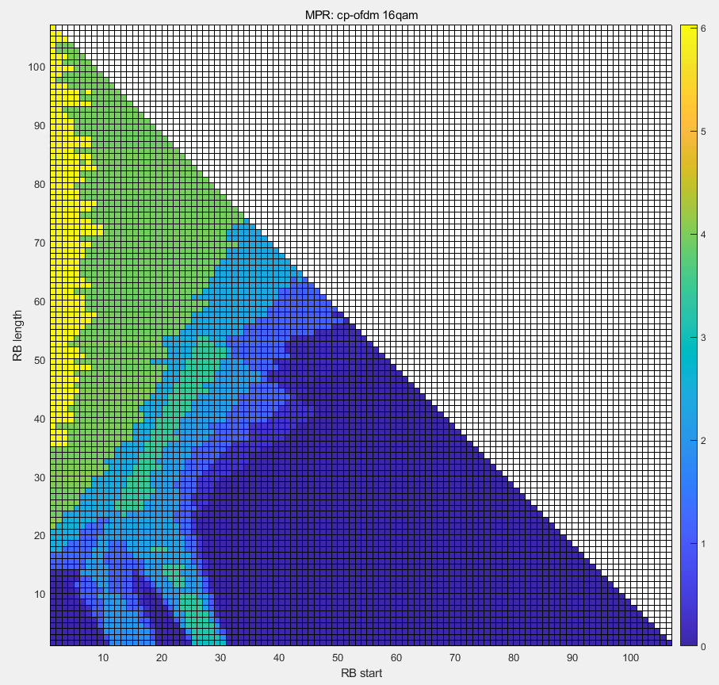

[QPSK] [16QAM]

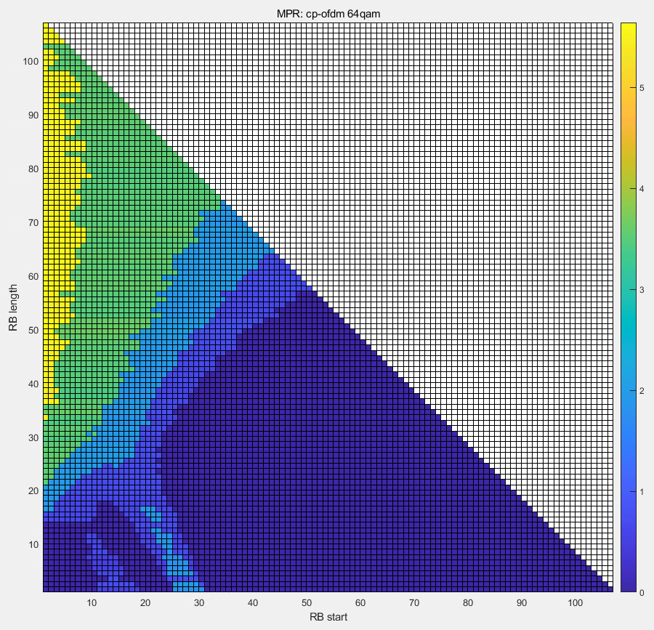 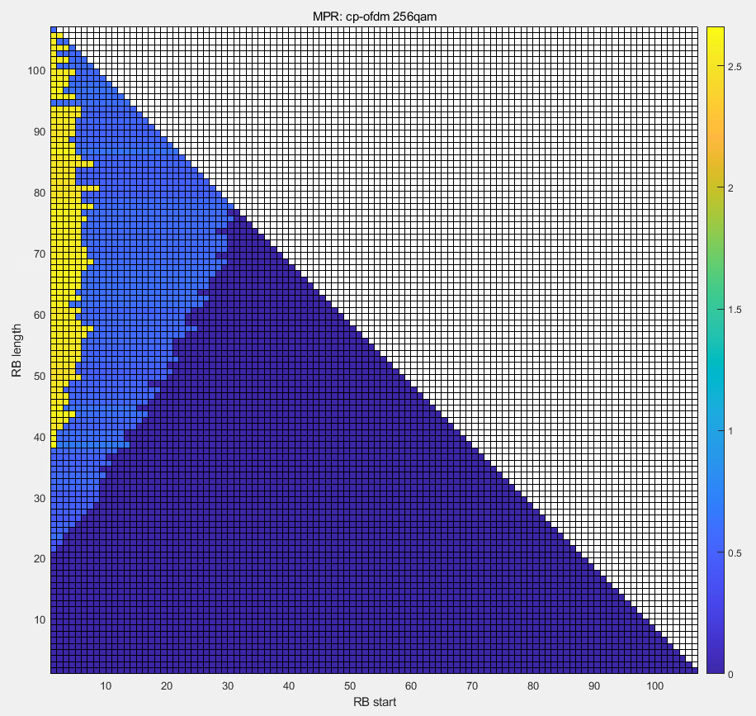

[64QAM] [256QAM]

## Annex A.3 1T PC2 DFT-S-OFDM

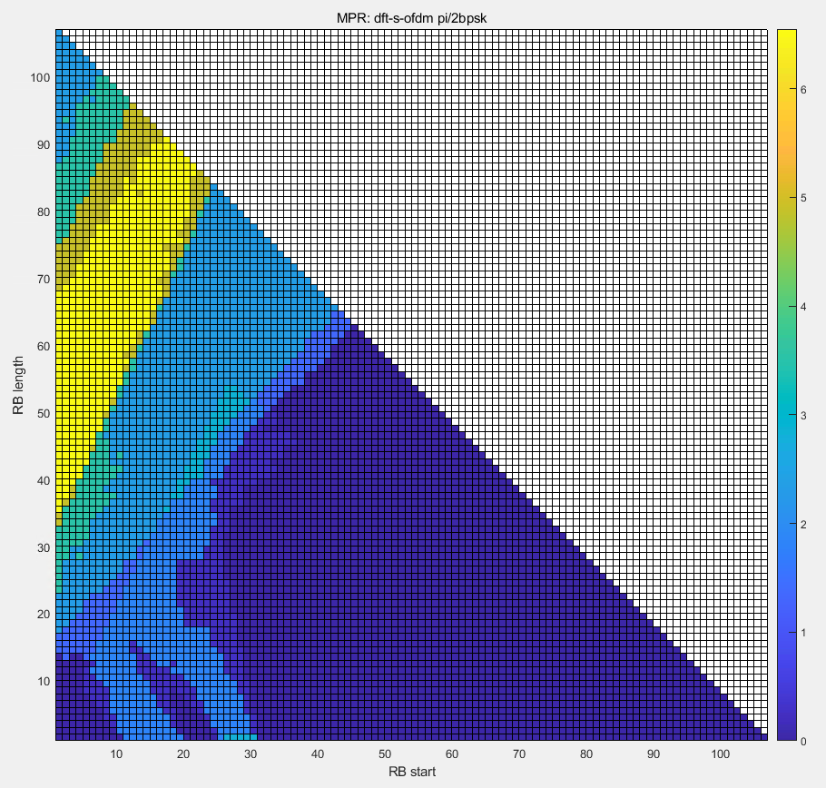 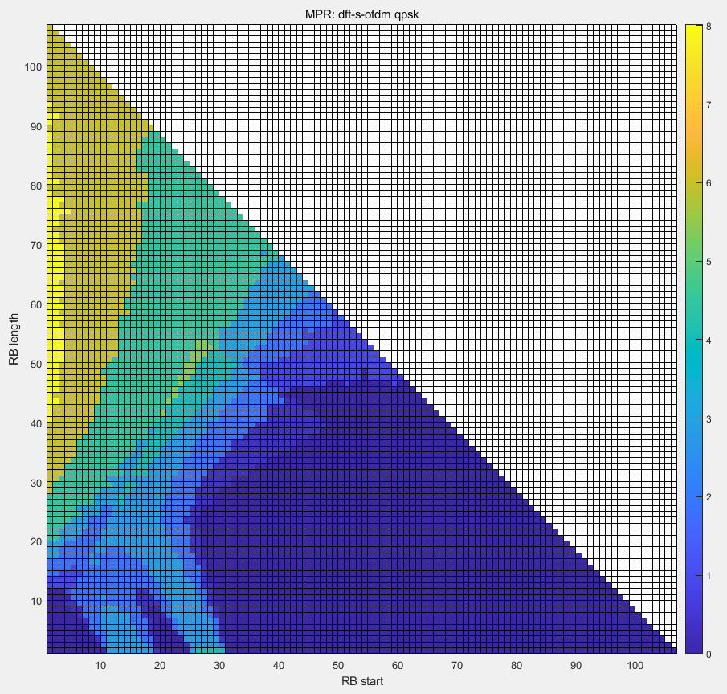

[pi/2 BPSK] [QPSK]

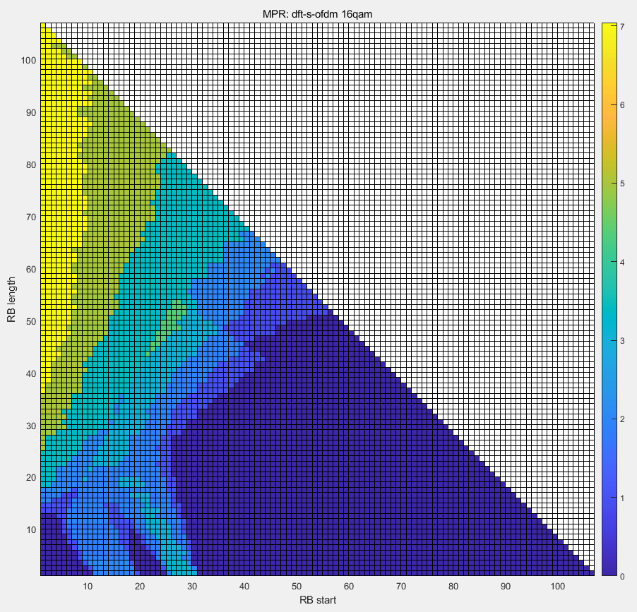 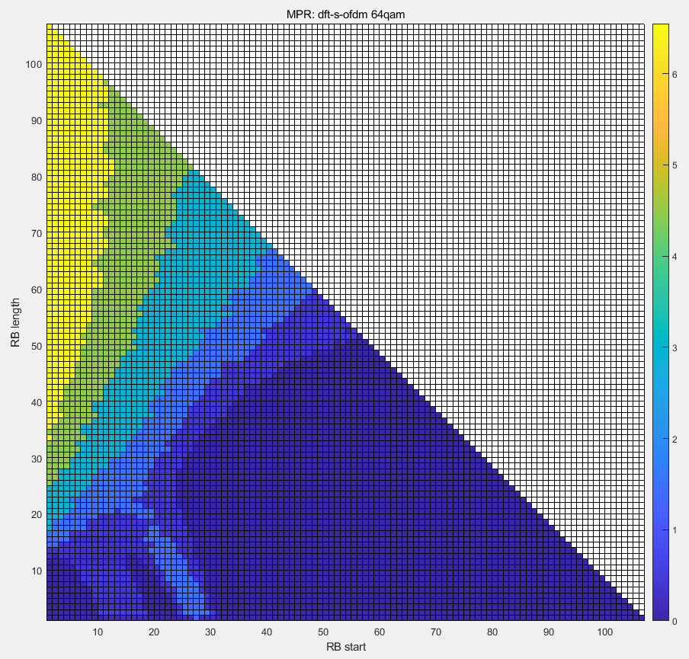

[16QAM] [64QAM]

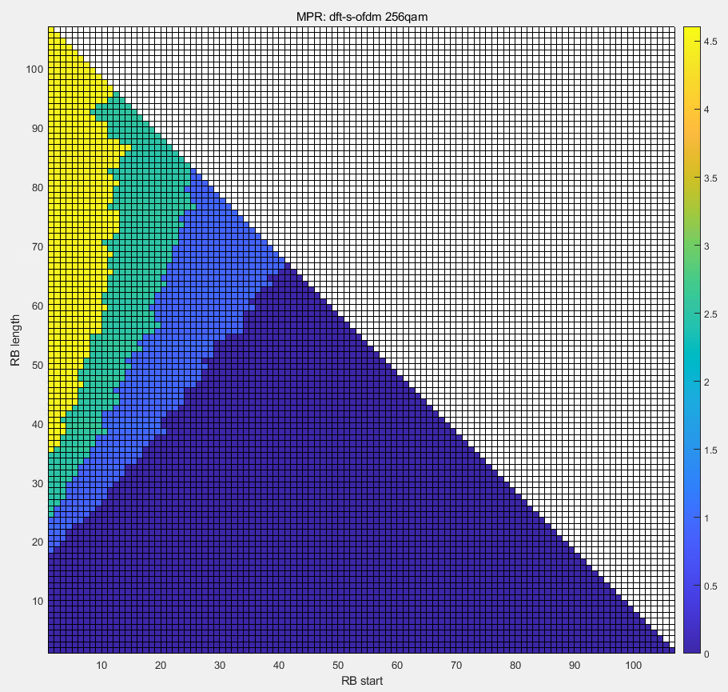

[256QAM]

## Annex A.4 1T PC2 CP-OFDM

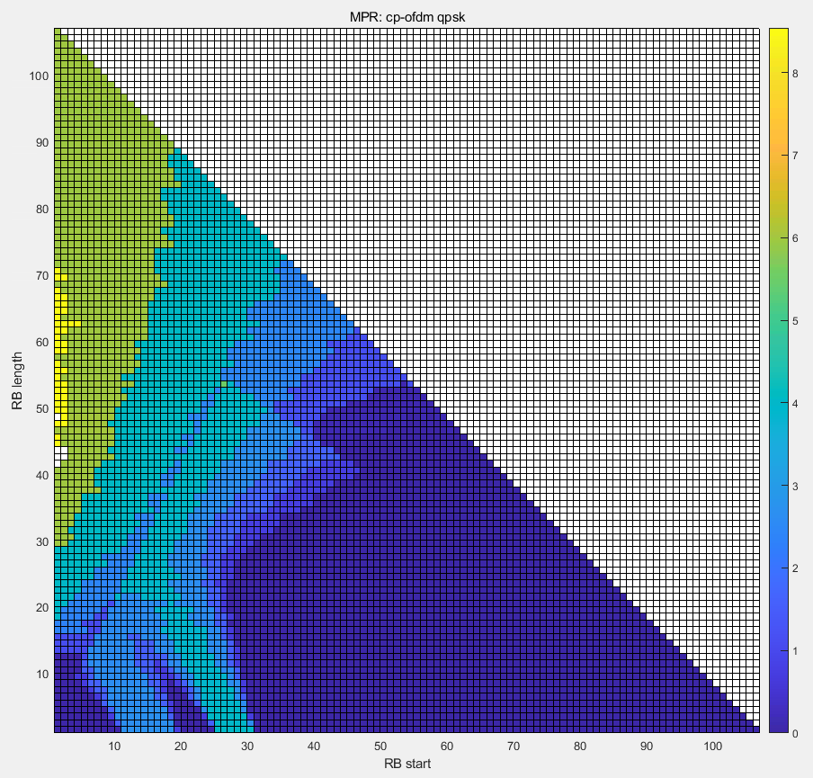 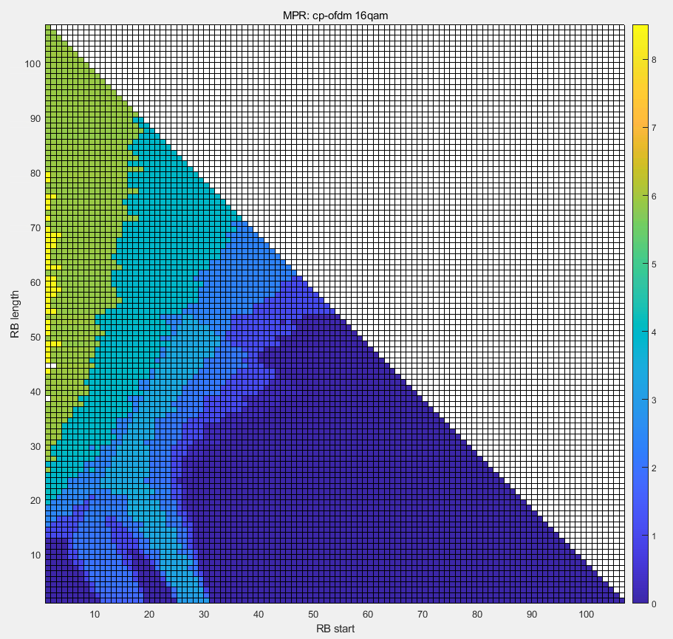

[QPSK] [16QAM]

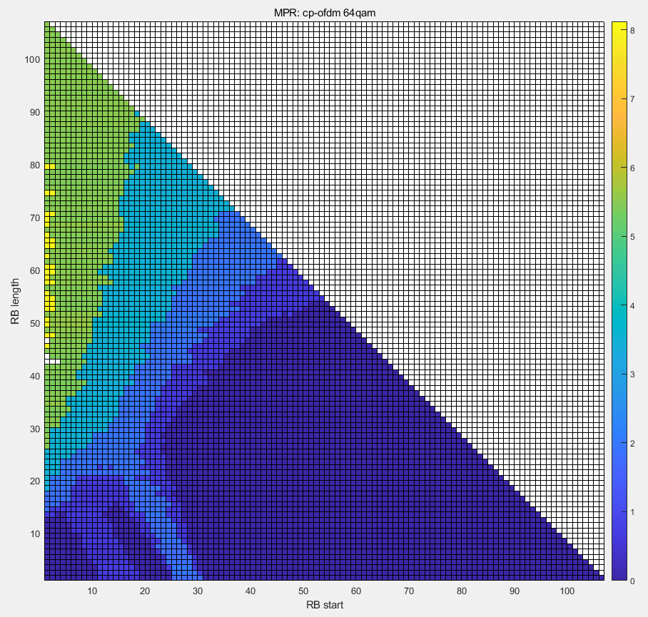 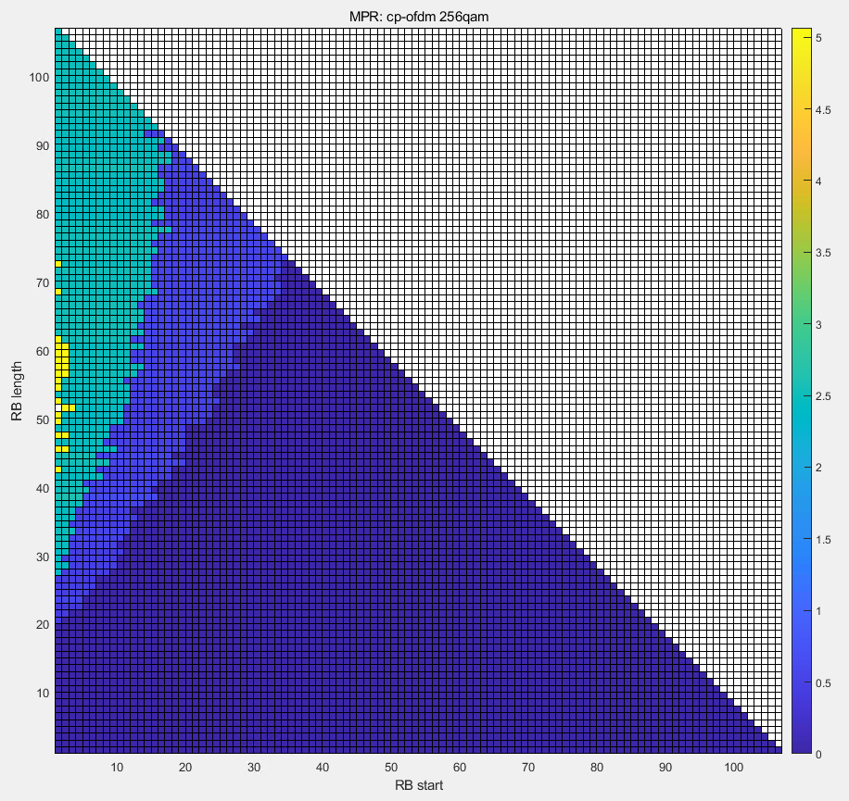

[64QAM] [256QAM]

## Annex A.5 2T PC2 DFT-S-OFDM

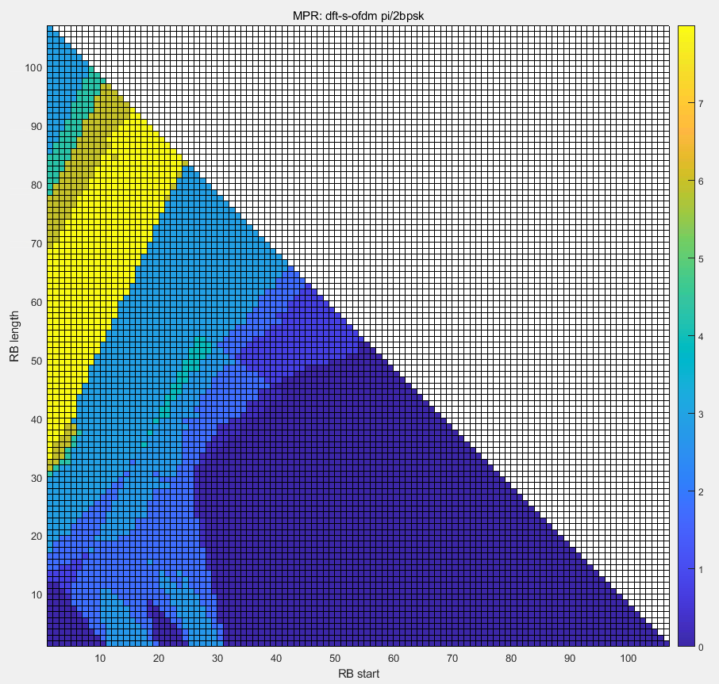 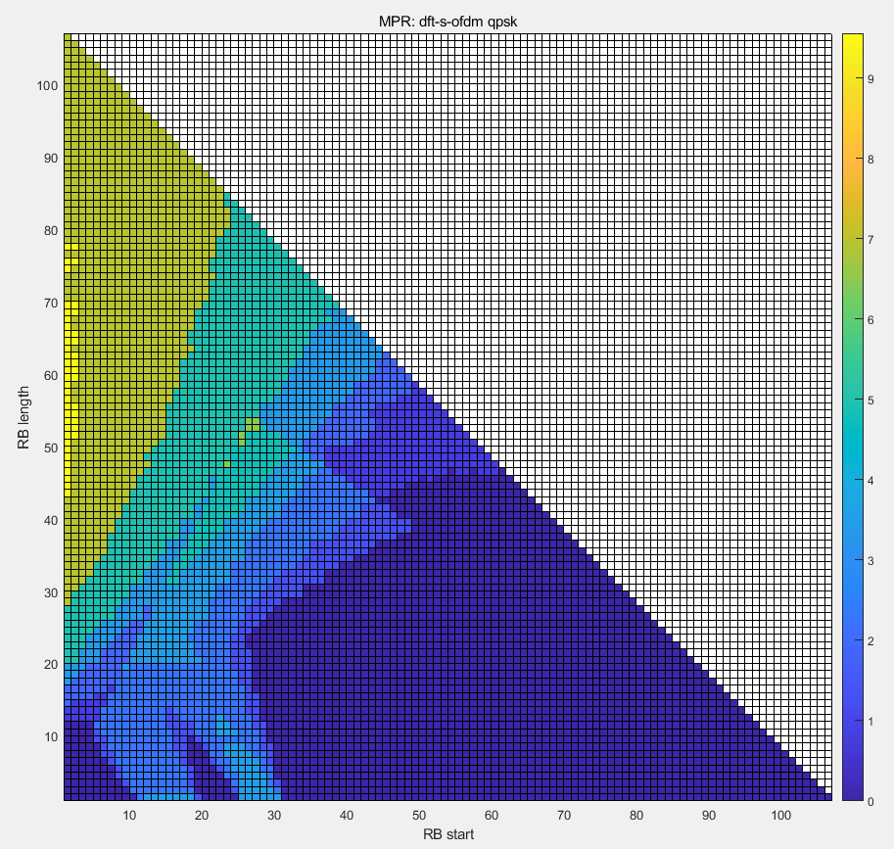

[pi/2 BPSK] [QPSK]

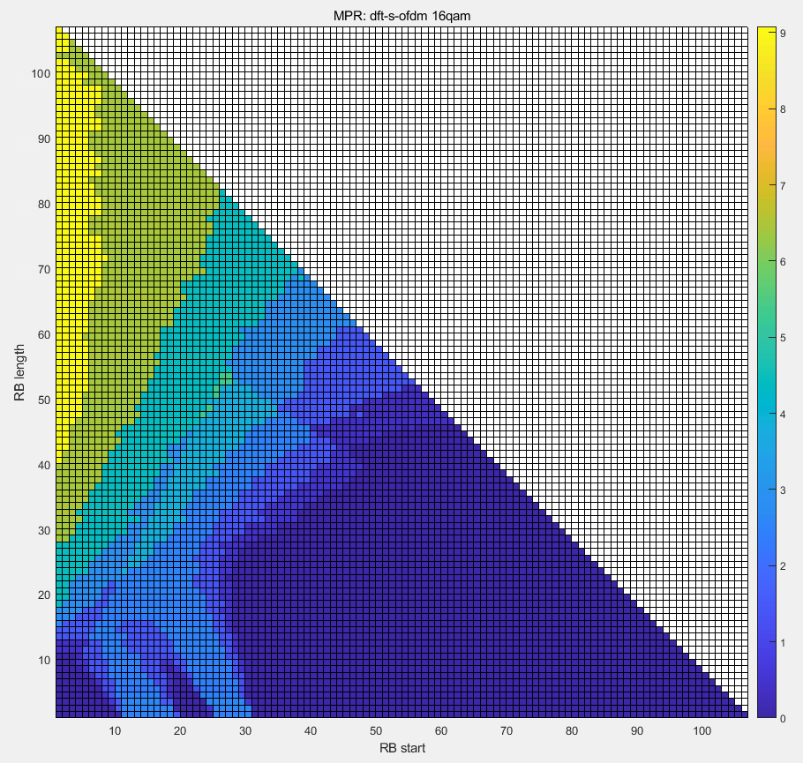 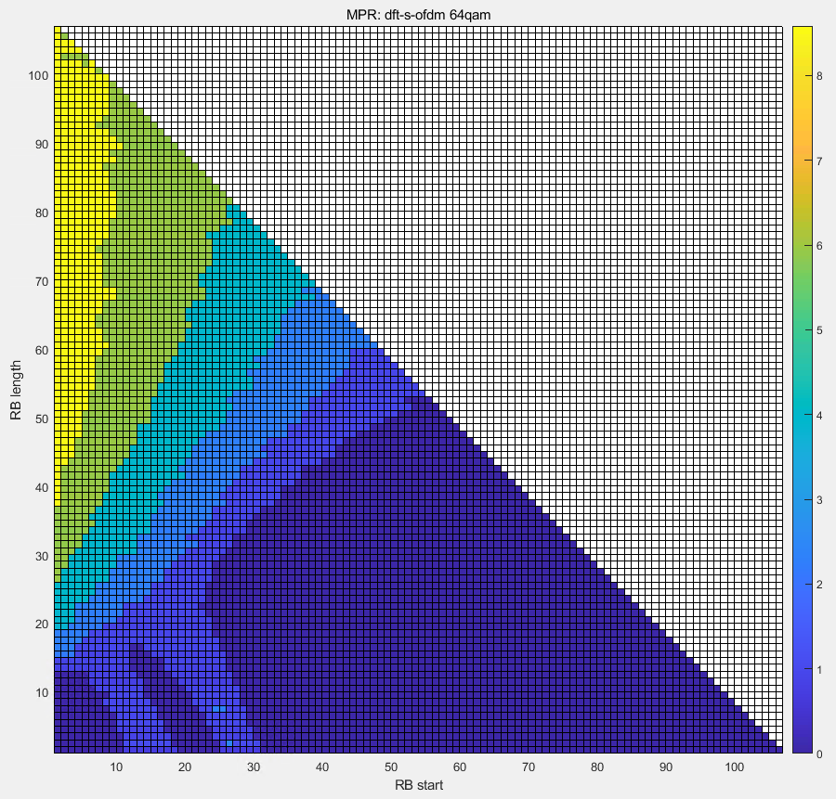

[16QAM] [64QAM]

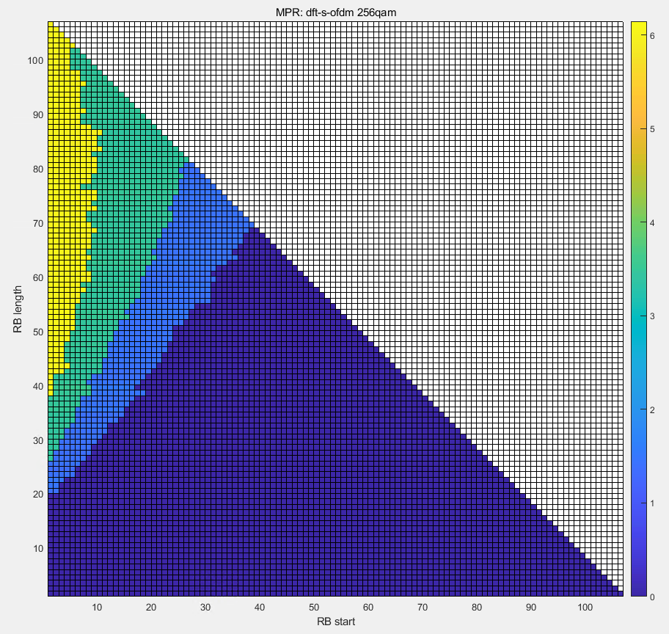

[256QAM]

## Annex A.6 2T PC2 CP-OFDM

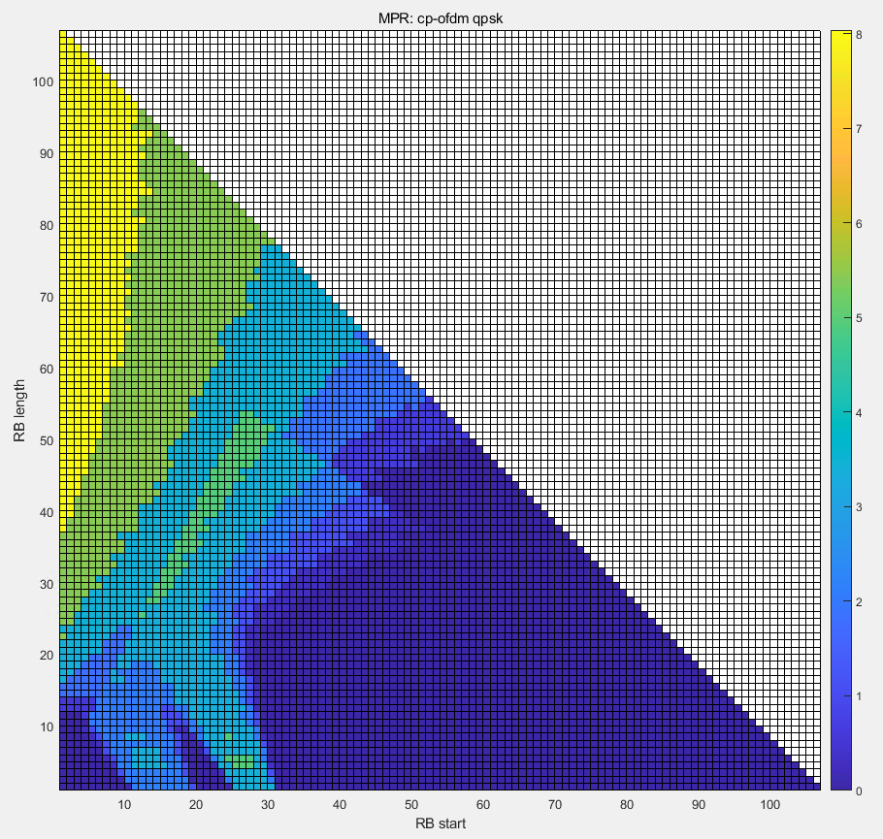 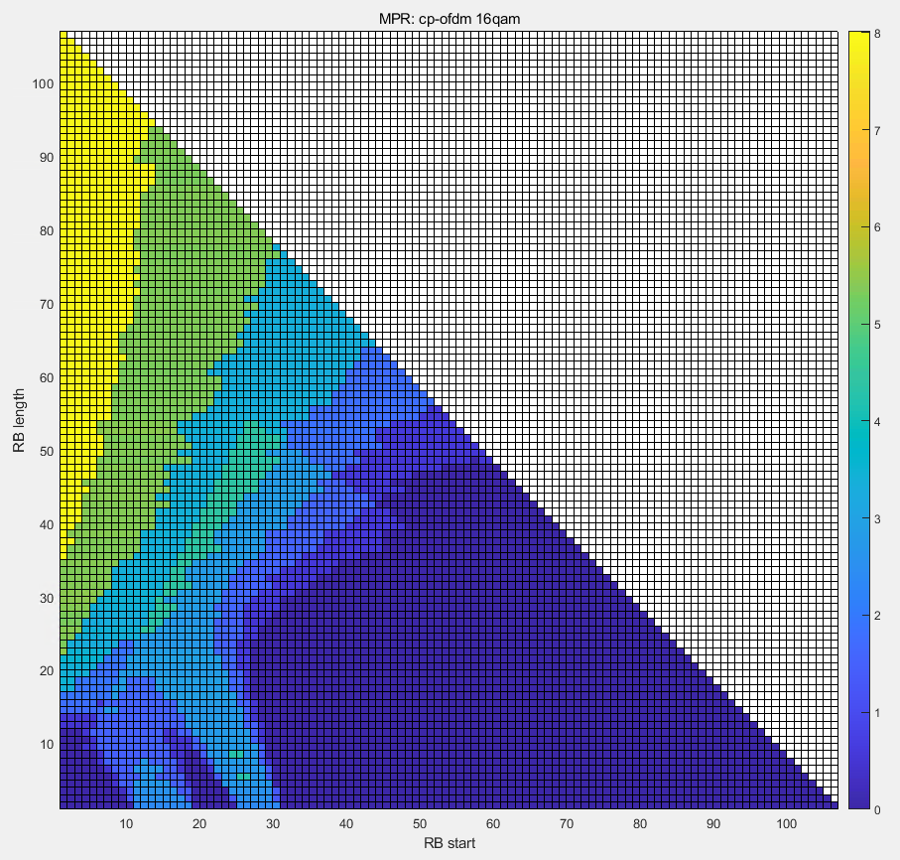

[QPSK] [16QAM]

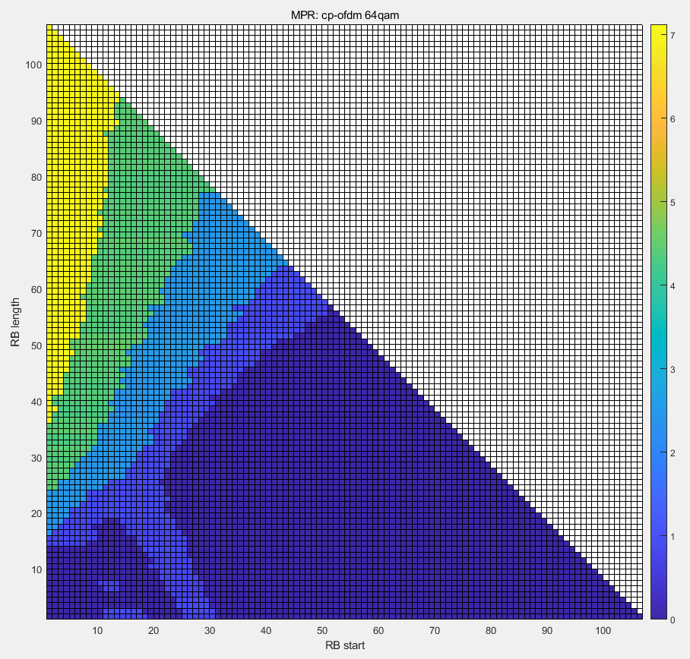 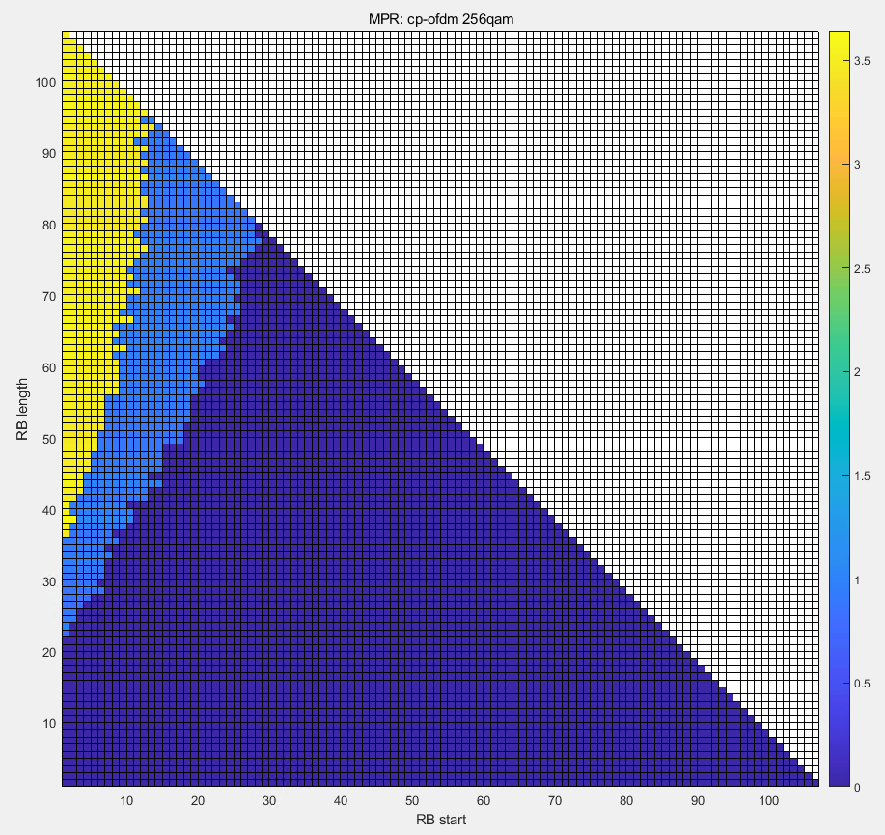

[64QAM] [256QAM]

# Annex B: AMPR simulation results

## Annex B.1 1T PC3 DFT-S-OFDM

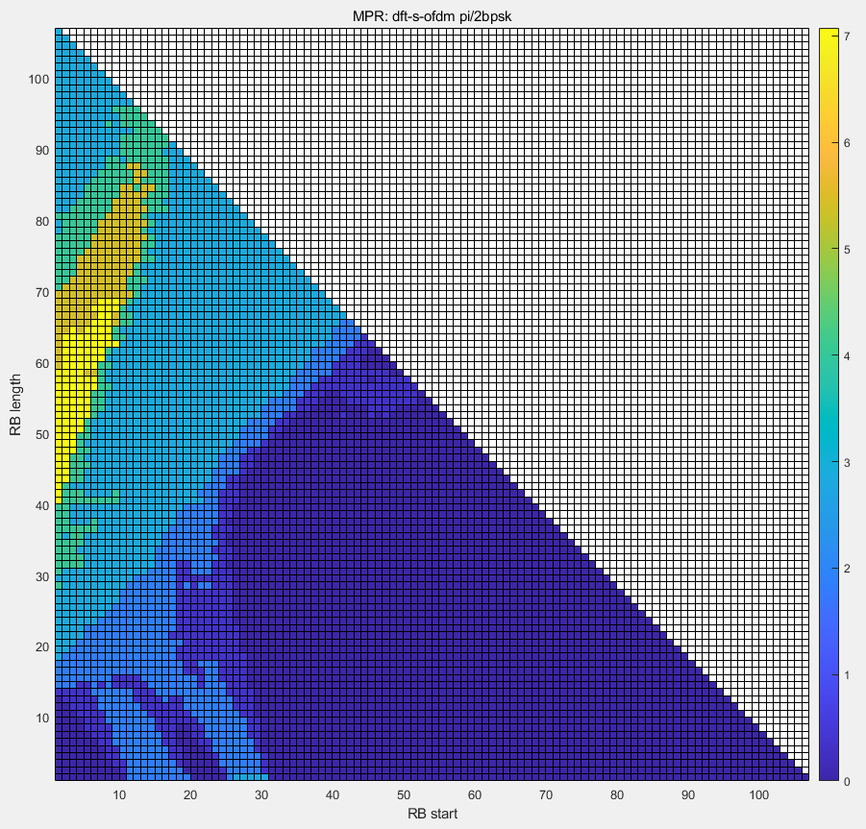 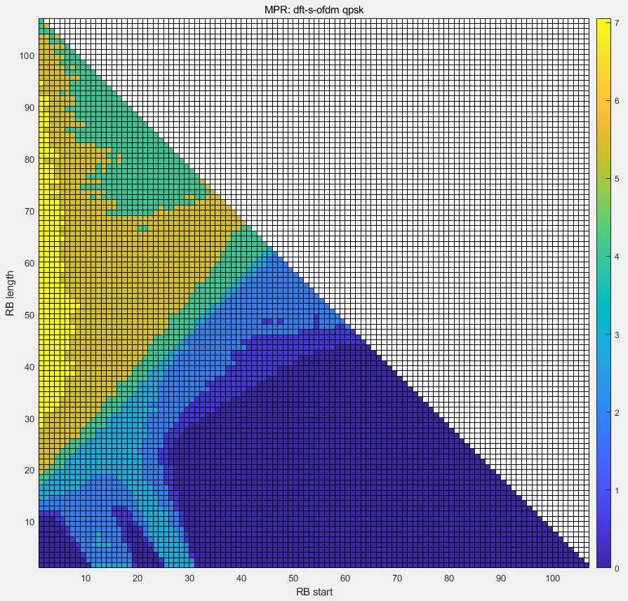

[pi/2 BPSK] [QPSK]

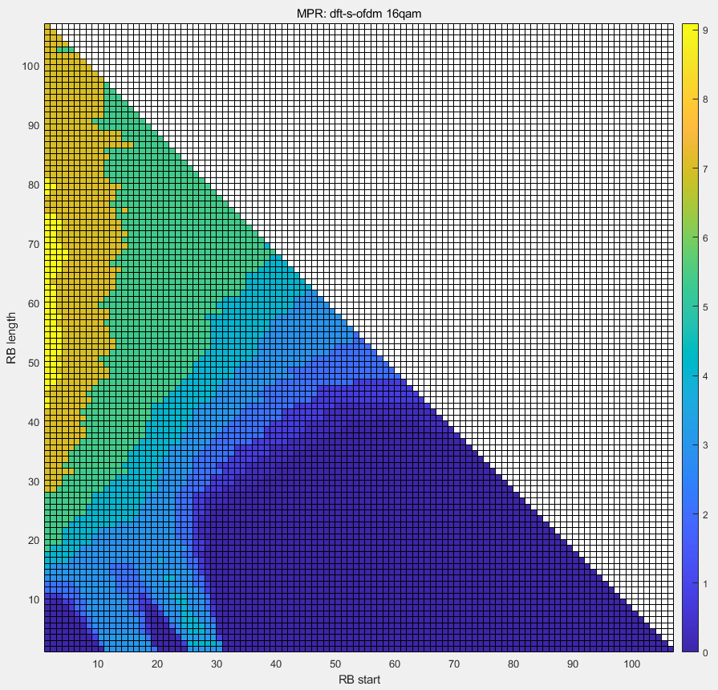 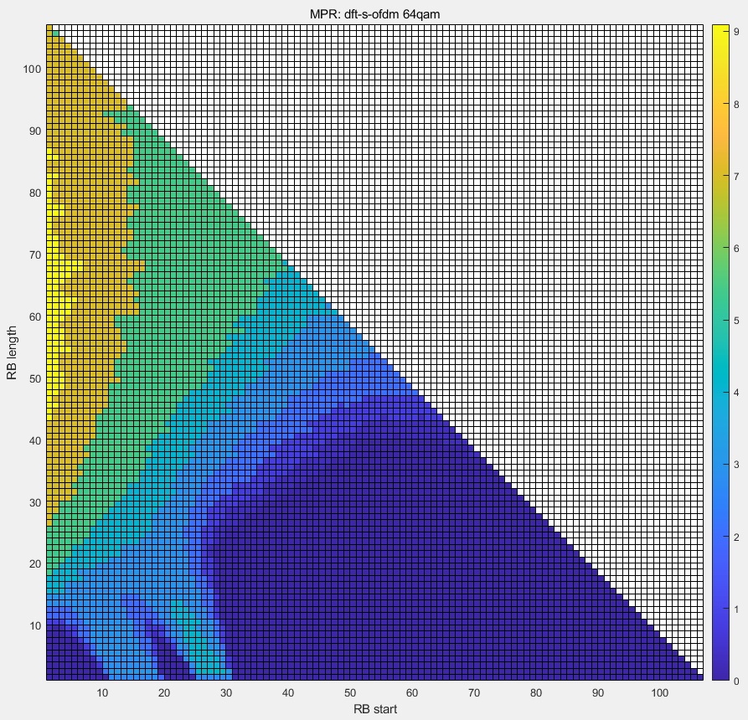

[16QAM] [64QAM]

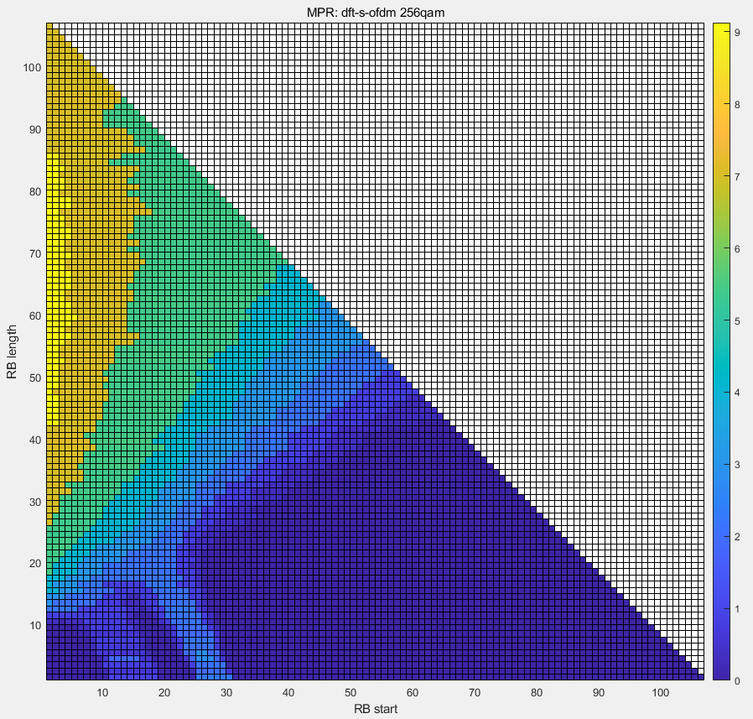

[256QAM]

## Annex B.2 1T PC3 CP-OFDM

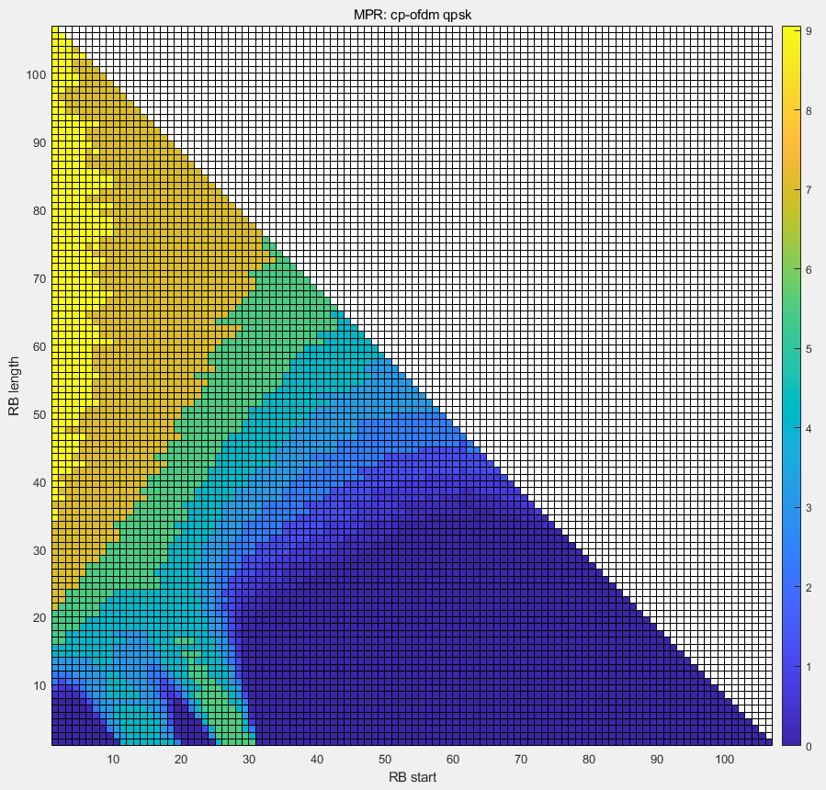 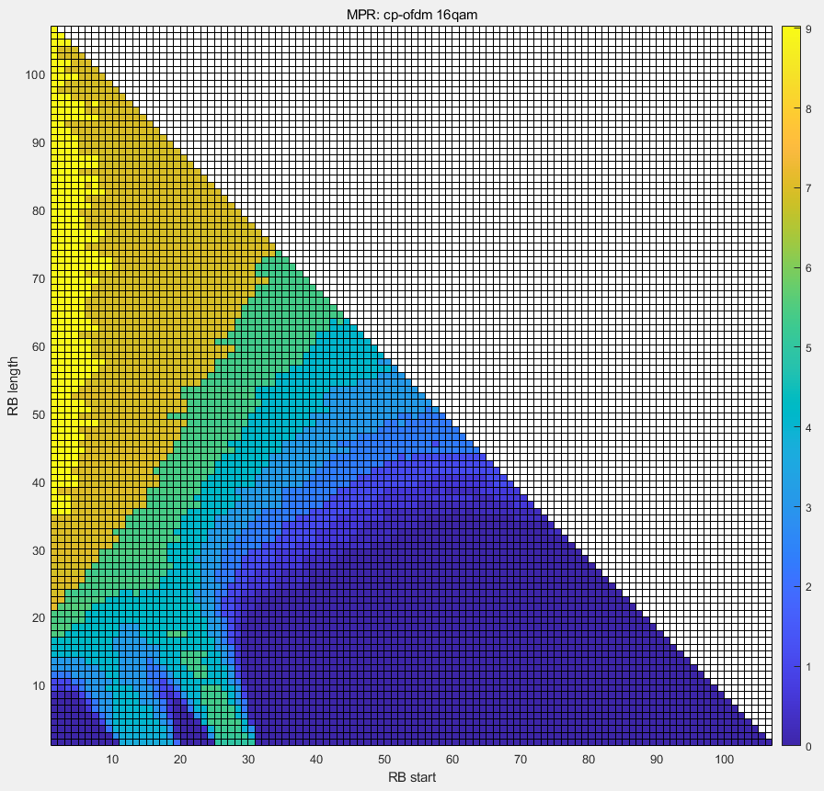

[QPSK] [16QAM]

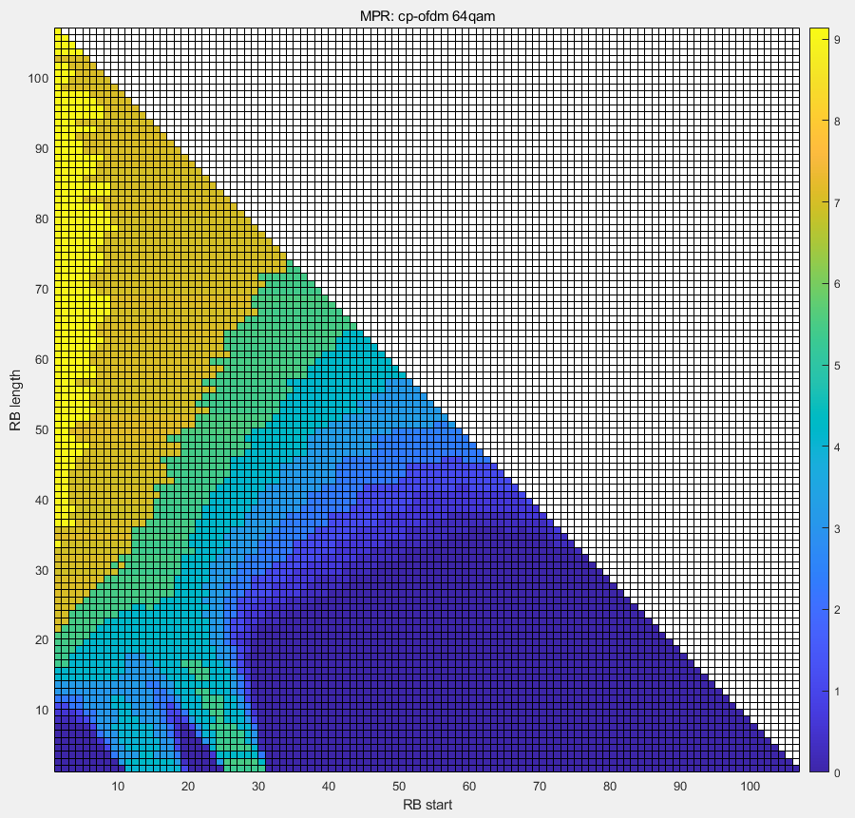 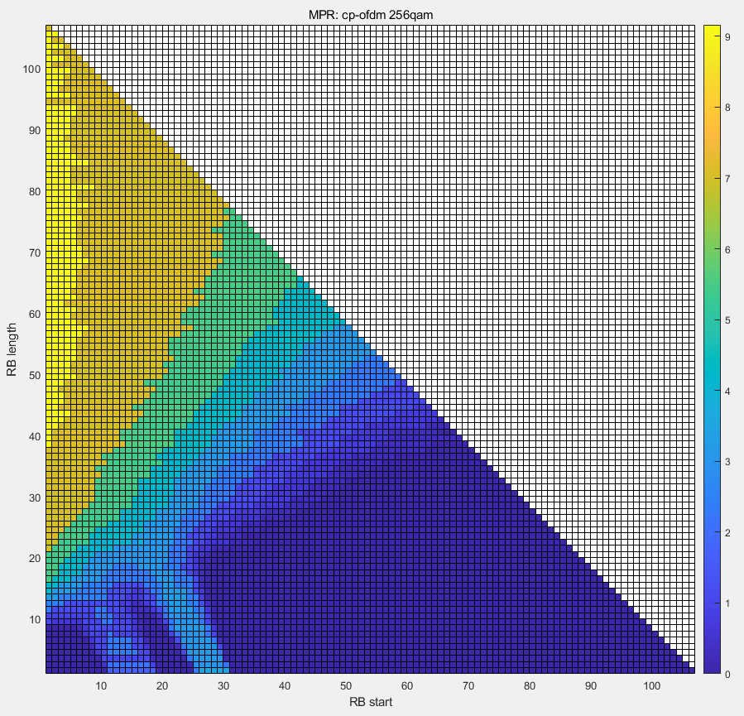

[64QAM] [256QAM]

## Annex B.3 1T PC2 DFT-S-OFDM

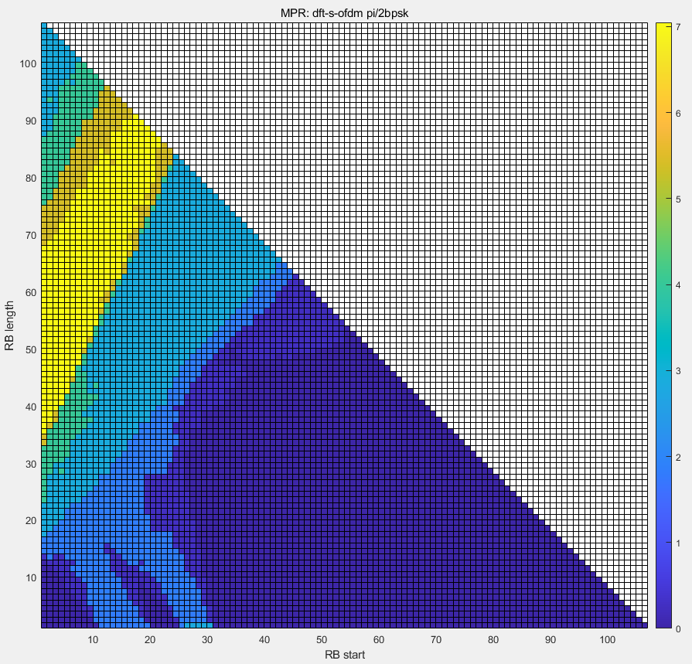 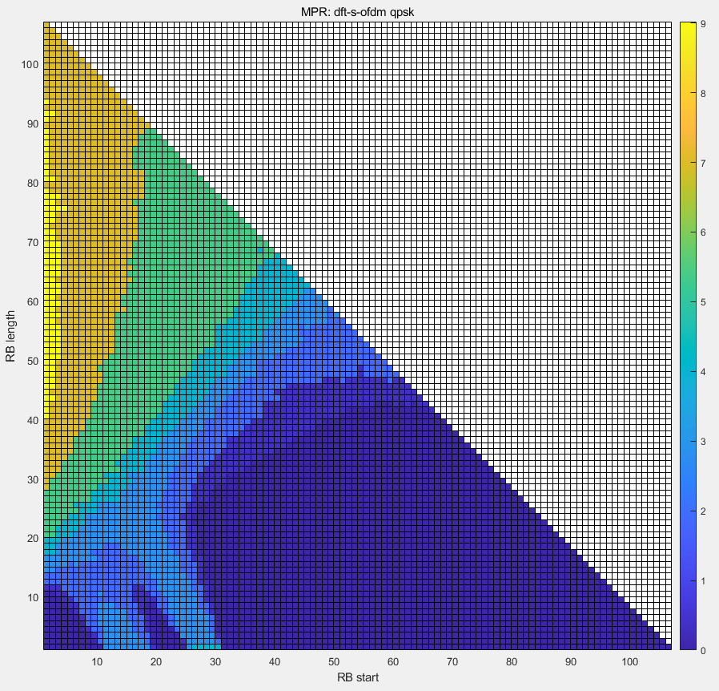

[pi/2 BPSK] [QPSK]

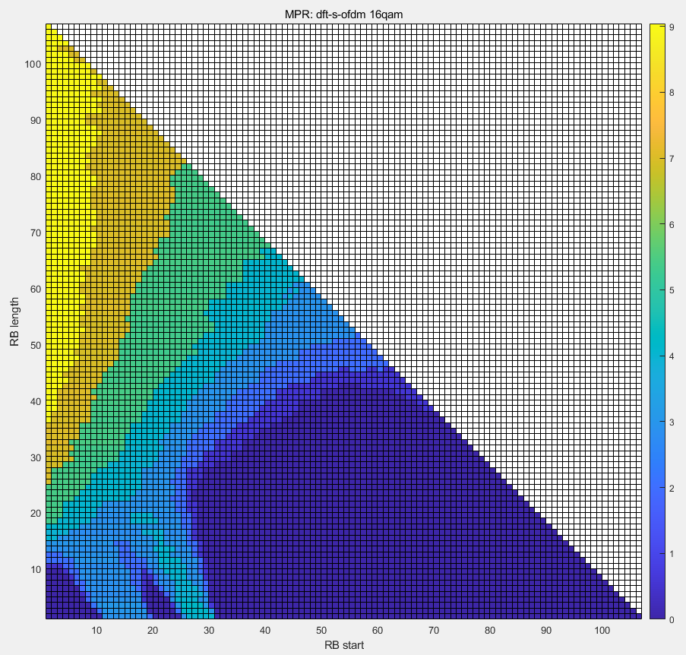 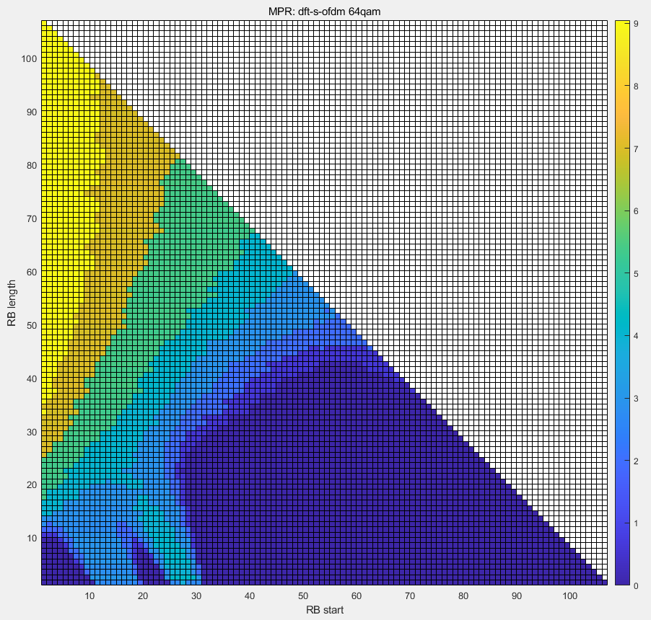

[16QAM] [64QAM]

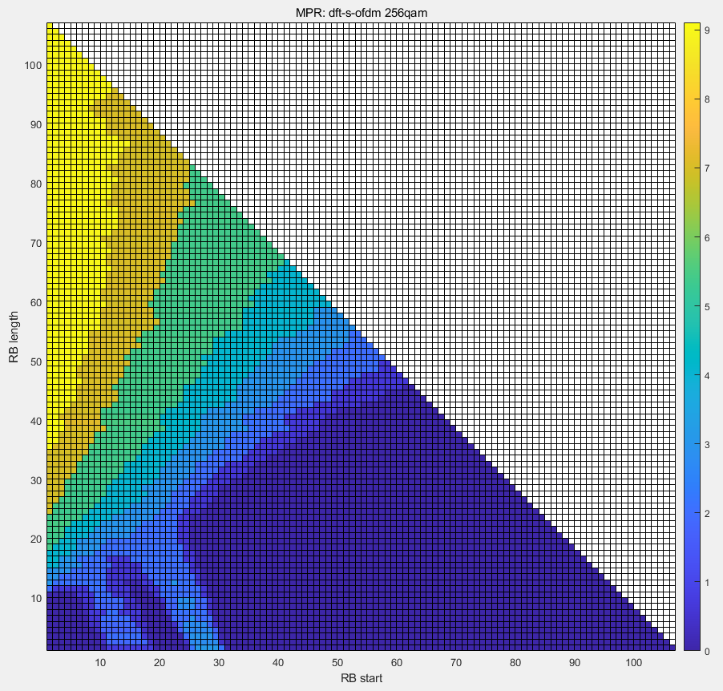

[256QAM]

## Annex B.4 1T PC2 CP-OFDM

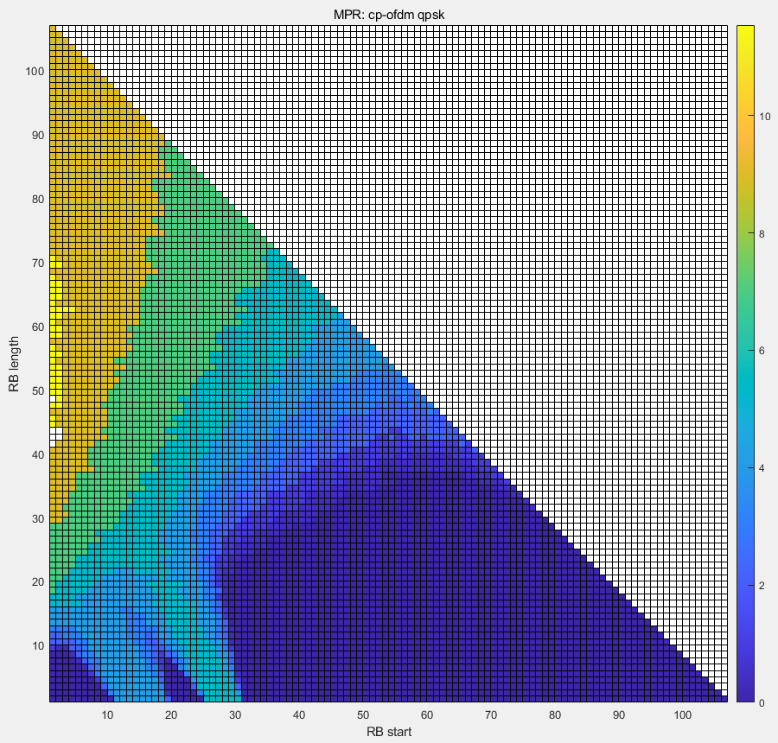 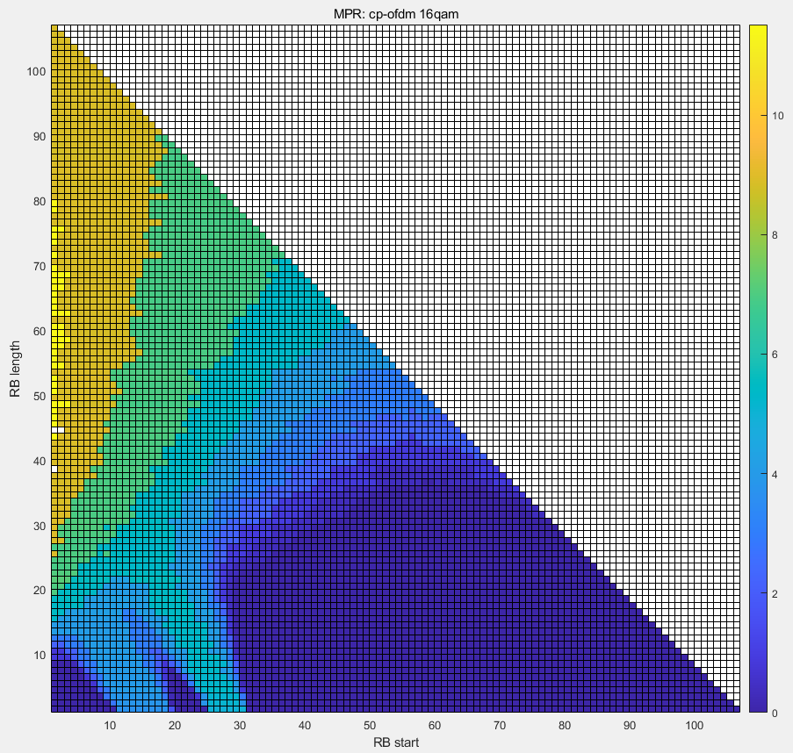

[QPSK] [16QAM]

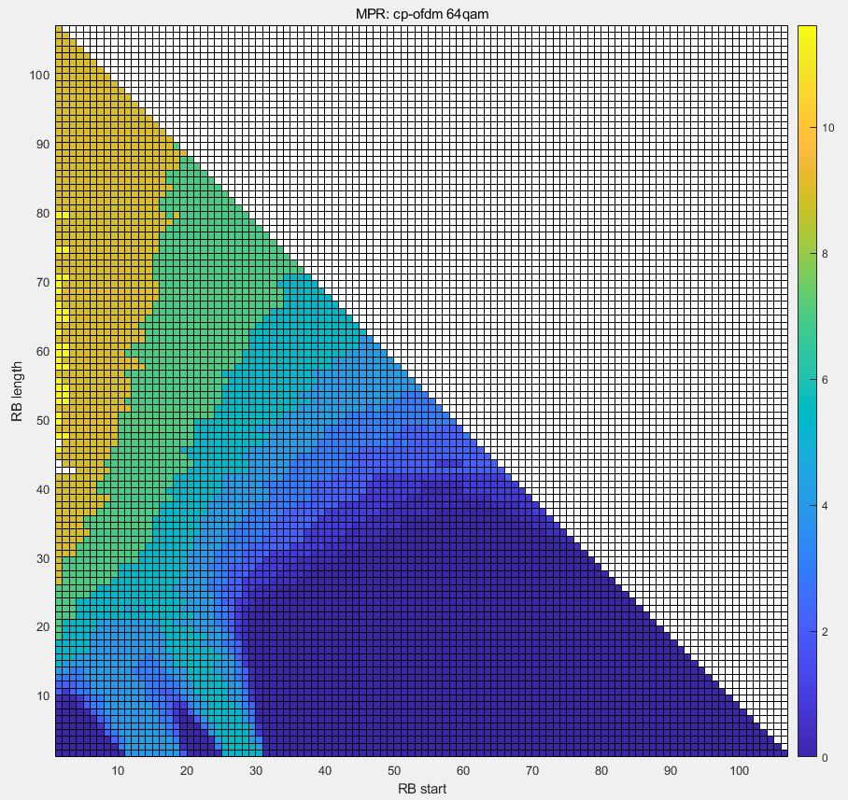 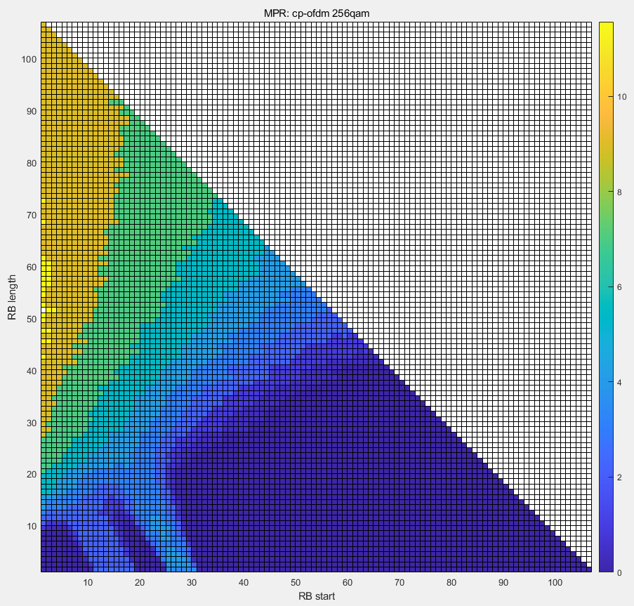

[64QAM] [256QAM]

## Annex B.5 2T PC2 DFT-S-OFDM

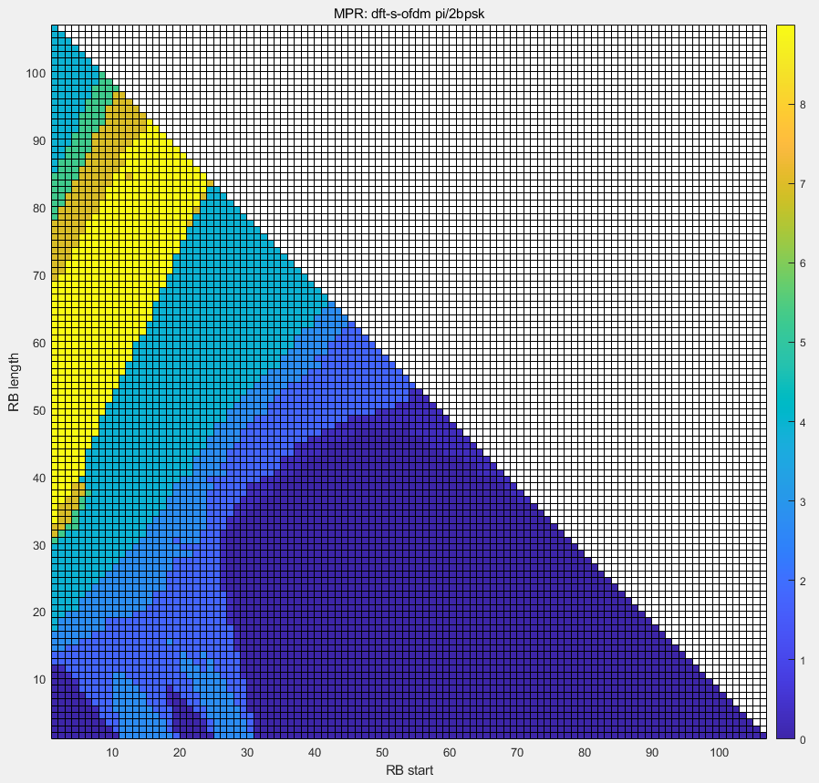 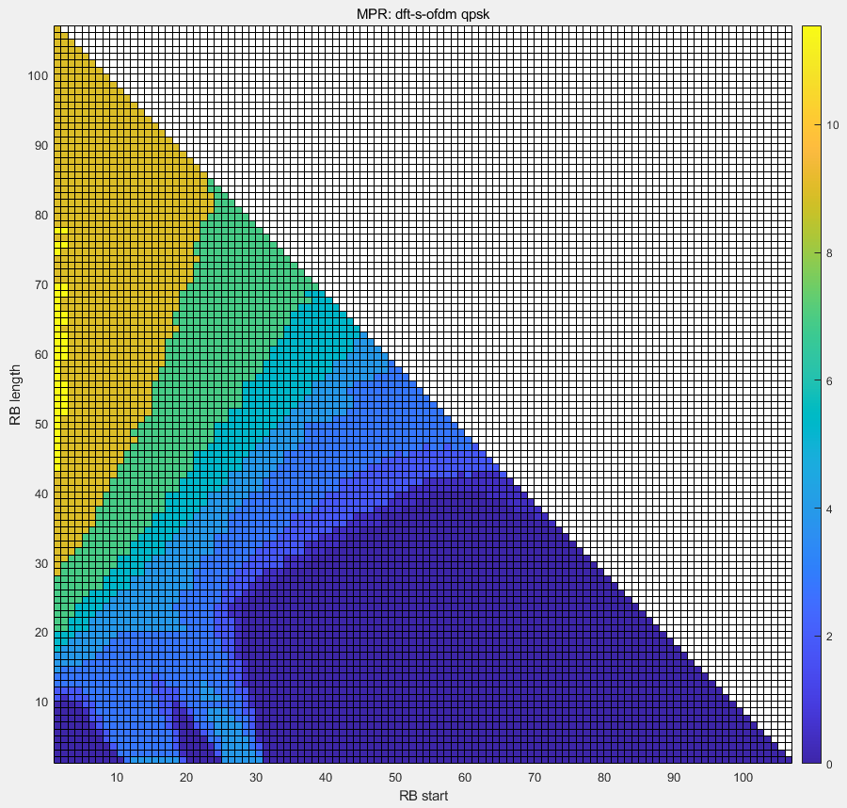

[pi/2 BPSK] [QPSK]

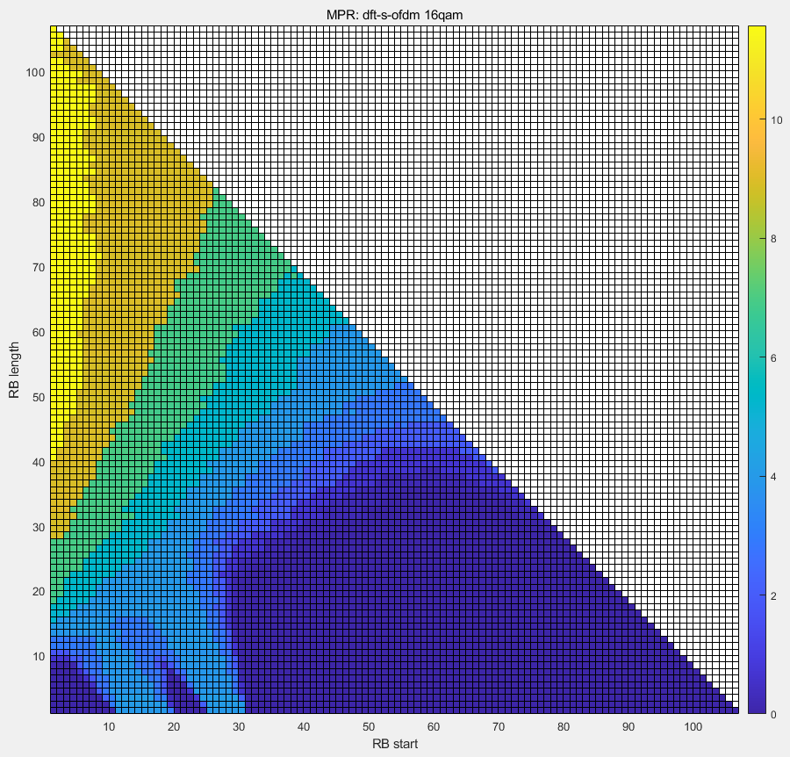 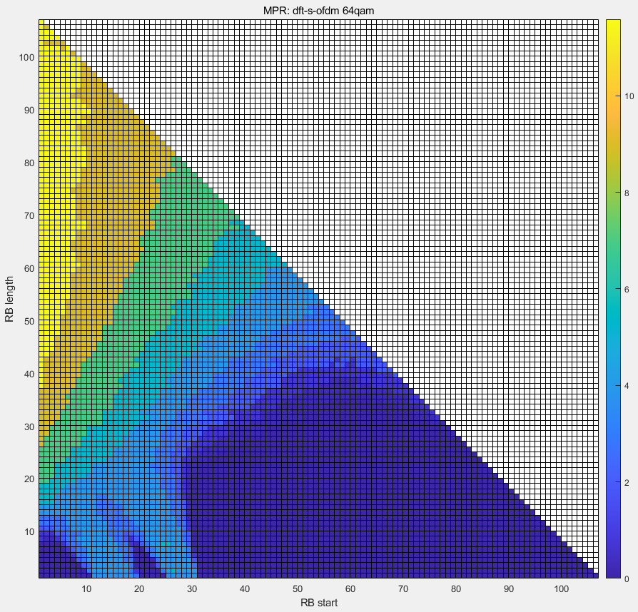

[16QAM] [64QAM]

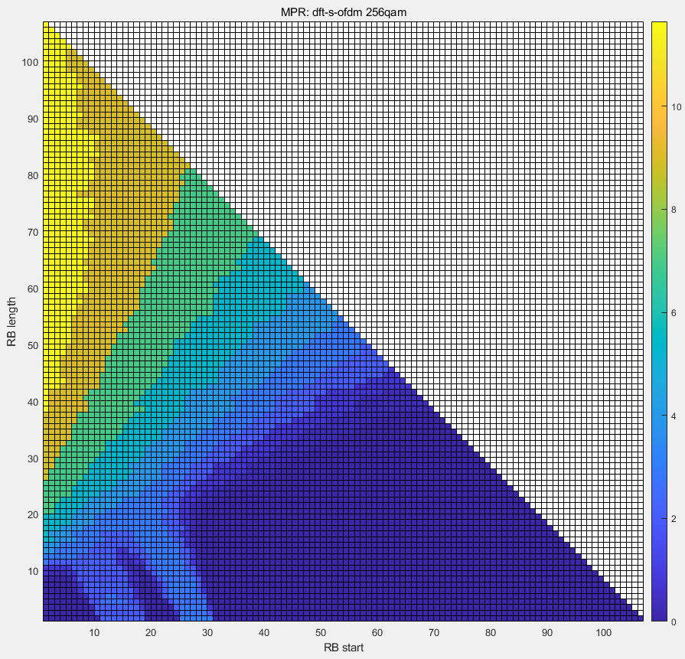

[256QAM]

## Annex B.6 2T PC2 CP-OFDM

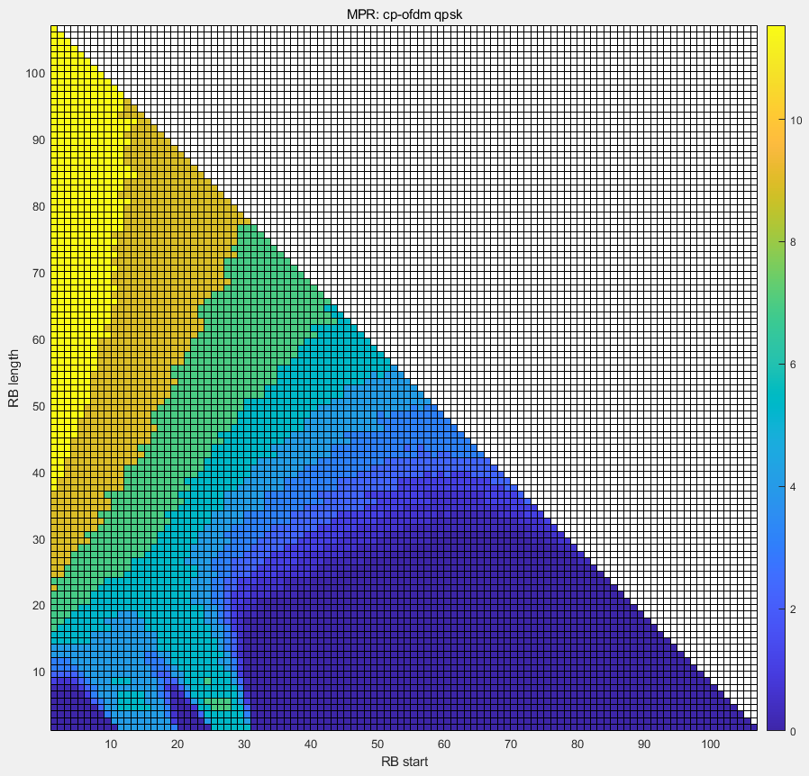 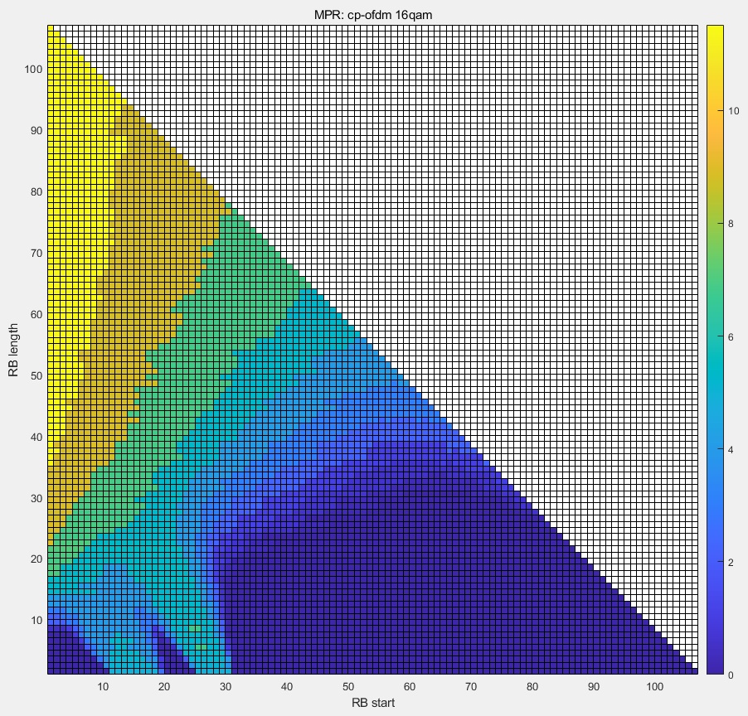

[QPSK] [16QAM]

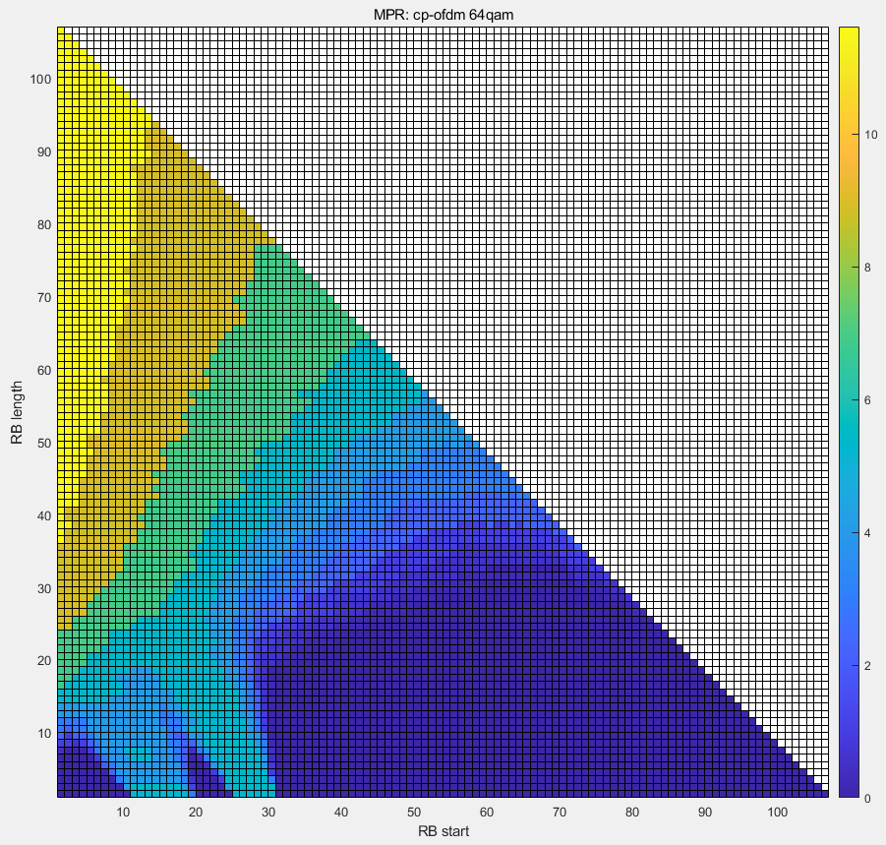 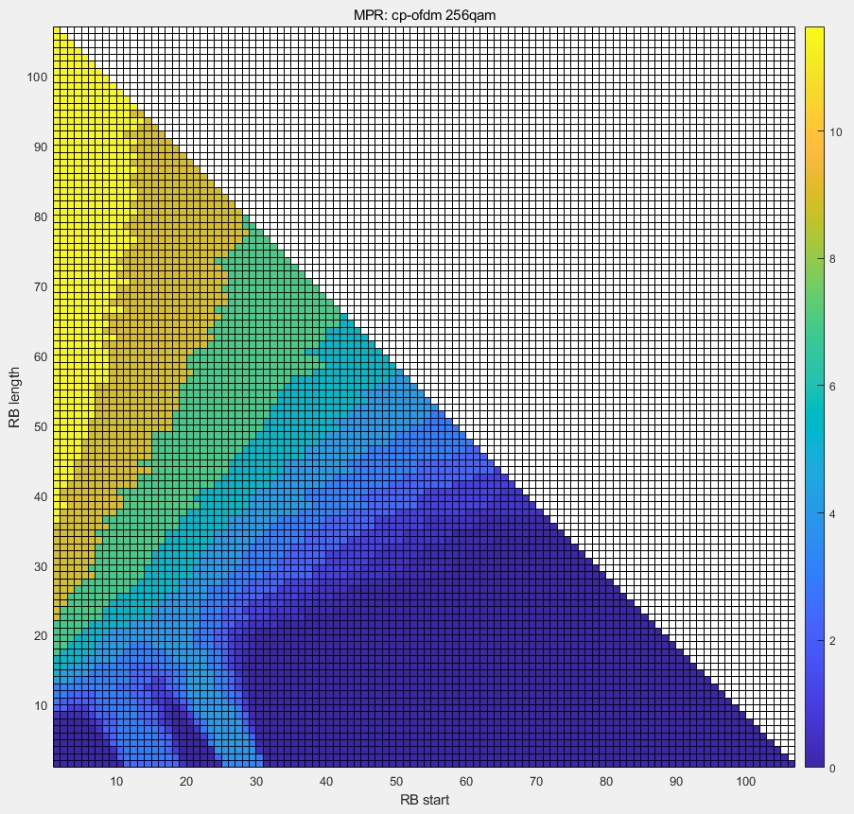

[64QAM] [256QAM]