3GPP TSG-RAN WG1#117 R1-24abcde
Fukuoka, Japan, May 20th-24th 2024

Agenda Item: 8.1
Source: Moderator (Ericsson)
Title: Summary of Rel-18 maintenance for UE power savings
Document for: Discussion

Introduction
This is the moderator summary for discussion of Rel-18 maintenance for UE power savings.

UE Power Savings
Following tdocs will be treated in adhoc session #1 – Xiaodong:
R1-2405100 Draft CR for 38.211 on TRS occasions for idle/inactive UEs Ericsson
R1-2405101 Draft CR for 38.212 on TRS occasions for idle/inactive UEs Ericsson
R1-2405102 Draft CR for 38.213 on TRS occasions for idle/inactive UEs Ericsson
R1-2405103 Draft CR for 38.214 on TRS occasions for idle/inactive UEs Ericsson

Background
Contributions [1][2][3][4] propose corrections to the RAN1 specifications (38.211/212/213/214) to reflect the new parameters that RAN2 agreed to introduce for configuring TRS occasions for idle/inactive UEs (via a new Rel-18 SIB, see references [5][6][7]). Following shows the coversheet information from [1] for example, and same reason/summary/consequence apply for the changes proposed in [2][3][4].

Reason for change: | In RAN2#125-bis, RAN2 agreed to CRs introducing a new Rel-18 SIB for configuring TRS occasions for idle/inactive UEs, and the network either broadcasts SIB17 or the new Rel-18 SIB. This was related to the LS that RAN1 sent to RAN2 in R1-2312620.  RAN2 agreed the CRs in principle:  R2-2403847 Clarification on TRS in idle and inactive CATT, Ericsson CR 38.300 (Rel-18)  R2-2403848 Clarification on TRS in idle and inactive Ericsson CR 38.331 (Rel-17)  R2-2403849 Clarification on TRS in idle and inactive Ericsson CR 38.331 (Rel-18)  - 3 above are in-principle agreed
Summary of change: | Reflect the new layer parameters introduced for configuring TRS occasions for idle/inactive UEs in 38.211.
Consequences if not approved: | Incorrect specification regarding the TRS occasion provisioning for idle/inactive UEs.

Discussion
As explained in the background section, the draft CRs are proposed corrections for RAN1 specifications to reflect the new parameters for configuring TRS occasions for idle/inactive UEs.
Companies are invited to provide inputs in the following regarding the draft CRs.

Q1 (CR for 38.211):
Please provide your view on the draft CR for 38.211 in R1-2405100.
Company | Support (Y/N) | Comment

Q2 (CR for 38.212):
Please provide your view on the draft CR for 38.212 in R1-2405101.
Company | Support (Y/N) | Comment

Q3 (CR for 38.213):
Please provide your view on the draft CR for 38.213 in R1-2405102.
Company | Support (Y/N) | Comment

Q4 (CR for 38.214):
Please provide your view on the draft CR for 38.214 in R1-2405103.
Company | Support (Y/N) | Comment

Discussion for comeback
In the first online discussion, it was discussed to check whether RAN2 has made any final agreements on the CRs. It was also discussed whether proposed changes to RAN1 specification are considered as correction or alignment. Two companies proposed to agree to the draft CRs as corrections. One company proposed to wait for RAN2 to make final agreements on the CR, and to leave how to change the RAN1 specifications up to the respective four editors as part of the alignment.
Below is the RAN2 status from the ongoing RAN2#126 meeting.
On Tuesday, RAN2 agreed to the final CRs for configuring TRS occasions for idle/inactive UEs via a new Rel-18 SIB.
From RAN2#126 session chair (Ericsson) notes (maintenance, SON/MDT and eRedCap breakout session):
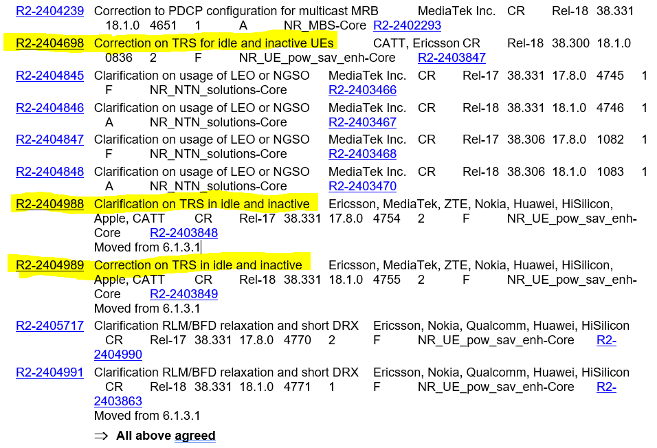

Following are updated draft CRs to the RAN1 specifications (38.211, 38.212, 38.213 and 38.214) with additional co-sourcing companies and updated coversheet, including reflection of the relevant RAN2 information from RAN2#126, reason for change, summary of change and consequences if not approved.

Proposed draft CRs are as follows:
R1-2405633 Draft CR for 38.211 on TRS occasions for idle/inactive UEs Ericsson, Nokia, Mediatek, CATT
R1-2405634 Draft CR for 38.212 on TRS occasions for idle/inactive UEs Ericsson, Nokia, Mediatek, CATT
R1-2405635 Draft CR for 38.213 on TRS occasions for idle/inactive UEs Ericsson, Nokia, Mediatek, CATT
R1-2405636 Draft CR for 38.214 on TRS occasions for idle/inactive UEs Ericsson, Nokia, Mediatek, CATT

Conclusion

References
- R1-2405100 Draft CR for 38.211 on TRS occasions for idle/inactive UEs Ericsson, RAN1#117, Fukuoka, Japan, May 2024
- R1-2405101 Draft CR for 38.212 on TRS occasions for idle/inactive UEs Ericsson, RAN1#117, Fukuoka, Japan, May 2024
- R1-2405102 Draft CR for 38.213 on TRS occasions for idle/inactive UEs Ericsson, RAN1#117, Fukuoka, Japan, May 2024
- R1-2405103 Draft CR for 38.214 on TRS occasions for idle/inactive UEs Ericsson, RAN1#117, Fukuoka, Japan, May 2024
- R2-2403847 Clarification on TRS in idle and inactive CATT, Ericsson CR 38.300 (Rel-18), RAN2#125bis, Changsha, China, April 2024
- R2-2403848 Clarification on TRS in idle and inactive Ericsson, MediaTek, ZTE, Nokia, Huawei, HiSilicon, Apple, CATT CR 38.331 (Rel-17), RAN2#125bis, Changsha, China, April 2024
- R2-2403849 Clarification on TRS in idle and inactive Ericsson, MediaTek, ZTE, Nokia, Huawei, HiSilicon, Apple, CATT CR 38.331 (Rel-18), RAN2#125bis, Changsha, China, April 2024
- R2-2404698 Correction on TRS for idle and inactive UEs CATT, Ericsson, RAN2#126, Fukuoka, Japan, May 2024
- R2-2404988 Clarification on TRS in idle and inactive Ericsson, MediaTek, ZTE, Nokia, Huawei, HiSilicon, Apple, CATT, RAN2#126, Fukuoka, Japan, May 2024
- R2-2404989 Correction on TRS in idle and inactive Ericsson, MediaTek, ZTE, Nokia, Huawei, HiSilicon, Apple, CATT, , RAN2#126, Fukuoka, Japan, May 2024

