3GPP TSG-SA5 Meeting #156 S5-244854d1
Maastricht , NL, 19 - 23 Aug 2024

Source: China Unicom

Title: Add potential solution for service-based management architecture and access requirements for MOCN

Document for: Approval
Agenda Item: 6.19.19

1 Decision/action requested
In this box give a very clear / short /concise statement of what is wanted.

2 References
[1] 3GPP TR 28.878 Study on Management of Network Sharing Phase 3
[2] 3GPP TR 28.835 Study on Management Aspect Enhancement of 5G MOCN Network Sharing Phase2

3 Rationale
It was approved to study Management of Network Sharing Phase 3 [1]. In Rel 18, there are some remaining issues that have not been resolved. In TR 28.835[2], Issue #4: Service-based management architecture for MOCN and Issue #5: Use of MSAC for MOCN sharing scenarios should be studied further. The corresponding use case, requirement on service-based management architecture and access requirements for MOCN are approved during last two meetings. In order to achieve the study objective, potential solution for service-based management architecture and access requirements for MOCN is proposed in this contribution.

4 Detailed proposal
This contribution proposes to make the following changes in [1].
1st Change

5.1 Use Case#1: Service-based management architecture and access requirements for MOCN

5.1.1 Description
In TR 28.835[5], there are some remaining issues that need to continue to study, including Issue #4: Service-based management architecture for MOCN and Issue #5: Use of MSAC for MOCN sharing scenarios.
The Service Based Management Architecture (SBMA) defind in TS 28.533 [7] need to be provided for MOCN networking sharing. But the potential solution is an example of the service-based management architecture for MOCN, and the comprehensive service-based management architecture needs further study.
The management system of MOP should have the capability to allow authorized POP users to access, read and download data of configuration, performance metrics (including performance measurement and KPI) and alarms. Therefore, some potential solutions of users’ access and relevant system user permissions for each POP need to be studied.

5.1.2 Potential requirements
REQ-NetShare_Config-1: The MnS producer of MOP should support MnS consumer to request to access the MOP’s management system.
REQ-NetShare_Config-2: The MnS producer of MOP should allow or forbid MnS consumer to obtain configuration, performance and alarm data.
REQ-NetShare_Config-3: The MnS producer of MOP should support roles for each POP as MnS consumers.

5.1.3 Potential solutions

5.1.3.1 Potential solution #1: Enhance the existing service-based management architecture and management workflow for MOCN
This solution is proposed to enhance service-based management architecture for MOCN defined in TS 32.130 [4].
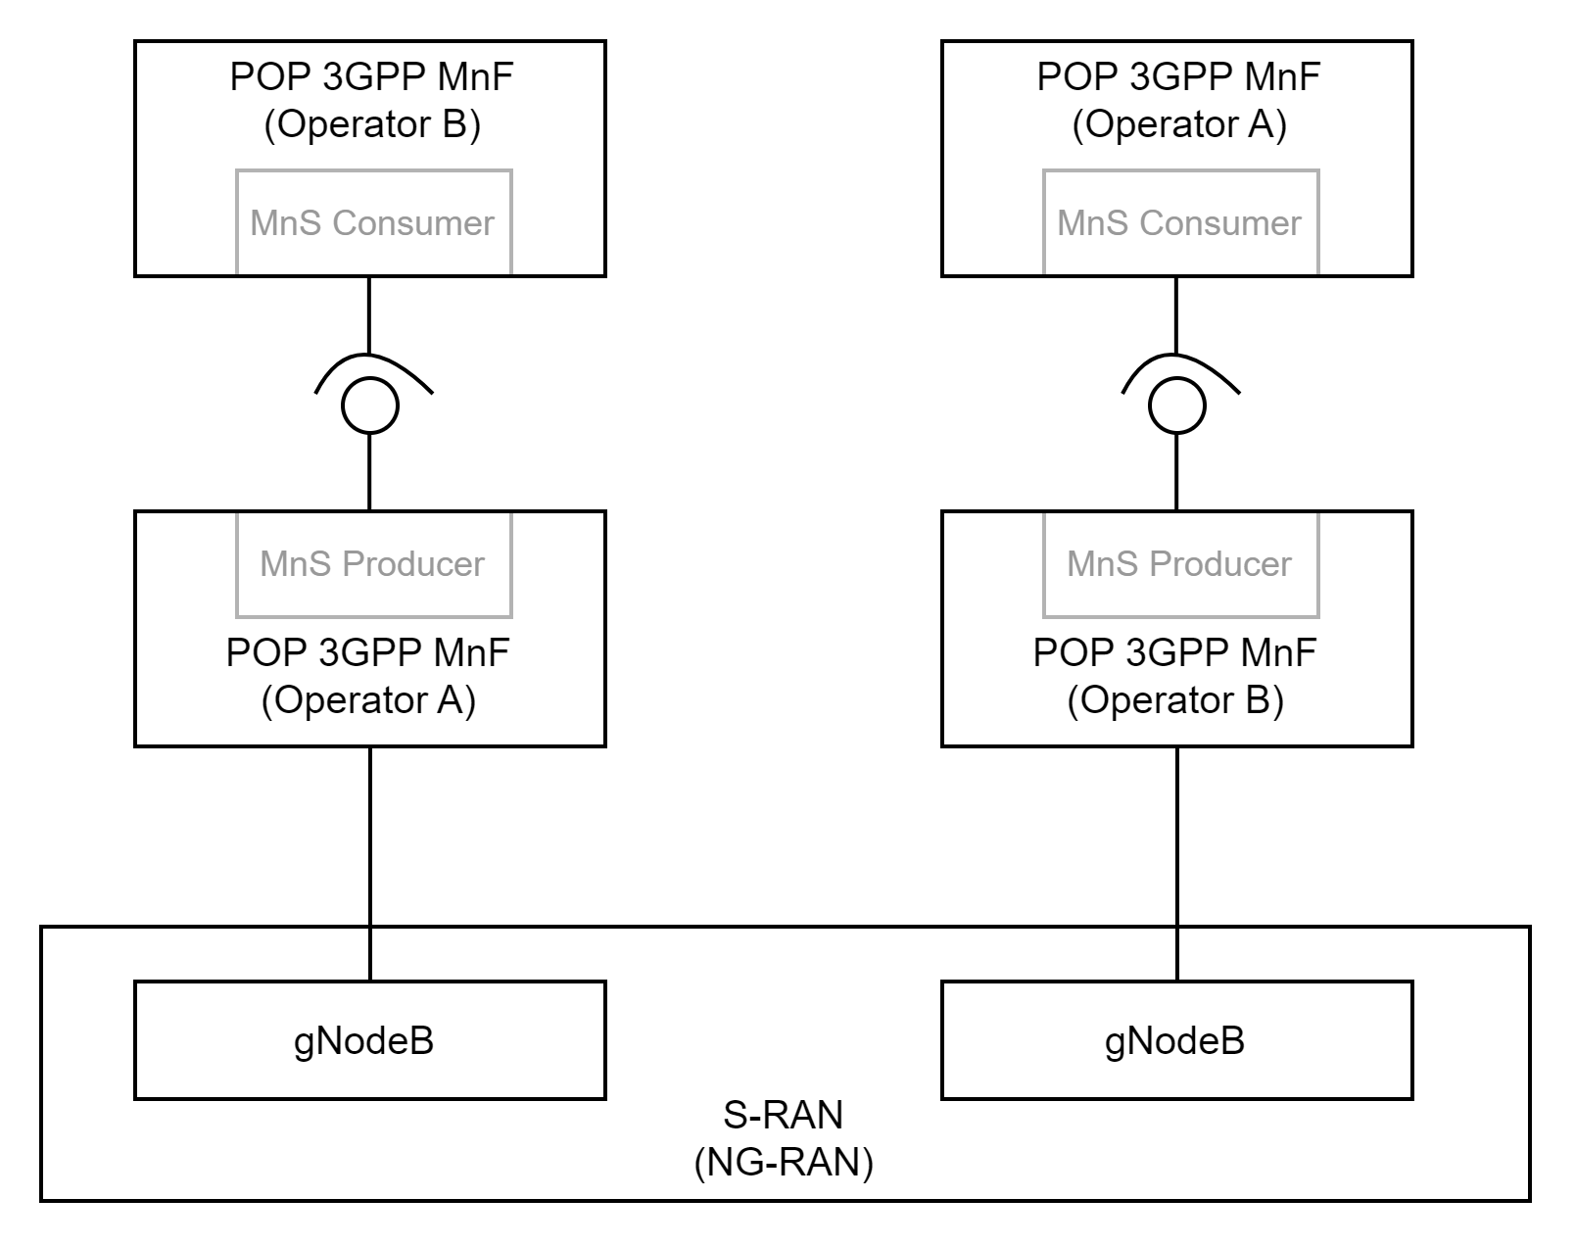

5.1.4 Evaluation of potential solutions
TBD

End of Changes

