3GPP TSG-SA5 Meeting #156 S5-244843
Maastricht, Netherland, 19-23 Aug 2024

Source: Rakuten Mobile

Title: Adding new implementation example in Annex for message bus-based data streaming with data aggregator

Document for: Approval
Agenda Item: 6.19.6

1 Decision/action requested
The group is asked to discuss and approve.

2 References

3 Rationale
This contribution proposes to add a new use case on data streaming for cloud native network functions.

4 Detailed proposal
It proposes to make the following changes to TR 28.869 [1].
Begin Change

Annex <Y>: Parallel streaming, scaling and resiliency aspects of using management data streaming solution based on message bus
The figure Y-1 below illustrates an example implementation using the potential solution for management data streaming based on message bus for scenarios requiring parallel data streaming from NFs with dynamic scaling and resiliency. As shown in figure Y-1, the component workload instances of the NFs send data in parallel to the message broker. The number of parallel instances and streaming connections with the message broker can scale in and out dynamically depending on the real-time demand. Furthermore, multiple message broker instances can exist simultaneously with parallel connections to the NFs and MnFs to scale up the transport capacity beyond what a single message broker instance is able to provide. Furthermore, there can be additional redundant message broker instances and connections to provide fault protection and resiliency to the system. The capability for automatic handling of dynamic scaling and resiliency can be provided along with the message broker middleware implementation. This example can be applied to any cloud deployment scenarios, e.g. either at the edge, regional or central cloud.

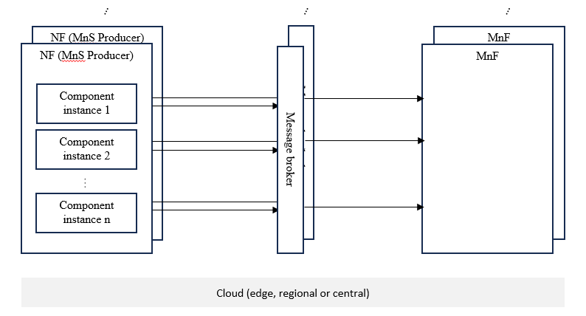
Figure Y-1 Parallel data streaming, scaling and resiliency with solution based on message bus, without data aggregator
Figure Y-2 below illustrates another variation of the implementation illustrated in Figure Y-1 where there is one or more data aggregator(s) which collect and aggregate the data produced by the NFs and their component instances locally before sending it to the message broker(s). The aggregator aggregates the data from multiple data sources (e.g. multiple NFs, or multiple component workload instances of the NFs) first and act as a single point which stream the data to the management system via the message broker(s). This is needed in some deployment scenario when the number of NFs or NF component workload instances are large, and the overhead introduced by the message broking workload for the large number of connections need to be optimized. Apart from the local data aggregation, all the rest described in previous paragraphs apply the same. The same management service solution support both of the implementation options.s

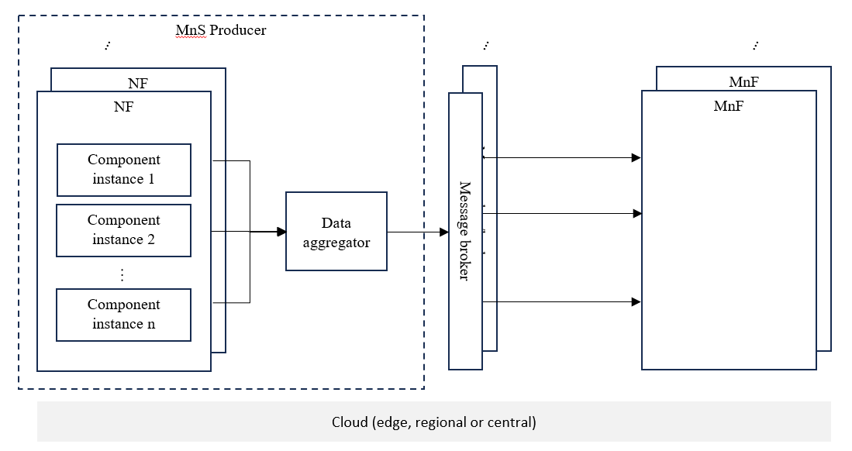
Figure Y-2 Parallel data streaming, scaling and resiliency with solution based on message bus, with data aggregator

End Change

