**3GPP TSG-SA5 Meeting #154 *S5-244196***

Changsa, China, 15 April - 19 April 2024

**Source: Samsung**

**Title: Predictive Data for NDT**

**Document for: Approval**

**Agenda Item: 6.19.4**

# 1 Decision/action requested

***In this box give a very clear / short /concise statement of what is wanted.***

# 2 References

None

# 3 Rationale

Regarding the potential solution in 5.5.3 and 5.1.3.1 the simulation time can be a future time. In that case the Simulation data has to be predictive in nature. This contribution proposes to make the solutions clear on this aspect.

# 4 Detailed proposal

|  |
| --- |
| **First Change** |

### 5.5.3 Potential Solutions

* introduce an information object class representing an NDT, say called NetworkDigitalTwin
* introduce a data type representing the network scenario to be modeled and simulated, say called nDTSimulationScope
* introduce a data type representing the output of modelling and simulating a specific network scenario. The datatype may be called nDTSimulationOutput
  + the NDT may have 1 or more nDTSimulationOutput objects wit
* introduce a data type representing the performance data and/or KPI that are computed by the NDT for the simulated scenario to report the NDT results.

|  |
| --- |
| **Next Change** |

### 5.1.3 Potential solutions

### 5.1.3.1 solution1

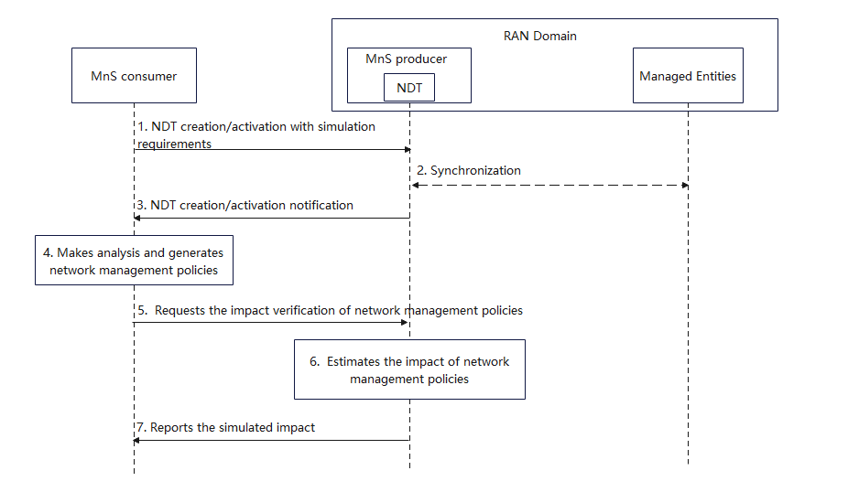

Figure 5.1.3-1: procedure of network management policy verification

1. MnS consumer requests MnS producer (the entity who provides the NDT for network simulation) to create/active an NDT with simulation requirements. Simulation requirements are used to specify the scope and time of the simulated network in NDT.

* Simulation scope: the area of actual mobile network or the managed object that needs to be simulated in NDT. For instance, a geography area, a network slice, etc.
* Simulation time: the timestamp indicates if the simulation is for the past, present, or future.
* Simulation data: the data that is to be collected for NDT simulation, e.g., PM data as defined in TS 28.552/28.554, CM data as defined in TS 28.541/28.622, etc. The predicted values of data is required when the simulation time is for future. The prediction of some of the data can be requested from MDAS using MDA type “Predictions.PMData” as defined in 28.104.

1. Based on the simulation requirements given in step 1, NDT collects the data from the managed entities within the specified simulation scope, time and data. If the Simulation time indicates the timestamp in the past, NDT collects the historical network data. If the Simulation time indicates the timestamp in the present, NDT collects the data from live network. If the Simulation time indicates the timestamp in the future, NDT collects the data based on prediction (utilizing MDA type “Predictions.PMData” as defined in 28.104.). In this step NDT is also fed with the performance data and/or KPI which can help to induce a particular network state to be simulated
2. MnS producer receives the simulation requirements for NDT and create/activate the NDT capability. MnS producer notifies MnS consumer that the NDT capability is ready.
3. MnS consumer makes analysis and generates network management policy. For instance, MnS consumer collects and analyses energy saving related performance measurements and notices that the energy consumption is too high. MnS consumer decides to lower the energy consumption and generates RAN energy saving policies. A simple example of RAN energy saving policy could be the configuration on certain NR capacity booster cells which specifies to enter the energySaving state or not.
4. MnS consumer requests NDT to verify the policy in the simulated network which synchronizes with actual mobile network. The request parameters may include:

* Policy: the relevant policy for a certain use case. For example, the policy for RAN ES policies verification use case could be the ES policy as described in TS 28.310.
* Impact detectors: specified performance metrics and/or alarm types that needs to be collected and reported by NDT after the behaviour happens in NDT.
* Performance requirements: the expected network simulation performance of NDT. For instance, the time spent for the network simulation, the expected proximity between the network simulation results and the actual network execution outcome.

1. NDT executes network management policy according to the performance requirements and collects its impact on the simulated network. The impact could be performance measurement or alarm reporting from simulated network.
2. MnS producer reports the simulated impact and result to MnS consumer. The report content may include the impact which is a key-value list where the keys contain the impact detectors specified in step5. Alarms are reported if any raised. Possibly an indicator, which shows whether the performance of the network simulation satisfies the performance requirements or not, is also reported.

Editor’s note: whether NDT can optionally reside outside of MnS producer is FFS.

|  |
| --- |
| **End Change** |