**3GPP TSG-SA5 Meeting #156 *S5-244836***

**Maastricht, Netherlands 19 - 23 August 2024 revision of S5-243749**

**Source: Huawei**

**Title: pCR TR 28.915 Update RAN ES policy verification**

**Document for: Approval**

**Agenda Item: 6.19.5**

# 1 Decision/action requested

***The group is asked to discuss and agree on the proposal.***

# 2 References

[1] 3GPP TR 28.915: " Study on management aspects of Network Digital Twin"

# 3 Rationale

It’s proposed to update the description of ES policy verification as described in clause 5.1 of [1]

# 4 Detailed proposal

This document proposes the following changes in TR 28.915.

|  |
| --- |
| **1st Change** |

## 5.1 Use case 1: Network management RAN ES policy verification using NDT

### 5.1.1 Description

When configuring the energy saving for RAN, normally the policy is applied in execution with monitoring and optimization loop to minimize the influence on network service quality. That’s to say, there could be multiple ES policies executed iteratively in actual mobile network until the network performance, e.g., energy efficiency of NG-RAN, UE throughput in gNB, etc., meets certain requirements from operators.

This may bring two problems from network management perspective:

- Redundant ES policies configurations due to conservative adjustment on ES policy for each iteration.

- Risk of unexpected deterioration in actual mobile network performance.

The digital twin technology may be used to evaluate the impact of RAN ES policy while satisfying simulation performance requirements (e.g., precision, maximum run time, etc).

The consumer could request the NDT to verify the impact of behaviour (e.g., the configuration of RAN energy saving policies) and receive the report of simulated impact generated by NDT.

### 5.1.2 Potential requirements

**REQ-NDT-FUN-01** The NDT shall have the capability to estimate the impact of network management RAN ES policies.

**REQ-NDT-FUN-02** The NDT shall have the capability allowing the consumer to configure the network management RAN ES policies.

**REQ-NDT-FUN-03** The NDT shall have the capability to report the simulated impact of network management RAN ES policies.

### 5.1.3 Potential solutions

### 5.1.3.1 solution1

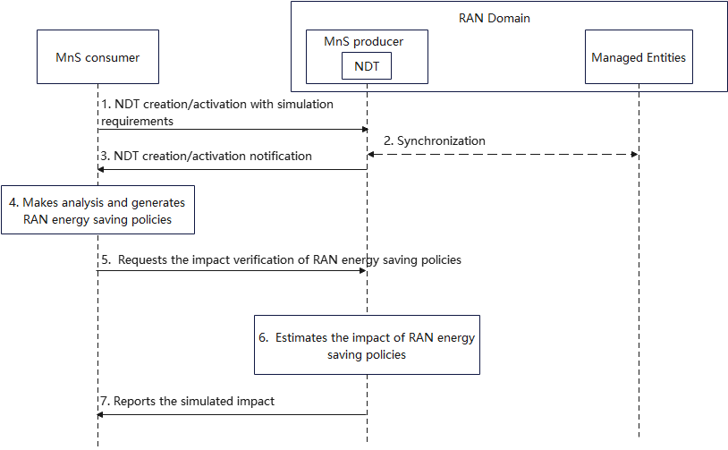

Figure 5.1.3-1: procedure of network management RAN ES policy verification

1. MnS consumer requests MnS producer (the entity who provides the NDT for network simulation) to create/active an NDT with simulation requirements. Simulation requirements are used to specify the scope and time of the simulated network in NDT.

* Simulation scope: the area of actual mobile network or the managed object that needs to be simulated in NDT. For instance, a geography area, a network slice, cell/gNB list, etc. The simulation scope can also include frequency range and RAT (e.g., NR or E-UTRAN) in this use case.
* Simulation time: the timestamp indicates if the simulation is for the past, present, or future.
* Simulation data: the data that collected for NDT simulation, e.g., energy efficiency, RAN UE throughput, latency as defined in TS 28.552/28.554, CM data for ES management function as defined in TS 28.541, etc.

1. Based on the simulation requirements given in step 1, NDT collects the data from the managed entities within the specified simulation scope, time and data. If the Simulation time indicates the timestamp in the past, NDT collects the historical network data. If the Simulation time indicates the timestamp in the present, NDT collects the data from live network. If the Simulation time indicates the timestamp in the future, NDT collects the data based on prediction. In this step NDT is also fed with the performance data and/or KPI which can help to induce a particular network state to be simulated
2. MnS producer receives the simulation requirements for NDT and create/activate the NDT capability. MnS producer notifies MnS consumer that the NDT capability is ready.
3. MnS consumer makes analysis and generates network management RAN ES policy. MnS consumer collects and analyses energy saving related performance measurements and notices that the energy consumption is too high. MnS consumer decides to lower the energy consumption and generates RAN energy saving policies. A simple example of RAN energy saving policy could be the configuration on certain NR capacity booster cells which specifies to enter the energySaving state or not.
4. MnS consumer requests NDT to verify the RAN ES policy in the simulated network which synchronizes with actual mobile network. The request parameters may include:

* RAN ES Policy: the RAN ES policy as described in TS 28.310.
* Impact detectors: specified performance metrics and/or alarm types which include Energy efficiency, RAN UE throughput, latency, etc., that needs to be collected and reported by NDT after the RAN ES Policy executed in NDT.
* Performance requirements: the expected network simulation performance of NDT. For instance, the time spent for the network simulation, the expected proximity between the network simulation results and the actual network execution outcome.

1. NDT executes network management RAN ES policy according to the performance requirements and collects its impact on the simulated network. The impact could be performance measurement or alarm reporting from simulated network.
2. MnS producer reports the simulated impact and result to MnS consumer. The report content may include the impact which is a key-value list where the keys contain the impact detectors specified in step5. Alarms are reported if any raised. Possibly an indicator, which shows whether the performance of the network simulation satisfies the performance requirements or not, is also reported.

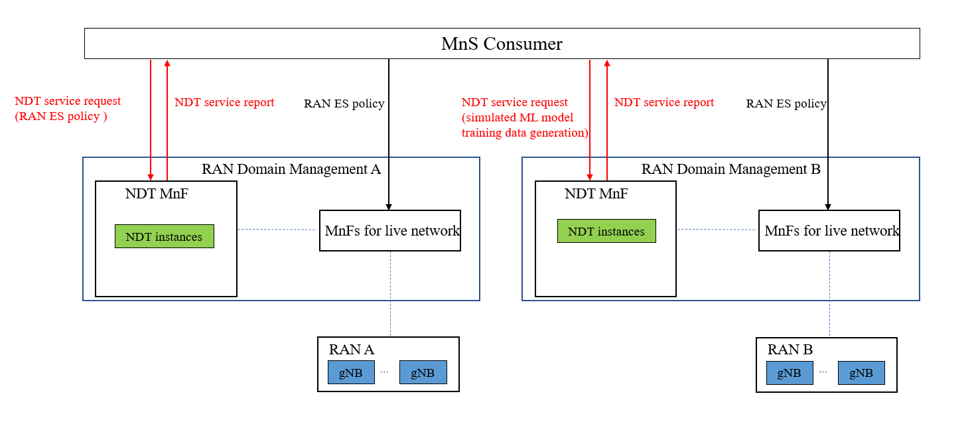

Figure 5.1.3-x: example of NDT service – RAN ES policy verification

Figure 5.1.3-x shows the example of NDT service which provides the RAN ES policy verification. The red arrows represent the new services, in this case ES policy verification, provided by NDT MnF. The black arrow represents RAN ES policy as defined in TS 28.310. The MnS consumer in cross domain management sends RAN ES policy which is to be verified to NDT MnF. The ES policy is the same as the one sent to MnF for live network and it is vendor specific. NDT instance is an instance of mobile network replica with limited network scope in a specific time. The creation of NDT instances is introduced in Figure 5.1.3-1 step 1-3 above.

|  |
| --- |
| **End of change** |