**3GPP TSG-SA5 Meeting #156 *S5-243696***

Maastricht, Netherlands, 19 - 23 August 2024

**Source: Huawei**

**Title: Adding a new solution for signaling storm**

**Document for: Approval**

**Agenda Item: 6.19.5**

# 1 Decision/action requested

***The group is asked to discuss and approval.***

# 2 References

[1] 3GPP draft TR 28.915: “Management and orchestration; Study on management aspects of Network Digital Twin v0.3.0”.

[2] SP-231727 "New Study on management aspects of Network Digital Twin"

# 3 Rationale

This contribution proposes to add a new solution for signaling storm analysis for TR 28.915 based on [1]

# 4 Detailed proposal

It proposes to make the following changes to TR 28.915[1].

|  |
| --- |
| **1st Change** |

### 5.2.3 Potential solutions

### 5.2.3.x solution x

This solution aims to resolve REQ-SIMULATION_NDT-02, 03 and 04 of issue#2, a NDT is created to model (either using emulation method or simulation method) a specific network scenario and its possible impact on the network. It is used to determine whether the current network can defend against a possible future signaling storm when such network scenario happens.

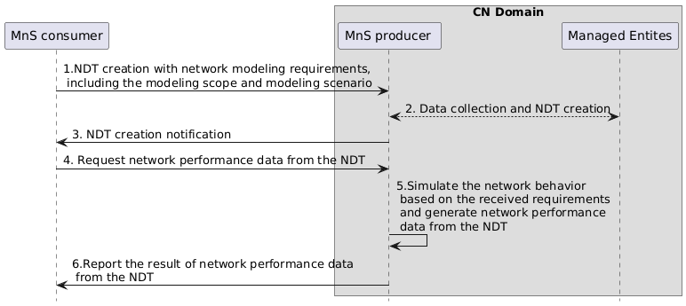

Figure 5.2.3.x-1: procedure of NDT for sinaling storm analysis

1. MnS consumer requests MnS producer (the entity who provides the NDT management service) to create an NDT instance (i.e., a new IOC, may be called NetworkDigitalTwin, is required. It may be name contained in a subnetwork or managed function) with modeling requirements. The modeling requirements are used to specify the scope of the network to be modelled and the to be modelled network scenario , which may include,

* NDT scope: the area of actual mobile network or the managed object that needs to be simulated or emulated in NDT. For instance, a geography area, a network slice, etc.
* Modeling scenario: the network scenario required to be modelled, e.g., the number of PDU session received by AMF increases to 10 times.
* Modeling data: the selected data to be modelled by NDT, e.g., 5GC related PM data as defined in TS 28.552/28.554, CM data as defined in TS 28.541/28.622, etc.

1. Based on the modeling requirements given in step 1, the MnS producer collects the data from the network and creates a NDT instance.
2. MnS producer notifies MnS consumer that the NDT instance is created.
3. MnS consumer requests NDT to output the impact on the network (e.g. whether a signalling storm occrus). The request parameters may include:

* Identified event: in this use case, a signalling storm is identified possiblely be occered in the future.
* Impact detectors: specified performance metrics and/or alarm types that needs to be collected and reported by NDT after the behaviour happens in NDT.

1. NDT simulates/emulates the network behaviour and generate network performance data and/or alarm data from the NDT.
2. MnS producer reports the result to MnS consumer. The report content may include the result of the evaluation and impact which is a key-value list where the keys contain the impact detectors specified in step 4. Alarms are reported if any raised.

|  |
| --- |
| **End of Changes** |