**3GPP TSG-SA5 Meeting #156 *S5-244786d1***

**Maastricht, The Netherlands, 19 - 23 August 2024**

|  |  |  |  |  |  |  |  |  |
| --- | --- | --- | --- | --- | --- | --- | --- | --- |
| *CR-Form-v12.1* | | | | | | | | |
| **CHANGE REQUEST** | | | | | | | | |
|  | | | | | | | | |
|  | **32.422** | **CR** | **0476** | **rev** | **-1** | **Current version:** | **18.3.0** |  |
|  | | | | | | | | |
| *For* [***HE******LP***](http://www.3gpp.org/3G_Specs/CRs.htm#_blank)*on using this form: comprehensive instructions can be found at* [*http://www.3gpp.org/Change-Requests*](http://www.3gpp.org/Change-Requests)*.* | | | | | | | | |
|  | | | | | | | | |

|  |  |  |  |  |  |  |  |  |
| --- | --- | --- | --- | --- | --- | --- | --- | --- |
| ***Proposed change affects:*** | UICC apps |  | ME |  | Radio Access Network | **X** | Core Network |  |

|  |  |  |  |  |  |  |  |  |  |  |
| --- | --- | --- | --- | --- | --- | --- | --- | --- | --- | --- |
|  | | | | | | | | | | |
| ***Title:*** | Rel-19 CR 32.422 Trace new RRC reports | | | | | | | | | |
|  |  | | | | | | | | | |
| ***Source to WG:*** | Ericsson | | | | | | | | | |
| ***Source to TSG:*** | S5 | | | | | | | | | |
|  |  | | | | | | | | | |
| ***Work item code:*** | TraceQoE_OAM | | | | |  | ***Date:*** | | | 2024-08-09 |
|  |  | | | |  | |  | | |  |
| ***Category:*** | **B** |  | | | | | ***Release:*** | | | Rel-19 |
|  | *Use one of the following categories:* ***F*** *(correction)* ***A*** *(mirror corresponding to a change in an earlier release)* ***B*** *(addition of feature),* ***C*** *(functional modification of feature)* ***D*** *(editorial modification)*  Detailed explanations of the above categories can be found in 3GPP [TR 21.900](http://www.3gpp.org/ftp/Specs/html-info/21900.htm). | | | | | | | | *Use one of the following releases: Rel-8 (Release 8) Rel-9 (Release 9) Rel-10 (Release 10) Rel-11 (Release 11) … Rel-15 (Release 15) Rel-16 (Release 16) Rel-17 (Release 17) Rel-18 (Release 18)* | |
|  |  | | | | | | | | | |
| ***Reason for change:*** | | Implement tracing of RRC reporting meeting Stage 1 requirements. This will align with RAN2 specified RRC reports. Efficient tracing of RRC reports will be possible. | | | | | | | | |
|  | |  | | | | | | | | |
| ***Summary of change:*** | | Addition of feature for tracing RRC reports. | | | | | | | | |
|  | |  | | | | | | | | |
| ***Consequences if not approved:*** | | Tracing of RRC reports would be very inefficient. | | | | | | | | |
|  | |  | | | | | | | | |
| ***Clauses affected:*** | | 1, 3.2, 4.X (new), 4.X.1 (new), 4.X.2 (new), 5.9a, 5.9X (new), 9X (new) 10.X (new), Annex X (new) | | | | | | | | |
|  | |  | | | | | | | | |
|  | | **Y** | **N** |  | | | |  | | |
| ***Other specs*** | |  | **X** | Other core specifications | | | |  | | |
| ***affected:*** | |  | **X** | Test specifications | | | |  | | |
| ***(show related CRs)*** | | **X** |  | O&M Specifications | | | | TS 28.622 CR 0438 | | |
|  | |  | | | | | | | | |
| ***Other comments:*** | |  | | | | | | | | |
|  | |  | | | | | | | | |
| ***This CR's revision history:*** | | S5-244074 | | | | | | | | |

|  |
| --- |
| **First change** |

# 1 Scope

The present document describes the mechanisms used for the control and configuration of the Trace, Minimization of Drive Test (MDT) in E-UTRAN/NG-RAN, Radio Link Failure (RLF), RRC reporting and RRC Connection Establishment Failure (RCEF) reporting functionality, and 5GC UE level measurements collection at the management system (at the Element Manager (EM) and or Network Manager (NMs) in UMTS, EPS and NR), Network Elements (NEs) and User Equipment (UEs). For Trace functionality, it covers the triggering events for starting/stopping of subscriber/UE activity traced over 3GPP standardized signalling interfaces, the types of trace mechanisms, configuration of a trace, level of detail available in the trace data, the generation of Trace results in the NEs and UE and the transfer of these results to management system. For MDT, it also covers logged MDT and immediate MDT mechanisms in both management based and signalling based scenarios. GSM is excluded from the RAT systems which the present document can be applied to. For 5GC UE level measurements collection, it also covers management based and signalling based scenarios.

The mechanisms for Trace, MDT, RLF, RCEF and RRC reporting, and 5GC UE level measurements activation/deactivation are detailed in clause 4; clause 5 details the various Trace, MDT, RLF, RCEF and RRC reporting, and 5GC UE level measurements control and configuration parameters and the triggering events that can be set in a network. Trace, MDT, RLF, RCEF and RRC reporting concepts and requirements are covered in 3GPP TS 32.421 [2] while Trace and MDT data definition and management is covered in 3GPP TS 32.423 [3]. The 5GC UE level measurements definitions and use cases are covered in 3GPP TS 28.558 [62].

The conditions for supporting Network Sharing are stated in 3GPP TS 32.421 [2].

The condition for supporting user consent handling for MDT does not apply to Standalone Non-Public Network, i.e., SNPN as per TS 23.501[40].

|  |
| --- |
| **Next change** |

## 3.2 Abbreviations

For the purposes of the present document, the abbreviations given in TR 21.905 [4], TS 32.101 [1] , TS 23.501 [40], TS 38.300 [42] and the following apply. An abbreviation defined in the present document takes precedence over the definition of the same abbreviation, if any, in TR 21.905 [4].

AS Application Server

BGCF Breakout Gateway Control Function

CAG Closed Access Group

CSCF Call Session Control Function

I-CSCF Interrogating-CSCF

IM CN SS IP Multimedia Core Network Subsystem

IMEI-TAC IMEI Type Allocation Code

MHI Mobility History Information

NID Network ID

P-CSCF Proxy – CSCF

PNI-NPN Public Network Integrated Non-Public Network

RCEF RRC Connection Establishment Failure

RLF Radio Link Failure

S-CSCF Serving-CSCF

SHR Successful Handover Report

SNPN Stand-alone Non-Public Network

SPR Successful PSCell Addition/Change Report

TAU Tracking Area Update

TRSR Trace Recording Session Reference

TR Trace Reference

UHI UE History Information

|  |
| --- |
| **Next change** |

## 4.X RRC reporting

### 4.X.1 Trace session activation for RRC reporting in NG-RAN

RRC reporting is activated to the gNB as a special Trace Session where the Job Type parameter indicates RRC report, and the RRC Report Type parameter indicates which RRC reports should be traced. The detailed procedure is shown in figure 4.X.1.1 where one UE experiences an event which results in a RRC report being generated and traced.

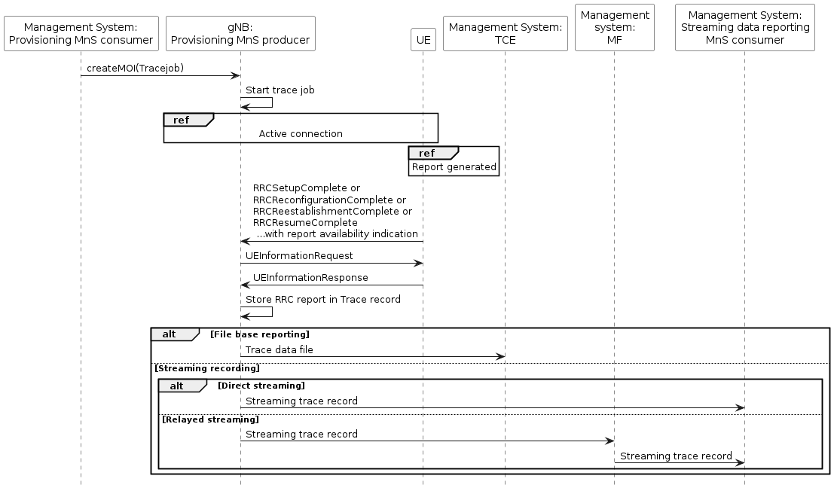

Figure 4.X.1.1 Example scenario for RRC reporting when UE generates a RRC report.

Upon Trace Session activation indicating RRC reporting, the gNB shall start a Trace Session. This Trace Session shall collect one or more RRC reports received from the UE. The Trace Session activation information shall contain the following information:

- Trace Reference

- Job Type set to the value "RRC report".

- RRC Report Type.

- TCE IP Address for file based reporting and Trace Reporting Consumer URI for streaming reporting if streaming based report is supported.

### 4.X.2 Trace session deactivation for RRC reporting in NG-RAN

Upon trace session deactivation where the Job Type denotes that RRC reports is used the gNB shall deactivate the trace session for the indicated Trace Reference of RRC reporting and stop RRC reporting.

|  |
| --- |
| **Next change** |

## 5.9a Job Type (M)

The Job Type is a mandatory parameter. The condition is either MDT or RLF or RCEF data collection functionality is supported. It defines if a single trace job, a combined MDT and trace job or RLF report collection job or RCEF report collection job is activated. This parameter also defines the MDT mode. The Job Type parameter is an enumerated type with the following values:

- Immediate MDT only (0);

- Logged MDT only (1);

- Trace only (2);

- Immediate MDT and Trace (3);

- RLF reports only (4);

- RCEF reports only (5);

- Logged MBSFN MDT (6);

- 5GC UE level measurements only (7);

- Trace and 5GC UE level measurements (8);

- Immediate MDT and 5GC UE level measurements (9);

- Trace, Immediate MDT and 5GC UE level measurements (10);

- RRC Report (11).

NOTE 1: The Job Type "RLF reports only" and "RCEF reports only" are applicable only in management based trace activation in E-UTRAN and NG-RAN.

NOTE 2: Logged MBSFN MDT is applicable only for activation in E-UTRAN.

NOTE X: The Job Type "RRC Report" is applicable only in management based trace activation in NG-RAN.

|  |
| --- |
| **Next change** |

### 5.X RRC Report Type (CM)

The RRC Report Type parameter is a conditionally mandatory parameter. It shall be present when RRC Reporting is supported.

The RRC Report Type defines which of the possible RRC reports that are requested. These reports are specified in 3GPP TS 38.331 [43].

• RLF report

• RCEF report

• SHR

• SPR

• MHI

• RA Report

• UHI report

|  |
| --- |
| **Next change** |

# 9X RRC Reporting

For reporting of RRC data in single operator and Participating Operator cases, see clause 7.

|  |
| --- |
| **Next change** |

## 10.X RRC report

The measurement names for the RRC report consists of the following names:

* The first item identifies the RRC job type, i.e. "rrcReport".
* The second item identifies the kind of RRC Report i.e. one of "rlfReport", "rcefReport", "shr", "spr", "mhi", "raReport", or "uhiReport".

Possible examples:

* rrcReport.rlfReport
* rrcReport.rcefReport
* rrcReport.shr
* rrcReport.spr
* rrcReport.mhi
* rrcReport.raReport
* rrcReport.uhiReport

|  |
| --- |
| **Next change** |

# B.2 Routing the Trace file via the management system

Routing the Trace file via the NE’s management system to the TCE may be used when the NEs are located a network that is outside the operator's control and a secure connection between the NE and the management system is to be reused (via secure gateways etc). Another reason can be that the operator wants to minimise the number of connections from a NE to TCEs. A third reason can be that a Master Operator and Participating Operator want to reuse existing management connections.

# Annex X (informative): Plant UML code

## Annex X.1 Code for figure 4.X.1.1

@startuml

hide footbox

participant "Management System:\nProvisioning MnS consumer" as prov #white

participant "gNB:\nProvisioning MnS producer" as gnb #white

participant "UE" #white

participant "Management System:\nTCE" as tce #white

participant "Management\nsystem:\nMF" as mf #white

participant "Management System:\nStreaming data reporting\nMnS consumer" as data #white

prov -> gnb :createMOI(Tracejob)

gnb -> gnb : Start trace job

'note over gnb,UE: Active connection

'note over UE: RRC Report generated

ref over gnb,UE: Active connection

ref over UE: Report generated

UE -> gnb :RRCSetupComplete or\nRRCReconfigurationComplete or\nRRCReestablishmentComplete or\nRRCResumeComplete\n ...with report availability indication

gnb -> UE: UEInformationRequest

UE -> gnb: UEInformationResponse

gnb -> gnb: Store RRC report in Trace record

alt File base reporting

gnb -> tce: Trace data file

else Streaming recording

alt Direct streaming

gnb -> data: Streaming trace record

else Relayed streaming

gnb -> mf: Streaming trace record

mf -> data: Streaming trace record

end

end

@enduml

Annex C (informative): Change history

|  |
| --- |
| **End of changes** |