3GPP TSG-SA5 Meeting #156 S5-244741d1

Maastricht, NL, 19-23 August 2024

Source: Huawei, Deutsche Telekom

Title: Potential solution for carbon emission of operator site

Document for: Approval
Agenda Item: 6.19.20

1 Decision/action requested
The group is asked to discuss and agree on the proposal.

2 References
[1] 3GPP TS 22.261: Service requirements for the 5G system; Stage 1
[2] 3GPP SP-231723: Study on energy efficiency and energy saving aspects of 5G networks and services
[3] 3GPP TR 28.880 0.3.0: Study on energy efficiency and energy saving aspects of 5G networks and services

3 Rationale
TS 22.261 [1] clause 6.15a makes the following statements:
“
6.15a Energy Efficiency as a Service Criteria
6.15a.1 Description
Climate change and the rising consumption of energy motivate increased energy efficiency. Energy efficiency is a strategic priority for telecom operators around the world.
Energy efficiency as a service criteria allows services to be delivered with diverse energy efficiency and energy consumption policies. Energy consumption and efficiency information and network energy states can be exposed to third parties and energy consumption can be constrained.
Energy related information can include ratio of renewable energy and carbon emission information when available. Calculation of energy related information as described in the following requirements is done by means of averaging or applying a statistical model. The requirements do not imply that some form of 'real time' monitoring is required.
”.

Amongst other study objectives in [2], WT-2.2 addresses the issue about which and how carbon emission information and renewable energy consumption information of the 5G system can be obtained:
“
- WT-2: New Rel-19 topics from other SA WGs
- WT-2.1 Consideration of energy consumption measurement/estimation at various granularities
- WT-2.2 Study whether and how mapping measured or estimated energy consumption measurements on to carbon emissions is possible. Study the estimation of carbon emissions efficiency and how to achieve carbon emissions saving in the 5G system. Additionally, whether and how renewable energy consumption information can be obtained will be studied
- WT-2.3 Study the support of different energy states of network elements and network functions. SA5 may have to provide OAM support
”.

This contribution proposes to introduce a potential solution for the use case #3 (Enable renewable energy consumption and carbon emission information reporting) in TR 28.880 [3]. It focuses on describing how the network operator can obtain the carbon emission factor of its sites.

4 Detailed proposal
This document proposes the following changes in TR 28.880 [3].
1st Change

2 References
The following documents contain provisions which, through reference in this text, constitute provisions of the present document.
- References are either specific (identified by date of publication, edition number, version number, etc.) or non-specific.
- For a specific reference, subsequent revisions do not apply.
- For a non-specific reference, the latest version applies. In the case of a reference to a 3GPP document (including a GSM document), a non-specific reference implicitly refers to the latest version of that document in the same Release as the present document.
[1] 3GPP TR 21.905: "Vocabulary for 3GPP Specifications".
[2] 3GPP TS 28.554: "Management and orchestration; 5G end to end Key Performance Indicators (KPI)".
[3] ETSI GR NFV-IFA 029 V3.3.1 (2019-11): "Network Functions Virtualisation (NFV) Release 3; Architecture; Report on the Enhancements of the NFV architecture towards "Cloud-native" and "PaaS"".
[4] ETSI GS NFV-IFA 040 V4.3.1 (2022-05): "Network Functions Virtualisation (NFV) Release 4; Management and Orchestration; Requirements for service interfaces and object model for OS container management and orchestration specification".
[5] ETSI GS NFV-IFA 027 V4.3.1 (2022-06): "Network Functions Virtualisation (NFV) Release 4; Management and Orchestration; Performance Measurements Specification".
[6] ETSI GS NFV-IFA 027 V5.1.1 (2024-4): "Network Functions Virtualisation (NFV) Release 5; Management and Orchestration; Performance Measurements Specification".
[7] 3GPP TS 22.261: Service requirements for the 5G system; Stage 1
[8] ETSI GS OEU 020 V1.1.1 (2020-03): "Operational energy Efficiency for Users (OEU); Carbon equivalent Intensity measurement; Operational infrastructures; Global KPIs; Global KPIs for ICT Sites".
[9] ETSI EN 303 472 V1.0.0 (2018-06): "Environmental Engineering (EE); Energy Efficiency measurement methodology and metrics for RAN equipment".
[10] ISO/IEC 30134-3:2016: Information technology - Data centres - Key performance indicators - Part 3: Renewable energy factor (REF)
[11] 3GPP TS 28.552: "Management and orchestration; 5G performance measurements".
[12] 3GPP TS 28.310: "Management and orchestration; Energy efficiency of 5G"
[x] Electricity maps – available at https://app.electricitymaps.com/map

Editor’s note: reference [6] is not published yet, will be published soon

Next Change

5.3.3 Potential solutions

5.3.3.j Potential solution #j: Carbon Emission of operator site

5.3.3.j.1 Introduction
This potential solution describes how the carbon emission of an operator site can be obtained.

5.3.3.j.2 Description
In this potential solution, the Network Operator gathers information about:
- the source(s) of the energy used to provide electricity to the operator site
- for each energy source, the respective energy consumed during the observation period
, and provides the 3GPP management system with this information.
NOTE 1: the source(s) of energy can be renewable, i.e. from renewable non-fossil sources (cf. the definition of renewable energy in clause 3.1), or non-renewable, i.e. from fossil sources (e.g. coal, natural gas, oil) or nuclear plants.
NOTE 2: how the Network Operator gets this information from the energy supplier is out of scope of the present study.
NOTE 3: to enable the Network Operator to provision the 3GPP management system with this information requires NRM update – this is FFS.

In case of multiple types of energy sources, CE_{Site} can be obtained by summing up, for each type of energy source i used to power the operator site, the energy consumed using this type of energy source multiplied by the Carbon Emission Factor of the energy source i:

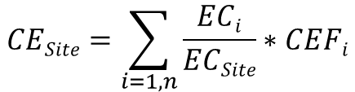
Equation 1: Carbon Emission of a multi-energy-source operator site
, where:
- EC_{i} is the Energy Consumption corresponding to the type of energy source i used to power the operator site. Its unit is kWh;
- EC_{Site} is the total Energy Consumption of the operator site. Its unit is kWh;
- CEF_{i} is the Carbon Emission Factor of the type of energy source I;
- CE_{Site} unit is kg CO2eq.

- Case of off-grid site (site not connected to the electricity grid): this scenario involves the direct supply of electricity without using the public grid. In this case, the energy production plant is located in the operator site, or there is a direct line between the two. Typical sources of energy for off-grid sites can be diesel generators and/or solar PV and/or etc. The Carbon Emission Factor is equivalent to the standard emission factor from annexes A.3 and A.4 of ETSI GS OEU 020 [8], whose tables are partially copy/pasted here below for information:
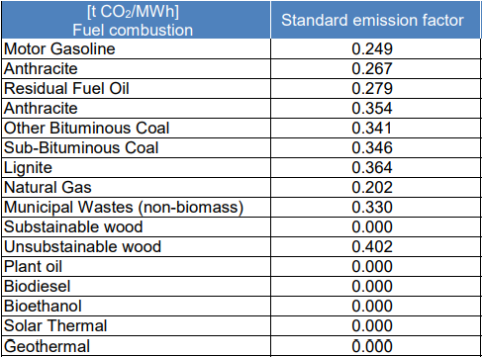
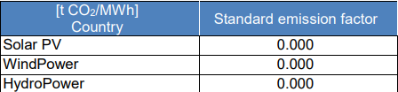

Figure 5.3.3.j.2-1: Standard emission factors per type of energy source

For example:
- For an operator site where only Solar PV is used to power the site, given that the Standard emission factor of Solar PV is 0.000 (see Figure 5.3.3.j.2.3-1), CE_{Site} is equal to 0.000
- For an operator site where Solar PV is the main energy used but, due to some outages, Diesel generators (whose standard emission factor equals to 0.249 tCO2/MWh – see Figure 5.3.3.j.2-1) had to be used during 10% of the time, CE_{Site} can be calculated as follows:
CE_{Site} = (0.9 * 0) + (0.1 * 0.249)
CE_{Site} = 0.0249 kg CO₂eq
In case of off-grid site, the Network Operator may have direct access to this information (i.e. without having to gather this information from the energy service provider); the granularity of this information is per site.
- Case of on-grid site: The Network Operator periodically (e.g. per day, per week, per month, etc.) receives, from its energy service provider, information which indicates the total energy consumed during the period and the proportion of each type of energy sources used by the energy service provider to serve the Network Operator. Based on this information, the Network Operator can calculate, for each operator site, CE_{Site}, as per equation 1.
For example, if the energy service provider indicates to the Network Operator that an energy mix has been used to power the operator’s network as follows:
- Lignite: 20%
- Natural gas: 30%
- Motor Gasoline: 40%
- Wind Power: 10%
, one can calculate CE_{Site} as follows:
CE_{Site} = (0.2 * 0.364) + (0.3 * 0.202) + (0.4 * 0.249) + (0.1 * 0)
CE_{Site} = 0.0728 + 0.0606 + 0.0996 + 0
CE_{Site} = 0.233 kg CO2eq
The granularity of the information received from the energy service provider may vary from site level (finest grain) up to the whole Network Operator network level (coarsest grain).
In case the Network Operator has footprint in the European Union and can’t obtain sufficient energy related information from its energy service provider, it can apply the standard emission factor from annex A.2 of ETSI GS OEU 020 [8], whose table is partially copy/pasted here below for information, to its sites:

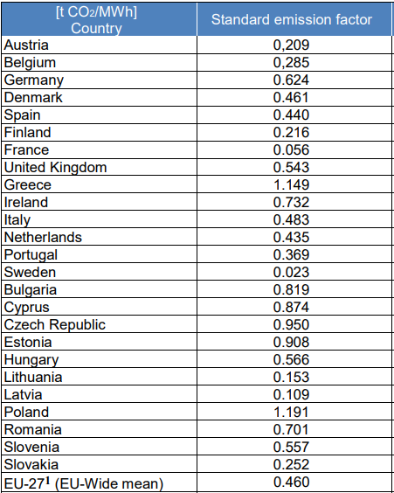
Figure 5.3.3.j.2-2: Standard emission factors per European country

Network Operators may also use non-official information such as e.g. the information available at [x].

End of changes

