**3GPP TSG-SA5 Meeting #156 *S5-244691***

**Maastricht, Netherlands 19 - 23 August 2024**

**Source: Huawei, China Mobile, Nokia**

**Title: pCR TR 28.915 Update network automation functions**

**Document for: Approval**

**Agenda Item: 6.19.5**

# 1 Decision/action requested

***The group is asked to discuss and agree on the proposal.***

# 2 References

[1] 3GPP TR 28.915: " Study on management aspects of Network Digital Twin"

# 3 Rationale

It’s proposed to update the description of network automation functions to keep alignment between clause 4.2.2 and 5.5 of [1].

# 4 Detailed proposal

This document proposes the following changes in TR 28.915.

|  |
| --- |
| **1st Change** |

### 4.2.2. Relations between digital twins and network automation functions

The NDT can be requested by the consumer to model a mobile network or part of one, support evaluating the corresponding impact, and return the report of the simulated impact generated by the NDT. The NDT may be used as a replica of a mobile network, which may synchronize data from the managed network for modeling. The digital twins provide modelling capabilities that are used by the network automation functions (e.g., MDA, SON, etc.) to accomplish their automation functionality. The related automation capabilities are provided by the network automation functions regardless of whether the digital twin models are integrated within or external to the network automation functions – see figure 4.2.2-1 below.

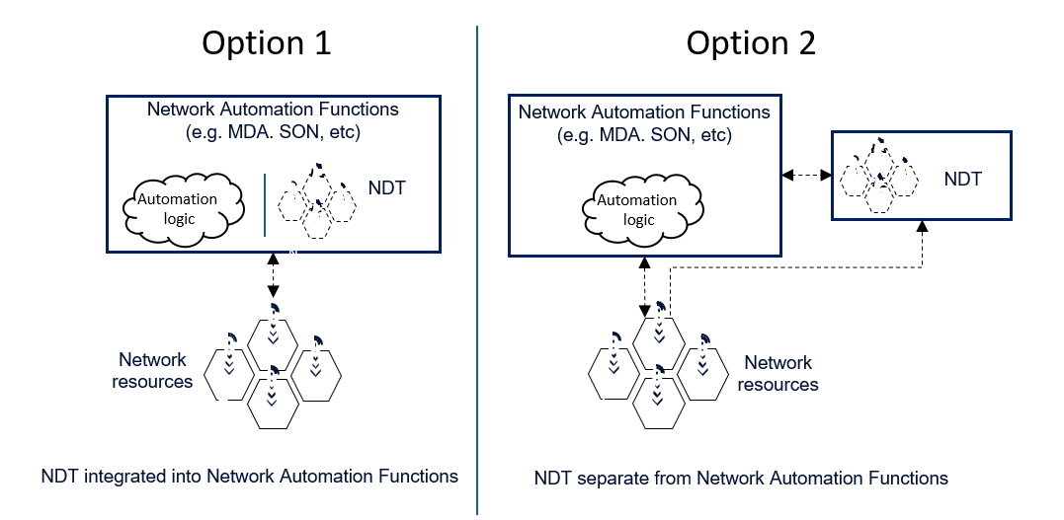

Figure 4.2.2-1: relation of NDTs with network automation functions, option 1- NDT internal/integrated into MnF. Option 2-NDT External to MnF .

Note: The double headed arrows indicate candidate flow of data and controls from the network to the NDT and to the management function and related flow of control from the MnFs to the network of NDT while one headed arrows indicate only flow of control.

|  |
| --- |
| **Next Change** |

## 5.5 Use case 5: NDT support to network automation

### 5.5.1 Description

NDTs may be used to support many automation use cases (e.g., MDA, SON, etc.). An NDT may be integrated into a network automation function, or it may be external to the network automation function. In the case where the NDT is external to the network automation function, it could be possible for the network automation function to configure the NDT and the scenario that could be modelled and simulated by the NDT. Then the NDT needs to implement the defined scenario, simulate it, and subsequently provide an output representing the statues of different network metrics for the simulated scenario. NDTs may not make decisions for the configuration of live network but could support to make decision recommendations.

|  |
| --- |
| **End of change** |