**3GPP TSG-SA5 Meeting #156S5-243539**

**19 - 23 August 2024, Maastricht, Netherlands**

**Source: Nokia**

**Title: Rel-19 pCR TR28.867 Enhance CCL Escalation solution**

**Document for: Approval**

**Agenda Item: 6.19.4**

# 1 Decision/action requested

***The group is asked to discuss and agree on the proposal.***

# 2 References

[1] 3GPP TR 28.867: “Closed control loop management” v0.3.0

# 3 Rationale

Use cases 5.12in this TR proposes a solution for escalation but its not clear how the proposed information objects accomplish escalation. This pCR extends the solutions to clarify how escalation is achieved.

# 4 Detailed proposal

|  |
| --- |
| **First Change** |

### 5.12 CCL decision escalation

5.12.1 Description

CCLs will make decisions in different contexts (states, status, conditions, etc.) of the network and not all decisions are equally effective. In some cases, the CCL may need to provide feedback indication the challenges faced on reaching a definite decision. The feedback may include a request to escalate its decision making to another entity.

A CCL can be fully or partially autonomous derivation or execution of its decisions. The degree to which the CCL independently executes decisions or escalates them, should be flexibly configurable by the MnS consumer as a confidence threshold. The confidence threshold could be configured based on the sensitivity of the operations under its control, the trust level in the decisions of the CCL and the necessity to consider a bigger picture at times. Then, based on how much confidence the CCL has in its decisions, the CCL can escalate a decision or situation to an escalation recipient which has this bigger picture (say has wider scope), can execute a different(larger) set of actions or has better capabilities, e.g., a larger and more capable ML model.

Note: the computation of confidence within the CCL is up to implementation as it depends on the CCL’s purpose and the scenario that the CCL is addressing.

The escalation recipient CCL enables the escalator CCL to request for escalation for a given network context or state with e.g., information about the escalator CCL preferences and observed constraints when driving decisions. Based on its evaluations, the escalation recipient CCL should provide to the escalator CCL a report that holds the outcomes that the CCL (acting as an escalation recipient) has derived for a given escalation request.

Note: The relation with existing Assurance closed loop execution supervision use case in TS 28.535 needs to be clarified.

#### 5.12.2 Potential requirements

**REQ- CCL-ESC-1:** The CCL MnS producer should have a capability to enabling an authorized consumer to configure the degree of autonomy of the CCL as characterisation of the conditions under which the ACCL should escalate a decision

**REQ- CCL-ESC-2:** The CCL MnS producer should have a capability to enabling an authorized consumer to configure the entity to which a decision should be escalated

**REQ-CCL-ESC-3:** The CCL MnS producer (acting as an escalation recipient CCL) should have a capability to enabling an authorized MnS consumer (e.g., an escalator CCL) to request escalation of a decision or escalation of decision-making for a given network context or state to the CCL associated with the CCL MnS producer

**REQ-CCL-ESC-4**: The 3GPP management system (or the CCL Mns producer) should have a capability enabling an MnS consumer to provide information related to its previous decisions, decision constraints, preferences, … as input to be used in resolving escalations sent towards the CCL associated with the CCL MnS producer.

**REQ-CCL-ESC-5:** The CCL MnS producer (acting as an escalation recipient CCL) should have a capability to provide to an authorized MnSconsumer (e.g., an escalator CCL) a report that holds the outcomes that the CCL (acting as an escalation recipient) has derived for a given escalation request.

### 5.12.3 Possible solutions

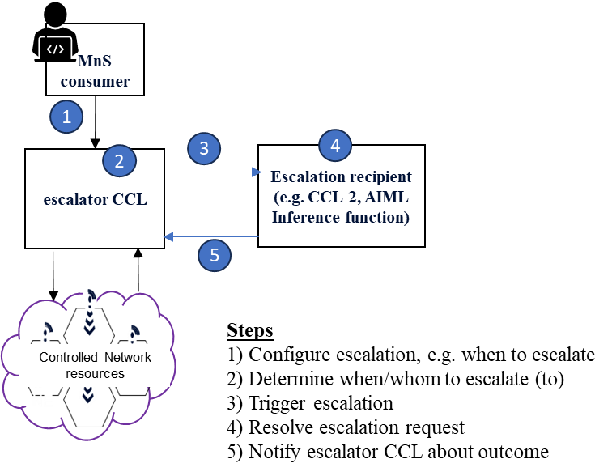

Fig 5.12.3-1: end-to-end flow of CCL decision escalation

* Introduce an attribute defining the entity to which the decision is escalated to, say called the escalationRecipient.
* Introduce an attribute on the CCL for defining the condition that triggers the escalation. For example, the CCL may trigger escalation when its level of confidence in the derived decision is below some threshold, say called a confidence threshold. The confidence threshold attribute enables the CCL to autonomously make decisions for each situation and context based on its computed confidence level in the given situation. If the confidence level is lower than the confidence threshold the decision is escalated otherwise the decision is executed.
* Introduce on the CCL representing the escalationRecipient. an IOC representing the request for escalation, say called EscalationRequest, that holds all information related to the request for escalation. The EscalationRequest may include :
  + A proposedCMChange attribute which describes the configuration management changes that has been proposed by the escalator CCL.
  + A decisionConstraints attribute indicating the constraints observed by the escalating CCL in making the decision(s). The constraints may be of type context as defined in TS28.312 or conditions expressed using JEX/XPATH
  + The EscalationReason attribute can provide an optional description of the reason behind the escalation to provide more context and further clarification.
* The escalationRecipient may send an output representing the outcome of the escalation. Introduce in the AssuranceReport an escalationOutcome data type that holds the outcomes of the escalation. When the escalationOutcome attribute of the report is updated, the escalation recipient CCL sends a notification to the escalator CCL that the report is available.
  + The escalation outcome indicates whether the CCL should take any action and what that action is. Introduce an attribute to indicate what shall be done by the CCL. It is an ENUM with the values:
    - “DONOTHING”- indicating that the CCL does not ned to take any action, i.e., the escalationRecipient is addressing the scenario
    - “APPLYACTION”- indicating that the CCL should apply a specific set of actions proposed by the escalationRecipient. The action may be placed a new attribute, say called “proposedActions that list as et of CM changes
    - “APPLYGUIDANCE”- indicating that the CCL should compute a new CM change based on the guidance from the escalationRecipient. The guidance may be placed in the proposedActions attribute

5.12.4 Evaluation of solutions

The potential solution described in clause 5.12.3 is a fully NRM-based approach that extends the ACCL NRM to realise escalation of decisions by CCLs. The solution allows the CCL through its MnS producer to escalate to an escalation recipient a situation in which the CCL is not confidence to its decision. The solution also enables the escalation recipient as Mns consumer to provide the output of the escalation (the recommended next actions) to the CCL that escalated the scenario. The escalation recipient may be another CCL, e.g. the coordinationCCL.

Therefore, the solution described in clause 5.12.3 is a feasible solution to enable escalation of decisions by CCLs.

# 6. Conclusions and Recommendations

6.X. CCL decision escalation

* It is recommended to move on to the normative specification development phase for the use case on CCL decision escalation, the normative specification development should follow the solution outlined in clause 5.12.3.