3GPP TSG-SA5 Meeting #156 S5-243531

19 - 23 August 2024, Maastricht, Netherlands

Source: Nokia

Title: Rel-19 pCR 28.914 Alignment of intent negotiation use cases

Document for: Approval

Agenda Item: 6.19.3

1 Decision/action requested
The group is asked to discuss and agree on the proposal.

2 References
[1] 3GPP TR 28.914: " Study on intent driven management service for mobile network phase 3 v0.3.0"

3 Rationale
Use cases 5.16 and 5.17 in this TR are overlapping as they both are concerned with intent negotiation. This pCR aggregates the two into a single use case without losing any of the contained features.

4 Detailed proposal

First Change

5.16 Use case #16: Negotiation on fulfilment of intents

5.16.1 Description
In TS 28.312 R18, the intent fulfilment feasibility check is already supported. When an intent-driven MnS producer receives the intent instance creation or modification request, it automatically conducts a feasibility check to determine whether the intent instance is feasible. If the feasibility check result is feasible, the MnS producer performs the service or network management tasks to satisfy the intent instance.
However, the MnS Producer cannot decide the content of the intent it receives, and the MnS Consumer may express a feasible intent, but the producer has multiple ways to fulfil it. One of these solutions might be better in one aspect and another solution might be better in another aspect. Although this intent is feasible, the producer may not have the knowledge and capability to determine which solution is appropriate. For example, the MnS Consumer may express intent for energy saving but only specify the target for energy consumption reduction without more constraints, e.g., reduce 20% energy consumption. There will be numerous solutions to fulfil the energy consumption target with various impacts, e.g., one solution may reduce the coverage and one may reduce the user number. The consumer may have concerns on the possible impact of the selected solution by the Producer, which means that negotiation with the MnS Consumer is necessary. In such cases, the MnS consumer and Mns producer may negotiate on the best way to fulfil the intent. For example, through an MnS capability enabling the MnS producer to provide feedback (e.g., possible solutions, possible outcomes, and possible impacts) to the Mns consumer allowing the MnS consumer to select the appropriate solution.

There are multiple negotiations that can happen for an intent that is feasible, many of them employing interaction that are similar.
Note: although some of these may be applicable during the feasibility check process, they are considered part of intent negotiations and not part of feasibility checking.

5.16.1.1 Checking for fulfillable outcomes
The MnS consumer wants to know the possible fulfillable outcomes for a given intent. The MnS consumer creates an intent that should be evaluated by the MnS producer be see what the MnS producer can deliver.
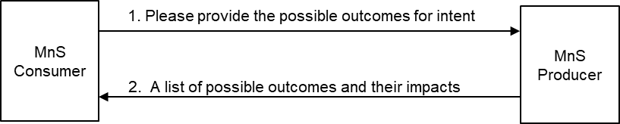
Figure 5.16.1.1-1: MnS consumer requests and receives a list of fulfillable outcomes on an intent.
Subsequently, the MnS producer provides a report indicating what is fulfillable for each intent aspect (intentExpectation and expectationTarget) within that intent. Since different fulfillable outcomes may have different impacts, the report should include the relative impacts of each outcome.

5.16.1.2 Checking for best possible outcome on an intent, intent expectation, or expectation target
The MnS consumer wants to know the best possible outcome for a given intent or intent expectation or expectation target. This could be prior to or during fulfilment.
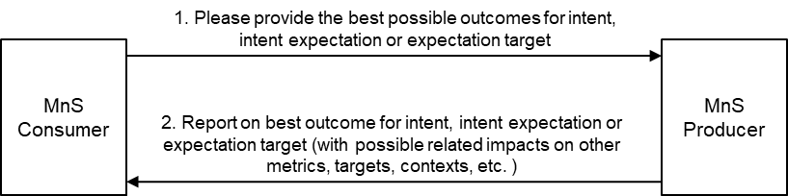
Figure 5.16.1.2-1: Checking for best possible outcome on intent or intent expectation or expectation target.
The MnS consumer creates an intent that should be evaluated by the MnS producer with a request to provide the best possible outcome. Subsequently, the MnS producer provides a report indicating that best possible outcome. The best possible outcome is defined as follows:
- The request is to evaluate an intent with only 1 expectation target: The best possible outcome is the best value on that expectation target that does not adversely affect other aspects of the network.
- The request is to evaluate expectation target in an intent with multiple expectation targets (e.g. multiple expectations or one expectation with multiple expectation targets): The best possible outcome is the best value on that expectation target that maintains the other expectation targets to within the ranges specified in the intent and does not adversely affect other expectation targets or aspects of the network.
- The request is to evaluate all expectation targets in an intent with multiple expectation targets (e.g. multiple expectations or one expectation with multiple expectation targets): The best possible outcome is the best value on each expectation target that maintains the other expectation targets to within the ranges specified in the intent and does not adversely affect other aspects of the network.
The MnS producer should support an fulfillable outcomes report that lists the fulfillable outcomes for any of the three scenarios, the report including the related impact on other targets in the intent or on other metrics and contexts.

5.16.1.3 MnS producer to recommend fulfillable intent targets and contexts
rThe MnS consumer wants to know what the MnS producer recommends what to be applied for particular intent characteristics. The MnS consumer creates an intent and asks the MnS producer to recommend what changes could be made to the intent or other intents to make the intent fulfillable (Figure 3.2.1-1). Alternatively, the MnS producer has attempted to fulfil the intent and indicated that it cannot be fulfilled, so the MnS consumer asks the MnS producer to recommend what changes could be made to the intent or other intents to make the intent fulfillable.
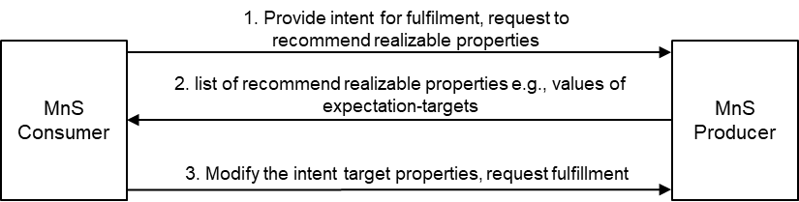
Figure 5.16.1.3-1: Enabling the MnS consumer to request and receive a recommendation on the fulfillable intent properties prior to fulfilment.
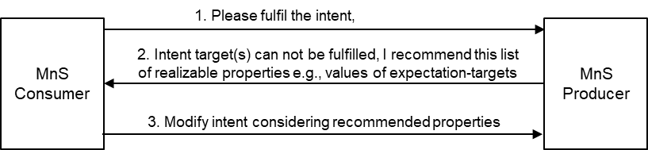
Figure 5.16.1.3-2: Enabling the MnS producer to recommend to the MnS consumer a set of fulfillable intent properties in case of inability to fulfil an intent.
Subsequently, the MnS producer provides a (intent modification recommendation) report indicating the changes to be applied to the intent to make the intent fulfillable. The MnS producer should support a recommended-changes report that lists the proposed candidate changes to each unfulfillable target within an unfulfillable expectation.
Note: the nature of the report and what can be included if FFS

5.16.1.4 MnS consumer advises on preferred alternatives
The MnS consumer wants an intent fulfilled. The intent is feasible, but the MnS producer has multiple alternatives related to fulfilling the intent. The MnS producer wants the MnS consumer to advise on their (the MnS consumer’s) preference among these alternatives.
Note 1: An alternative is the combination a set of expectation target values that the MnS producer can achieve together with their (expected) impacts on the network (objects). E.g. for an expectation target on energy consumption, the impact may include which cells could be deactivated, or which other intents (e.g. coverage related intents) could be affected.
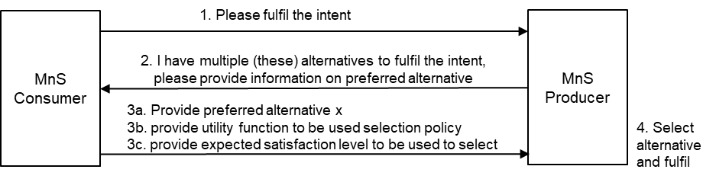
Figure 5.16.1.4-1: MnS consumer advises the MnS producer on the preferences among alternatives at the MnS producer.
After the MnS consumer creates an intent to be fulfilled, the MnS producer determines that there are multiple alternatives, so the MnS producer and provides a report to the MnS consumer so that the MnS consumer may help chose the best alternative.

The report to the MnS consumer may include:
- the list of available/fulfillable expectation target values that the MnS producer is able to apply/achieve.
- The expected relative impacts of the different alternatives – on aspects of the submitted intent or other intents and intent expectations.
- A request to the MnS consumer to select one among the alternatives.
Given the alternatives, the MnS consumer takes one or both of the two actions,
- Chooses and indicates the preferred alternative.
- Defines the relative importance of their expectation Targets so that the MnS producer may consider these in deciding upon the solution/ solution approach/ closed loops/ action/ outcome to be applied/deployed/achieved.

5.16.1.5 MnS producer requests for extra information to be used to select another alternative post initial fulfilment
The MnS consumer wants an intent fulfilled and the MnS producer has multiple alternatives related to fulfilling the intent. After the MnS consumer creates an intent to be fulfilled, the MnS producer independently choses the alternative to be applied. But on realizing that they cannot achieve better outcomes, MnS producer allows the MnS consumer to provide extra information that guarantee better satisfaction (see Figure 5.16.1.5-1). The MnS producer reports the fulfillment outcomes (imperfect fulfillment) and indicates to the MnS consumer that if the MnS consumer is unsatisfied with the outcomes, the MnS consumer should provide extra information to help select a better alternative.
The report to the MnS consumer may include one or more of the following:
- The list of available/ fulfillable expectation target values which can guide the MnS consumer when providing the preference policy.
- The relative impacts of the different alternatives – on the submitted intent or on other intents and intent expectations or on the network.
- A request to evaluate the fulfilment and provide information that could help improve fulfilment.
The extra information provided by the MnS consumer may be one or more of the following:
- A Binary indication that they accept the provided fulfillment or that they do not accept, and another alternative should be tried.
- A utility function indicating the MnS consumer’s relative benefits of their expectation Targets. The utility function is the MnS consumer’s policy for evaluating of the extent to which they are satisfied with the selected alternative
- MnS consumer’s level of satisfaction which is the evaluation of the extent to which the achieved outcomes match the MnS consumer’s expectation as computed from the utility function.
- changes to the expectation Targets or the relative importance of the expectation Targets to the MnS consumer’s objectives
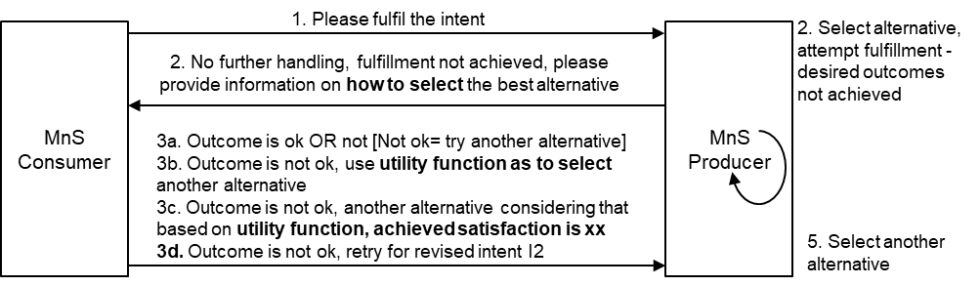
Figure 5.16.1.5-1: MnS producer requests MnS consumer to provide information to help select (better) alternative

5.16.2 Potential Requirements
REQ-Intent_Negotiation _01: The intent-driven MnS should have the capability to enable the MnS producer to provide possible outcomes to the MnS Consumer.
REQ-Intent_Negotiation_02: The intent-driven MnS should have the capability to allow MnS Consumer decide appropriate outcome for fulfilment based on possible outcomes.
Note: the definition for outcome is FFS.
REQ_INT_NEGOT-1: The MnS producer should support a capability enabling an MnS consumer to provide an intent with a request for the MnS producer to provide information on the alternative fulfillable outcomes for an intent.
Note: An alternative is the combination of a set of expectation target values that the MnS producer can achieve together with their (expected) impacts.
Note: The impacts refer to information about the changes and outcomes on the expectation objects of the intent and on other related intents from the same intent MnS consumer. The exact characterization of what is reported is FFS.
E.g. for an expectation target on energy consumption, the impact may include which cells could be deactivated, or which other intents (e.g. coverage related intents) could be affected. be applied to the intent (i.e.,) to make the intent fulfillable
Note: example changes could include: omitting certain intentExpectations and/or expectationTarget(s) or changing the properties of intentExpectations and/or expectationTarget(s)
REQ_INT_NEGOT-2: The MnS producer should support a capability to provide to an MnS consumer an intent report indicating the alternatives that the MnS producer can support for the provided intent, intent expectations, or expectation Targets and the expected relative impacts of the different alternatives
REQ_INT_NEGOT-3: The MnS producer should support a capability to request an MnS consumer to indicate its preference among a set of alternatives that the MnS producer can support for the provided intent, intent expectations, or expectation Targets.
REQ_INT_NEGOT-4: The MnS producer should support a capability enabling an MnS consumer to provide to the MnS producer information indicating the MnS consumer’s preference among alternatives that the MnS producer can support for the provided intent, intent expectations, or expectation Targets.
REQ_INT_NEGOT-5 The MnS producer should support a capability enabling an authorized MnS consumer to provide information on a policy that should be used by the be used by the MnS producer to select among the alternatives available at the MnS producer.
Note: The policy may be provided in the form of a utility function
REQ_INT_NEGOT-6 The MnS producer should support a capability to request the MS consumer to provide an evaluation of the MnS producer’s alternatives based on the expected relative impacts of the different alternatives.
REQ_INT_NEGOT-7 The MnS producer should support a capability enabling an MnS consumer to provide an evaluation of the MnS producer’s alternatives to then be used to select among the alternatives.
REQ_INT_NEGOT-8 The MnS producer should support a capability to inform an authorized MnS consumer that an alternative among multiple alternatives has been selected and (will be/has been) applied for the submitted intent.
REQ_INT_NEGOT-9 The MnS producer should support a capability to inform an authorized MnS consumer that since no more improvement to intent fulfillment shall be possible the MnS consumer should evaluate the extent to which the applied alternative satisfies the MnS consumer’s objectives or provide extra information which can help improve satisfaction.
REQ_INT_NEGOT-10 The MnS producer should support a capability enabling an authorized consumer to inform the producer that the alternative selected by the MnS producer was not satisfactory and another alternative should be applied.
REQ_INT_NEGOT-11 The MnS producer should support a capability enabling an authorized MnS consumer to provide information on the level of fulfillment which the MnS producer can use to differently attempt the fulfillment.
REQ_INT_NEGOT-12 (already supported) The MnS producer should support a capability enabling an authorized MnS consumer to revise the properties of an intent as the means to improve the chances of the intent being fulfillable.

5.16.3 Potential Solutions
This solution proposes to enhance the existing Intent IOC and IntentReport IOC defined in TS 28.312 [2] to describe intent negotiation information between MnS producer and MnS consumer during fulfilment phase. e Following are the proposed enhancements:
Enhancement on Intent IOC: Introduce attribute “ expectedReportType” and corresponding ENUM Value “IntentNegotiationReport” in the Intent IOC to determine the intent negotiation information including the possible outcomes the MnS Consumer can obtain from the MnS Producer).
The detailed definition for attribute “expectedReportType” see clause 5.3.3.

- Introduce a dataType representing the feedback information for the MnS consumer’s response to the MnS producer. It may be called IntentNegotiationFeedback. It may contain:
- An attribute for a specific alternative among those indicated by the MnS producer.
- A policy that should be used by the be used by the MnS producer to select among the alternatives. The policy may for example be MnS consumer’s utility function.
- An attribute indicating the MnS consumer’s satisfaction from a deployed fulfillment as computed form the MnS consumer’s utility function
  - It may contain a list indicating the MnS consumer’s expected satisfaction from the different alternatives e.g. as evaluated form the MnS consumer’s utility function. This may be a key-value pair where the key is an identifier of the alternative and the value’s the MnS consumer’s expected satisfaction.
    - It may also be used to indicate the true MnS consumer’s satisfaction as evaluated for an alternative that has been applied
- Optionally includes an ENUM attribute indicating the type of extra action information being provided. The values representing the type of extra information could include: IS_SELECTED_OPTION_NOT_OK, SELECTED_OPTION, SATISAFACTION_POLICY
- Note: the fulfillableOutcomesReport and SupportedAlternativesReport will include the impact on the related ExpectationObjects

Enhancement on IntentReport IOC: Introduce an IntentNegotiationReport<<dataType>> as an attribute of Intent Report IOC to represent the MnS producer’s information on the negotiations. It may indicate what is fulfillable for an intent, what the MnS producer recommends for an intent or the MnS producer’s alternatives from which the MnS consumer may chose. IntentNegotiationReoprt <<dataType>> includes following attributes:
Note: whether IntentNegotiationReport<<dataType>> as an attribute of IntentReport IOC or intentFulfilmentReport dataType needs further clarification.
- PossibleOutcomeList, it indicates the possible or fulfillable outcomes for the intent expectations and expectationTargets within that intent and the relative cost/impact (on the related ExpecationObjects) of achieving that outcome
Note: The “PossibleOutcomeList” will include the potential impact on the related ExpectationObjects
- PossibleOutcomeType, an attribute for what the information indicates, i.e. either
  - the fulfillableOutcomes,
- recommendedChanges, it indicates the potential changes to the intent that could make the intent fulfillable
- SupportedAlternativesReport. Inclusion of a SupportedAlternativesReport inherently asks theMnS consumer to choose one alternative among those in the SupportedAlternativesReport.
- ExtraActionInformaton indication:, an ENUM attribute indicating need for extra information. The values representing the type of extra information needed could include: SELECT_FROM_OPTIONS, IS_SELECTED_OPTION_OK, PROVIDE_EXTRA_INFO_.

5.16.4 Evaluation of solutions

Next Change

5.17 Use case #17: Negotiation on the possible outcomes during the fulfilment phase
See clause 5.16.

